Name: Date:

Induced Seismicity: Are humans causing earthquakes? – Student Worksheet
Version – 6.2; Last updated – June 2017

The purpose of this activity is to explore
- the processes involved in unconventional gas resource exploration and production (hydraulic fracturing),
- how we monitor seismic activity and draw correlations (or lack thereof) between fluid injection (related to hydrofracking or from wastewater disposal) and earthquake activity,
- ways that we might establish a better understanding of correlations between the two.

Introduction
The process of removing hydrocarbons from Earth’s crust has become an important activity for humankind. Over time, the most accessible oil and gas reservoirs have been, or are being consumed. To meet humankind’s demand for hydrocarbons, the oil and gas industry has developed new technologies to reach previously inaccessible gas resources and increase the efficiency of production. While this increases hydrocarbon availability, challenges arise when attempting to access these non-traditional (or unconventional) oil and gas fields, which have the potential to affect the natural and built environments in a variety of ways. We will explore these challenges below.

The term conventional oil and gas (or simply conventional) resources, applies to oil and gas extracted through a drilled well, either by the natural pressure of the well and/or by pumping or compression operations. Another approach to recovering hydrocarbons is from unconventional gas resources, by a process known as high-volume hydraulic fracturing (“hydrofracking”). High-volume hydrofracking involves injecting large volumes of water, sand and chemicals into the rock under high pressure to create cracks through which the gas may escape the rock formation and then be collected. Hydrofracking most commonly takes place in gas fields found in shales, which are soft, finely stratified sedimentary rocks that form from consolidated mud or clay.

In addition to releasing hydrocarbons, formation water or naturally occurring water rich in brine (salts) that contains toxic metals and low levels of radioactivity, are also released. This is because the formation water is also trapped in the same pore space as the oil and natural gas. Both the hydrofracking fluids used to fracture the rock and the formation water, a combination called flowback water, are recovered during the gas production process. The disposal of the flowback water presents a major challenge given its large volume and chemical makeup. Fortunately, much of the flowback water can be recycled and reused by the industry. However, a disposal solution is still eventually needed, given the large volumes of fluid involved. One option is to remove contaminates from the flowback water. Unfortunately, standard municipal water treatment plants are not equipped to handle this level of waste treatment. An alternative is to inject the wastewater back into Earth’s crust. Some states, such as Oklahoma and Ohio, allow both hydrofracking and wastewater injection. Other states, such as Pennsylvania, allow hydrofracking but require wastewater to be transported out of state for disposal. In Oklahoma, 90% of the wastewater being injected into deep disposal wells comes from the natural formation water, not the fluids used in the hydrofracking process [Rubinstein and Mahani, 2015].

In some cases, the stress generated from either hydrofracking or wastewater disposal can cause increased levels of earthquake activity (“induced seismicity”). By its very nature, hydraulic fracturing causes very small earthquakes, which are normally not felt. However, the causal relationship between fluid injection (either hydrofracking or wastewater displosal) and induced seismicity is an active topic of scientific research and debate, as the largest earthquake ever thought to correlate with wastewater injection is a M5.8 earthquake in Oklahoma that occurred in September 2016.

Activity
Let’s explore the locations of earthquakes, wastewater injection wells and hydrofracked production wells in the next section to see if there is a correlation. Keep in mind that establishing a direct link between injections and earthquakes is very difficult because unknown subsurface geologic structures make establishing causal mechanisms difficult.

Part I: Hydrofracking and Wastewater Injection: Process and Effects

Let’s first start with understanding a bit about the hydrofracking and wastewater disposal process.

Start by viewing a video produced by Marathon Oil: https://www.youtube.com/watch?v=VY34PQUiwOQ

- Based on what you observed in the video, describe the process of hydraulic fracturing (hydrofracking). Are hydrofracking wells vertical or horizontal, or a bit of both? Explain. Can multiple hydrofracking operations take place from the same drilling site? In the hydrofrack fluid, what is the percentage of additives to water, and what do these additives do to the rock? On the plot below, sketch how the hydrofrack fluids break up the rock and release the oil/natural gas. Please also show the hydraulic fracturing stages, and how this is used to release oil/natural gas.

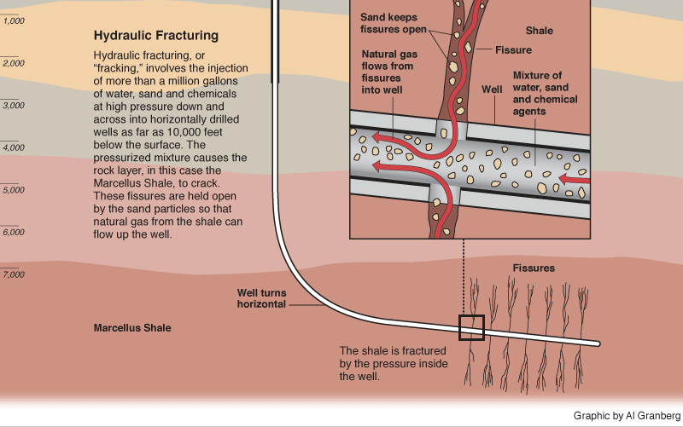

As an optional activity, also watch this fracking video from a group in Germany: https://www.youtube.com/watch?v=Uti2niW2BRA
Discuss with a partner how you could determine which of the two videos are more accurate and better describe the process?

- Now that we’ve thought a bit about the hydrofracking process itself, what kinds of stresses would be generated when fluids are injected into the shales during hydrofracking? Sketch the stress directions on the above figure that you think the hydrofracking process would create.

- Do you think the stresses created by hydrofracking as you sketched above could cause earthquakes? Why or why not?

Now, watch this video by the Ohio Department of Natural Resources about wastewater disposal (or Class II injection wells): https://www.youtube.com/watch?v=tgw3An4IHpc

- Describe the process of wastewater disposal. Does disposal take place in vertical or horizontal wells? In Ohio, are disposal fluids ever exposed to the outside, or are they contained either within storage or on trucks? What type of layer (permeable or impermeable) are fluids pumped into? Why is this important?

The disposal wells are drilled vertically into a permeable layer below an impermeable layer. In Ohio, the waste fluid isn’t exposed to the outside. The layer where the fluids are pumped needs to be permeable because otherwise the fluids couldn’t diffuse away from the well.

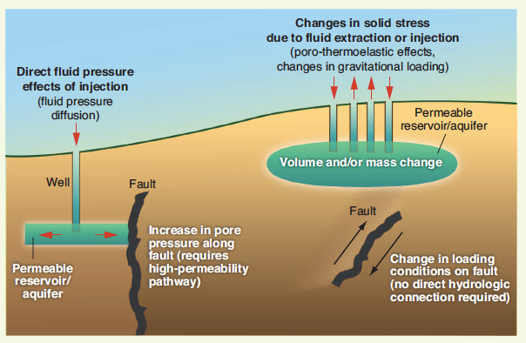
Figure from Ellsworth [2013]

- Based on the above sketch, with a fault in the area of wastewater disposal, describe in your own words how changes in stresses generated by fluid injection might cause changes in fault stresses, and therefore induce earthquakes?

Part II: Hydrofracking, wastewater injection, and seismic activity - general

Let’s start our examination of regions with active fluid injection operations, and how the injection may or may not relate to regional seismic activity.

Let’s explore areas in the United States with significant hydrofracking and/or wastewater injection activity. Go to: http://bit.ly/1JdncUR

This is the most recent oil and gas wells activity map. You can use the ‘Layers’ tab, to overlay or remove data layers. You can simplify the map by selecting the Layers tab at the top of the screen, and deselecting all layers and selecting only “Oil and Gas Wells (generalized)”.

- Explore the map by zooming in and panning around. What patterns do you notice about the location of oil and gas wells?

- What are your hypotheses about the distribution of where the oil and gas wells are located?

Keep the view of the well data on fractracker.org open in a browser tab so you can refer to it again in this next section.

In a new browser tab, let’s examine seismicity in the United States using the IRIS Earthquake Browser (ds.iris.edu/ieb). With this link (http://bit.ly/2pJe7ui), the tool will open to a map of the United States showing earthquakes (dots) from January 1, 2008 to present (options on right). Currently, the view is set to show the 5000 most recent earthquakes. You can also look at the seismicity in a table view using the “Open: Other formats” on the bottom right side of the screen.

- Compare and contrast the earthquake activity in California with the rest of the continental United States. California has many active faults that are well known, like the San Andreas Fault. What other states appear to have significant earthquake activity? List at least two.

- Are there any of the other states with earthquake activity that are surprising to you? If so which ones? What makes the earthquake activity in these states surprising?

- Now take a look at this map (http://bit.ly/2qDkMv7) to examine the central and eastern United States (or the Rockies to the east coast). Compare the well maps you examined earlier to this seismicity map, and describe at least two (2) regions that appear to contain both wells and significant concentrations of seismic activity. Describe the type of geology in the region (i.e., if it’s in an area of a known shale play and/or basin), the extent of well activity, and the magnitude range of seismic activity.

Next, we want to look at changes in the central and eastern United States over time. We want to compare the earthquake activity from 2000-2008 (http://bit.ly/2smW13a), and from 2008 to the present (http://bit.ly/2pJhjGi). The rate of hydraulic fracturing and wastewater injection has increased in the central and eastern US since 2009.

- What is the overall number of earthquakes during both time frames, 2000-2008 and 2008 to the present, respectively? (Look in the orange ‘Earthquake Count’ box, in case the number of earthquakes exceeds the maximum 5000 shown.) What specific regions jump out to you? Are there obvious changes in seismicity rates for areas showing clusters of activity? Why or why not?

Part III: Hydrofracking, wastewater injection, and seismic activity – Oklahoma case study

Here we will investigate potential connections between hydraulic fracturing (hydrofracking), fluid injection and seismicity. We begin by looking at 2009 and later, when the hydraulic fracturing boom occurred in the central and eastern United States.

As alluded to in the previous portions of this exercise, there is no comprehensive publicly available dataset that documents injection well activities. In lieu of actual well activity data, we will utilize a dataset of well completion dates, combined with a high-resolution catalog of seismicity for the state of Oklahoma.

For this activity, you’ll need the Google Earth KMZ file OK_Earthquakes_Hydrofracking_Injection_Wells_2009-2016.kmz. Detailed information for each of the datasets is included in the “Places” tab to the left under “Temporary Places.”

- Red circles: Earthquakes located by the USGS, 2009-2016
- White triangles: Hydrofracking wells completed 2009-2016
- Green circles: UIC Class II injection wells active 2009-2016

A time slider should appear once the data file is loaded in Google Earth. The injection wells are set to display for the entire time period and may or may not have operated during the entire time frame. The length of time for the time window in view can be adjusted using either the wrench on the time slider popup, or adjusting the time sliders manually.

First, take some time to familiarize yourself with the operation of Google Earth and the time slider bar. For instance, make sure that the ‘Borders and Labels’ layer is selected (can be found under ‘Layers’ tab) and that the ‘Scale Legend’ is on under the ‘View’ tab to answer some of the following questions.

- Look at the state as a whole. Is there a correlation in space and/or time between the seismicity and either the hydrofracking or disposal (Class II injection) wells? Write your claim, and support it with evidence.

Next, visually inspect the dataset over time to probe for earthquake swarms (a large number of earthquakes clustered in space and time).

- With the KMZ file in Google Earth, use the sliders to examine the year 2011. Focusing on the earthquakes only, zoom into the central portion of the state near Oklahoma City, where many earthquakes happened that year. Now toggle on the location of hydraulic fracturing wells, and then the location of nearby wastewater injection wells. Do the earthquakes appear to be spatially located near hydraulic fracturing wells or wastewater disposal? Write your claim, and support it with evidence. How does this compare to your statewide claim in the previous question?

- Based on your data and analysis with the KMZ file and with the IEB results from the previous section, is there a causal link between hydraulic fracturing and induced seismicity OR wastewater disposal and increased seismicity?

- What additional evidence would help you support your claim?

References

Ellsworth, W. L. (2013), Injection-Induced earthquakes, Science, 341, 142-149.

Keranen, K. M., H. M. Savage, G. A. Abers, E. S. Cochran (2013), Potentially induced earthquakes in Oklahoma, USA Links between wastewater injection and the 2011 M_{w}5.7 earthquake sequence, Geology, doi:10.1130/G34045.1.

Keranen, K. M., M. Weingarten, G. A. Abers, B. A. Bekins, and S. Ge (2014), Sharp increase in central Oklahoma seismicity since 2008 induced by massive wastewater injection, Science, doi:10.1126/science.1255802.

Langenbruch, C., and M. D. Zoback (2016), How will induced seismicity in Oklahoma respond to decreased saltwater injection rates? Sci. Adv. 2, e1601542.

National Research Council (2013), Induced seismicity potential in energy technologies,
Washington, D.C., The National Academies Press, 262 p., http://www.nap.edu/catalog.php?record_id=13355.

Rubinstein, J. L., and A. B. Mahani (2015), Myths and Facts on Wastewater Injection, Hydraulic Fracturing, Enhanced Oil Recovery, and Induced Seismicity, Seismo. Res. Lett., 86, no. 4, doi: 10.1785/0220150067.

