Earl of Rochester

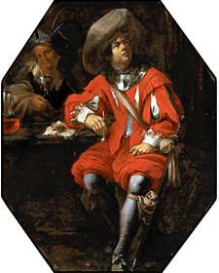
S O N G.
Love a Woman! y'are an Ass,
'Tis a most insipid Passion,
To Chuse out for Happiness
The idlest part of God's Creation.
Let the Porter and the Groom,
Things design'd for Dirty Slaves,
Drudg in Fair Aurelia's Womb,
To get Supplies for Age and Graves.
Farewel Woman, I intend
Henceforth ev'ry Night to sit
With my Lewd Well-natur'd Friend,
Drinking, to engender Wit.
Then give me Health, Wealth, Mirth, and Wine,
And if busie Love intrenches,
There's a sweet soft Page of mine,
Do's the Trick worth Forty Wenches.

