Method

Assessment

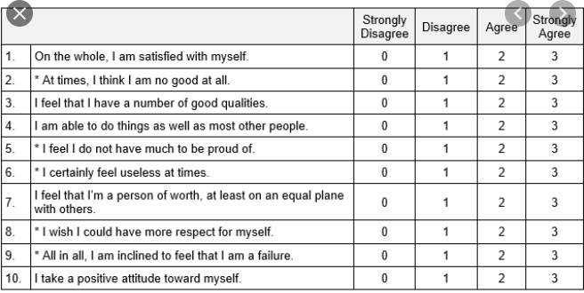

Rosenberg’s Self Esteem Scale

Self esteem will be assessed using the RSE scale which consists of 10 Likert-type items. Items are anchored between strongly disagree and strongly agree using a 4-point scaling system. There is no middle point. Five items are positively worded and five negatively worded.

Reliability will be assessed using several means. First, test-retest reliability will be evaluated using a 5-day interval. This process will be followed by 10-15% of the participants. Evidence on reliable measurement will be in rates of agreement between pre-post measures equal to 80%. However, this 80% should not reflect exact agreement but allowed variability would be in the range +-0.20. Internal consistency reliability will be assessed using Cronbach’s alpha. Acceptable values are in the range of .75 and above. Furthermore, split-half reliability will be assessed using Guttman’s coefficient in which acceptable values are in the range of .65 and greater. Interrater reliability will be assessed using Cohen’s kappa statistic in which acceptable values are in the range of .5 and greater.

Construct validity will be assessed using factor analysis. Convergent validity will be assessed by correlating self-esteem with self-image. Evidence on convergent validity will be provided with correlation coefficients that are both statistically different from zero and in excess of .5 (where .5 is a large correlation based on Cohen, 1992). Discriminant validity will be assessed using the known-groups approach. Specifically, low and high achievers will be contrasted on their levels of academic self-esteem. Low and high achievement will be determined using a mean/median split (or 25th vs 75th percentile).

References

Cohen, J. (1992). A power primer. Psychological Bulletin, 112, 155-159.