https://www.politico.eu/article/fake-news-busters-germany-ben-scott/

Former Hillary Clinton aide fights fake news in Germany
As Germans head to the polls, efforts are under way to prevent false information from swaying the election.
By Mark Scott
9/14/17, 10:00 AM CET
Updated 9/21/17, 1:46 PM CET
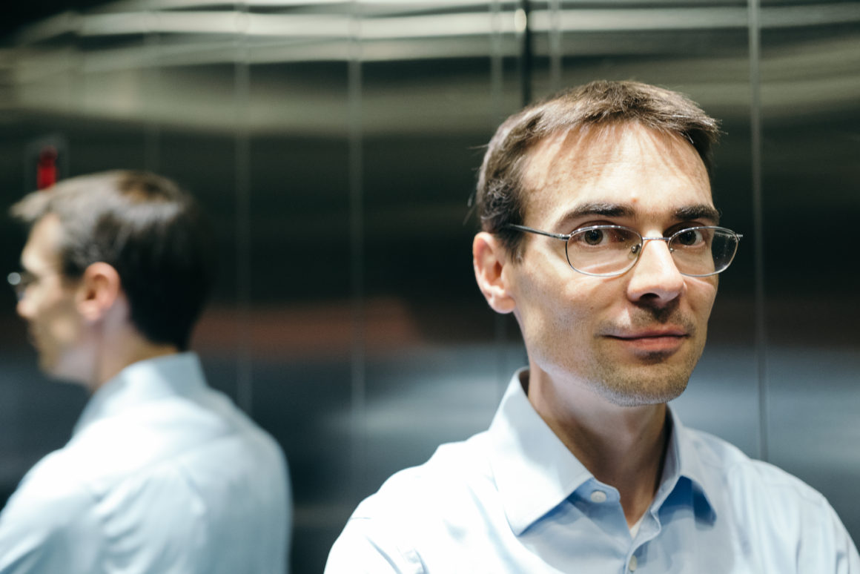
Ben Scott has been tracing how digital falsehoods worm their way through social media sites like Facebook and Twitter | Kai Müller for POLITICO
Ben Scott has been tracing how digital falsehoods worm their way through social media sites like Facebook and Twitter | Kai Müller for POLITICO
Ben Scott is on the hunt for fake news.
As an outside technology adviser to Hillary Clinton’s failed 2016 U.S. presidential campaign, Scott has first-hand knowledge of how digital falsehoods can infiltrate — and, he would add, sway — an election.

Scott, who also served as a Clinton aide on technology when she was U.S. secretary of state, is part of a growing brigade of policymakers, national intelligence agencies and fact-checking agencies working to ensure the same thing does not happen in Germany as voters head to the ballot boxes.
“It’s my own personal regret that we didn’t understand the significance of this during the U.S. election,” said the soft-spoken American who has teamed up with Stiftung Neue Verantwortung, a digital think tank in Berlin, to combat potential online misinformation in the run up to the September 24 vote.
In the months building up to Germany’s election, 39-year-old Scott — who splits his time between Berlin and Toronto — and a small team of researchers have been scouring the country’s news outlets and social media ecosystem in search of fake news.
Their goal: to trace how digital falsehoods worm their way through social media sites like Facebook and Twitter, penetrate traditional media and influence the public debate — and ultimately the election.
By flagging how such falsities are spread virally, the Berlin-based team hopes to develop countermeasures, potentially suppressing false information and ensuring the integrity of elections, both in Germany and in future votes worldwide.
That has involved creating an online database since early summer of potential digital falsehoods and tracking how such misinformation has seeped into the current election campaign, in which Angela Merkel still maintains a healthy lead against her main challenger, Martin Schulz.

“State-backed actors are trying to amplify their views and increase the mainstream nature of fake news” — Janis Sarts, director of a NATO think tank
In late May, for instance, Scott’s group tracked how extremist groups successfully hijacked comments made by Margot Käßmann, the former bishop of Hanover.
Over a two-week period, more than 30,000 social media posts and articles falsely claimed that Käßmann had called many native-born Germans neo-Nazis, according to Stiftung Neue Verantwortung’s analysis of the online activity.
Traditional media quickly debunked the allegations. But the fake news was much more widely shared and commented on across social media than the debunking. That finding, said Scott, highlights how Germans — like their American counterparts — are susceptible to fake news, even if many of the country’s policymakers already claim victory over the phenomenon.
“Even small blogs peddling misinformation can punch above their weight online,” said Scott. “It’s like a snowball rolling down a hill. It’s hard to stop it when it starts.”

An unwieldy troop
Scott and his team are part of wider global efforts to fight fake news, inspired in large part by the build-up to the 2016 U.S. election, when false reports — some allegedly created and shared online by Russian-backed groups — went viral, making it difficult for voters to tell myth from reality.
Underhanded efforts to sway campaigns around the globe existed well before 2016. But the ability of fake news, cyberattacks and other digital trickery to raise doubts in voters’ minds, experts say, is a relatively new problem that has caught lawmakers off-guard.
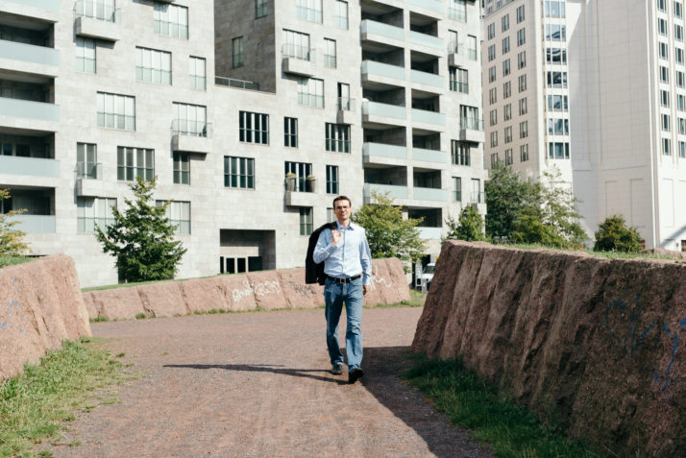
Ben Scott believes Germany has much to teach countries like the U.S. when it comes to fake news | Kai Müller for POLITICO
The phenomenon has now become part of almost every country’s election cycle.
During elections across Europe this year — in the Netherlands, France, Britain, Sweden and soon Germany, Austria and the Czech Republic — an unwieldy troop of government agencies, media groups and political researchers have tried to perfect the imprecise art of debunking digital falsehoods.
That includes educating people about fake allegations targeted at candidates and protecting campaigns from increasingly sophisticated online cyberattacks. It also means working with tech companies like Google and Facebook to combat misinformation and hate speech often aimed at skewing elections toward extremist politicians or viewpoints.
European governments — many stirred into action after last year’s U.S. presidential election — have also doubled down on their efforts.
Countries like Britain and France have provided national security agencies with additional resources to bolster digital security connected to electoral campaigns and voting systems.
The Czech Republic, Finland and the European Commission, among others, have either created or expanded in-house fact-checking teams, mostly directed at countering Russian-sponsored propaganda spread on social media.
“Every country is different. Every election has brought a new challenge” — Claire Wardle, head of strategy and research at First Draft News
And even NATO — better-known for preparing for traditional warfare — has joined the fight, holding hackathons and training sessions in recent months with researchers, policymakers and tech companies to find new ways of combatting the growing online threat.
“There’s an increased amount of misinformation out there,” said Janis Sarts, director of the NATO Strategic Communications Center of Excellence, a think tank in Riga, Latvia. “State-backed actors are trying to amplify their views and increase the mainstream nature of fake news.”

Tech firms under pressure
As the main vehicle used to spread such digital misinformation, tech companies like Google, Facebook and Twitter also have come under increased pressure from lawmakers worldwide to do more.
Industry executives were initially caught off guard by the backlash about their role in how such falsities were spread online, including Facebook’s recent revelation that Russian-backed groups had bought $150,000 worth of ads on the social network during the 2016 U.S. campaign.
As the size of the threat became more understood, the companies have started removing hundreds of thousands of illegal accounts from their networks across Europe and the United States.
Facebook and Google also have held a series of digital security training sessions with national lawmakers, providing tips on how to protect against cyberattacks. They similarly have financed fact-checking initiatives from the U.S. to Germany, doling out cash to bolster efforts at debunking myths in real time.
“There’s no easy answer for this complicated issue,” said David Dieudonné, head of Google’s news lab in France, which worked with local media outlets to debunk a relatively small amount of digital misinformation during the recent French election.

Evolving threat
Some question if this international push to combat online misinformation can ever truly corral an online threat — often financed by deep-pocketed and hostile governments — that is both widespread and continually changing.
“After the U.S. election, we thought there would be a one-size-fits-all approach to our work,” said Claire Wardle, head of strategy and research at First Draft News, a fact-checking group that first partnered with tech companies and media organizations during the U.S. election to debunk fake news and that has since expanded its work across Europe.
“The reality is much more complicated,” she said. “Every country is different. Every election has brought a new challenge.”
Fake news in last year’s U.S. election was mostly disseminated through online articles and social media posts. The digital falsehoods in Europe, by contrast, have increasingly been transmitted via easily-shareable doctored images, either about politicians like Emmanuel Macron or hot-button issues like the refugee crisis.
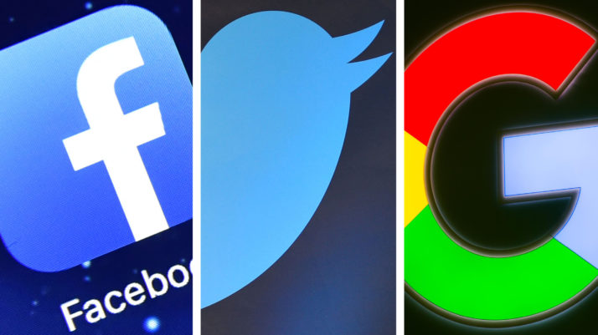
Facebook, Twitter and Google — some of the tech giants confounded by fake news | Source images by Getty Images
That has made it difficult, if not impossible, to use fact-checking methods and technological solutions designed to combat text-based falsehoods. It also has forced media organizations, political campaigns and government agencies to repeatedly reinvent the wheel as tactics used in one election got out of date by the next vote.
“The 2016 campaign was a great proof of concept for how to run a misinformation campaign,” said Robby Mook, campaign manager for Clinton’s failed presidential bid. “They won’t use the same playbook again.”

Lessons from Germany
Fake news has yet to play a major role in Germany’s election, according to Scott’s research at Stiftung Neue Verantwortung.
With less than a week to go before the vote, he is cautiously optimistic that Europe’s largest economy may have sidestepped the worst of the online misinformation, learning lessons from the U.S. and elsewhere in the EU on how to combat the threat.
“In the U.S., we have not invested in public media, and have watched with apathy when newspapers closed” — Ben Scott
“The scale of the problem in Germany is a magnitude smaller than what we saw in the U.S.,” said Scott, who plans to continue his fake news-busting work ahead of other elections worldwide. “But we’re not out of the woods yet.”
Plenty of uncertainly remains — notably a successful cyberattack against the German Bundestag in 2015 by Russian-backed hackers that has yet to lead to the publication of sensitive information. And, as Scott learned in last year’s U.S. election, nothing is ever certain until the last vote is counted.
Still, said Scott, Germany has much to teach countries like the U.S.
After World War II, the victorious Allies — foremost among them the U.S. — helped install stable democratic institutions in the country, including a well-functioning (and, often, publicly-funded) media industry. But while Germany has maintained such institutions, elsewhere, including in the U.S., the media landscape has drastically changed over the last 70 years.
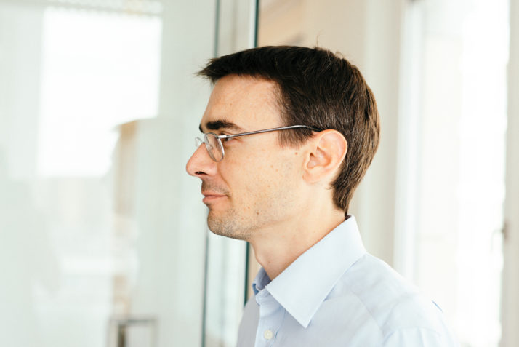
Ben Scott bemoaned the rise of partisan news outlets and one-sided echo chambers created on social media in the U.S. | Kai Müller for POLITICO
When Scott first arrived in Berlin, for instance, he said he was struck how the country had maintained much of its public-interest media outlets in contrast to the demise of many such organizations in the U.S. Many local publishers remain on strong financial ground, and well-read locals are already aware of the fake news threat.
“In the U.S., we have not invested in public media, and have watched with apathy when newspapers closed,” said Scott. “In its wake, the rise of infotainment has fractured the media world and allowed misinformation to thrive.”
Social media companies like Twitter also remain bit players in Germany when it comes to how people share and discuss political events. Even Facebook — with its 35 million German users — is still more a place to share vacation photos than to trade barbs with distant relatives about politics like in the U.S.
“The chickens came home to roost,” said Scott, bemoaning the rise of partisan news outlets and one-sided echo chambers created on social media in the U.S. “It’s not an accident the fake news phenomenon happened when it did.”

https://www.politico.eu/article/germany-election-campaign-fake-news-angela-merkel-trump-digital-misinformation/

Ahead of election, Germany seeks fake news antidote
Government braces for influx of last-minute false stories, digital hacks or online hate speech that could alter the vote.
By Mark Scott
8/31/17, 4:15 PM CET
Updated 9/12/17, 8:18 AM CET
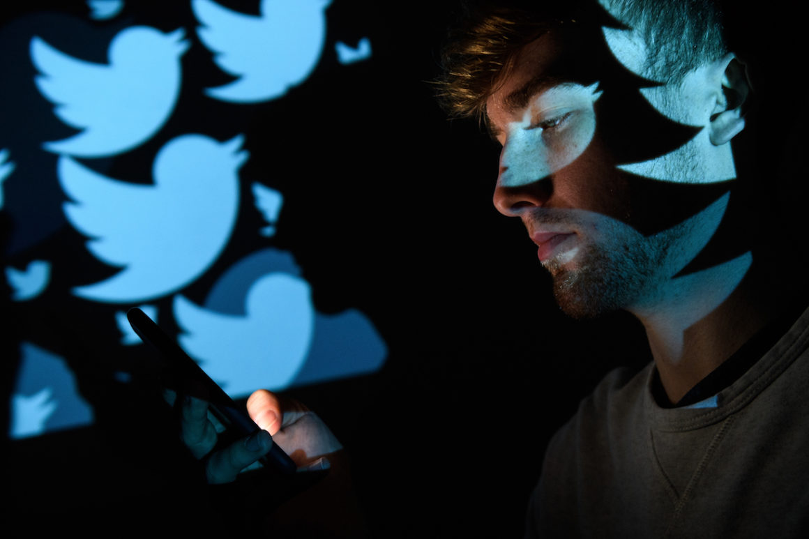
Leon Neal/Getty Images
BERLIN — The German election is still waiting for its fake news moment.
With less than a month before voters head to the polls, the country’s political parties, intelligence agencies and growing number of fact-checking organizations are scouring the depths of the internet for signs of digital misinformation that may sway the election.
So far, false reports — targeted either at politicians like Chancellor Angela Merkel or hot-button issues like the refugee crisis — have not broken through into the campaign. But as the days clock down to the September 24 election, policymakers fret that Germany may still see an influx of last-minute fake news, digital hacks or online hate speech that could alter the vote.
Merkel, who remains ahead in the polls, is expected to again take the reins of the most politically and economically important country in Europe. But her position may be weakened if any digital trickery makes a late appearance in the campaign — or during the haggling over a new coalition government after the election.
“Disinformation campaigns have not yet had an effect on the German election,” said Jakub Janda, deputy director of the European Values think tank in Prague, who tracks state-backed fake news efforts across the Continent. “It took major institutions two years to wake up to this threat, but they’re now taking it seriously.”
Germany still remains on edge after a group of Russian hackers broke into the computer systems of the national parliament in 2015.
The inability of fake news to make a political dent in Germany, experts say, stands in contrast to elections in the Netherlands, France, the United Kingdom and the United States, where online falsities — either published by traditional media outlets or through social media — were widely shared with potential voters.
The effect of such digital misinformation campaigns made many Germans keenly aware of potential false reports shared online. German publishers — whose readerships remain relatively robust despite newspaper subscription declines across the Western world — also have beefed up fact-checking tools in recent months.

And the role of social media, particularly Twitter, has been less pronounced in spreading false reports compared to what happened in the United States and other European countries.
“Twitter in Germany is a more niche environment,” said Ben Nimmo, a senior fellow of the digital forensic research lab at the Atlantic Council, a think tank, who is tracking online fake news and hate speech ahead of the election.
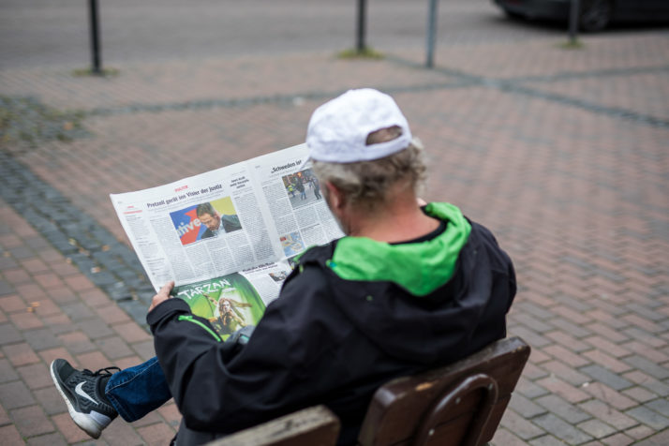
A newspaper with news on AfD prior to state elections in North Rhine-Westphalia in April | Lukas Schulze/Getty Images
Germany, though, still remains on edge after a group of Russian hackers, who also targeted U.S. and French elections and have links to the Kremlin, broke into the computer systems of the national parliament in 2015 to collect reams of information on lawmakers and their staff.
Intelligence agencies and security experts say this hacked material may be made public, potentially in the aftermath of the election, when Merkel is expected to start negotiations to form a ruling coalition. Experts warn these emails could be mixed with outright falsehoods, making it difficult to tell what is, and isn’t, real.
That could echo a similar data attack against French President Emmanuel Macron, which led to the publishing of reams of emails from Macron’s political party before the second round of France’s presidential election. The hack — published hours before a media blackout period before election day — failed to sway many undecided voters, according to political experts.
Hans-Georg Maaßen, head of Germany’s domestic intelligence agency, warned in July that such hacks were still a possibility ahead of the election, adding that the aim was to “hamper the trust in the functioning of our democracy.”

Taking no chances
In typical German style, the country is not taking any chances.
Local publishers — many of which still receive hefty government subsidies — have established, or expanded, fact-checking programs, mirroring similar initiatives in France, Britain and Spain, where outlets like Le Monde and El País tried to debunk myths almost in real time.
Tech giants like Google and Facebook also have pumped in money and technical resources to boost public awareness of potential online misinformation and hate speech, as well as to educate politicians whose knowledge of digital threats is often rudimentary, at best.
At a security conference in Munich earlier this year, for instance, Facebook held a joint training workshop for politicians with the German Federal Office for Information Security.
During the daylong event, according to a person with knowledge of the matter, lawmakers were schooled on basic online security measures, including protecting their social media accounts from potential hacks.
Such efforts come as Germany will implement some of the Western world’s toughest hate speech laws on October 1, which could lead to fines of up to €50 million for social media companies if they do not remove such content within 24 hours.
The failure of digital misinformation to sway the election, experts warn, does not mean that Germany is yet out of the woods.
Facebook, which is the country’s largest social network with roughly 35 million users, is expected to face the brunt of this legislation. To prepare, the tech giant has removed racist and other illegal content, including deleting tens of thousands of fake accounts and hiring hundreds of monitors to rake through online messages.
These efforts, though, have failed to win over many German publishers, which have mostly rebuffed Facebook’s pleas to join the company’s fact-checking initiative to debunk potentially false online posts that are flagged by users.
That program also has been rolled out across the U.S. and in parts of Europe, but has so far had limited impact in Germany, according to Jutta Kramm, head of fact-checking at Correctiv, the only German media group to sign up.
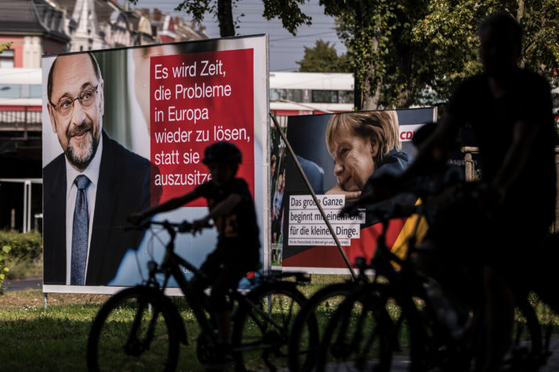
With Merkel’s CDU/CSU and Martin Schulz’s SPD almost certain to come in first and second, four parties are left racing for bronze | Maja Hitij/Getty Images
“The main challenge is measuring our impact,” Kramm said. She added that her group, on average, selected just one potentially fake news story daily to review — a small drop in the vast ocean of Facebook posts.
“It’s not perfect, but you have to be where the people are,” said Kramm, in reference to Correctiv’s fake news debunking program. “It’s a problem for Facebook. They need to do something more about it.”

Not out of the woods
The failure of digital misinformation to sway the election, experts warn, does not mean that Germany is yet out of the woods.
Across social media, online message boards and digital media outlets, far-right groups from Germany and outside the country have targeted specific issues, notably the refugee crisis, trying to galvanize support and make a dent in the election campaign.
In one of the more noticeable events, according to Alexander Sängerlaub, project leader of the fake news initiative at digital think tank Stiftung Neue Verantwortung, online groups hijacked comments made by Margot Käßmann, the former bishop of Hanover.
Over a two-week period in late May, more than 30,000 social media posts and articles were published that took Käßmann’s comments out of context, claiming, falsely, that she had said many native-born Germans were neo-Nazis, according to Stiftung Neue Verantwortung’s analysis of the online activity.
“We’re more prepared than the U.S. was to debunk fake news” — Alexander Sängerlaub, digital think tank Stiftung Neue Verantwortung
While traditional media quickly debunked the allegations, the fake news reports still received double the level of engagements on social media than these mainstream reports, highlighting that people were more willing to share — and comment on — the false reports than the fact-checking articles.
Such avid sharing on social media showed that Germans were just as willing to disseminate fake news as their American or British counterparts, Sängerlaub said. It also illustrated that unknown blogs, fake news sites and social media accounts often can garner more attention than traditional media rivals, particularly when promoting controversial topics.
“We’re more prepared than the U.S. was to debunk fake news,” Sängerlaub said. “So far, we haven’t seen anything big. But we still have a month to go.”

