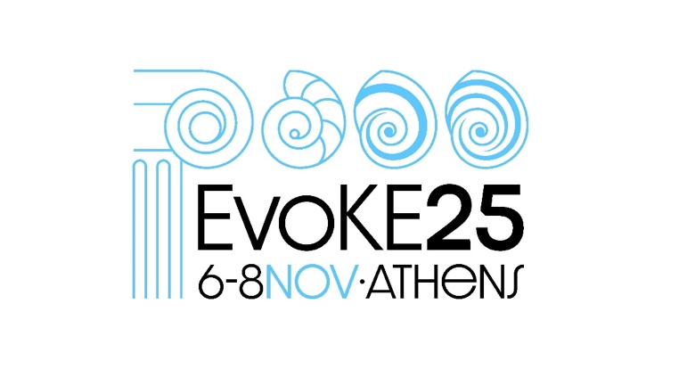

Thursday 6/11/2025
School of Education, NKUA, Navarinou 13A, 10680
2.30-4 | Registration (ground floor)
4-4.30 | Welcome address (Big Amphitheatre of the School of Education, 1st floor)
4.30-6 | Chair: Ioannis Trougakos  Telma G. Laurentino, Rita Ponce, Bento Cavadas, Raquel Branquinho, Maria João Fonseca, Rita Campos, Patrícia Pessoa, Teresa Nogueira, Bruno Sousa, Susana A. M. Varela, João Alpedrinha, Leonor R. Rodrigues, Adérito Cunha, André Rodrigues, Susana Carneiro, Margarida Rodrigues, Sara Aboim, Susana Ambrósio, João Cão Duarte, Miguel Ferreira, Tania Jenkins, Heloise D. Dufour, Luís Azevedo Rodrigues, João Lourenço Monteiro, Sara Branco, Diana Barbosa, Paulo de Oliveira, Xana Sá-Pinto Stronger together: systemic impacts of 11 years of education & outreach towards evolution literacy by a transdisciplinary participatory community  Lucía Vázquez-Ben, Patrícia Pessoa, Gonçalo Abreu, Tatiana Almeida, Maria Teresa Gallo, Alexandra Moorman, Giulia Realdon, Hannah Schröeder, Xana Sá Pinto Evolutionary literacy to explain the past and predict the future: what can primary school students tell us?  Nikos Mantelas & Evangelia Mavrikaki Exploring future educators’ conceptual knowledge of randomness and probability within evolutionary theory  Constantina Stefanidou Emergent Processes as a Crosscutting Concept: Epistemologically Enriching Science Education
6-7 | Chair: Evangelia Mavrikaki  Spyros Sfenthourakis On apes and men, or, misconceptions, tactics, and truths in talking about evolution to the public
7 | Welcome dinner

Friday 7/11/2025
Big Amphitheatre of School of Education, NKUA, Navarinou 13A, 10680
9-10 | Chair: Popi Papadopoulou  Patricia Pessoa, Bernardino Lopes, Alexandre Pinto and Xana Sá-Pinto Fostering Biodiversity Conservation through Evolutionary Literacy in Primary Education  Kostas Skordoulis The Alleged Darwin-Marx Correspondence  Gianna Katsiampoura The Reception of Darwinism in Greece: An Early Discussion on the Relationship between Marxism and Darwinism by a Feminist in the Interwar Period
10.00-10.30 | Coffee break
10.30-12 | Joelyn de Lima How to support student giving each other feedback, especially in situations that can evoke strong emotions (Workshop at the Biology Laboratorym Navarinou 13A, 4th floor) | Keira Cozens, Spreading Science by Stickers (Workshop at the Science Laboratory, Navarinou 13A, 4th floor)
12-1.30 | General Assembly of EvoKE
1.30 – 2.30 | Lunch break
2.30 -- 4 | Tania Jenkins (Co)-designing evolutionary research, education and outreach for societal impact (Workshop)
4 – 4.30 | Coffee break
4.30-6 | Chair: Constantina Stefanidou  Gregor Torkar Step-by-step application of the Framework for the Assessment of School Curricula on the Presence of Evolutionary Concepts (FACE) in the Slovenian curriculum reform.  George Ampatzidis Evolution by Natural Selection in the New Greek Upper Secondary Education Curriculum  Mpazou Olympia, Kapsala Nausica, Koutra-Iliopoulou Myrto, Talamagas Asimakis, Apostolia Galani, Evangelia Mavrikaki Is knowledge and acceptance of Evolution related to ethnocultural empathy?  Nikolaos Vakirlis Understanding the evolution of novel genes "from scratch"
6–7 | Chair: Xana Sa Pinto  Dana Zeidler The Evolution of Epistemic Insight and Socioscientific Issues in Science Education: A Scientific Literacy Perspective
8 | Dinner at a Greek tavern (cost 25 euros/person). Please, send us an email if you are interested or register at the reception of the conference at least a day before so we can have a draft number of people.

Saturday 8/11/2025
Big Amphitheatre of School of Education, NKUA, Navarinou 13A, 10680
9-10.30 | Chair: George Ampatzidis  Maria Ntertili, Nausica Kapsala, GENIO educational board game – A survival game!  Elia Mascolo, Yseult Héjja-Brichard, Replicards: Teaching evolution with a card game  Bethany Teale School-based adaptive laboratory evolution to promote evolutionary understanding, practical skills and interest in scientific research: A citizen science model.  Irene Prieto Saiz, Héctor del Valle Blanco Integrating sports and scientific knowledge: a practical example through outreach activities about geology and paleontology in the field
10.30-11 | Coffee break
11-12 | Chair: Apostolia Galani  Maria João Fonseca Evolution education in science centres and museums
12-1.30 | Rita Ponce Creating written content — crafting evolution stories and getting your message across (Workshop)

