THE IMPACTS OF SOLAR RADIATION ON HUMAN HEALTH

Rita Ponce¹, Susana Carneiro², André Rodrigues³, Mustafa Sami Topcu⁴
¹Departamento de Ciências da Vida, Escola de Psicologia e Ciências da Vida, Universidade Lusófona de Humanidades e Tecnologias, Lisboa, Portugal, ²Secondary School of Trofa, Portugal, ³Independent researcher, ⁴ Yildiz Technical University, Istanbul, Turkey

ABSTRACT
The correlation between the geographic distribution of human skin colour and the intensity of solar radiation is one of the most remarkable examples of how natural selection has shaped the evolution of our species and the divergence between human populations. The selective pressures shaping this distribution are still acting today, resulting in health problems for individuals whose skin colour is not adapted to the environment in which they live. Healthy sun exposure habits depend on both the individual’s skin colour and the environment in which they live. Thus, health communication strategies should recognise and reflect this diversity. However, although it is an important feature, skin colour is sometimes not mentioned—possibly due to a historical association with racism.
Herein, we propose an activity aimed at 9th to 12th-grade students in which they are invited to plan and implement a dissemination campaign to inform their school community about the health impacts of solar radiation. During this process, students will learn about natural selection, how it causes population divergence and how such divergence is related to evolutionary processes. Additionally, students will explore the concepts of subspecies and races (and how the latter does not have a true biological meaning). They will also debate the ethical and medical consequences of using ethnic information to diagnose and communicate health issues whilst learning about the nature of science. Additionally, students will develop scientific practices such as asking questions and obtaining, evaluating and communicating information.
KEYWORDS: health education, human evolution, racism, skin colour, sunlight exposure

1. WHAT DO WE KNOW ABOUT THIS SOCIOSCIENTIFIC ISSUE AND HOW IT CAN BE INFORMED BY AN EVOLUTIONARY PERSPECTIVE?
On the first day of June 1858, Charles Darwin and Alfred Russell Wallace's theory of evolution by natural selection was presented at the Linnean Society of London. This idea would revolutionise not only biology but also society. Currently, evolution is one of the central concepts of biology, being essential to understanding the world around us and our origins, with additional implications for our health and well-being. One important contribution of evolutionary biology has been enabling us to understand the origin and implications of human skin colour. Body colour is an important feature in the animal kingdom that serves many roles, from sexual selection to adaption to the environment.
Skin colour is one of the characteristics that shows the greatest variation among human populations, with a significant correlation being observed between the degree of skin pigmentation of native populations in a region and the intensity of ultraviolet (UV) radiation. Current evidence suggests that this distribution is due to the occurrence of different selective pressures that acted on ancestral human populations due to latitudinal variation in the intensity and seasonality of UV radiation (Crawford et al., 2017; Jablonski & Chaplin, 2000).
When it reaches our skin, part of the energy from UV radiation (especially UVB) is used to produce vitamin D. Vitamin D is an essential nutrient for human development and has important effects on human health. However, intense exposure to UV radiation can cause cell damage, including damage to DNA and the destruction of nutrients (e.g., folate) that are essential for the survival and reproduction of individuals.
The outermost layers of the skin serve as a barrier against the harmful effects of solar radiation, thereby decreasing the intensity of UV radiation reaching the innermost layers of the skin and body. Melanocytes, which are cells located in the basal layer of the epidermis, produce a natural sunscreen known as melanin, which is capable of absorbing and dissipating between 50 and 75% of incident UV radiation (Brenne & Hearing, 2007; Solano, 2020).
In humans, two types of melanin are produced within the melanocytes: a) brown/black eumelanin, which has a greater capacity to absorb and protect against UV radiation; b) lighter red/yellow pheomelanin, which has a lower capacity to absorb and protect against UV radiation. In addition to protecting against UV radiation, melanin is also responsible for skin pigmentation, which depends on the location, total amount and proportion of the two types of melanin produced. Notably, the global distribution of skin colour results from this dual function of melanin (i.e., pigmentation and protection) (Schlessinger et al., 2021).
The human species originated near the equator in Africa, where the intensity of UV radiation (both UVA and UVB) is high throughout the year. Without clothes or sunscreen, the main barrier against the harmful effects of UV radiation on the skin was melanin (particularly eumelanin). Thus, the individuals who had it in greater quantity survived longer and, more importantly, left more offspring who would also carry their parents’ genes coding for higher melanin content. Thus, in each generation, individuals with darker skin colour benefited. Over time, due to natural selection, the number of individuals with darker skin increased in equatorial populations. Although a higher amount of melanin in the skin reduces the amount of UVB radiation available to produce vitamin D, the high intensity of this type of radiation throughout the year in this area of the globe would still allow the necessary amount of this molecule to be synthesised.
However, when humans began dispersing throughout the world, they started living in areas where UV radiation (especially UVB) is less intense and has important seasonal variations. In fact, in some areas of Asia, Europe and America, the incident UVB radiation is not sufficient to produce the necessary amount of vitamin D during most months of the year. Notably, this production is much lower in individuals with a darker skin tone. Under these circumstances, the lighter the skin tone of the individuals, the greater the probability of producing enough vitamin D for their healthy development and reproduction. Thus, over the generations, individuals with lighter skin colour left more offspring that inherited their lighter skin tone—an effect that led to the depigmentation of populations further north. This depigmentation occurred independently in European and Asian populations, with different genes being involved in the two cases (Crawford et al., 2017; Jablonski & Chaplin, 2017).
However, beyond historical curiosity, what is the relevance of knowing the evolutionary processes involved in the current distribution of skin colour? The relevance is that the factors that acted in the past to cause selective mortality and fertility in humans are still acting today, causing health and fertility problems for individuals worldwide. Understanding that the propensity to suffer from these problems depends—among other factors—on one’s skin colour and the environment in which they live allows individuals to make informed decisions to prevent them. Notably, this is also important for health professionals when communicating information on these topics.
However, human skin colour is a feature that has been historically associated with complex social problems such as racism and discrimination (Jones, 2001; Pew Research Center, 2021). The discussion about whether and how to use features such as skin colour or ethnic group to support diagnoses and communicate health information remains a hotly debated issue in scientific and medical communities (Klonoff & Landrine, 2000; Landley et al., 2019). The purposes, ethics and values that should inform how to use skin colour to prevent or diagnose a health problem and communicate with the public is an important debate in society. It is also important to understand the most appropriate ways of doing this to avoid people feeling harmed, ashamed or insulted by the way such information is communicated.
In this activity, we explore the relationships between health and skin, particularly solar exposure and skin colour. One of the factors affecting the consequences of sun exposure is the individual’s skin colour. Therefore, the use and sharing of ethnic information (e.g., skin colour) in diagnosing diseases could be important to the agenda of the medical and scientific communities. However, this is not a simple decision or an easy debate. It could be said that accessing and sharing such information could offer opportunities such as taking preventive health measures, the early diagnosis of diseases, identifying and applying treatment methods specific to certain ethnic groups and even working in a suitable job. However, it can also be argued that this implies classifying certain groups as stronger or weaker regarding a certain health issue, which may also lead to possible undesirable consequences, such as discrimination in hiring or health insurance conditions based on shared genetic information. Therefore, ‘stop using skin colour to determine health tendency’ and ‘early diagnosis saves lives’ are two common and opposing perspectives.

2. PRACTICE DESCRIPTION
2.1 Materials

A projector, a blackboard and computers with internet access (for students to perform online research).

The editable scripts for the students can be found here: https://docs.google.com/document/d/1ep8lnwsZOaXjFnwqkJtoEAaxFNiUYHGlJRjBAZIP328/edit?usp=sharing

2.2 Time
This activity can be implemented in four 90-minute sessions, which coincide with the four stages of the activity. However, depending on your setting, the length of time can be extended (as described in the tips).

2.3 Target audience
Suggested target audience: 9th to 12th-grade students.

2.4 Learning objectives
2.4.1 Learning objectives related to awareness of the Socioscientific issue (SSI)
- Understand dynamic relationships between science, technology and society.
- Many decisions are not made using science alone but rely on social and cultural contexts to resolve issues.
- Argue, criticise and make informed decisions on the effects of science and technology on society.
- Recognise the complex, scientific inquiry-based, sceptical and multiple-perspective nature of SSIs.
- Discuss the epistemological, ethical and moral dimensions of science-related social issues in the context of daily life.

2.4.2 Learning objectives related to evolution

- Recognise the existence of heritable intraspecific diversity.
- Describe the process of natural selection by explicitly mentioning how the environment impacts the survival and reproduction of organisms with distinct features.
- Describe how differences in environmental features may lead to population divergence.
- Discuss the concepts of species and subspecies as biological concepts, their relationship with evolutionary processes and the concept of race as a non-biological concept.

2.4.3 Learning objectives related to scientific practices

- Asking questions.
- Obtaining, evaluating and communicating information.
- Analysing and interpreting data.
- Scientific inquiry-based practices.

2.4.4 Learning objectives related to the nature of science

- Science is based on empirical evidence.
- Scientific knowledge is open to revision in light of new evidence.
- Science models laws, mechanisms and theories to explain natural phenomena.

The following objectives are in the interphase between the nature of science and SSIs:
- Science and engineering are influenced by society, whilst society is influenced by science and engineering.
- Not all questions can be answered by science.
- Scientific knowledge can predict what can happen in natural systems but does not indicate what should happen. The latter involves ethics, values and human decisions related to the use of knowledge.

2.4.4 Learning objectives related to transversal skills

- Analyse issues from multiple perspectives.
- Identify aspects of issues that are subject to ongoing inquiry.
- Explore how science can contribute to addressing current health problems in humans and understand the limitations of science.
- Perspective taking.
- Collaborative problem-solving skills.

2.5 Description of the educational practice
- Before the sessions:
If possible and desirable, articulate with the arts and humanities subjects courses since connections may be found with these curricula. Our experience has shown us that in addition to these courses, effective articulations can be fostered with geography, history, philosophy, biology, arts, history of science and religious education courses.

Ask your school board if they agree with the letter from page 2 of your students’ script (see Figure 1). If they agree, ask them to sign it.

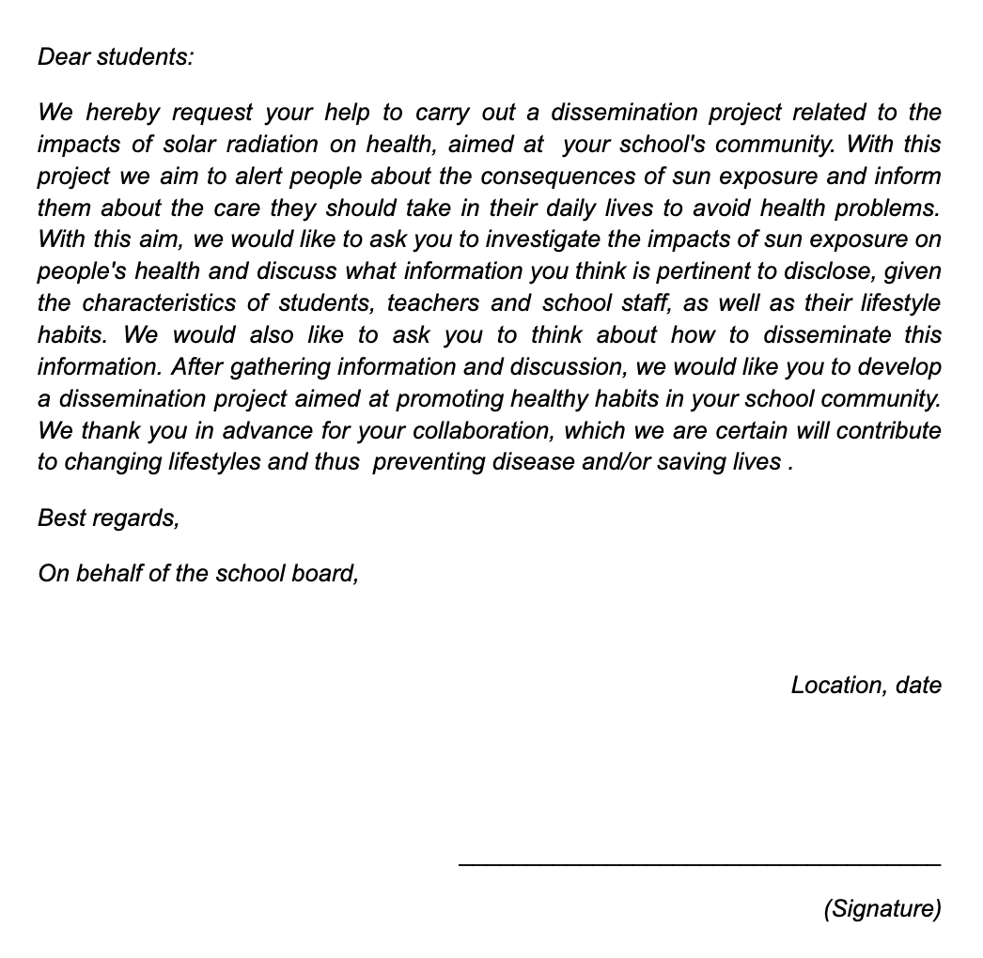

Figure 1: Presentation letter

- In the first session (or first stage) — Introduction:
Present the letter from page 2 of the student’s learning script (Figure 1) to introduce the project and the problem to be addressed.

Present the UV and skin colour distribution maps (Figures 2 and 3, below) from page 3 of the student script to your students.

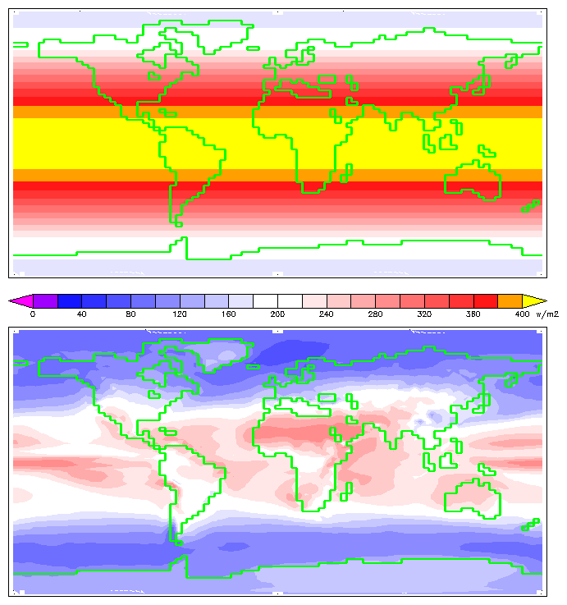
Figure 2- Annual insolation reaching the Earth's surface after passing through the atmosphere. Credits: This image was produced by William M. Connolley using HadCM3 data and is available at https://commons.wikimedia.org/wiki/File:Insolation.png.

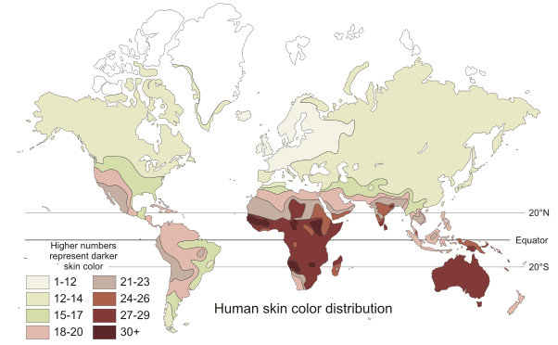
Figure 3- Distribution of skin colour in indigenous populations before colonisation processes based on the chromatic scale of Von Luschan (data from Biasutti, 1940; disputed). Credits: This image was first uploaded to Wikipedia by The Ogre and was reshaped and coloured by Crisco 1492. Data from: Jablonski & Chaplin (2000).

To foster a discussion, ask students the following questions:
• What is the relationship between skin pigmentation and UV radiation?
• What do you think can be the causes of the global distribution of skin colour?

In small groups, ask the students to first think about these questions themselves. Then, ask them to share and discuss their thoughts within the group and register the group's ideas in the sections ‘Your idea’ and ‘Other ideas in the group’ (see Table 1) from their script. This may take 5 to 10 minutes. Ask the groups to share their ideas with the classroom, which may take 5 minutes.

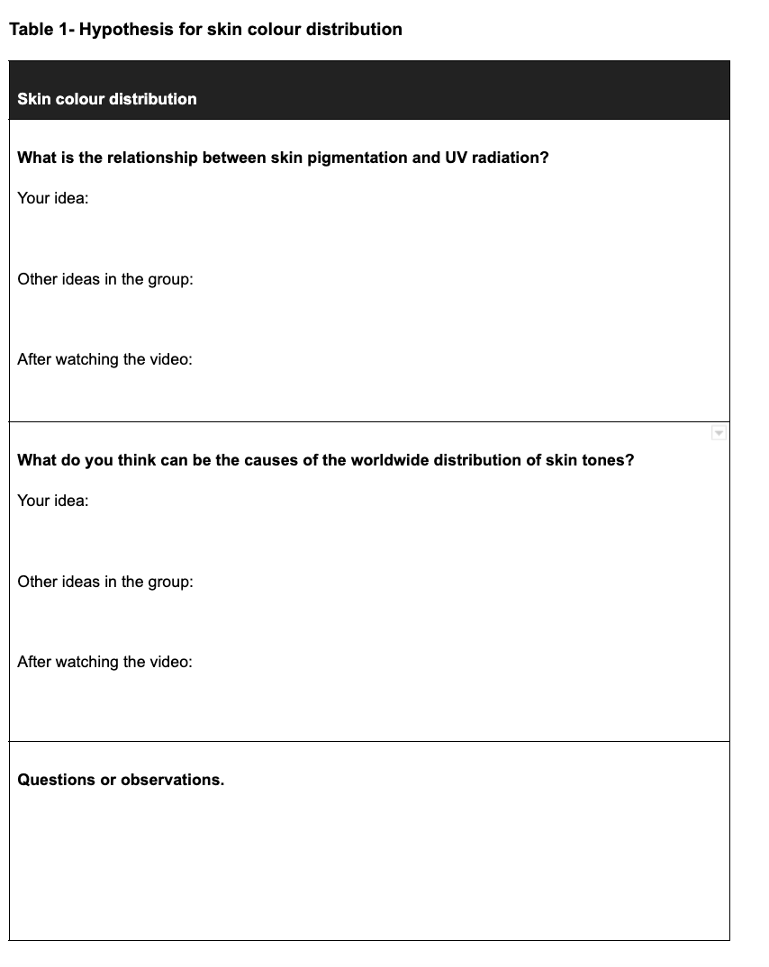

With your students, watch the TED Talk from Nina Jablonski (https://www.ted.com/talks/nina_jablonski_skin_color_is_an_illusion#t-865407; 15 minutes). In this video, researcher Nina Jablonski reflects upon the evolution of skin colour and how skin colours are an adaptation to different levels of UV exposure.

In small groups, ask students to compare their initial ideas with what was described in the video. Then, ask them to discuss these differences within their groups, register their new ideas and answer the questions in Table 1 from their script. Ask the groups to then share their ideas with the classroom and promote a classroom discussion (this may take 15 to 20 minutes).

At this stage, make sure that the students understand that natural selection does not offer individuals what they need to survive, but instead acts by causing mortality and reduced fertility to individuals with less adapted features. Skin colour is a consequence of melanin presence, which can have two important roles: protecting from the damaging effects of UV light and influencing vitamin D production. Also, make sure they notice that this is related to health problems that are still affecting people today.

In a class discussion, ask students to state what they know about the impact of solar radiation on human health, what information they feel is still missing for them to prepare for the dissemination campaign and how they will look for this information. Register this information on the blackboard and ask each group to register it in Table 2 of their script. They can then be prompted to decide what information will they be looking for until the next class.

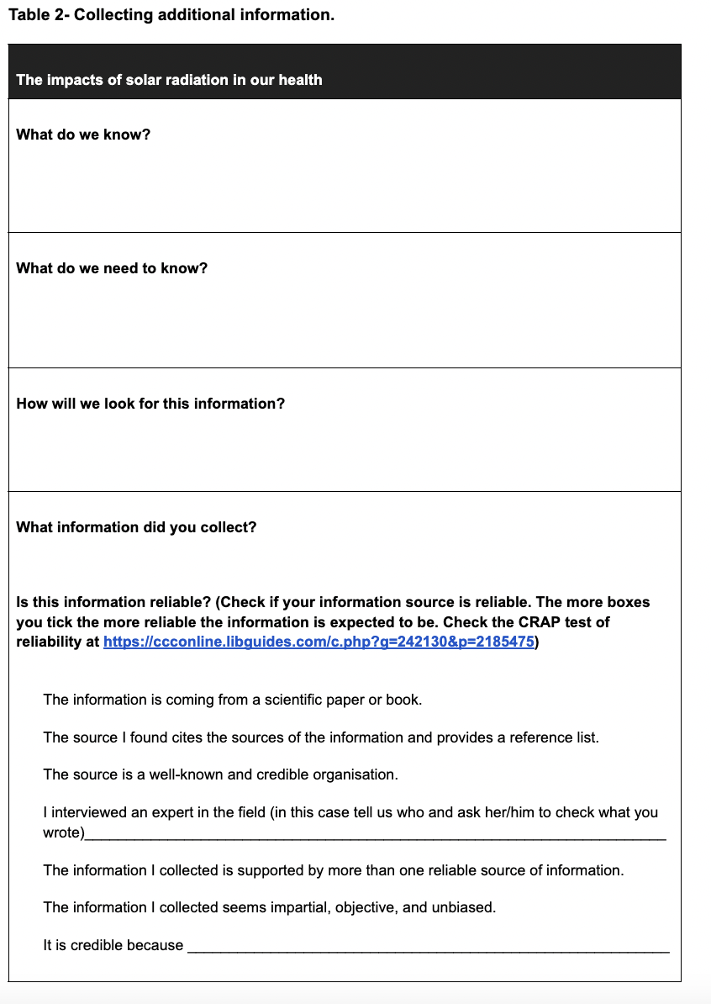
Autonomous work: Each group will look for the required information and prepare a 5- to 10-minute presentation (depending on the number of groups in the class) to share their information with the other groups.

- In the second session (or second stage) — Reflection:

Ask each group to present the information they collected with the other groups.

After the presentations, in a class discussion, ask students what key messages should be part of the dissemination campaign that they will prepare for their school community to promote healthy lifestyles, as well as who their target audience will be (students can then complete Table 3).
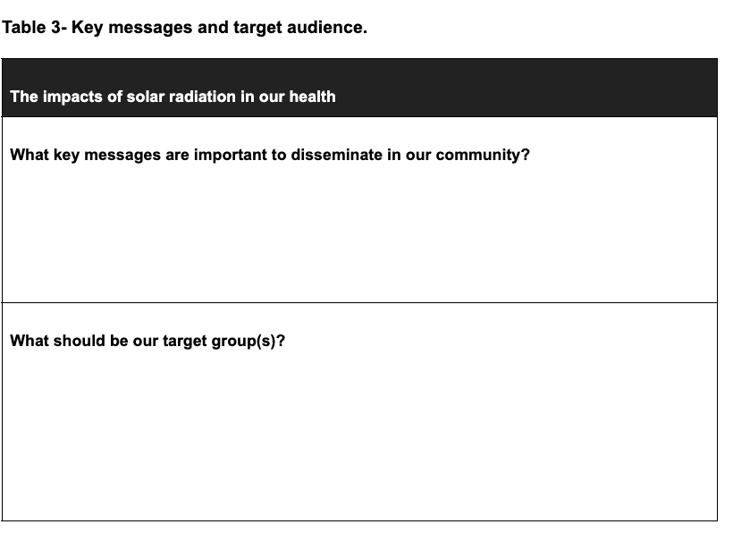
After the key messages are chosen, ask them to discuss how they will communicate these to the school community.

During these discussions, introduce the following questions (see Table 4):
Questions related to medical and ethical issues:
- Should we use information about ethnic groups to inform people about health issues?
- What ethical and medical problems are associated with the position held by the authors of the articles?
- What good practices are mentioned by the authors of the articles for communicating human health issues that are different for individuals with distinct features?
Questions that invite students to rethink the misinterpretation of the association of skin colour with race:
- What is the difference between a ‘race’, a ‘subspecies’ and a ‘species’? Why aren’t there races in humans?
- How are these concepts related to evolution?

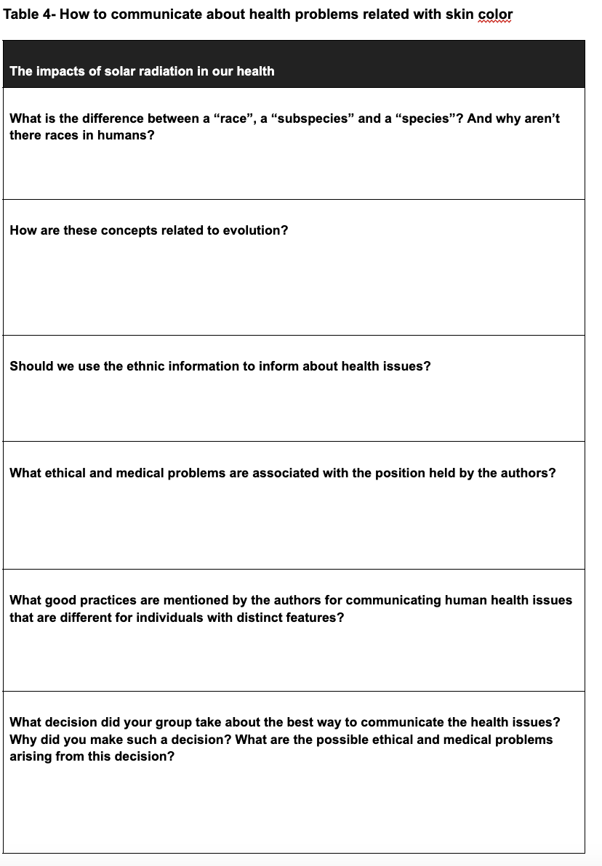

For a deeper exploration of these issues, you may also want to introduce the following questions (adapted from Sadler & Zeidler, 2005). These are suited for older students and/or when relating the activity to other subjects (e.g., philosophy).
- What do you think about using skin colour information for medical research, communication, diagnosis and treatment? What factors were influential in determining your position on this subject?
- If somebody agrees with your decision, what are the arguments he/she may have?
- If somebody disagrees with you, what arguments may he/she hold?
- Why do you agree/disagree with using skin colour to prevent or diagnose a health problem and/or communicate with the public? Explain your position.
- Do you think that using skin colour as described in this case is subject to any kind of moral rules or principles? If so, how did this affect your decision making?
- Did you immediately feel that using skin colour to prevent or diagnose a health problem and/or communicate with the public was the right/wrong course of action in this context? Did you know your position on the issue before you had to consciously reflect on it?
- Is there anything else that I should know about your thinking process or decision making as you considered this issue?

Divide your students into groups and ask each group to look for information to answer the previous questions in the documents shared with them. Ask your students to complete Table 4 with the information they collected. Based on that, ask the students to debate and decide whether and how they would use ethnic information in their proposal and the implications that this decision may have.

- In the third session (or third stage) — Development of the dissemination campaign:
Based on their findings and previous debates, ask each group to develop a proposal and a product for the dissemination campaign for the school community by using Table 5 to describe it. Ask the students to prepare a 5-minute presentation of their proposal and present it to their classmates. When presenting, the students should ask for feedback from their classmates and consider incorporating it into their final product. Additionally, ask your students to plan the dissemination campaign and ensure that it gets high visibility.

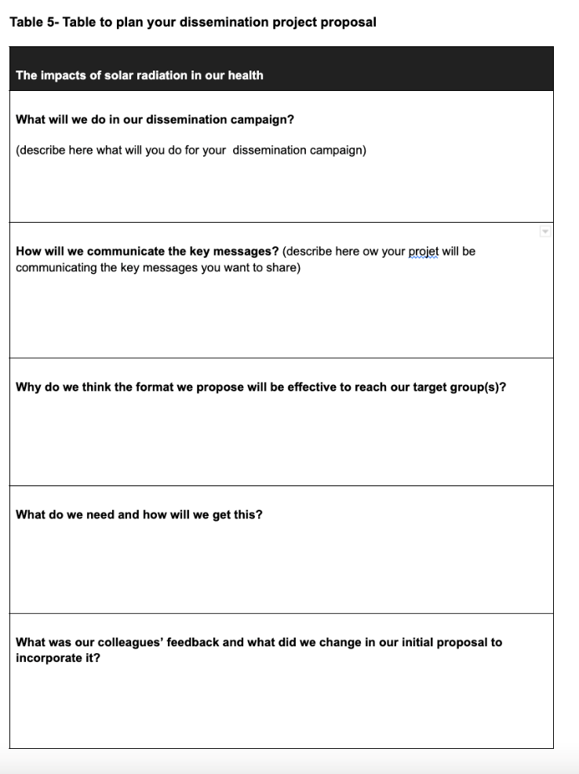

- In the fourth session (fourth stage) — Presentation of the dissemination campaign:
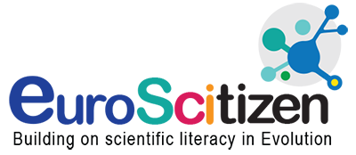
In the final session, the students should present their final product and plan for the dissemination campaign.

TIP 1 Skin colour is a trait that is frequently not thoroughly analysed in the school context. However, it seems important to explore the biology behind this very diverse trait, address health issues and promote a deconstruction of racist ideas associated with skin colour. From our experience, the natural course of an open discussion usually leads to a deconstruction of racist ideas. However, we wish to alert the leaders of the discussion that it may be important to consider that we are addressing skin colour as a physical trait and that race and other classifications are social constructs. As such, it might be good to be prepared to talk about the topic.

TIP 2
We have already implemented this activity in a formal education setting (i.e., classroom) and an informal education setting (i.e., science club) with 9th-grade students. However, we found this activity to be suitable for students from the 9th to 12th grade.
Additionally, according to the settings, this activity can be extended to more than four sessions. In particular, this would be necessary if sessions are shorter (e.g., 50–60 minutes). If sessions are shorter, you may wish to explore one topic per session. When coordinating the activity with other courses—and when in a problem-based learning setting—more sessions may be required (we consider that it can be extended to up to 12 sessions of 60 minutes).

TIP 3
During the first session, when asking the students to think about the relationship between skin pigmentation and UV radiation and the causes of the global distribution of skin tones, students may answer that humans developed features to protect them from UV radiation because they needed them. This corresponds to a frequent misconception of evolution.

TIP 4
Please be aware that the way Nina Jablonski presents this topic in the TED Talk may reinforce the frequent misconception that natural selection provides individuals with what they need.

TIP 5
This activity may serve as the basis for interesting reflections when schools have students from diverse backgrounds by valuing the diversity of the group.
TIP 6
When articulating with art courses, we have complemented this activity with another TED Talk (https://www.ted.com/talks/angelica_dass_the_beauty_of_human_skin_in_every_color?language=pt) and discussed the project Humanae (https://angelicadass.com/pt/foto/humanae/). Additionally, students also attempted to use different painting techniques to reproduce their own skin colours.

TIP 7
In the student script we indicate four articles as suggested reading. Herein we provide a list of articles that may be considered as an alternative.
https://www.nytimes.com/2017/10/12/science/skin-color-race.html
https://www.newscientist.com/article/mg24132210-100-too-much-sunscreen-why-avoiding-the-sun-could-damage-your-health/
https://www.newscientist.com/article/dn13922-skin-tone-gene-could-predict-cancer-risk/
https://www.scientificamerican.com/article/how-skin-cancer-rates-vary-across-the-globe/
https://www.sciencedaily.com/releases/2021/02/210218142820.htm
http://douglasallchin.net/papers/Allchin-skin-color-and-NOS.pdf

3. BIBLIOGRAPHY
Barsh, G. S. (2003). What controls variation in human skin color? PLoS Biology, 1(1), e27. https://doi.org/10.1371/journal.pbio.0000027
Brenner, M., & Hearing, V. J. (2008). The protective role of melanin against UV damage in human skin. Photochemistry and Photobiology, 84(3), 539–549. https://doi.org/10.1111/j.1751-1097.2007.00226.x
Crawford, N. G., Kelly, D. E., Hansen, M. E. B., Beltrame, M. H., Fan, S., Bowman, S. L., Jewett, E., Ranciaro, A., Thompson, S., Lo, Y., Pfeifer, S. P., Jensen, J. D., Campbell, M. C., Beggs, W., Hormozdiari, F., Mpoloka, S. W., Mokone, G. G., Nyambo, T., Meskel, D. W., … Tishkoff, S. A. (2017). Loci associated with skin pigmentation identified in African populations. Science, 358(6365), eaan8433. https://doi.org/10.1126/science.aan8433
Jablonski, N. G., & Chaplin, G. (2000). The evolution of skin coloration. Journal of Human Evolution. 39, 57–106. https://doi.org/10.1006/jhev.2000.0403.
Jablonski, N. G., & Chaplin, G. (2017). The colours of humanity: The evolution of pigmentation in the human lineage. Philosophical Transactions of the Royal Society B, 372 (1724): 20160349. http://doi.org/10.1098/rstb.2016.0349.
Jones, T. (2001). Shades of brown: The law of skin color. Duke Law Journal, 49(1487). http://dx.doi.org/10.2139/ssrn.233850.
Klonoff E. A., & Landrine, H. (2000). Is skin color a marker for racial discrimination? Explaining the skin color-hypertension relationship. Journal of Behavioral Medicine, 23(4), 329–338. https://doi.org/10.1023/A:1005580300128.
Pew Research Center. (2021). Majority of Latinos say skin color impacts opportunity in America and shapes daily life. https://www.pewresearch.org/hispanic/wp-content/uploads/sites/5/2021/11/RE_2021.11.04_Latinos-Race-Identity_FINAL.pdf
Crawford, N. G., Kelly, D. E., Hansen, M. E. B., Beltrame, M. H., Fan, S., Bowman, S. L., Jewett, E., Ranciaro, A., Thompson, S., Lo, Y., Pfeifer, S. P., Jensen, J. D., Campbell, M. C., Beggs, W., Hormozdiari, F., Mpoloka, S. W., Mokone, G. G., Nyambo, T., Meskel, D. W., … Tishkoff, S. A. (2017). Loci associated with skin pigmentation identified in African populations. Science, 358(6365), eaan8433. https://doi.org/10.1126/science.aan8433
Sadler, T. D., & Zeidler, D. L. (2005). Patterns of informal reasoning in the context of socioscientific decision making. Journal of Research in Science Teaching, 42(1), 112–138. https://doi.org/10.1002/tea.20042
Schlessinger, D. I., Anoruo, M. D. & Schlessinger, J. (2022) Biochemistry, Melanin. [Updated 2022 May 8]. In: StatPearls [Internet]. Treasure Island (FL): StatPearls Publishing. https://www.ncbi.nlm.nih.gov/books/NBK459156/.
Solano, F. (2020). Photoprotection and skin pigmentation: Melanin-related molecules and some other new agents obtained from natural sources. Molecules, 25(7), 1537. https://doi.org/10.3390/molecules25071537
Laidley, T., Domingue, B., Sinsub, P., Harris, K. M.& Conley, D. (2019). New evidence of skin color bias and health outcomes using sibling difference models: A research note. Demography, 56 (2), 753–762. https://doi.org/10.1007/s13524-018-0756-6

4. APPENDIX
The editable scripts can be found here: https://docs.google.com/document/d/1ep8lnwsZOaXjFnwqkJtoEAaxFNiUYHGlJRjBAZIP328/edit?usp=sharing

