Connecting Embodied Learning in educational practice to the realisation of science educational scenarios through performing arts

Smyrnaiou Z.¹, Sotiriou M. ², Georgakopoulou E. ¹, Papadopoulou O. ¹
¹National Kapodistrian University of Athens (NKUA)
School of Philosophy, Faculty of Philosophy, Pedagogy and Psychology
Department of Pedagogy, University Campus, 15784 Ilissia, Athens, Greece
zsmyrnaiou@ppp.uoa.gr, elgeorgakop@hotmail.com
²Science View, sotiriou@scienceview.gr

Abstract. Embodied Learning constitutes a contemporary pedagogical theory of learning, which emphasizes the use of the body in the educational practice. Several researches related to various areas of expertise highlight the usefulness and the necessity of the body itself as a learning tool. Despite this, until recently the body was mostly used as a means to enable students’ experiential participation and to attract their interest. Given the significance of Embodied Learning to new teaching methods and approaches, this paper presents results from a large scale implementation activity in Greece within the framework of the “Learning Science through Theatre”, initiated by Science View during the school year 2014-2015. The Initiative is based on the pedagogical framework which was developed by the European project CREAT-IT and continues to be implemented in the framework of the European Project CREATIONS. This study aims at highlighting the fact that Embodied Learning is connected to the development of skills such as creativity and critical thinking, to the active engagement with scientific topics and phenomena and to the interdisciplinary connection of science with different forms of Art. The data were collected from thirteen (13) theatrical performances that were organized by secondary school students (500 subjects). In the Data analysis, meaning generation, communication and student motivation were analyzed in relation to isolated gestures, full body movements, students’ emotional attachment, and facial expressions. As a consequence, it is suggested that Embodied Learning may lead to scientific learning outcomes of a higher quality while at the same time it may reinforce student communication and motivation in scientific topics.

Keywords. Embodied Learning, Dramatization, Theatre, Art, Creativity

1. Introduction
Embodied Learning constitutes a contemporary pedagogical theory of learning, which emphasizes the use of the body in the educational practice and the student-teacher interaction both inside and outside the classroom and in digital environments as well. Using the body is essential in concept representation and communication while this is also confirmed by the emphasis other fields and cognitive objects place on the body as a learning tool, such as dance theatre, kinesiology, athletics even Mathematics and Physics. All these cognitive objects have student collaboration, movement and the process of cognitive development as a common denominator.
Traditionally the body has not been used in education. Every involvement of the body had been consistently excluded from the educational practice, the process of learning and the interaction among students. The notion of Embodied Learning was not known and therefore not acceptable by the educational community such as the teachers and the students. Consequently it was difficult to understand that the body does not solely constitute a means of knowledge, or a mediator, but it also reflects the student’s interaction with the environment.
Embodied Learning is closely related to constructivist models and to modern educational theories regarding the role of the teacher, of the student and of learning itself in the educational practice. Embodied Education has been defined as the basic concept which includes Embodied Teaching and Embodied Learning [7]. In fact, the terms Embodied Learning and Embodied Teaching are used alternately to refer to new scientific and educational practices [13].
In accordance with the constructivist principles, the body is used both inside and outside classroom for experiential learning and is not treated as a place of learning. The principles of Embodied Learning provide answers to questions related to the ways knowledge is constructed by students as they leave behind them the academic model of perceiving knowledge and treat each student as a whole, while they view everyone’s body as a tool for knowledge construction and as a knowledge carrier [2],∙ [6]. Language and full-body motion have been studied as an integral means through which students express thoughts and meanings when they interact with a set of collaborative digital games designed by the researchers [11] in creative and innovative teaching approaches [12]. This way, each student is placed in the center of the educational process, while disinterestedness is transformed into active participation and emotional neutrality into cooperation.
In Embodied Learning, new knowledge is affected by the conditions it is used and by the types of activities the student is expected to participate in. Consequently, the following parameters should be taken into consideration when designing an activity:
- cognitive involvement to the topic, cognitive processes, representation of a scientific notion
- body movements
- expression of the student’s feelings
- clarity of instructions
- holistic design of activities
- student cooperation
- ability of students to apply acquired knowledge to new environments
It becomes evident that Embodied Learning is in accordance with new educational practices, as it uses personality as a whole, and promotes the way students learn and not the content of learning in the learning process. However, only few studies have been conducted to link Embodied Learning to the dramatization of educational theatrical scenarios and to the representation of scientific concepts and knowledge, with the aim of developing student creativity and critical thinking, their active participation to the learning process, their deep understanding of scientific notions and phenomena and the interdisciplinary connection of Sciences to forms of Art.

2. Literature Review

- Defining Embodied Learning
The body can be defined based on two parameters. There is the embodied/biological/ sensual way of being, but at the same time there is also the sociocultural and relational/interactive way in which skills are developed. The notion of body in Embodied Learning, does not merely include that body itself but it also includes the senses, the mind, and the brain, that is the whole of the student’s personality. The body functions as a natural source of meaning production, since it helps students to express themselves in a natural way. The body is defined as the human corporeal experience and the subsequent psychological consequences, while others state that the unconscious aspects of corporeal experience constitute the basis of cognitive activity and linguistic expression [9].
The primary characteristics of embodied learning are the following [5]:
a. sensorimotor activity
b. relevance of gestures [8] to the theme that is to be reproduced
c. emotional involvement
Both the sensorimotor system and body movements are involved in the process of Embodied Learning and the perceived stimuli can be transformed into a more stable memory and cognitive representations [1]. As it has been mentioned relevance of gestures refers to the analog or structural correlation of symbols and their meanings [10]. Given the aforementioned, it becomes obvious that embodied learning involves coordinated movements either of body parts or of the whole body in order for a learning goal to be achieved combined with the students’ sensorimotor activity and their emotional involvement. The procedure that is followed during Embodied Learning is gradually escalating. During the first stage, the student may not proceed to a movement related to the representation of concepts. However, students understand that they are going to be exposed to scientific concepts and they are concerned about the way of representing them. During the second stage, movements are produced sometimes unconsciously or even as the result of imitation while during the third stage the students are asked to think of ways of representing the suggested content.
During the final stage which is also the most important one, students apply the newly acquired knowledge to new environments, through dramatization (image/interactive theatre) or role play, where they represent the scientific concept not only verbally or by using body movements, but also by participating both mentally and emotionally to the extent of embodying this new knowledge. It becomes evident that Embodied Learning is a procedure during which the student employs mental processes expressed through coordinated body movements which are linked to the represented content, through his/her emotional involvement and verbal communication skills.
It is worth stating that at each moment the student acts in a coordinated way and even though he/she is lead to random, unconscious movements, they are most of the times compatible with the content. This way the level of understanding and embodiment of new knowledge to the student’s cognitive repertoire is verified. Everything that happens at each moment is of importance since the body is always active and becomes the sender and receiver of messages. The network of all momentary actions is thus gradually constructed which leads as a whole to Embodied Learning.
Furthermore, student-teacher cooperation either in a school or in a digital environment plays a pivotal role in Embodied Learning. This way, certain characteristics of a person or a group of people may affect the rest of the students. By visualizing this interaction in intersecting circles, students learn how their own experiences are met and complement those of others, even if they come from different sociopolitical and cultural backgrounds etc. Cooperation in school environment increases the students’ learning outcomes, offers motivation and further enhances their social skills.
It is worth stating that student participation in the learning procedure with the help of Embodied Learning is not only limited to the student being physically present. Students’ response depends on their personality, their physical presence, their mental development, their sensorimotor ability and their past experiences.
4. Research Design
- Organization and the “Learning Science though Theatre” action
Taking into consideration the importance of Embodied Learning to new educational methods and approaches there has been an attempt to link this theory to the “Learning Science through Theatre” action 2014-2015 (LSTT- - http://lstt2.weebly.com/). This action is based on the pedagogical framework which has been developed by the European CREAT-IT project (http://creatit-project.eu/) [3], [4] and continues to be applied in the concept of the European CREATIONS project (http://creations-project.eu/). This initiative follows the principles of the Science Education Declaration, of creativity, of effective and efficient research and aims at enhancing creativity in classroom (http://www.opendiscoveryspace.eu/community/culture-creativity-curiosity-413201).
Given the fact that Embodied Learning is connected to the development of creative skills and of skills which enhance critical thinking, to the students’ active participation in rendering and deeply understanding scientific concepts and phenomena and the scientific interconnection of sciences to arts, the present study aims at examining the contribution of Embodied Learning to:
a) the representation of scientific concepts (connecting movement to concept)
b) art (dance movements, humour in movements etc) and
c) recording random/unconscious movements.
That is, there are 3 kinds of movements, those which are used in approaching/representing scientific content, those which are related to art and the unconscious/random movements.
ii. Participants, Sampling
Data was collected from 13 theatrical performances which were organized by secondary education students (500 subjects). High school students (Gymnasium and Lyceum) of Attica schools dramatized scientific concepts and knowledge related to their course syllabus, through a non-restrictive scenario entitled “Parallel Worlds” which related to the scientific fields of Biology, Astronomy, and Physics.
iii. Methodology, Tools
The methodological tool of content analysis was used to analyze the data collected from the observation of the dramatized scenarios and to connect them to the characteristics of Embodied Learning. Based on the theoretical framework presented earlier there has been developed a system of categorizing the ways which students through Embodied Learning: a) represent scientific content/generate meaning, b) communicate with one another, c) entertain the audience while they dramatize scientific scenarios which take into account both the teaching of sciences and theatre techniques.
5. Results

In order to attempt and combine Embodied Learning to theatrical performances of the schools which participated in the “Learning Science though Theatre” project, we watched and observed the performances (fig.1).
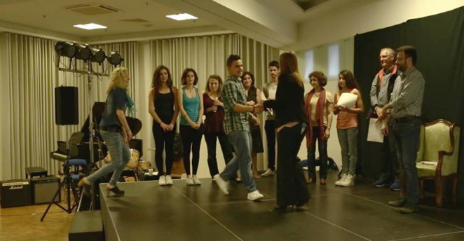Fig. 1 Awards to schools in the “Learning Science though Theatre” initiative
As can be seen from the fig. 2 regarding to the category “Representation of scientific context/ meaning generation” Embodied Learning can contribute a lot both to the understanding and to the application of knowledge. As far as the understanding of knowledge is concerned, students seem to be able to understand the key features of each notion, using scientific terminology and simple vocabulary at the same time, to reliably describe notions and to use their past experience so as to describe scientific knowledge. For instance, in a theatrical scenario students sat next to each other and another student revolved around them in order to represent the movements of atoms, electrons, protons, neutrons, etc. Furthermore, one student who impersonated Aristarchus explained his theory showing the Sun and the Moon at the same time, or in another theatrical scenario another student impersonated a shooting star and used her whole body when other students pulled her from the scene so as to represent the fall of the star. Regarding the application of knowledge, students were several times able to link scientific notions to everyday life and to reach conclusions, such as a student who impersonated Fred Hoyle and popped a balloon with a needle to represent the Bing Bang.

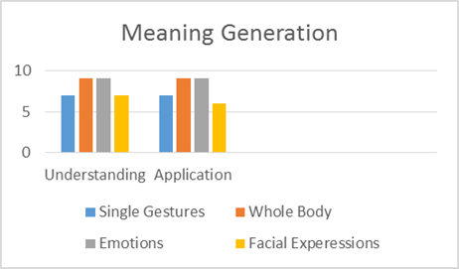
Fig. 2 Embodied Learning and Meaning Generation
It is really important to mention that whole body movements and emotional involvement reinforce the representation of scientific content/ meaning generation in relation to single gestures or facial expressions (fig. 2).
As far as “Communication” is concerned, Embodied Learning facilitated communication among students (fig. 3). For instance, regarding the successful rendering of meaning is concerned a scientist explains the rising temperature because of the Big Bang and his assistant shows the red table where the rise is described while at the same time she moves according to the music. Successful rendering of meaning is possible both through verbal and through non-verbal communication. For instance, a student explains that matter prevailed and utters the adverb “Finally!” while using his hand whereas another student- Physicist uses his facial expressions to show his irony towards all other sciences as he thinks that Physics is the only true science, expressing this way his irony in a non-verbal way. At the same time, students used appropriate material to help them render the scientific concepts. A student narrates the way the Universe began and the Big Bang theory and uses a red umbrella while another student who has the role for Fred Hoyle pops a balloon with a needle, an action that signifies the explosion. As far as student interaction and cooperation is concerned, all students worked together to accomplish a task. Actions such as body movements or scenes in the theatrical performances like the one where a student who pretends to be a particle runs around the stage and the scientist is anxiously trying to find her prove the interaction among students.

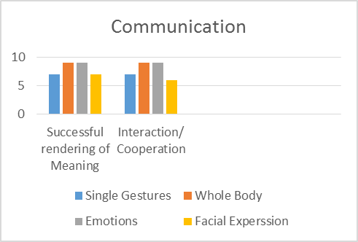
Fig. 3 Embodied Learning and Communication
The students managed to create a positive atmosphere both during the rehearsals and during the actual theatrical performance. Students’ emotional and body involvement enhances student communication to a greater degree compared to facial expressions or simple gestures.
Since “Entertainment” is an important part of the theatrical performance, it is worth mentioning that students retained their interest throughout and enjoyed the whole procedure (fig. 4). Student creativity and imagination is evident in most theatrical performances. A student talks with Einstein and asks for his autograph while another student points to the Scorpius constellation while the planets dance hugging. In another performance, planet Pluto appears last on stage and being short of breath, which signifies that he is the last planet in our solar system, while another student-researcher is trying hard as we can infer from his facial expressions to discover the God particle, highlighting the importance of its existence. The students seemed to enjoy the whole process as humorous scenes in the performances verify. For instances, all students who participated in the performance where a party was held by the academic community to announce the discovery of the God particle, were laughing. All students have understood the clarity of roles; for instance, a student who pretends to be a particle runs around the stage representing particle movement while another student-scientist is trying to find her.

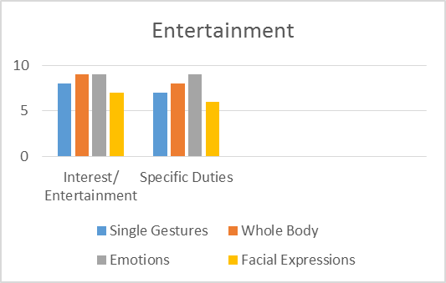
Fig. 4 Embodied Learning and Entertainment
The students have also included personal elements in their performances, which signifies a high degree of embodiment of the concepts. Students use their hands to emphasize specific parts, for instance the difference between astrology and science, while in some scenes students used their imagination; a student/journalist of a show, Ms. Poirot, appears holding a magnifying glass to solve the mysteries.
It becomes obvious that 2 out of 4 characteristics of Embodied Learning, those of whole body movements and of emotional involvement lead to a successful representation of scientific content, to student communication and enjoyment. Those characteristics appear with a very high frequency which underlines the relation of Embodied Learning to the aforementioned categories and subcategories. At the same time, there is a relation between the two subcategories within each category, which verifies the achievement of goals. On the other hand, it was observed that simple gestures and facial expressions play a significant yet not decisive role in using Embodied Learning in the educational practice, with a percentage of 68% and 62% accordingly.
Moreover, unconscious movements appear in a fewer percentage in whole body movements and in emotional involvement, which indicates that students in Embodied Learning act consciously, having fully understood the scientific scenario. On the contrary, they appear in a higher percentage in simple gestures and in facial expressions, which leads us to conclude that students may perform unconscious movements to express themselves in a more performative way.

6. Conclusion

This study aimed at connecting Embodied Learning in the educational practice to the dramatization of educational theatrical scenarios and the representation of scientific concepts and knowledge in the context of the “Learning Science through Theatre” project 2014-2015 The study examined the contribution of Embodied Learning to
- the representation of scientific content (linking movement and concept)
- Art (dance movements, humour in movements etc.) and
- random/unconscious movements
The findings suggest that Embodied Learning leads students to the most successful representation of scientific concepts, enables the connection of student to modern forms of Art while even the unconscious movements performed by the students may be indicative of the degree of appropriation and embodiment of scientific concepts. Furthermore, collaborative learning is supported while student creativity is enhanced. Dramatization of theatrical plays could be included to the educational reality since it constitutes an exemplary educational practice. The learning environment of the “Learning Science though Theatre” project included authentic theatrical scenarios which were performed by the students and were in accordance with their interests and cognitive load. Finally, we examined the students’ cognitive involvement, the representation of scientific content using their cognitive processes, their sensorimotor involvement using their bodies or gestures, their emotional involvement, social interaction and communication between the students, the use of past experiences and creation of new ones based on sociopolitical and historical framework and on beliefs and behaviors, their brain-body-emotion coordination, the holistic use of their personality and their motives.

7. Acknowledgment
CREAT-IT (2012-2015) 539818-LLP-1-2013-1-NO-COMENIUS-CMP.
CREATIONS (2015-2018), H2020-SEAC-2014-1 CSA, 665917.

8. References
[1] Abrahamson, D., Gutiérrez, J. , Charoenying, T., Negrete, A., & Bumbacher, E. (2012). Fostering hooks and shifts: Tutorial tactics for guided mathematical discovery. Technology, Knowledge and Learning, 17(1/2), 61–86.
[2] Caine, R. & Caine, G. (1997). Unleashing the power of perceptual change. Alexandria, Virginia: USA, Association for supervision and curriculum Development.
[3] Craft, A., Ben Horin, O., Sotiriou, M., Stergiopoulos, P., Sotiriou, S., Hennessy,S., Chappell, K., Slade, Ch., Greenwood, M., Black, A., Lale Dobrivoje, E., Timotijević, Đ., Drecun, A., Brajović, A., Belmontecinzia, C., Conforto, G. (2016), CREAT-IT: Implementing Creative Strategies into Science Teaching, New Developments in Science and Technology Education, Springer, Innovations in Science Education and Technology Volume 23, DOI 10.1007/978-3-319-22933-1, 163-179.
[4] CREAT-IT Pedagogical Framework, http://www.opendiscoveryspace.eu/node/822174
[5] Dixon, M., & Senior, K. (2011). Appearing pedagogy: from embodied learning and teaching to embodied pedagogy. Pedagogy, Culture & Society, 19(3), 473-484.
[6] Kalantzis, M. & B. Cope (2013). Νέα Μάθηση: Βασικές Αρχές για την Επιστήμη της Εκπαίδευσης. Αθήνα: Κριτική.
[7] Lindgren, R., & Johnson- Glenberg, M. (2013). Emboldened by Embodiment: Six Precepts for Research on Embodied Learning and Mixed Reality. Educational Researcher, 42 (8), 445-452. doi: 10.3102/0013189X13511661.
[8] Lozano, S. C., & Tversky, B. (2006). Communicative gestures facilitate problem solving for both communicators and recipients. Journal of Memory and Language, 55(1), 47-63.
[9] Núñez, R., Edwards, L., & Matos, J. F. (1999). Embodied cognition as grounding for situatedness and context in mathematics education. Educational Studies in Mathematics, 39(1–3), 45–65.
[10] Segal, A. (2011). Do Gestural Interfaces Promote Thinking? Embodied Interaction: Congruent Gestures and Direct Touch Promote Performance in Math. Unpublished PhD thesis, New York: Columbia University.
[11] Smyrnaiou, Z. G., & Kynigos, C. (2012). Interactive movement and talk in generating meanings from science. Bulletin of the IEEE Technical Committee on Learning Technology, 14(4), 17.
[12] Riopel, M. et Smyrnaiou, Z. (2016). New Developments in Science and Technology Education. New York: Springer.
[13] Wilcox, H. N. (2009). Embodied Ways of Knowing, Pedagogies, and Social Justice: Inclusive Science and Beyond. NWSA Journal, 21 (2), 104–121.

