ΔΗΜΟΚΡΙΤΟΣ

μτφ. Δ. Κούρτοβικ από G. Kirk, J. Raven & M. Schofield, Οι Προσωκρατικοί. Αθήνα: ΜΙΕΤ 1988
trans. C. C. W. Taylor, The Atomists, Leucippus and Democritus. Fragments: A Text and Translation with a Commentary. Toronto 1999

- Άτομα και κενό

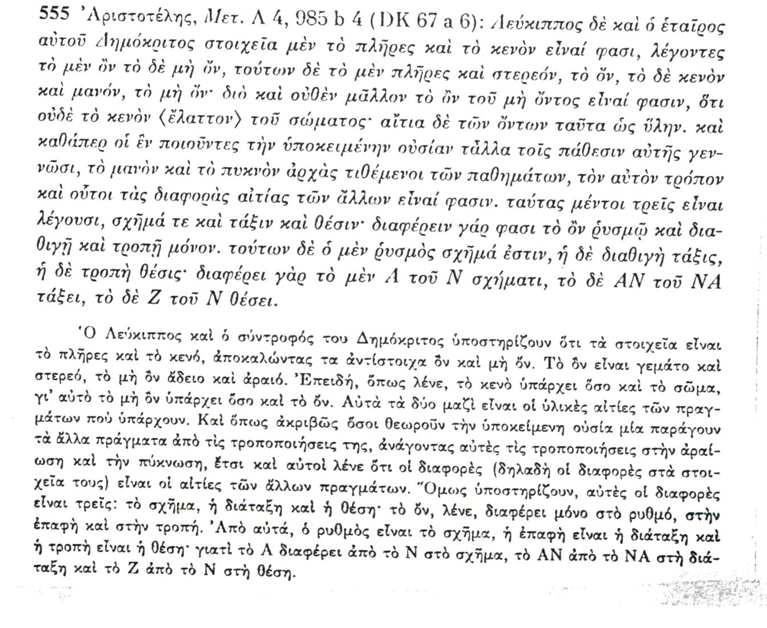

- νόμῳ

Πλούταρχος, Προς Κωλώτην 1110E–1111A
τὸ γὰρ νόμῳ χροιὴν εἶναι καὶ νόμῳ γλυκὺ καὶ νόμῳ σύγκρισιν <ἅπασαν, ἐτεῇ δὲ τὸ κενὸν καὶ> τὰς ἀτόμους εἰρημένον φησὶν ὑπὸ Δημοκρίτου <μάχεσθαι> ταῖς αἰσθήσεσι, καὶ τὸν ἐμμένοντα τῷ λόγῳ τούτῳ καὶ χρώμενον οὐδ’ ἂν αὑτὸν ὡς <ἄνθρωπός> ἐστιν ἢ ζῇ διανοηθῆναι… τί γὰρ λέγει Δημόκριτος; οὐσίας ἀπείρους τὸ πλῆθος ἀτόμους τε καὶ ἀδιαφθόρους, ἔτι δ' ἀποίους καὶ ἀπαθεῖς ἐν τῷ κενῷ φέρεσθαι διεσπαρμένας· ὅταν δὲ πελάσωσιν ἀλλήλαις ἢ συμπέσωσιν ἢ περιπλακῶσι, | φαίνεσθαι τῶν ἀθροιζομένων τὸ μὲν ὕδωρ τὸ δὲ πῦρ τὸ δὲ φυτὸν τὸ δ' ἄνθρωπον, εἶναι δὲ πάντα τὰς ἀτόμους, ἰδέας ὑπ' αὐτοῦ καλουμένας, ἕτερον δὲ μηδέν· ἐκ μὲν γὰρ τοῦ μὴ ὄντος οὐκ εἶναι γένεσιν, ἐκ δὲ τῶν ὄντων μηδὲν ἂν γενέσθαι τῷ μήτε πάσχειν μήτε μεταβάλλειν τὰς ἀτόμους ὑπὸ στερρότητος· ὅθεν οὔτε χρόαν ἐξ ἀχρώστων οὔτε φύσιν ἢ ψυχὴν ἐξ ἀποίων καὶ <ἀψύχων> ὑπάρχειν.
For he says that Democritus’ statements that colour and sweetness and the compound and the rest are by convention, but the void and the atoms in reality contradict the senses, and that someone who abides by this theory and applies it would not consider that he is a man or that he is alive… For what does Democritus say? That an infinite number of atomic, undifferentiated substances, incapable of affecting or being affected, travel about, scattered in the void. And whenever they approach one another, come together or get entangled with one another, these collections appear as water, fire, a plant, or a man. Everything consists of the atoms, which he calls ‘forms,’ and there is nothing else. For there is no coming to be from what is not, and nothing could come to be from what is, since, because of their solidity, the atoms neither are affected nor change. Hence no colour comes into being from colourless things, nor any nature or soul from things which can neither affect nor be affected.

Γαληνός, Περὶ στοιχείων κατὰ Ἱπποκράτην I.2, 1.417.8–418.7K
‘Νόμῳ γὰρ χροιὴ νόμῳ γλυκὺ νόμῳ πικρὸν, ἐτεῇ δ' ἄτομα καὶ κενόν’ ὁ Δημόκριτός φησιν ἐκ τῆς συνόδου τῶν ἀτόμων γίγνεσθαι νομίζων ἁπάσας τὰς αἰσθητὰς ποιότητας ὡς πρὸς ἡμᾶς τοὺς αἰσθανομένους αὐτῶν, φύσει δ' οὐδὲν εἶναι λευκὸν ἢ μέλαν ἢ ξανθὸν ἢ ἐρυθρὸν ἢ γλυκὺ ἢ πικρόν. τὸ γὰρ δὴ νόμῳ ταὐτὸ βούλεται τῷ οἷον νομιστὶ καὶ πρὸς ἡμᾶς, οὐ κατ' αὐτὴν τῶν πραγμάτων τὴν φύσιν. [ὅπερ δ' αὖ πάλιν ἐτεῇ καλεῖ παρὰ τὸ ἐτεὸν, ὅπερ ἀληθὲς δη|λοῖ, ποιήσας τοὔνομα.] καὶ εἴη ἂν ὁ σύμπας νοῦς αὐτοῦ τοῦ λόγου τοιόσδε· νομίζεται μέν τι παρὰ τοῖς ἀνθρώποις λευκὸν εἶναι καὶ μέλαν καὶ γλυκὺ καὶ πικρὸν καὶ τἆλλα πάντα τὰ τοιαῦτα, κατὰ δὲ τὴν ἀλήθειαν ἓν καὶ μηδέν ἐστι τὰ πάντα. καὶ γὰρ αὖ καὶ τοῦτ' εἴρηκεν αὐτὸς ἓν μὲν τὰς ἀτόμους ὀνομάζων, μηδὲν δὲ τὸ κενόν.
‘For by convention colour, by convention sweet, by convention bitter, but in reality atoms and the void’ says Democritus, who thinks that all the perceptible qualities are brought into being, relative to us who perceive them, by the combination of atoms, but by nature nothing is white or black or yellow or red or bitter or sweet. By the expression ‘by convention’ he means ‘conventionally’ and ‘relative to us’, not according to the nature of things themselves, which he calls by contrast ‘reality,’ forming the term from ‘real’ which means ‘true’. The whole substance of this theory is as follows. People think of things as being white and black and sweet and bitter and all the other qualities of that kind, but in truth ‘thing’ and ‘nothing’ is all there is. That too is something he himself said, ‘thing’ being his name for the atoms and ‘nothing’ for the void.

Σέξτος Εμπειρικός, Πρὸς μαθηματικούς 7.135
Δημόκριτος δὲ ὁτὲ μὲν ἀναιρεῖ τὰ φαινόμενα ταῖς αἰσθήσεσι καὶ τούτων λέγει μηδὲν φαίνεσθαι κατ’ ἀλήθειαν, ἀλλὰ μόνον κατὰ δόξαν, ἀληθὲς δὲ ἐν τοῖς οὖσιν ὑπάρχειν τὸ ἀτόμους εἶναι καὶ κενόν· ‘νόμῳ’ γάρ φησι ‘γλυκὺ καὶ νόμῳ πικρόν, νόμῳ θερμόν, νόμῳ ψυχρόν, νόμῳ χροιή· ἐτεῇ δὲ ἄτομα καὶ κενόν.’ (ὅπερ <ἔστι>· νομίζεται μὲν εἶναι καὶ δοξάζεται τὰ αἰσθητά, οὐκ ἔστι δὲ κατ’ ἀλήθειαν ταῦτα, ἀλλὰ τὰ ἄτομα μόνον καὶ τὸ κενόν).
In some places Democritus does away with the sensory appearances, and says that none of them appear in reality but only in opinion, and that what is real in things is that there are atoms and void. For he says ‘By convention sweet and by convention bitter, by convention hot, by convention cold, by convention colour; but in reality atoms and void.’ That is to say, the sensible qualities are conventionally considered and thought to exist, but in reality they do not exist, but only atoms and the void.

- Θεωρία της γνώσης

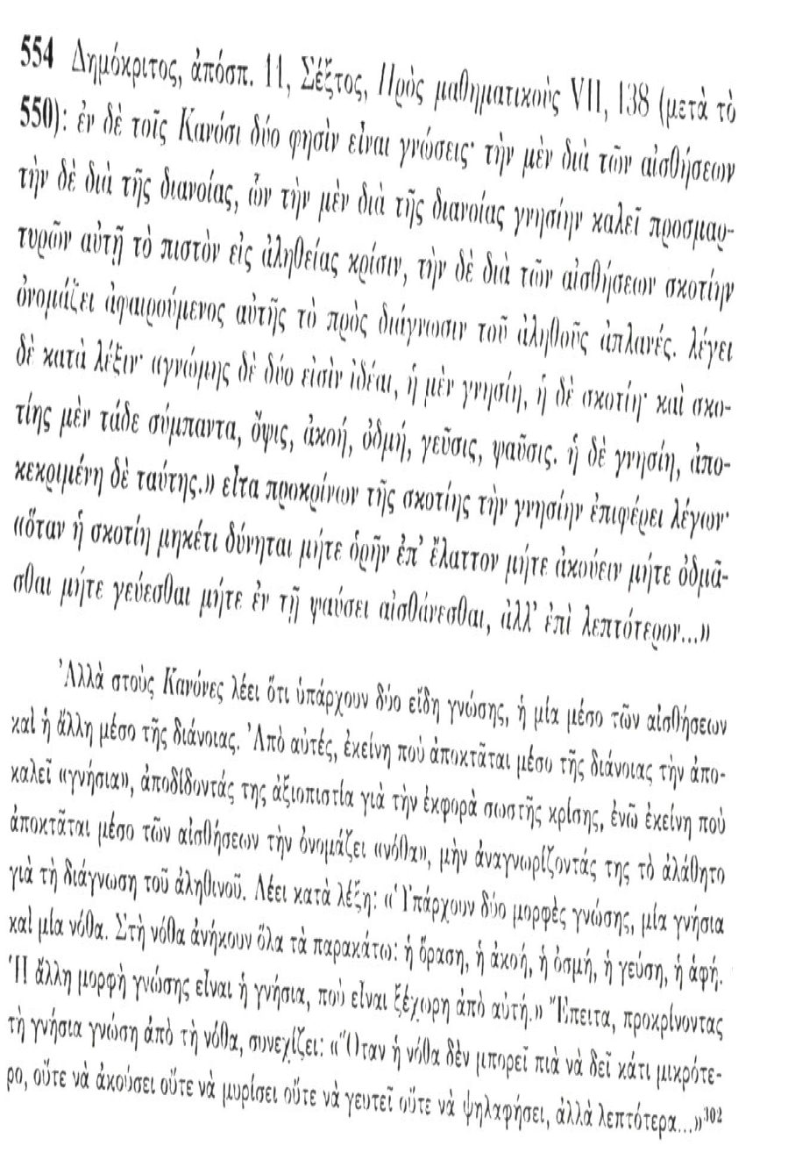

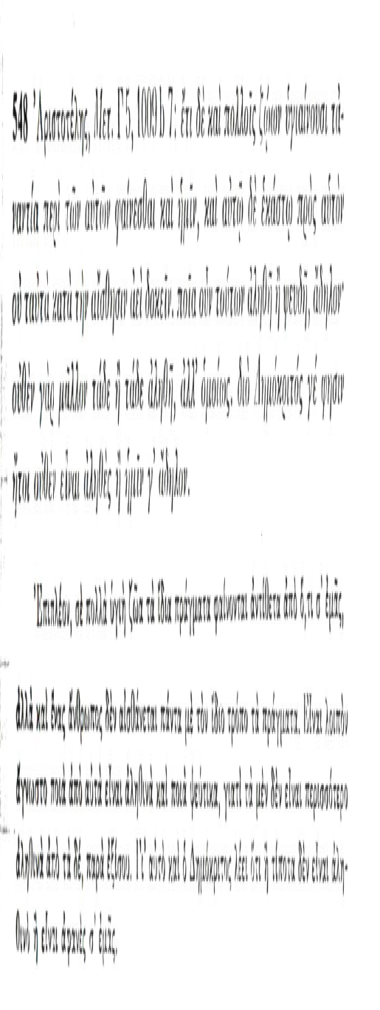

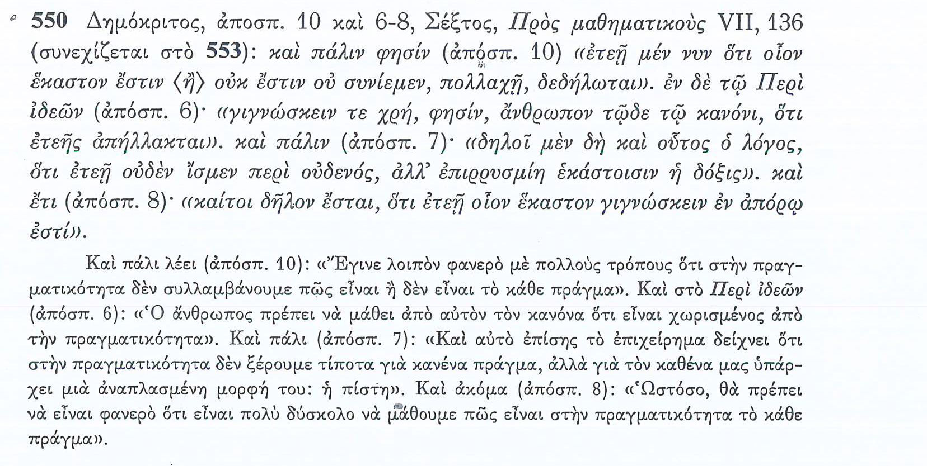

- Θεωρία της αντίληψης

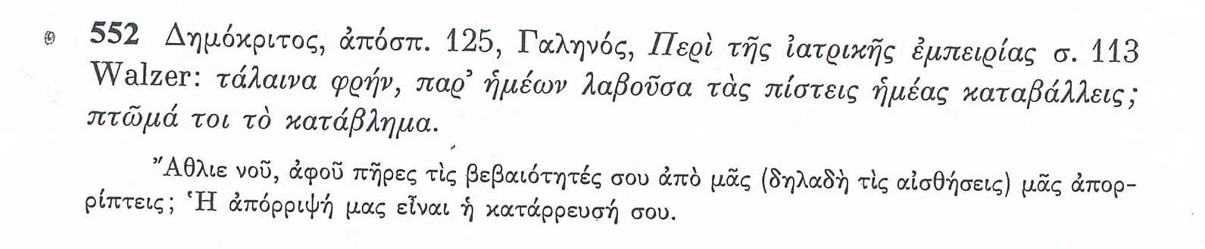

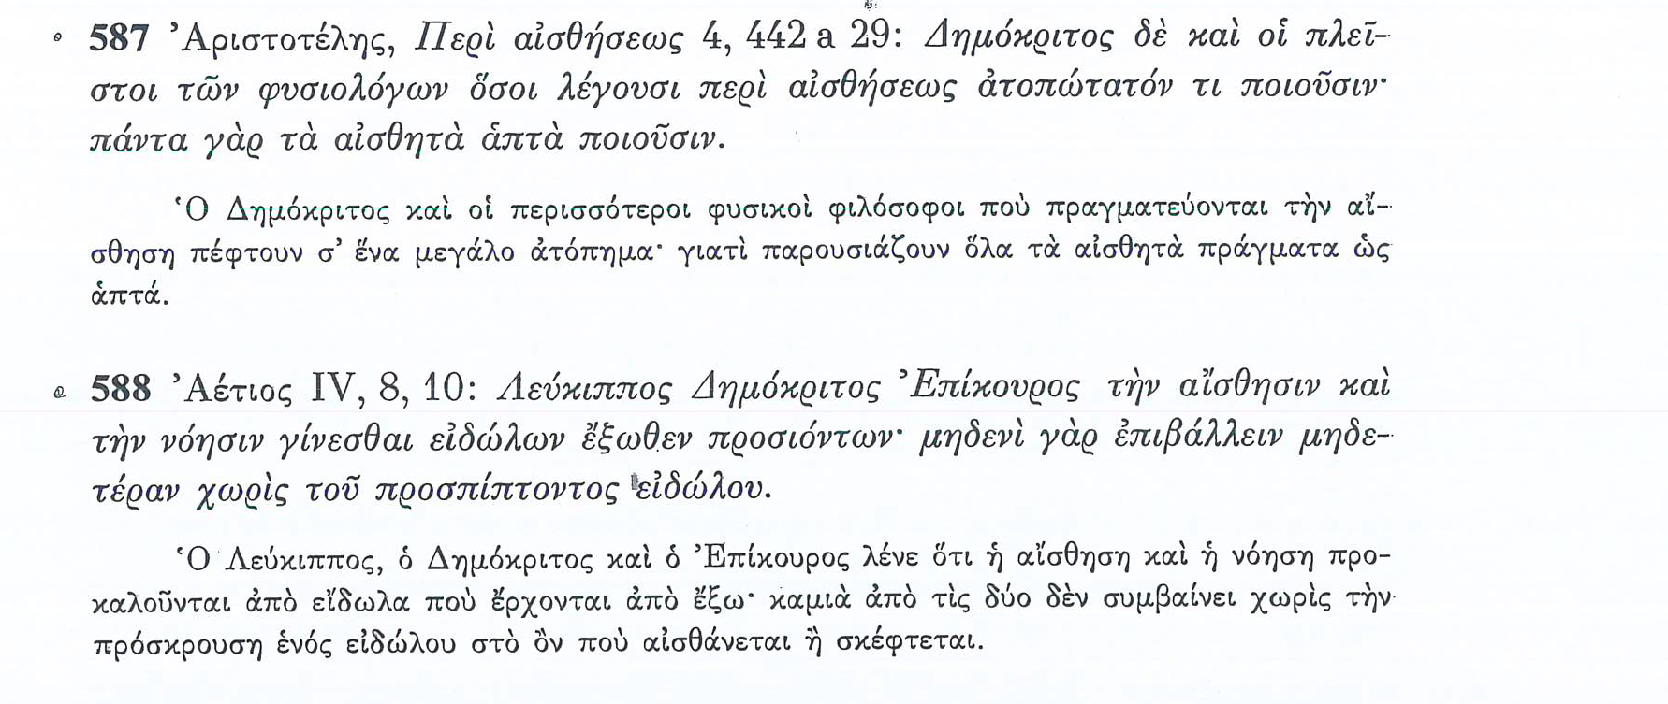

- Θεωρία της όρασης
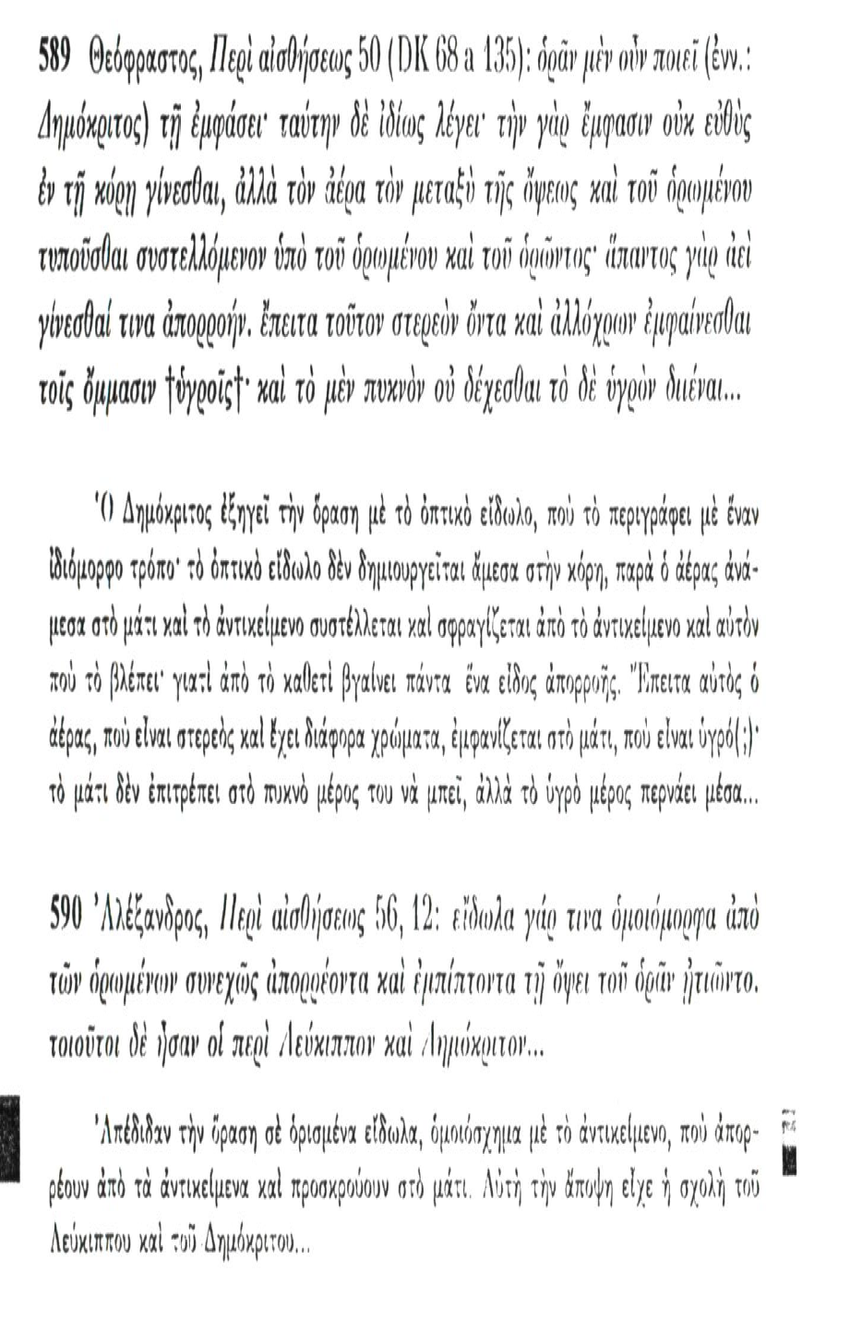
- Χρώματα

Θεόφραστος, Περὶ αἰσθήσεων 79
Πρῶτον μὲν οὖν τὸ πλείους ἀποδοῦναι τὰς ἀρχὰς ἔχει τινὰ ἀπορίαν· οἱ γὰρ ἄλλοι τὸ λευκὸν καὶ τὸ μέλαν ὡς τούτων ἁπλῶν ὄντων μόνων.
First of all, there is a problem in positing several principles; the others posit only white and black, as the only simple ones.

Θεόφραστος, Περὶ αἰσθήσεων 73–6
τῶν δὲ χρωμάτων ἁπλᾶ μὲν λέγει τέτταρα. λευκὸν μὲν οὖν εἶναι τὸ λεῖον. ὃ γὰρ ἂν μὴ τραχὺ μηδ' ἐπισκιάζῃ μηδὲ δυσδίοδον ᾖ, τοιοῦτον πᾶν λαμπρὸν εἶναι. δεῖ δὲ καὶ εὐθύτρυπα καὶ διαυγῆ τὰ λαμπρὰ εἶναι. τὰ μὲν οὖν σκληρὰ τῶν λευκῶν ἐκ τοιούτων σχημάτων συγκεῖσθαι οἷον ἡ ἐντὸς πλὰξ τῶν κογχυλίων· οὕτω γὰρ ἂν ἄσκια καὶ εὐαγῆ καὶ εὐθύπορα εἶναι. τὰ <δὲ> ψαθυρὰ καὶ εὔθρυπτα ἐκ περιφερῶν μὲν λοξῶν δὲ τῇ θέσει πρὸς ἄλληλα καὶ κατὰ δύο συζεύξει, τὴν δ' ὅλην τάξιν ἔχειν ὅτι μάλιστα ὁμοίαν. τοιούτων δ' ὄντων ψαθυρὰ μὲν εἶναι, διότι κατὰ μικρὸν ἡ σύναψις· εὔθρυπτα δ', ὅτι ὁμοίως κεῖνται· ἄσκια δέ, διότι λεῖα καὶ πλατέα· λευκότερα δ' ἀλλήλων τῷ τὰ σχήματα τὰ εἰρημένα καὶ ἀκριβέστερα καὶ ἀμιγέστερα εἶναι καὶ τὴν τάξιν καὶ τὴν θέσιν ἔχειν μᾶλλον τὴν εἰρημένην. τὸ μὲν οὖν λευκὸν ἐκ τοιούτων εἶναι σχημάτων. τὸ δὲ μέλαν ἐκ τῶν ἐναντίων, ἐκ τραχέων καὶ σκαληνῶν καὶ ἀνομοίων· οὕτω γὰρ ἂν σκιάζειν καὶ οὐκ εὐθεῖς εἶναι τοὺς πόρους οὐδ' εὐδιόδους. ἔτι δὲ τὰς ἀπορροίας νωθεῖς καὶ ταραχώδεις· διαφέρειν γάρ τι καὶ τὴν ἀπορροὴν τῷ ποιὰν εἶναι πρὸς τὴν φαντασίαν, ἣν γίνεσθαι διὰ τὴν ἐναπόληψιν τοῦ ἀέρος ἀλλοίαν. ἐρυθρὸν δ' ἐξ οἵωνπερ καὶ τὸ θερμόν, πλὴν ἐκ μειζόνων. ἐὰν γὰρ αἱ συγκρίσεις ὦσι μείζους ὁμοίων ὄντων τῶν σχημάτων μᾶλλον ἐρυθρὸν εἶναι. σημεῖον δ' ὅτι ἐκ τοιούτων τὸ ἐρυθρόν· ἡμᾶς τε γὰρ θερμαινομένους ἐρυθραίνεσθαι καὶ τὰ ἄλλα τὰ πυρούμενα, μέχρις ἂν οὗ ἔχῃ τὸ τοῦ πυροειδοῦς. ἐρυθρότερα δὲ τὰ ἐκ μεγάλων ὄντα σχημάτων οἷον τὴν φλόγα καὶ τὸν ἄνθρακα τῶν χλωρῶν ξύλων ἢ τῶν αὔων, καὶ τὸν σίδηρον δὲ καὶ τὰ ἄλλα τὰ πυρούμενα· λαμπρότατα μὲν γὰρ εἶναι τὰ πλεῖστον ἔχοντα καὶ λεπτότατον πῦρ, ἐρυθρότερα δὲ τὰ παχύτερον καὶ ἔλαττον. διὸ καὶ ἧττον εἶναι θερμὰ τὰ ἐρυθρότερα· θερμὸν [μὲν] γὰρ τὸ λεπτόν. τὸ δὲ χλωρὸν ἐκ τοῦ στερεοῦ καὶ τοῦ κενοῦ συνεστάναι † μεγάλων ἐξ ἀμφοῖν, τῇ θέσει δὲ καὶ τάξει αὐτῶν τὴν χρόαν. τὰ μὲν οὖν ἁπλᾶ χρώματα τούτοις κεχρῆσθαι τοῖς σχήμασιν· ἕκαστον δὲ καθαρώτερον, ὅσῳ ἂν ἐξ ἀμιγεστέρων ᾖ. τὰ δὲ ἄλλα κατὰ τὴν τούτων μῖξιν·
On colours, he says that there are four simple ones. White is what is smooth. For whatever is not rough or shadowy or difficult to penetrate, anything like that is bright. Bright things must also have straight pores to let the light pass through. Hard, white things are composed of shapes like the inner surface of shells, so they are shadowless and shining, with straight pores. Those which are friable and brittle are composed of spherical atoms positioned obliquely in pairs, in an arrangement which is practically uniform overall. They are friable because the connections hold between small groups of atoms, brittle because they are uniformly positioned, and shadowless because they are smooth and flat. The more exclusively things are composed of these shapes, unmixed with others, and the more they display that position and arrangement, the whiter they are. White consists of shapes of those kinds and black of the opposite, rough, uneven, and dissimilar, for they cast shadows and their pores are not straight or easily penetrable. Further their effluences are dull and confused; effluences differ relative to appearances, which are produced by the reception of impressions of different kinds made on the air. Red consists of the same sort of hot, only bigger; for the bigger the combinations of similar atoms are, the redder the thing is. The evidence that red consists of that sort of atoms is that we go red when we get hot, and so do other things that are burning, until they catch fire. And things composed of large atoms, such as flame and coal, are redder than green or dry wood. And so are iron and other things when they are burning; the brightest are those which have the most and the finest fire, while those which have less, thicker in texture, are redder, as the fine-textured is hot. Greenish-yellow consists of a mixture of solid and void, the colour varying according to their position and arrangement. The simple colours use these shapes; the less each is mixed, the purer it is. The other colours are produced by mixture of these.

Στοβαίος I.16.1 = Αέτιος I.15.8
Δημόκριτος φύσει μὲν μηδὲν εἶναι χρῶμα, τὰ μὲν γὰρ στοιχεῖα ἄποια, τά τε ναστὰ καὶ τὸ κενόν· τὰ δ’ ἐξ αὐτῶν συγκρίματα κεχρῶσθαι διαταγῇ τε καὶ ῥυθμῷ καὶ προτροπῇ, ὧν ἡ μέν ἐστι τάξις ὁ δὲ σχῆμα ἡ δὲ θέσις· παρὰ ταῦτα γὰρ αἱ φαντασίαι. τούτων δὲ τῶν πρὸς τὴν φαντασίαν χρωμάτων τέτταρες αἱ διαφοραί, λευκοῦ μέλανος ἐρυθροῦ *ὠχροῦ.*
Democritus says that by nature there is no such thing as colour, for the elements, the solid things and the void are propertyless. The compounds made from them are coloured by ‘contact,’ ‘rhythm,’ and ‘tuning,’ i.e., arrangement, shape, and position; for the appearances arise from these. There are four varieties of these apparent colours, white, black, red, and yellow.

Θεόφραστος, Περὶ αἰσθήσεων 63–4
περὶ μὲν <οὖν> βαρέος καὶ κούφου καὶ σκληροῦ καὶ μαλακοῦ ἐν τούτοις ἀφορίζει. τῶν δὲ ἄλλων αἰσθητῶν οὐδενὸς εἶναι φύσιν, ἀλλὰ πάντα πάθη τῆς αἰσθήσεως ἀλλοιουμένης, ἐξ ἧς γίνεσθαι τὴν φαντασίαν. οὐδὲ γὰρ τοῦ ψυχροῦ καὶ τοῦ θερμοῦ φύσιν ὑπάρχειν, ἀλλὰ τὸ σχῆμα ‘μεταπῖπτον’ ἐργάζεσθαι καὶ τὴν ἡμετέραν ἀλλοίωσιν... σημεῖον δ' ὡς οὐκ εἰσὶ φύσει τὸ μὴ ταὐτὰ πᾶσι φαίνεσθαι τοῖς ζῴοις, ἀλλ' ὃ ἡμῖν γλυκύ, τοῦτ' ἄλλοις πικρὸν καὶ ἑτέροις ὀξὺ καὶ ἄλλοις δριμὺ τοῖς δὲ στρυφνὸν καὶ τὰ ἄλλα δ' ὡσαύτως. ἔτι δ' αὐτοὺς μεταβάλλειν τῇ κράσει κατὰ τὰ πάθη καὶ τὰς ἡλικίας· ᾗ καὶ φανερόν, ὡς ἡ διάθεσις αἰτία τῆς φαντασίας. ἁπλῶς μὲν οὖν περὶ τῶν αἰσθητῶν οὕτω δεῖν ὑπολαμβάνειν. οὐ μὴν ἀλλ' ὥσπερ καὶ τὰ ἄλλα καὶ ταῦτα ἀνατίθησι τοῖς σχήμασι· πλὴν οὐχ ἁπάντων ἀποδίδωσι τὰς μορφάς, ἀλλὰ μᾶλλον τῶν χυλῶν καὶ τῶν χρωμάτων καὶ τούτων ἀκριβέστερον διορίζει τὰ περὶ τοὺς χυλοὺς ἀναφέρων τὴν φαντασίαν πρὸς ἄνθρωπον.
That is his account of heavy and light and hard and soft. None of the other sensible qualities has any nature of its own, but all are states of the sense when it is altered so as to give rise to an appearance. For there is no nature belonging to hot or cold, but change in shape [sc. of the thing perceived] brings about alteration in us... The evidence for this is that things do not naturally seem the same to all creatures, but what is sweet to us is bitter to other creatures, sharp-tasting to others, pungent to others, sour to others again, and the same for other cases. Further, they [i.e., observers] vary in their judgments according to their different states and to their ages; which makes it clear that their disposition is the cause of how things seems to them. Of course, these too [i.e., states of observers] are, like everything else, ascribed to the shapes [sc. of the atoms]. Though he does not set out the shapes underlying them all, but rather those underlying flavours and colours, and of these flavor is given the more precise account, in which the appearance is referred to [the state of] the individual.

Θεόφραστος, Περὶ αἰσθήσεων 69
ὅλως δὲ μέγιστον ἐναντίωμα καὶ κοινὸν ἐπὶ πάντων, ἅμα μὲν πάθη ποιεῖν τῆς αἰσθήσεως, ἅμα δὲ τοῖς σχήμασι διορίζειν, καὶ τὸ αὐτὸ φαίνεσθαι τοῖς μὲν πικρόν, τοῖς δὲ γλυκύ, τοῖς δ' ἄλλως. οὔτε γὰρ οἷόν <τε> τὸ σχῆμα πάθος εἶναι οὔτε ταὐτὸν τοῖς μὲν σφαιροειδές, τοῖς δ' ἄλλως. ἀνάγκη δ' [εἴπερ] ἴσως, εἴπερ τοῖς μὲν γλυκύ, τοῖς δὲ πικρόν, οὐδὲ κατὰ τὰς ἡμετέρας ἕξεις μεταβάλλειν τὰς μορφάς. ἁπλῶς δὲ τὸ μὲν σχῆμα καθ' αὑτό ἐστι, τὸ δὲ γλυκὺ καὶ ὅλως τὸ αἰσθητὸν πρὸς ἄλλο καὶ ἐν ἄλλοις, ὥς φησιν. ἄτοπον δὲ καὶ τὸ πᾶσιν ἀξιοῦν ταὐτὸ φαίνεσθαι τῶν αὐτῶν αἰσθανομένοις καὶ τούτων τὴν ἀλήθειαν ἐλέγχειν, καὶ ταῦτα εἰρηκότα πρότερον τὸ τοῖς ἀνομοίως διακειμένοις ἀνόμοια καὶ πάλιν τὸ μηθὲν μᾶλλον ἕτερον ἑτέρου τυγχάνειν τῆς ἀληθείας.
But in general the greatest contradiction, which pervades the whole theory, is his both making them states of perception and at the same time distinguishing them by their shapes, and saying that the same thing appears bitter to some, sweet to others, and different to yet others. For it is impossible for the shape to be a state, or for the same thing to be spherical to some and differently shaped to others (yet perhaps that is how it has to be, if it is sweet to some and bitter to others), or for the shapes to change according to our dispositions. It is simply the case that shape is intrinsic, but sweet and sensible qualities in general are relative and dependent on other things, as he says. And it is absurd to require that the same appearance should be presented to everyone who perceives the same thing, and should be the test of their truth, when he has previously said that things appear differently to those who have different dispositions, and again that none has more truth than any other.

