

International Journal of Serious Games

ISSN: 2384-8766
https://journal.seriousgamessociety.org/

Article
A Hybrid Approach in Teaching and Experiencing Sport Event Management through the Serious Game Top Eleven

Keywords:
Serious Games
Computer based learning
Virtual sport event
Management tools
Virtual football tournament
Sport event management
Top Eleven

Received: XXXX
Accepted: XXXX
Published: XXXX
DOI: 10.17083/ijsg.XXXX
Abstract
The intention of this study was to innovate in teaching and experiencing sport event management. Conventional teaching methods do not meet modern needs. Therefore, we investigated whether a serious game such as Top Eleven can be used as an auxiliary educational tool for sport event management. Following the case study methodology, a virtual football tournament planned, organized, managed, and evaluated by N=44 students who attended Sport Event Management class. In tournament participated N=328 freshmen students. A hybrid process was followed, as part of the tournament has been run online, while another part was implemented in real life. Data were collected via a set of deliverables, written test, and a questionnaire. The organizational process was conceptualized by the “Unified Model of Events Management” and the “Scenario Based Education Framework”. The data analysis revealed a satisfactory level of knowledge acquisition, skills development, and experiences gained related to investigated topic. Consequently, it can be argued that a Serious Game such as Top Eleven can be used as an auxiliary educational tool for the above purposes, via the implementation of a hybrid approach that is proposed. This study advances Serious Games state of the art in learning and teaching methods through an innovative gamification process, which allows students to acquire not only theoretical knowledge but also practical experiences that develop their sport event managerial skills.

Introduction
Since the late of 19th century, technology influence our lives with increasingly importance. Currently it dominates and affects all sectors of society, including education at all levels. In recent decades, technology has offered students many educational tools for the development of their knowledge and skills mainly by simulation. Especially in the era of Covid-19 pandemic during the lockdown period, where face-to-face learning was impossible, technology became an essential tool and an integral part of education. In this effort, Serious Games (SG) could serve as an important auxiliary educational tool.
SGs are now widely used in higher education [1] mainly due to their ability to “transfer” students to a virtual environment that resembles the real world for which they need to be trained. Through SGs that save money, time, and resources as well [2], students can gain knowledge and skills by managing resources, make decisions, and generally operate in an environment similar to their future work positions. Since digital SGs can simulate the “real” world [3], their demand has been increased for educational purposes [4] during recent years [5]. According to Vlachopoulos and Makri [1, p. 1], “As rapidly evolving technological applications, games and simulations are already widely integrated in the traditional educational process. They are deployed extensively in the field of education, with an existing body of work examining the relation of games and education”. Although the use of SGs in education is not something new, these games are more effective, as they are designed in such way that give user the opportunity to act in a simulated environment, with clearly defined goals, regulations, decision making, instant feedback and evaluation [6].
SGs are even employed in higher education as educational means [7], especially during the last decade since simulation games rapidly increased both in quality and numbers allowing researchers to investigate their learning effectiveness more thoroughly [8]–[10]. Many scholars addressed the conversion of SGs into educational tools as an alternative, though quite promising solution to the educational process. Players of SGs cultivate their knowledge and practice their skills through accomplishing various tasks [11]. According to Zhonggen [12, p. 2], “educational elements can be integrated into the gameplay, which will be subconsciously acquired by the players during the gaming process”. This meta-analysis [12, p. 4] shows that, SGs are effective to: (1) facilitate learners’ holistic understanding of scientific conceptions, (2) obtain cognitive abilities, (3) increase positive affect of learning and improve teaching in the sciences, (4) provide flexible learning, (5) improve learning outcomes, (6) facilitate socio-cultural learning in terms of cognitive and motivational effects and team opinions, (7) improve cross cultural communication competence, and (8) improve script collaboration based professional learning and learner satisfaction.
Regarding Sport Management’s courses, an educational gamified virtual environment, using as a medium SG, can help students acquire experience, skills, and competencies by practicing their professional knowledge otherwise gained only through the internship or work in a sport organization [13]. Consequently, a Virtual Intramural Football Tournament (VIFT) is established, with two different groups of students involved: a) students attending the Sport Event Management class with the responsibility to plan, program, run and evaluate the VIFT (hereafter referred as “organizers”), and b) students participating in the VIFT managing their virtual teams (hereafter referred as “participants”).
The necessity of employing simulation games in the management of sports events is evident, as the economic viability of sports organizations is sufficiently complex to justify the integration of experiential simulation. Event organizers face a singular opportunity to execute an event successfully; therefore, the inability to rectify organizational errors necessitates a proactive approach to training. Consequently, providing aspiring professionals with training in a simulated environment affords them the chance to acquire knowledge and skills without the repercussions associated with real-world mistakes.
The research literature resulted no sources that refers to a SG as a means for practical use in gaining experiences and develop managerial skills in the field of sport event management. Thus, the present study aims to assist in filling this gap by proposing a way of practical implementation through an innovative vest of a SG, which allows the practical implementation and the acquisition of work experiences and develop event management skills.

Furthermore, following the suggestion of Afthinos et al. [10] for a Top Eleven research more focused on sport management, the present study provides evidence demonstrating the potential conversion and use of this SG as an auxiliary learning tool for acquiring knowledge in sports event management.
Taking this into account, the aim of this study is to address the following main research question: Is Serious Game capable of serving as an auxiliary educational tool and serve as a means for acquiring theoretical knowledge and gaining practical experiences in the field of sport event management via the implementation of a hybrid approach?

Literature review

Digital games in education
Digital games first appeared in the last decades of 20th century and they are ubiquitous in the lives of students on phones, tablets, and laptops (Pope & Mangram, 2015). Nowadays there are thousands of games that are played by hundreds of millions of people all over the world. Most of them are played through the internet. Due to the spread of home internet connections and the use of mobile technology, the modern society turned into a “digital society” [15], where most young people play digital games. Taking this into account it’s not surprising that the 2012 global market of SGs raised at $2.57bn (€2.35bn) (De Gloria, Bellotti, & Berta, 2014), reaching $90.7 bn (€83.8 bn) in 2021 (Qu, et al, 2023) and $187.7 bn (€172.8 bn) in 2024, representing +2.1% year-onyear growth.
According to Aldrich [16], digital games classified in three categories: (a) video games, (b) serious games and (c) educational simulations.
Digital games are designed to be played on many different platforms such as PCs, laptops, tablets, consoles, and mobile phones. The first games were created aiming to entertain people. Nowadays, electronic games are designed to cover other needs as well, including pedagogical, learning, and educational. Since a digital game has pedagogical and educational purpose, then it is a SG [17]. According to Sawyer [18], SGs are those that have a substantial connection to the acquisition of knowledge. As Zyda [19] pointed out, serious are considered the digital games whose primary purpose is not entertainment, enjoyment or fun but the educational outcomes.
Digital SGs and educational simulations can both produce educational outcomes, however they are played in different environments. Afthinos et al. [10, p. 4] mentioned that “serious games combine both the environment of video games and the complexity of a legal organization; therefore, they produce learning objectives in a user-friendly environment which does not exist in educational simulators”. Thus, it might be preferable in certain cases (e.g., kids, pupils, students, etc.) to use digital SGs for educational purposes Baek, Park and Han, 2016), argued that SG are used for educational purposes and show particularly encouraging results in learners’ motivation.
Petridis et al (2015), emphasize that addressing modern challenges requires a wide range of knowledge and skills, which in turn highlights the need for finding new, innovative learning tools and training methods, such as serious games and gamification applications.
Mobile learning is an indisputable reality that combines a range of advantages, such as increased motives for participation, enhanced responsibility and efficiency, developes acquisition of knowledge and skills and better control and assesment of learners' progress (Barma, et al 2015).
According to Kotsopoulos et al (2018), the use of SG in education, as well as the gamification of the learning process, promotes the desired behavior and attitude change of users towards learning, increases participation, and improves performance. Research shows that SGs, develop users’ cognitive skills through their structured design and the activities they engage them (Chorianopoulos, & Giannakos, 2014) and encourages self-awareness through the setting of appropriate goals and the provision of periodic feedback (Cowley & Bateman, 2017). Furthermore Hellströ et al. (2023), stated that SG could be used for “moving from passive to active pedagogy, and as a means of developing both practical competencies and soft skills” (p1). Continuing their work they argued that SG a) could develop specific knowledge and skills that are necessary in real-life, b) improve the learning impact, c) is used to implement new kind of pedagogical approaches (such as experimental learning) and d) is used to increase students’ interest in learning.
Furthermore, previous research has highlighted the significant role of serious games in facilitating the acquisition of knowledge and the development of professional skills (Riedel & Hauge, 2011; Girard et al., 2013; Wouters et al., 2013; Boyle et al., 2016; López et al., 2021; Jacaard et al., 2022). López et al. (2021) identify education as a key factor for enhancing learning, a process that can be effectively achieved through methods like gamification. Riedel and Hauge (2011) suggest that serious games can serve as a mediator for professional skill development, while Boyle et al. (2016) found that knowledge acquisition was the most common outcome of serious games, followed by changes in cognitive, emotional, and behavioral domains, with fewer studies observing improvements in physiological or soft and social skills. Girard (2013) emphasizes that serious games promote constructive, experiential learning through active engagement and immersion, while Wouters (2013) highlights that they address both cognitive and emotional learning, enabling personalized learning experiences and boosting motivation. Jacaard et al. (2022) used empirical research to explore how serious games can transform project management education, relying on qualitative data to demonstrate their effectiveness.
2.2 Sport event management framework
In real life, successful management of sporting events depend on many different event operations [20], i.e., venues, accommodation, transportation, that are not applicable in digital games. However, regardless of one organizes a real sport event or a digital one, some operations remain common. For example, organizing a digital sport event, management consists of planning, assigning, coordinating, and controlling [20].
Salem et al. [21] conceptualized the Event Management framework “Unified Model of events management”. According to this model, Event Management consists of four basic elements: (a) decision, (b) detailed planning, (c) implementation and (d) evaluation. The decision process includes “aims and objectives”, “establishment of board management” and “feasibility study” (figure 1).
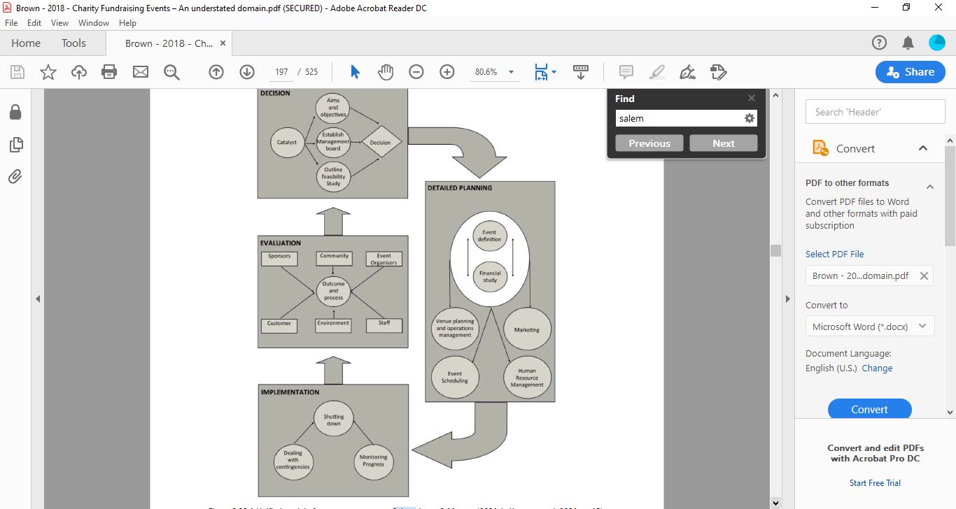
Figure 1. The Unified Model of Event Management (Salem et al., 2012)

Detailed planning includes event definition, financial study, marketing, human recourses management, event scheduling, and venue planning and operations management. Implementation includes dealing with contingencies, monitoring progress, and shutting down.
The event management is completed with the evaluation of the process, the evaluation of the organizers and the outcome of organizing a digital football tournament. Kendal et al. [22] consider that, it is essential for the event organizers to mapping out the event and lay down everything that concerns the event on a grid. Additionally, they suggest the use of various function sheets such as timelines. The effectiveness of planning and the successful event execution depends on how strictly someone adhere to the timelines.
Furthermore, Allen [23] highlights the importance of the event overview grid which provides valuable information for various event elements including event timing and orchestration. She also states that a post event summary is a very useful tool for planning as it gives the organizers the framework for the event.
When asked to plan a project, a common approach is to immediately identify what needs to be done first and then sequentially work through the tasks required to complete the project. Structured Task Analysis is a list with task actions required to achieve the given goal. This list follows a logical organizational sequence, and it is based on the planning tools [24]. Projects planned poorly are significantly more likely to run into problems. Our exercise is focused on the iterative, top-down development of a project plan, documented not just as a Gantt chart but as a complete project charter [25].
Planning is followed by the implementation of the event, which is one of the most critical points for the events’ overall effectiveness. As Pinto and Slevin [26] pointed out, monitoring the event and get feedback from the participants, allows organizers to control the process and evaluate how the event is running compared to initial projections.
Evaluation, the last element on Salem et al. [21] framework, is a procedure of systematic assessment of the worth or merit of the event, and the systematic acquisition and assessment of information to provide useful feedback for the event [27].

2.3 Scenario based education framework
According to the “Scenario Based Education Framework” developed by Misfeldt [29, p. 183], “The scenario can be framed as a teaching situation …”, “… and it can be framed as a simulation (that resembles a situation that it is important to master)”. This educational approach (see Figure 2), adapted by Afthinos et al. [10], enables students to undertake certain tasks, develop projects, take decisions, answering management problems and thus acquiring knowledge, develop their skills and experience [29]. The approach to use the SG Top Eleven as an educational sport event management and marketing means is based on a series of vested educational scenarios with the intent to meet certain educational objectives presented by Afthinos et al. [10].

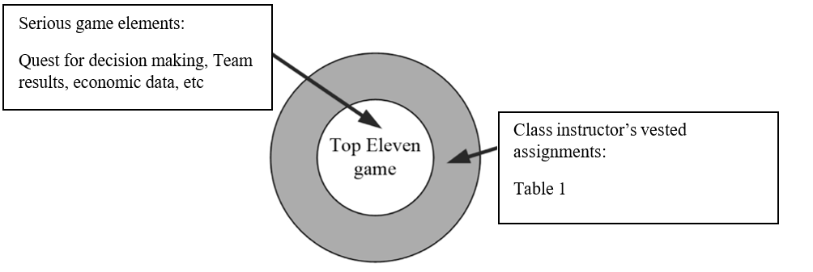 Figure 2. Educational approach to use Top Eleven as event management simulator [10]

Methodology
This is a case study on the use of a commercial sport SG for educational purposes, at the National and Kapodistrian University of Athens’s (NKUA) School of Physical Education and Sport Science (SPESS). To answer our main research question whether or not a Serious Game is capable of serving as an auxiliary educational tool for acquiring theoretical knowledge and gaining practical experiences in the field of sport event management via the implementation of a hybrid approach, we followed a methodology that entailed the use of the SG TOP Eleven and the the creation of a Virtual Intramural Football Tournament (VIFT) within the Game Top Eleven, to prove that students can act as event managers and thus acquire knowledge and develop managerial skills. This was achieved through the gamification of the educational scenario, which leveraged the Game’s capability for users to organize friendly matches.

Research Design
According to the research design, the methodology is structured around three key components:
- The development of educational scenarios for students, which would serve as a foundation for their roles as event organizers. Within this framework, students would be responsible for designing, organizing (through the production of specific deliverables listed in Table 2), and implementing the VIFT, the steps of which are outlined in detail below.
Following the Misfeldt ‘s “Scenario Based Education Framework” [29] and its adaptation by Afthinos et al. [10], the course instructor created various educational scenarios for the students attending the course on event management. These scenarios are reliable, as they are based both on the event management literature and practical experience. Such scenarios allow students to act as organizers and, for example, invite participants to a technical meeting or conduct draws and create the competition schedule.
b) The administration of a written knowledge assessment, intended to evaluate students' understanding and acquisition of knowledge regarding the processes and principals involved in tournament organization.
c) The evaluation of the tournament by the participants, aimed at gathering feedback on their experience, the effectiveness of the organization, and identifying areas for improvement in future events.

Study Procedure
The study procedure for the class laboratory was designed around the simulation of a football tournament using the SG Top Eleven platform, integrated with educational scenarios in a hybrid format. The process began with the organizers being briefed on the purpose and philosophy of the Virtual International Football Tournament (VIFT) and the establishment of its Organizing Committee (OC). The OC was structured into two distinct departments: sports and marketing.

The marketing department of the VIFT was tasked with two primary responsibilities: (a) creating and managing a website and a Facebook account to serve as official communication channels, and (b) designing and implementing a sponsorship program. Despite the tournament being virtual, the marketing department, operating on a full-scale basis, successfully secured sponsorships from real-world entities, such as Adidas Hellas and the Hellenic Football Federation, which provided trophies and prizes for the winners during the virtual closing ceremony.

The subsequent phase of the VIFT planning process involved the development of a Project Charter (Map), a detailed Timetable, and a Structured Task Analysis for both the sports and marketing departments, along with the formulation of the tournament’s Rules and Regulations. Following this, the organizers utilized the SPESS e-class platform to invite virtual team managers to participate in the tournament. Through this platform, the VIFT Participation Forms, Terms and Conditions, and Rules and Regulations were disseminated. At this stage, the members of the OC transitioned into the role of Project Managers (PMs), taking on the responsibility of overseeing the first phase (group stage) of the VIFT. The OC provided the PMs with a list of participating teams, which were then randomly divided into 82 groups of four teams each, forming the initial round-robin group stage. Each PM was assigned to manage one or two groups and was required to send a "Facebook friend" request to the team managers via email.

The PMs subsequently invited their assigned teams to a Technical Meeting conducted via the Webex platform. During this meeting, the PMs elaborated on the tournament’s objectives, philosophy, operational procedures, and Rules and Regulations. They also distributed the Timetable and Competition Schedule, outlining the participants' responsibilities, such as inviting their opponents to friendly matches as per the schedule and reporting match results to their respective PMs. Additionally, PMs informed participants about the available channels for contacting the OC (email and Facebook Messenger) and addressed any questions or concerns, thereby enhancing their communication skills.
As per the VIFT protocol, the home team was required to invite their opponent to a "friendly match" using the Top Eleven platform, creating an intramural championship exclusively for SPESS students. After each match, the home team manager was obligated to report the final score to their PM by submitting a screenshot of the result. The marketing department then updated the group scoreboard and uploaded it to the official VIFT website. The tournament proceeded smoothly, enabling continuous monitoring and evaluation of the educational process at every stage. In instances where issues or delays arose, the PMs, acting as organizers, proposed solutions, thereby developing their problem-solving and decision-making skills. The group stage concluded with the advancement of winning teams to the knockout rounds and ultimately to the final match.
Following the conclusion of the tournament, the OC proceeded to conduct a comprehensive evaluation of the VIFT. This evaluation aimed to assess the effectiveness of the tournament's organization, its alignment with educational objectives, and the overall experience of participants. The entire procedure is comprehensively outlined in Figure 3.
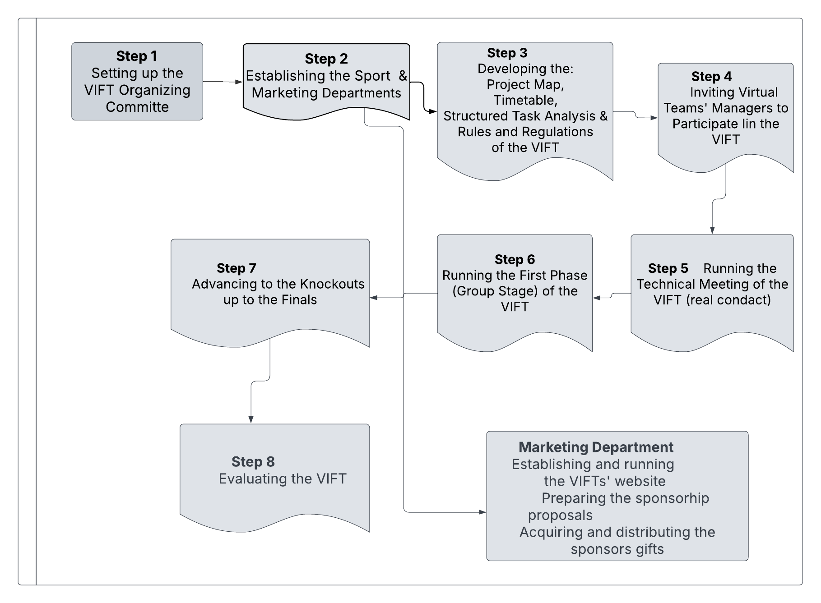
Figure 3: Study Procedure

3.3 The SG Top Eleven
Top Eleven is a free digital football game by Nordeus, launched in 2010 and available in 31 languages. It can be played on PC, laptops, mobile phones, and tablets via Facebook. The game focuses on decision-making rather than player avatars and users are not required during matches. Its core concept revolves four elements: (a) club resource development, (b) budget management, (c) investment in assets, and (d) improving team efficiency (photos 1 & 2).
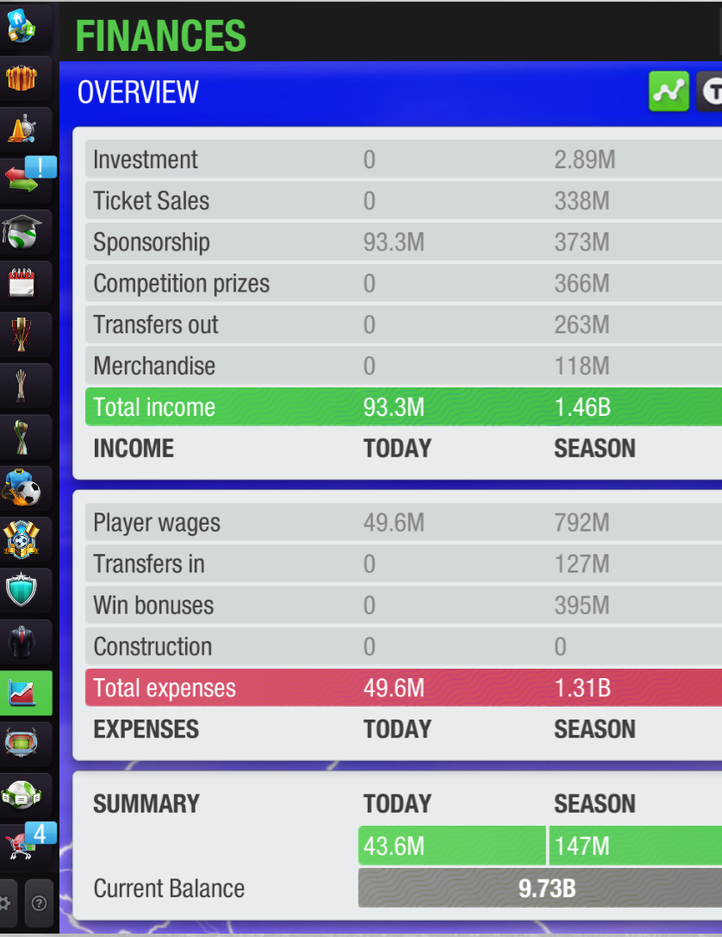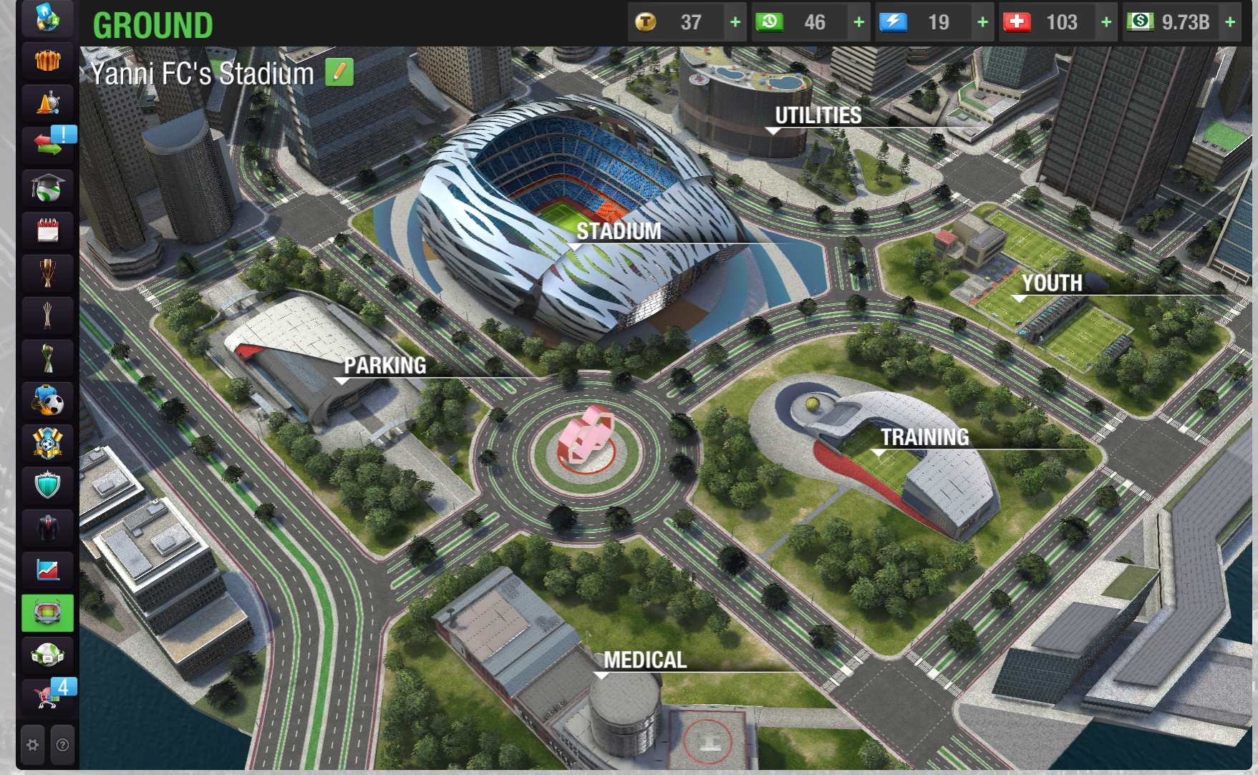

Photo 1. Club’s Financial Overview Photo 2. Club’s facility development

The relevant model was illustrated by Afthinos et al. [10] as shown in Figure 4.

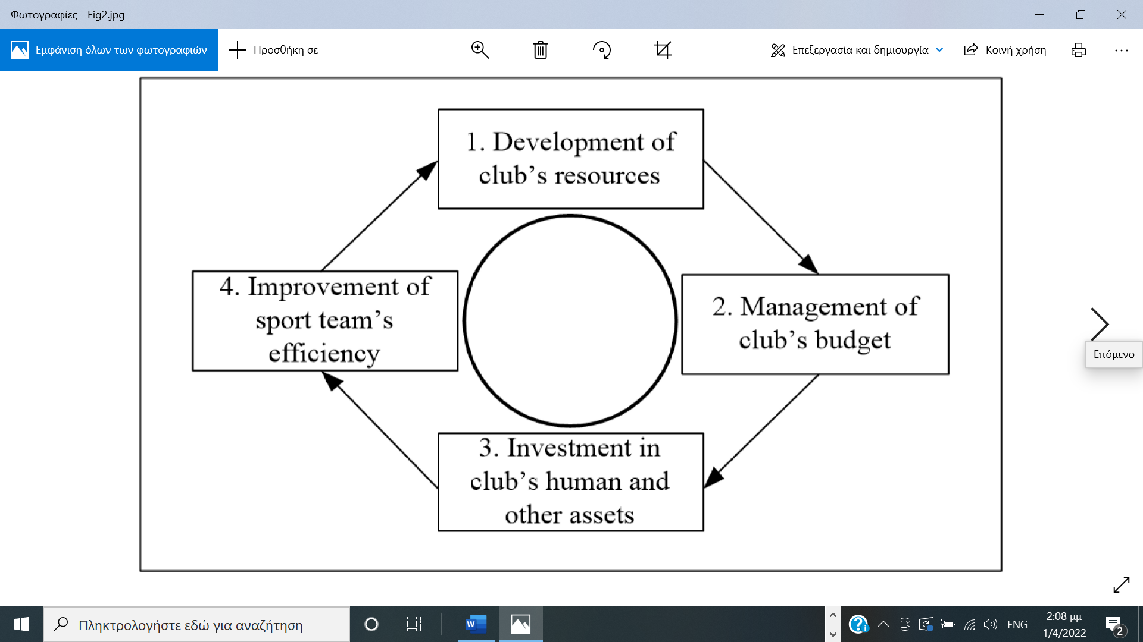
Figure4. Basic game concept [10]

The Top Eleven player acts as a football club/team manager with the duty to lead his/her team into winning titles. The game’s structure covers basic management functions of a conventional sport club simulating management work positions including the sport event manager. Regarding the sport event management work position, Top Eleven allows users’ team to participate in various events and tournaments, such as:
• League
• Champions League
• Super League
• Cup
• Super Cup
• Association Tournaments
• Special Tournaments
On top of these, the users of the game can arrange:
• Friendly matches, and
• Friendly Tournaments (photos 3& 4)
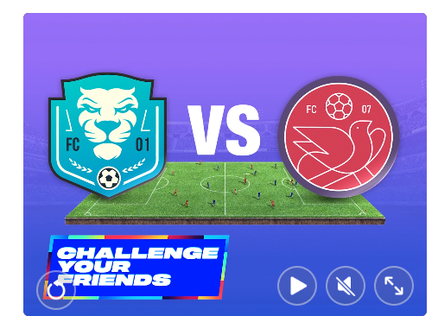
Photo 3: Friendly Matches Photo 4: Various Competition Tournaments

The approach to use SG Top Eleven as an educational simulator is based on the game’s ability to allow the club managers to play friendly matches and therefore to create virtual independent friendly tournaments. In this football SG, the fixtures are determined, and the matches are played automatically by the game except friendly matches.

The overall methodological approach to teaching sport event management is hybrid, since the management of the VIFT was mainly digital, while some management and marketing aspects were life sized.

3.4 Population and sample
The population of this study was N=372 School of Physical Education and Sport Science (SPESS) students divided in two groups: (a) the organizers consisted of Ν=44 senior students majoring in sport event management and attending the Sport Event Management class and b) the participants, consisted of Ν=328 freshmen students attending an introductory Sport Management class as football team managers of the virtual football teams (Table 1).

Table 1:Population of the study
Population of the study f %
Organizers (senior students) 44 11.83
Participants (freshmen students) 328 88.17
Total 372 100

Data collection instruments
Τhe teaching of the Sport Event Management class consist of the delivery of knowledge and theory and the development of sport event management skills through class laboratories. The laboratory approach was hybrid since the intended skills were developed both virtually (through the SG) and in real life (i.e. through real communication with the stakeholders).
The VIFT process was conceptualized by two models that mentioned before: the “Unified Model of Events Management” [21] and the “Scenario Based Education Framework” [29]. All students participated in this study as part of their attending classes’ assignments. Based on the Salem model, after the decision to create the event was made, we proceeded with detailed planning of the tournament (for example, establishing an organizing committee, creating announcements, mapping out the tournament, etc.). Subsequently, we moved forward with the tournament's implementation (technical meetings, draws, conducting matches, score tables, etc.), and in the end, we carried out an evaluation of the tournament.
Regarding the model, a scenario was created in which all students enrolled in the course on event organization were transformed into an organizing committee and project managers, each responsible for managing the participating teams assigned to their group. Within this framework, they were required to communicate with participants, send them informational material, resolve administrative issues, and make decisions

The data were collected by: a) a set of deliverables b) a written test that assessed skills in sport event management acquired by organizers, c) the Chertoff’s et al. [31] “Virtual Environment Evaluation Questionnaire”, that assessed organizers’ sport management efficiency and the overall VIFT evaluation.

Deliverables
The deliverables, as class assignments related to sport event management skills development, have set as part of the official assessment of the organizers before, during and after the completion of the VIFT. The organizers were obliged to deliver to the class instructor a set of event management tools such as the organization chart, the project charter (map) and the timetable of the event, the Structured Task Analysis etc. All deliverables are listed in Table 2. The aim of deliverables was to develop students’ skills (i.e., skills on preparing timetables, competition draw and schedules, scoreboard arraignments, etc). The evaluation of the deliverables was done on a scale from 1 to 10. Table 2 presents the class average score for each deliverable.

Knowledge Written Test
The written test aimed to evaluate the students' acquired theoretical knowledge on sports event management topics and were given after the completion of the VIFT. This test was created by the class instructor and included 20 multiple-choice and open-ended questions on various event organizational topics, such as planning of a sports tournament, (i.e. “what do you know about the project charter (map) ”), the competition announcements, (i.e. “what is included in a football tournament general announcement”), participants’ management (e.g “what kind of information should be included in a registration form”), technical meeting (e.g “what kind of information should be communicated to participants during a technical meeting”), calculation of the number of matches (“which mathematical type calculates the total number of the matches in a robin round system”), qualification criteria, (e.g. “what are the most common qualification criteria for teams that are tied in the standings in a robin round system”) etc.
The assessment of the written test was conducted on a scale of 1 to 10 (Table 3).

VIFT Evaluation
The VIFT evaluation conducted through the “Virtual Environment Evaluation Questionnaire” that had been adapted for the specific needs of the study. Some questions were modified to be more suitable for this research, while those that did not fit this survey were removed. Following that, the questionnaire was tested for its face validity by a committee of four faculty members, who agreed on its final form without further changes. The questionnaire was sent via Google Forms to the 328 first-year students who participated in the tournament with their teams. A total of 206 completed questionnaires were returned.
The assessment instrument used in this study consisted of 27 questions evaluated: a) organizers efficiency, and (b) VIFT organization & implementation. Answers were given on a Likert scale 1-5 (1=absolutely disagree and 5=absolutely agree).

Salem’s et al. [20] model | Sport event management educational scenarios vested to SG Top Eleven | Educational objectives/skills | Instructor’s  evaluation mean score (M)
DECISION | - The OC members create the event’s organization chart. | Students learn how to create an event organization chart by using office software. | 7.85
DECISION | - The OC members create the project map of the event. | Students learn how to create a project map by using office software (Word/Excel). | 8.24
DETAILED PLANNING | - The OC members create a timetable of the event. | Students learn how to create a timetable by using office software (Excel). | 7.05
DETAILED PLANNING | - The OC members produce a Structured Task Analysis of the event. | Students learn how to create the Structured Task Analysis of a project (sport event) by using office software (Word/Excel). | 7.43
DETAILED PLANNING | - The OC create and distribute the event’s Registration Form for the participant teams. | Students learn how to create an event’s Registration Form by using office software and registration applications (Word/Google Forms). | 8.32
DETAILED PLANNING | - The OC accepts the participating teams and proceeds on competition draws. | Students learn how to proceed on competition draws by using office software and random number applications (Word/Excel/random.org). | 8.75
DETAILED PLANNING | - The OC divide the total number of the participating teams into groups of four and assign among its members the PM of each group to proceed with the Competition Schedule. | Students learn how to create Competition Schedule by using office software (Word/ Excel). | 8.80
DETAILED PLANNING | - The PMs communicate with the participating teams’ managers. | Students acquire communication skills as they communicate with the team managers as part of the implementation of the VIFT to invite the participating teams’ managers to attend the technical tournament’s meeting. | 8.75
DETAILED PLANNING | - The PMs execute the VIFT’s technical meeting. | Students develop communication skills as they communicate the participating teams’ managers for the technical meeting and provide them with the necessary competition information of the VIFT. | 8.90
DETAILED PLANNING | - Development of the VIFT website | Using open access platform, students learn how to prepare and publish a website | 8.74
DETAILED PLANNING | - Preparation of sponsorship proposals | Students educated on the planning process of a sponsoring program | 8.34
IMPLEMENTATION | - The PMs run the VIFT having the responsibility of problem solving. | Students learn to run the competition and deal with problems. This fact helps them to develop problem solving skills. | 8.97
IMPLEMENTATION | - The PMs run the VIFT having the responsibility of decision taking. | During the VIFT students had to deal with problems and take some decisions. This fact helped them to develop decision making skills. | 9.13
IMPLEMENTATION | - The PMs run the VIFT having the responsibility of reception of results and update the scoreboard. | Students learn how to create and update the scoreboard by using office software (Word/Excel). | 9.15
IMPLEMENTATION | - The PMs run the VIFT having the responsibility to declare the promoting teams. | Students learn how to use Rules and Regulations and update scoreboard by using office software (Word/Excel). | 9.15
IMPLEMENTATION | - Run of the VIFT website | Students are trained on the maintenance and the administration of a website | 8.84
IMPLEMENTATION | - Implementation sponsorship program | Students learn how to communicate, negotiate, sale, and carry out the agreed terms of sponsorship. They also learn how to organize a virtual closing ceremony. | 8.24
EVALU-ATION | - The PMs run the evaluation of the VIFT | Students learn to evaluate an event, identify problems, and propose solutions. | 9.07

Results

Demographics
Research group organizers: Most of the organizers (N=44) were women (f=31, 70.45%) and the rest were men (f=13, 29.55%). Their average age was 22.88 years (min=21, max=28).
Research group participants: The participants were freshmen students (N=328) who were attending the introductory Sport Management class. The evaluation questionnaire completed by N=206 (62.80%) students, almost equally divided between men (f=100, 48.54%) and women (f=106, 51.45%). Their average age was 19.32 years (min=18, max=28). Most of them (f=155, 75.2%) declared that had no previous experience in Serious Games.

Deliverables: Evaluation of Organizers’ Skills
The organizer’s skills on sport event management have been assessed through deliverables by the class instructor as part of their official class grading procedure. The mean score of the deliverables was M=8.54 (see Table 2).

Table 2: Deliverables: Educational scenarios, objectives & instructor’s evaluation

Written test: Evaluation of theoretical knowledge in sport event management
Evaluation of the organizers’ theoretical knowledge on sport event management was conducted at the end of the VIFT. To examine both the level of the acquired knowledge on sport event management derived through the process of gamification and the efficiency of the relative educational scenarios presented in Table 2, the organizers were given a knowledge written test upon the completion of the VIFT.
In this test participated N=29 organizers, 24.0% of them were men (f=7) and 76.0% were women (f=22). Based on the results shown in Table 3, overall organizers’ knowledge is assessed well above the pass (M=6.61 in 0-10 scale, SD=2.46; t=3.522, df=28, p=.001).

Table 3: Written test: Theoretical knowledge on sport event management by gender and prior experience
 | Mean score (range 0-10) | Standard  deviation | f |  | %
Men | 5.34 | 2.48 | 7 | 24
omen | 7.01 | 2.36 | 22 | 76
With prior experience | 8.04 | 1.49 | 9 | 31
Without prior experience | 5.96 | 2.55 | 20 | 69
Total | 6.61 | 2.46 | 29 | 100

When gender is taken into consideration, men’s mean performance is M=5.34 while for women is M=7.01. However, results from t-test application (t=-1.606, df=27, p=.792), showed that this difference in organizers’ knowledge acquisition by gender is not found to be statistically significant (Table 3).
Regarding prior knowledge on sport event management, based on the t-test statistics value (t=-2.264, df=27, p=.032), organizers with prior knowledge on sport event management (M=8.04, SD=1.49) achieved higher academic performance than those without prior knowledge (M=5.96, SD=2.55).

VIFT Evaluation: Organizers, organization & implementation
After the completion of the VIFT the participants proceeded to the evaluation of the organizers regarding their sport event management efficiency and the overall organization & implementation of the VIFT, through the “Virtual Experience Test: A Virtual Environment Evaluation Questionnaire”. questionnaire.
The questionnaire completed by (N=206, participants. 51.45% of them were women and 48.54% were men).
Concerning the sport event management efficiency, from the results shown in Table 4, it can be drawn that the organizers have been highly rated by the participants (M=4.82, in a Likert scale 1-5, SD=.36).
Concerning the organizers’ management efficiency, the answers were given in a Likert scale 1-5 (1=Very Poor, 2=Poor, 3=Satisfactory, 4=Very good and 5=Perfect). The results showed that the vast majority (f=156, 75.72%) declared that the VIFT management was perfect, while another 18.92% (f=39) found it “Very good”. The mean score was extremely high (M=4.82, in a Likert scale 1-5, SD=.36).
The results are presented in Table 4.

Table 4: Evaluation of the organizers’ sport event management efficiency
Evaluation of the organizers’ efficiency | f | %
1 Very Poor | 1 | .49
2 Poor | 3 | 1.47
3 Satisfactory | 7 | 3.40
4 Very good | 39 | 18.92
5 Perfect | 156 | 75.72
Total | 206 | 100

With concern to the gender, there is not found any statistically significant difference (t=.896, df=204, p=.371) between men (M=4.84, SD=.29) and women (M=4.79, SD=.41), regarding their attitude toward the overall effort of the organizers (see Table 5).

Table 5: Evaluation of the organizers’ sport event management efficiency by the participants’ gender
 | Mean score (scale 1-5) | Standard  deviation | f | %
Men | 4.84 | .29 | 100 | 49
Women | 4.79 | .41 | 106 | 51
Total | 4.82 | .36 | 206 | 100

As far as the VIFT evaluation concerned, the frequency results is presented on Table 6 (Likert scale 1-5, 1=very poor, 5=perfect).

Table 6: Evaluation of the VIFT by the participants
VIFT Evaluation | f | %
1 Very Poor | 1 | .49
2 Poor | 6 | 2.91
3 Satisfactory | 55 | 26.70
4 Very good | 99 | 48.06
5 Perfect | 45 | 21.84
Total | 206 | 100

According to the results 48.06% (f=99) of the participants evaluated the VIFT as “Very good” and another 21.84% (f=45) as “perfect”. On the other hand, 26.70% (f=55), evaluated the VIFT as “Satisfactory”. The overall assessment was very high (M=4.45, in a Likert scale 1-5, SD=.44).

There is not found any statistically significant difference (t=-.498, df=204, p=.619) between men (M=4.44, SD=.43) and women (M=4.47, SD=.46) concerning the VIFT evaluation (see Table 7).

Table 7: Evaluation of the VIFT by gender
 | Mean score (scale 1-5) | Standard  deviation | f | %
Men | 4.44 | .43 | 100 | 48.54
Women | 4.47 | .46 | 106 | 51.46
Total | 4.45 | .44 | 206 | 100

The relation between VIFT and organizers evaluation has been tested via Pearson’ r test and found to be positively correlated (r=.497, p=.000).

4.5 Main research question
Based on the results presented above (high quality of deliverables, well above average scores in theoretical knowledge written test and the high level evaluation of organizers’ efficiency and the VIFT), it can be stated that indeed a Serious Game is capable of serving as an auxiliary educational tool and serve as a means for acquiring theoretical knowledge and gaining practical experiences in the field of sport event management.

Intuitively, the outcome of the above analysis can serve as an indicated validation of our approach; that is, the use of SG Top Eleven as an educational auxiliary tool to a Sport Event Management class through the implementation of the proposed hybrid.

Discussion & Conclusion
The purpose of the study was to explore the feasibility of converting a serious game (SG) to an auxiliary teaching tool for experiencing sport event management. In fact, the aim was to investigate whether through such a process, students can acquire knowledge, skills and practical experiences related to sport event management. The innovative approach was the extension of the original concept of the game by vesting educational scenarios and setting class assignments for sport event management students that emerged from the Virtual Intramural Football Tournament (VIFT). A hybrid approach followed since the procedure implemented both through the internet and in real life.
McGonigal [6] mentions that a game can be educational when it possesses the characteristic of clearly defined goals. Following the work of Afthinos et al. [10], we claim that in this case Top Eleven futures the educational goal of providing Sport Event Management class students with sport event management knowledge, skills and experience in the form of educational scenarios, given by the instructor (Table 1 & Table 4). In fact, the game is vested with the educational sport event management scenarios. This is a “learn by play” educational approach by transforming a SG game into a learning tool.
The idea was to create a football tournament in a strictly controlled environment, which would be run exclusively by the students following the Sport Event Management class. For this purpose, using the SG Top Eleven, the VIFT was created based on and supported by the “Unified Model of Events Management” [21] and the “Scenario Based Education Framework” [29]. Through this innovative approach of alternative teaching method and internship via a virtual team sport tournament, students trained in a laboratory dynamic in nature approach, by using various sport management and marketing tools.
Initially, followed the Misfeldts’ model the scenario of organizing an event was created and in accordance with the first element of Salem’s et al. [21] model, organizers set the mission statement, the goals of the VIFT and the Organizing Committee (OC). Following that, according to the second element of the model, organizers practiced in planning tools as suggested by Kendal et al. [22]. By using planning tools and through the creation of a list with actions required to achieve the given goal, organizers learned to form and use the Structured Task Analysis which is a pivotal tool for planning an event [24]. Regarding the implementation, the third element of the model, organizers learned by practice to deal with managerial issues. Concerning the evaluation, the fourth element of the model, both the VIFT and organizers were evaluated by the participants. Additionally, organizers were also assessed by the class instructor through written test and deliverables.
In terms of marketing, organizers created a website as VIFT’s main communication and information tool. They also developed and implemented the VIFT’s sponsorship program, which resulted in awarding, during the virtual closing ceremony, various sponsors’ in-kind offerings to the managers of the winning teams.
Based on the procedure followed results, managerial skills described in Table 1 were well developed and satisfactorily assessed by the class instructor. The above results are supported by the high quality of deliverables, the performance in the written test (57.14% above the average) and the VIFT’s successfully completion.
Regarding the written skills test results, prior experience displays a positive effect on the acquired skills level with no gender differentiation. The score of the written knowledge test, although lower than the corresponding skills test, was considered satisfactory. It is also verified that prior experience positively affects knowledge in sport event management while there is no found any gender differentiation.
The effort and effectiveness of the organizers were highly evaluated by the participants, which confirmed by the positive VIFT’s assessment. This statement indicates that the VIFT was successfully planned and managed. The validity of the evaluation was verified by the positive correlation between the VIFT’s and organizers assessment.
In conclusion it could be argued that the SG Top Eleven can be used as a teaching and experiencing simulator tool, vested with the educational scenarios that presented in this study, as it assists in acquiring knowledge and develop sport event management skills in a laboratory environment.

Conclusion
Based on the results presented above (high quality of deliverables, well above average scores in theoretical knowledge written test and the high level evaluation of organizers’ efficiency and the VIFT), it can be stated that indeed a Serious Game is capable of serving as an auxiliary educational tool and serve as a means for acquiring theoretical knowledge and gaining practical experiences in the field of sport event management.

Intuitively, the outcome of the above analysis can serve as an indicated validation of our approach; that is, the use of SG Top Eleven as an educational auxiliary tool to a Sport Event Management class through the implementation of the proposed hybrid.

Contribution to existing literature
This study adopts an empirical approach to pedagogical application, investigating the potential of serious games as an educational tool. In contrast to the studies reviewed in the literature, which predominantly emphasized knowledge acquisition with limited focus on the development of soft skills—primarily within the broader domain of project management and utilizing qualitative data—this research introduces an innovative approach by leveraging gamification as a means to implement a hybrid learning process. This process aims not only at knowledge acquisition but also at fostering the development of soft skills specifically related to event management, and gaining real experiences incorporating both qualitative and quantitative data
This paper adds to the existing literature in terms of the provision of a means to add skills and knowledge to students in the sport management field by using a SG to test skills knowledge and gain experience instead of intern to an actual event where a mistake can be costly to both organizers and the un-experienced individual.
The educational purpose is the attempt to provide validation for the use of SG Top Eleven as an auxiliary tool that provides an environment where a student can gain experience in sport event management.
As SG affect students’ performance, engagement, and learning motivation, the concept of efficiently integrating games as simulations in the educational process is often up to the instructor’s discretion [1]. In accordance, this study aimed to develop a framework to assist Sport Event Management class instructor to use the SG Top Eleven as an auxiliary tool in providing students with experience by setting up, plan manage and marketing a virtual football tournament.

Limitations of the study
The present study’s results are limited to one country, one university department and to the participating students. The population of the study was convenient, consisting of students who participated in form of a class assignment. Furthermore, there was no control group to test the effect of the education process. The means of data collection were based on education assessment rather than on standardized questionnaires. These factors make it hard to extrapolate universally.

Future research
The education process presented in this paper should be duplicated, with randomly assigned groups, including control, to compare the educational impact. Furthermore, it should be conducted in more universities and countries and focus on education assessment. Finaly, an attitude toward the gamification of education pre and post-test would provide insight as to whether the new education method had an attitude impact on students.

Abbreviations
NKUA National and Kapodistrian University of Athens
SPESS School of Physical Education and Sport Sciences
SG Serious game
OC Organizing Committee
PM Project Manager
VIFT Virtual Intramural Football Tournament

References
[1] D. Vlachopoulos and A. Makri, The effect of games and simulations on higher education: a systematic literature review, vol. 14, no. 1. International Journal of Educational Technology in Higher Education, 2017.
[2] P. Boinodiris, “Playing to win: serious games for business,” in The Bridge: Linking Engineering and Society, R. M. Latanision and C. H. Fletcher, Eds. National Academy of Sciences, 2012, pp. 34–39.
[3] L. Chalip, “Toward a Distinctive,” J. Sport Manag., vol. 20, no. 1, pp. 1–21, 2006.
[4] S. Xinogalos and M. M. Tryfou, “Using Greenfoot as a tool for serious games programming education and development,” Int. J. Serious Games, vol. 8, no. 2, pp. 67–86, 2021, doi: 10.17083/ijsg.v8i2.425.
[5] N. Kara, “A systematic review of the use of serious games in science education,” Contemp. Educ. Technol., vol. 13, no. 2, pp. 1–13, 2021, doi: 10.30935/cedtech/9608.
[6] J. McGonigal, Reality is broken: Why games make us better and how they can change the world. New York: The Penguin Press, 2011.
[7] H. Michel, “Characterizing serious games implementation’s strategies: Is higher education the new playground of serious games?,” Proc. Annu. Hawaii Int. Conf. Syst. Sci., vol. 2016-March, pp. 818–826, 2016, doi: 10.1109/HICSS.2016.106.
[8] V. Guillén-Nieto and M. Aleson-Carbonell, “Serious games and learning effectiveness: The case of It’s a Deal!,” Comput. Educ., vol. 58, no. 1, pp. 435–448, 2012, doi: 10.1016/j.compedu.2011.07.015.
[9] I. Afthinos, V. Manasis, and T. P. Chrysanthopoulos, “Serious game top eleven as an educational tool in sports economics,” Int. J. Serious Games, vol. 8, no. 2, pp. 3–19, 2021, doi: 10.17083/ijsg.v8i2.420.
[10] Y. Afthinos, Z. Kiaffas, and T. Afthinos, “The Serious Game ‘Top Eleven’ as an Educational Simulation Platform for Acquiring Knowledge and Skills in the Management of Sports Clubs,” Technol. Knowl. Learn., vol. 27, no. 1, pp. 255–273, 2022, doi: 10.1007/s10758-021-09573-8.
[11] A. A. Juan, B. Loch, T. Daradoumis, and S. Ventura, “Games and simulation in higher education,” Int. J. Educ. Technol. High. Educ., vol. 14, no. 1, pp. 0–2, 2017, doi: 10.1186/s41239-017-0075-9.
[12] Y. Zhonggen, “A Meta-Analysis of Use of Serious Games in Education over a Decade,” Int. J. Comput. Games Technol., vol. 2019, no. 3, 2019, doi: 10.1155/2019/4797032.
[13] Y. Afthinos, Sport administration: The structure and functioning of sports organizations. [Αθλητική διοίκηση: Η διάρθρωση και λειτουργία των αθλητικών οργανισμών]. Athens: Sport Option, 2017.
[14] M. Sailer and L. Homner, “The Gamification of Learning: a Meta-analysis,” Educ. Psychol. Rev., vol. 32, no. 1, pp. 77–112, 2020, doi: 10.1007/s10648-019-09498-w.
[15] M. Carter, D. Compeau, M. I. L. Kennedy, and M. Schmalz, “The content and context of identity in a digital society,” Proc. 25th Eur. Conf. Inf. Syst. ECIS 2017, vol. 2017, pp. 3245–3254, 2017.
[16] C. Aldrich, The complete guide to simulations and serious games. San Francisco: Pfeiffer, 2009.
[17] I. Gorbanev et al., “A systematic review of serious games in medical education: quality of evidence and pedagogical strategy,” Med. Educ. Online, vol. 23, no. 1, 2018, doi: 10.1080/10872981.2018.1438718.
[18] B. Sawyer, Serious games: Improving public policy through game-based learning and simulation. USA: Woodrow Wilson International Center for Scholars., 2022.
[19] M. Zyda, “From visual simulation to virtual reality to games,” Computer (Long. Beach. Calif)., vol. 38, no. 9, pp. 25–32, 2005, doi: 10.1109/MC.2005.297.
[20] P. Rattanapian, J. Tingsabhat, and V. Kanungsukkasem, “Factors influencing achievement of regional league division 2 football tournament management,” Kasetsart J. Soc. Sci., vol. 39, no. 3, pp. 542–549, 2018, doi: 10.1016/j.kjss.2017.07.014.
[21] G. Salem, E. Jones, and N. Morgan, “An overview of events management,” in Festival and events management: an international arts and culture perspective, I. Yeoman, M. Robertson, J. A. Ali-Knight, S. Drummond, and U. McMahon-Beattie, Eds. Boston, MA: Elsevier Butterworth-Heinemann, 2014, pp. 14–31.
[22] G. Kendall, S. Knust, C. C. Ribeiro, and S. Urrutia, “Scheduling in sports: An annotated bibliography,” Comput. Oper. Res., vol. 37, no. 1, pp. 1–19, 2010, doi: 10.1016/j.cor.2009.05.013.
[23] J. Allen, Event planning: The ultimate guide to successful meetings, corporate events, fundraising galas, conferences, conventions, incentives and other special events. Ontario: John Wiley & Sons Canada, Ltd, 2008.
[24] Y. Afthinos, Sport Event Organization [Οργάνωση αθλητικών αγώνων]. Athens: Sport Option, 2015.
[25] T. R. Robbins, “A Multipart Project Planning and Tracking Exercise,” Decis. Sci. J. Innov. Educ., vol. 17, no. 2, pp. 104–125, 2019, doi: 10.1111/dsji.12176.
[26] J. K. Pinto and D. P. Slevin, “Critical Factors in Successful Project Implementation.,” IEEE Trans. Eng. Manag., vol. EM-34, no. 1, pp. 22–27, 1987, doi: 10.1109/TEM.1987.6498856.
[27] S. Brown, D. Getz, R. Pettersson, and M. Wallstam, “Event evaluation: Definitions, concepts and a state of the art review,” Int. J. Event Festiv. Manag., vol. 6, no. 2, pp. 135–157, 2015, doi: 10.1108/IJEFM-03-2015-0014.
[28] M. Skoric, “Top Eleven Through the Years: An Infographic,” 2019. https://nordeus.com/top-eleven-through-the-years-an-infographic/.
[29] M. Misfeldt, “Scenario based education as a framework for understanding students engagement and learning in a project management simulation game,” Electron. J. e-Learning, vol. 13, no. 3, pp. 181–191, 2015.
[30] M. M. Farzalipour, S., Balci, V., Ghorbanzadeh, B., Moharamzadeh, M., Ameri, M. H. S., & Kashef, “Determining the competencies of sport event’s managers,” Sch. Res. Libr., vol. 4, no. 1, pp. 584–594, 2012.
[31] D. B. Chertoff, B. Goldiez, and J. J. LaViola, “Virtual experience test: A virtual environment evaluation questionnaire,” Proc. - IEEE Virtual Real., pp. 103–110, 2010, doi: 10.1109/VR.2010.5444804.

- Hellström, M. M., Jaccard, D., & Bonnier, K. E. (2023). A systematic review on the use of serious games in project management education. International Journal of Serious Games, 2.
- Chorianopoulos, K., & Giannakos, M. (2014). Design principles for serious video games in mathematics education: from theory to practice. International Journal Of Serious Games. 2014, 1 (3), 51-59.
- Kotsopoulos, D., Bardaki, C., Lounis, S., & Pramatari, K. (2018). Employee profiles and preferences towards IoT-enabled gamification for energy conservation. International Journal of Serious Games, 5(2), 65-85
- De Gloria, A., Bellotti, F., & Berta, R. (2014). Serious Games for education and training. International Journal of Serious Games, 1(1).
- Qu, J., Hu, B., Wu, Z., & Meng, C. (2023). Market development and revenue-sharing contract design for mobile game supply chains. IEEE Transactions on Engineering Management.
- newzoo, 2024. Global Games Market Report (released August, 2024)
https://resources.newzoo.com/
7 Baek, S., Park, J. Y., & Han, J. (2016). Teacher assessment of simulation-based serious games for science education. International Journal of Serious Games, 3(3).
8 Petridis, P., Hadjicosta, K., Guang Shi, V., Dunwell, I., Baines, T., Bigdeli, A., ... & Uren, V. (2015). State of the art in business games. International Journal of Serious Games, 2(1).
9 Barma, S., Daniel, S., Bacon, N., Gingras, M. A., & Fortin, M. (2015). Observation and analysis of a classroom teaching and learning practice based on augmented reality and serious games on mobile platforms. International Journal of Serious Games, 2(2).
10 Pope, H., & Mangram, C. (2015). Wuzzit trouble: The influence of a digital math game on student number sense. International Journal of Serious Games, 2(4).
11 Cowley, B. U., & Bateman, C. (2017). Green my place: evaluation of a serious social online game designed to promote energy efficient behaviour change. International Journal of Serious Games, 4(4).

Πρόσθετη βιβλιογραφία
Boyle, E. A., Hainey, T., Connolly, T. M., Gray, G., Earp, J., Ott, M., Lim T., Ninaus M., Ribeiro C., & Pereira, J. (2016). An update to the systematic literature review of empirical evidence of the impacts and outcomes of computer games and serious games. Computers & Education, 94, pp. 178-192.
Girard, C., Ecalle, J., & Magnan, A. (2013). Serious games as new educational tools: how effective are they? A meta‐analysis of recent studies. Journal of computer assisted learning, 29(3), 207-219.
Jaccard, D., Bonnier, K. E., & Hellström, M. (2022). How might serious games trigger a transformation in project management education? Lessons learned from 10 Years of experimentations. Project Leadership and Society, 3, 100047, pp.1-9
López, F. R., Arias-Oliva, M., Pelegrín-Borondo, J., & Marín-Vinuesa, L. M. (2021). Serious games in management education: An acceptance analysis. The International Journal of Management Education, 19(3) pp. 1-13
Riedel, J. C., & Hauge, J. B. (2011, June). State of the art of serious games for business and industry. In 2011 17th International conference on concurrent enterprising (pp. 1-8). IEEE.
Wouters, P., Van Nimwegen, C., Van Oostendorp, H., & Van Der Spek, E. D. (2013). A meta-analysis of the cognitive and motivational effects of serious games. Journal of educational psychology, 105(2), pp. 249-265

