COURSE OUTLINE
- GENERAL
SCHOOL | SCHOOL OF HEALTH SCIENCES
ACADEMIC UNIT | SCHOOL OF MEDICINE
LEVEL OF STUDIES | UNDERGRADUATE
COURSE CODE | 54800 | SEMESTER |  | 9th
COURSE TITLE | FOSTERING HUMANISTIC VALUES IN MEDICINE
INDEPENDENT TEACHING ACTIVITIES |  |  | WEEKLY TEACHING HOURS |  | CREDITS (ECTS)
INTERACTIVE LESSONS |  |  | 3 |  | 2
LABORATORY TRAINING |  |  | 1 practical workshop of two-hour duration, per semester |  | 2
Total |  |  | 6 |  | 2
COURSE TYPE | ELECTIVE MANDATORY COURSE /  GENERAL BACKGROUND, SPECIALIZED GENERAL KNOWLEDGE, SKILLS DEVELOPMENT
PREREQUISITE COURSES | NONE
LANGUAGE OF INSTRUCTION and  EXAMINATIONS | ENGLISH
MODE OF COURSES DELIVERY | Face to face interactive teaching, including 1 workshop (42%)  Synchronous distance interactive learning (58%) up to 4 hours per week
THE COURSE IS OFFERED TO ERASMUS STUDENTS | Yes
COURSE WEBSITE (URL) | https://eclass.uoa.gr/modules/document/index.php?course=?
- LEARNING OUTCOMES

Learning Outcomes

Background
The way individuals perceive reality, their philosophy of life, and the patterns of behavior that derive from it in both their professional and personal lives are shaped to a considerable extent by the stimuli they have received—and, above all, experienced—primarily within the family, but also within the broader social environment in which they were first socialized, especially during the earliest stages of their education.
Moreover, in contemporary society, an increasingly screen-mediated perception of the world and of interpersonal relationships, fostered by the pervasive and often excessive use of digital technologies, appears to lead many young people toward a form of acquired social disengagement characterized by self-enclosure and excessive preoccupation with the self. At the same time, they are exposed to a relentless flow of fragmented, superficial, and rapidly consumed stimuli and this influences the way they perceive life. Consequently, the capacity for meaningful face-to-face communication is progressively diminished, while the willingness and ability to engage deeply with a subject and devote sustained qualitative and quantitative attention to it are markedly weakened. These developments have profound implications for the practice of clinical medicine. The erosion of empathy and of its effective expression toward patients undermines patients’ trust in their physicians, often with detrimental consequences for therapeutic adherence and clinical outcomes.
Within this contemporary context, where students typically enter medical education with personalities and identities that are already largely formed, an important question arises: can exposure to the medical humanities stimulate the development of empathy and strengthen the interpersonal competencies required for effective physician–patient communication? If so, what pedagogical approaches are most appropriate for cultivating these capacities?
Medical humanities education employs the arts, literature, philosophy, and the social sciences to foster clinical observation, empathy, ethical reasoning, and critical reflection. These approaches challenge the traditional biomedical model by emphasizing patient-centered narratives, structural competency, and the recognition and mitigation of biases in healthcare.

General Educational Objectives

The objectives include
- encouraging thoughtful reflection,
- developing emotional intelligence,
- promoting empathy both among students and between future physicians and their patients, and
- fostering a holistic understanding of the patient as a person rather than merely as a carrier of disease.
After successfully completing the course, students should have experienced the humanistic stimuli with which they came into contact during the course and must have creatively reflected on what could be changed in their life theory and in their daily communication so that they can be led to happiness by benefiting those around them and balancing the “I” with the “we”.

3. COURSE DESCRIPTION

General Competences
Against the backdrop of an increasingly technology-dominated world, the cultivation of a humanistic ethos among students of the Health Sciences and Medicine in particular, has become more imperative than ever. Educational initiatives that provide meaningful exposure to the humanities for students who are receptive to such experiences have already been successfully incorporated into the curricula of numerous medical schools internationally.

This course aims to develop
- Adaptation to new situations
- Decision-making
- Autonomous work
- Teamwork
- Working in an interdisciplinary environment
- Respect for diversity and multiculturalism
- Respect for the natural environment
- Demonstration of social, professional and ethical responsibility and sensitivity to gender issues
- Exercise of criticism and self-criticism
- Promotion of free, creative and inductive thinking

Summary of the course content | The course interactive lessons and optional extracurricular activities revolve around fundamental themes including the value of human life, illness, professional medical identity, the physician–patient relationship, and death. These themes are explored through carefully selected stimuli drawn from philosophy, theology, sociology, literature, and the arts.  Following the introductory session and prior to each subsequent class, students are provided, through the course’s portfolio, with brief preparatory materials intended to stimulate reflection and critical engagement. During each session, a concise introduction to the topic is followed by interactive, face-to-face discussion between students and the instructor, creating an environment conducive to open dialogue and collaborative inquiry. The educational materials and thematic focus of individual sessions may be revised each semester and may draw upon ancient and modern philosophy, ethics, the physician’s role within contemporary sociopolitical contexts, poetry, prose, theatre, cinema, the visual arts, photography, and music.  The course is not intended to provide systematic theoretical instruction in the individual disciplines of the humanities or the arts. Rather, its primary aim is to facilitate students’ direct experiential engagement with carefully selected works and cultural stimuli that promote personal cultivation, while encouraging their active participation both in classroom discussions and in the development of the course’s educational activities.

- TEACHING AND LEARNING METHODS - EVALUATION
TEACHING METHODS | - Lessons / Interactive Teaching, either face to face or online  - Workshop Training
MODE AND FREQUENCY OF COMMUNICATION WITH STUDENTS  Email  Learning Management System (LMS)  Announcements platform  Office hours  Video conferencing  Discussion forums | Course Coordinator  Prof. Dr Med. Andreas C. Lazaris  First Department of Pathology  Medical School, The National and Kapodistrian University of Athens  Office telephone: +30 210 746 2051  Office location: 75 Mikras Asias Street, Building 10, 1st Floor  Office hours: Thursday 09:00–11:00, by appointment or via email alazaris@med.uoa.gr  Course Secretary  Mrs Maria Giannari, M. Ed.,  Email: mgiannari@med.uoa.gr  Office telephone: +30 210 746 2158  Office location: 75 Mikras Asias Street, Building 10, Ground Floor  Office address: First Dept. of Pathology, Medical school, NKUA, 75 Mikras Asias Street, Building 10, Goudi, GR-115 27 ATHENS  Office hours: Daily 11:00–13:00 (in person or via email)
ENSURING COMMUNICATION CHANNELS AMONG STUDENTS | Communication among students takes place primarily in person through direct interaction within the university environment, which enhances collaboration and the meaningful exchange of ideas. At the same time, communication is also supported via email, which facilitates the exchange of information, the distribution of educational material, and the resolution of questions outside regular face-to-face hours. Through the combination of these communication methods, active participation and continuous support of the learning process are promoted.
USE OF INFORMATION AND COMMUNICATION TECHNOLOGIES (ICT) | The use of Information and Communication Technologies (ICT) contributes significantly to the enhancement of teaching, laboratory training, and communication with students. In this context, PowerPoint presentations and multimedia material are used for the more effective and comprehensible presentation of the course content. Communication with students is supported through email, as well as through the E-class platform, thereby enhancing interaction and the continuous support of the learning process.
REQUIRED TECHNOLOGICAL EQUIPMENT AND IT SKILLS | For the effective attendance and participation in the course, appropriate technological equipment and corresponding technological skills are required. Students are expected to have access to a laptop or tablet, reliable internet connectivity, and basic skills in the use of office software applications. Where necessary, specialized software relevant to the subject area is also used to support the educational process.
COURSE PLAGIARISM POLICY / PLAGIARISM DETECTION TOOLS | In this course, students are required to submit a written assignment optionally. Students must submit original work. Any plagiarism, cheating, unauthorized collaboration, or academic misconduct will be handled in accordance with institutional regulations. Similarity detection software may be used.
COURSE POLICY ON THE USE OF ARTIFICIAL INTELLIGENCE | As written assignment may be selected as an assessment in this course, the use of Artificial Intelligence tools is permitted for supportive purposes, such as information retrieval and literature review.
TEACHING METHODS/ ORGANIZATION
  Activity | Semester Workload
  Interactive lessons | 22 hours
  Workshop | 2 hours
  Examination Duration | Indeterminable
  Study and Preparation | 30 hours
  Course Total | 54
  Core Educational Methodologies
  Narrative Medicine. Narrative medicine employs close reading of literary texts, creative writing, and reflective writing to deepen understanding of the lived experience of illness. Students engage with short stories, poetry, and autobiographical narratives concerning disease, compose reflective "parallel charts" that reconstruct the patient's experience from a human rather than exclusively biomedical perspective, and participate in facilitated group discussions.
  Visual Thinking Strategies. Facilitated discussions of works of visual art are used to enhance observational skills, diagnostic reasoning, and tolerance for ambiguity. Students are encouraged to examine artworks through a series of structured questions, such as: What is happening in this image? What do you see that makes you say that? What else can we discover? This methodology strengthens careful observation and cultivates the interpretive skills that underpin sound clinical judgment.
  Reflective Practice. Small-group reflective discussions address the emotional, psychological, and ethical challenges of clinical care. Participants critically examine clinical encounters, exploring their own emotional responses, implicit biases, professional responsibilities, and ethical dilemmas. Such reflective practice contributes to greater self-awareness, resilience, and protection against professional burnout.
  Arts-Based and Performative Learning. Theatre, drama, film, and other artistic media provide opportunities to explore embodiment, non-verbal communication, and the dynamics of interpersonal interaction. Activities may include observational drawing to enhance awareness of living anatomy, as well as critical analysis of films and documentaries addressing themes such as end-of-life care, professional identity, communication, and medical paternalism.
  Contextual and Intersectional Perspectives
  The course also introduces broader conceptual frameworks that situate medicine within its social, historical, and cultural contexts. The concept of the social construction of illness emphasizes that medicine functions not only as a scientific discipline but also as a cultural institution whose practices and assumptions have been shaped by historical developments. Students examine how factors such as racism, disability, gender, and other social determinants influence experiences of illness, embodiment, and health outcomes.
  Complementing this perspective, structural competency equips future physicians to recognize how institutional arrangements, economic inequalities, public policies, and broader systemic structures shape patient health. Rather than focusing exclusively on individual cultural sensitivity, this approach encourages a critical understanding of the structural determinants of health and healthcare disparities, thereby promoting more equitable and socially responsive medical practice.
EXAMINATION PERIOD | January Fall Semester exam period  September Retake Period
STUDENT ASSESSMENT | Upon completion of each Fall Semester, assessment for the January examination period may be completed by choosing one of the following options:  - Submission of answers to five exercises selected by the student from the question bank ("Exercises") available under the "Active Tools" section of the course portfolio. Students must also notify the course Secretariat (Ms. Maria Giannari: mgiannari@med.uoa.gr) in a timely manner of the exercises they have selected.  - Creation and posting (with technical support from the Secretary) 4 posts of content related to the course stimuli, up to 400 words each, on the "Blog" of the course's electronic portfolio.  - Submission of a written assignment of approximately 1,500 words. Assignments should focus on a topic freely chosen by the student and related to an aspect of the course subject matter. The selected topic may be based on material covered in one or more lessons or course activities, or on content available in the "Active Tools" section of the course portfolio. However, students should not directly address the specific questions included in the exercise bank.  For the September retake examination period, the only assessment option available is the timely submission of a written assignment.
GRADING POLICY | Minimum Passing Grade  In order to successfully pass the course, students must obtain a final grade of at least five (5) out of ten (10) in any of the above examination methods they select.
- REFERENCE MATERIAL / BOOKS REQUIRED
The supply of books is the student's responsibility, and the cost is not included in tuition fees.

Recommended Textbooks

https://escholarship.org/content/qt3gq0j8fm/qt3gq0j8fm.pdf

Dolan, Brian, editor. Humanitas: Readings in the Development of the Medical Humanities. University of California Health Humanities Press, 2015. eScholarship, escholarship.org/uc/item/3gq0j8fm.

ATTENDANCE AND OTHER STUDENT RESPONSIBILITIES
A. Attendance Policy
Attendance is mandatory for all lesson and workshops
Students may be absent up to:
- Lessons: 4 /12 teaching sessions
Absences beyond the permitted limit may affect eligibility for assessment.

Note for the Secretary: For the pre-clinical years (1st to 5th), each student is allowed up to 20% of the total lecture hours. For the clinical years (from the 6th semester onwards), the allowed absences are up to 30% of the total lecture hours for each course. Attendance requirements for practical sessions (labs, workshops, clinical exercises, etc.) are set by the Head Professor of each course.

STUDENT RESPONSIBILITIES & EXPECTATIONS:

Students are expected to attend all lectures and workshops. In cases of emergency or illness, students must promptly inform the central administration via email at medicen@uoa.gr and the course secretariat (Course Name: FOSTERING HUMANISTIC VALUES IN MEDICINE / Email: mgiannari@med.uoa.gr).

Punctual attendance is required for all sessions. Teaching staff will begin and conclude classes according to the scheduled timetable. Students arriving after the start of the session will be recorded as absent.

Students are encouraged to approach their studies with curiosity, active engagement, and a willingness to seek clarification whenever needed. Questions and constructive participation are strongly welcomed, as they contribute not only to individual learning but also to the class's collective understanding.

DRESS CODE
Physicians and medical students are expected to maintain a professional, neat, and well-groomed appearance at all times when interacting with patients, staff, and the public. Appropriate personal hygiene and professional attire help build patient trust, foster effective communication, and support high standards of patient care. Dress code requirements may therefore form part of the institutional professionalism policy.


FOSTERING HUMANISTIC VALUES

IN MEDICINE

EDUCATIONAL PROGRAM DRAFT

9TH SEMESTER MEDICAL STUDENTS
FALL SEMESTER 2026-7

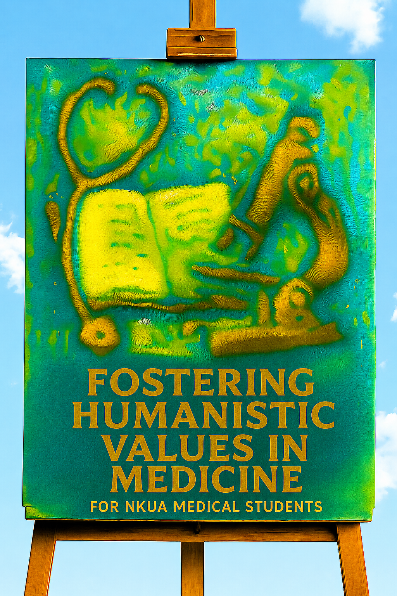

LOCATION:
BUILDING 10, 1st FLOOR EXERCISE HALL /
PATHOLOGY LECTURE HALL, BUILDING 10, BASEMENT

Τuesdays, Thursdays & Fridays: either 15.00-17.00 or 16.00-18.00

The course will be delivered according to the following schedule:
- November 24th , 15:00–17:00 (in-person)
- November 26th , 16:00–18:00 (online)
- November 27th , 16:00–18:00 (online)
- December 1st , 15:00–17:00 (in-person)
- December 3rd , 16:00–18:00 (online)
- December 4th , 16:00–18:00 (online)
- December 8th , 16:00–18:00 (online)
- December 10th , 15:00–17:00 (in-person)
- December 11th , 15:00–17:00 (in-person)
- December 15th , 15:00–17:00 (in-person)
- December 17th , 16:00–18:00 (online)
- December 18th, 16:00–18:00 (online)

TABLE OF CONTENTS OF PLANNED SESSIONS FOR THIS FALL SEMESTER

Lessons
- -Do You Feel Alive?  -A Friend, Through Their Example, Inspires in Us a Sense of Calling and Purpose | 
- Harnessing Our Inner Reserves of Strength: A Powerful Means of Restoring Health | 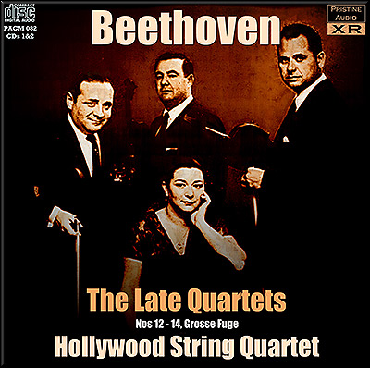
- - Literature on Film: James Joyce's Dubliners and the Society of Dublin in 1904 Become John Huston's Swan Song in The Dead (1987)  -The Harsh Face of Death: Hamlet's Conversation with Yorick's Skull and Ophelia's Burial in the First Scene of Act V of Shakespeare's Hamlet | 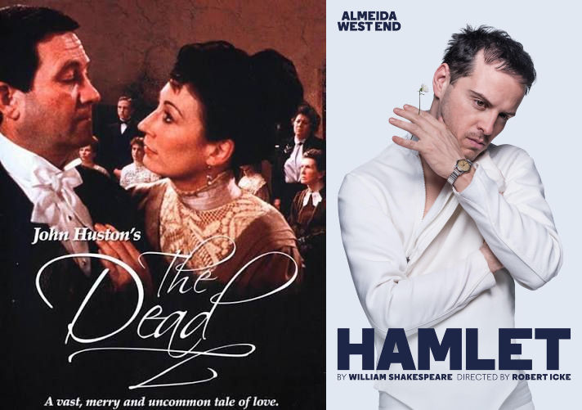
- When Science No Longer Inspires and Love, Numbed into Lifelessness, Is Replaced by the Silent Care of Nature: A Study of the Character of Dr. Astrov in Anton Chekhov's Uncle Vanya | 
- Love as the Foundation of the Soul's Evolution and Its Driving Force | 
- An Existential Journey with Venice as Both Departure Point and Destination | 
- The Only Antidote to Existential Loneliness Is Also a Decisive Step Toward Human Flourishing | 
- A Survival Guide with an Open Heart: The Role of Positive Emotions in Our Lives | 
- "There Are Two Lasting Bequests We Can Give Our Children: One Is Roots, the Other Is Wings." — Johann Wolfgang von Goethe | 
- We Lived Through All This, Yet We Never Really Noticed It": The Bittersweet Taste of Everyday Eternity in the Lived Moments of Our Little Lives | 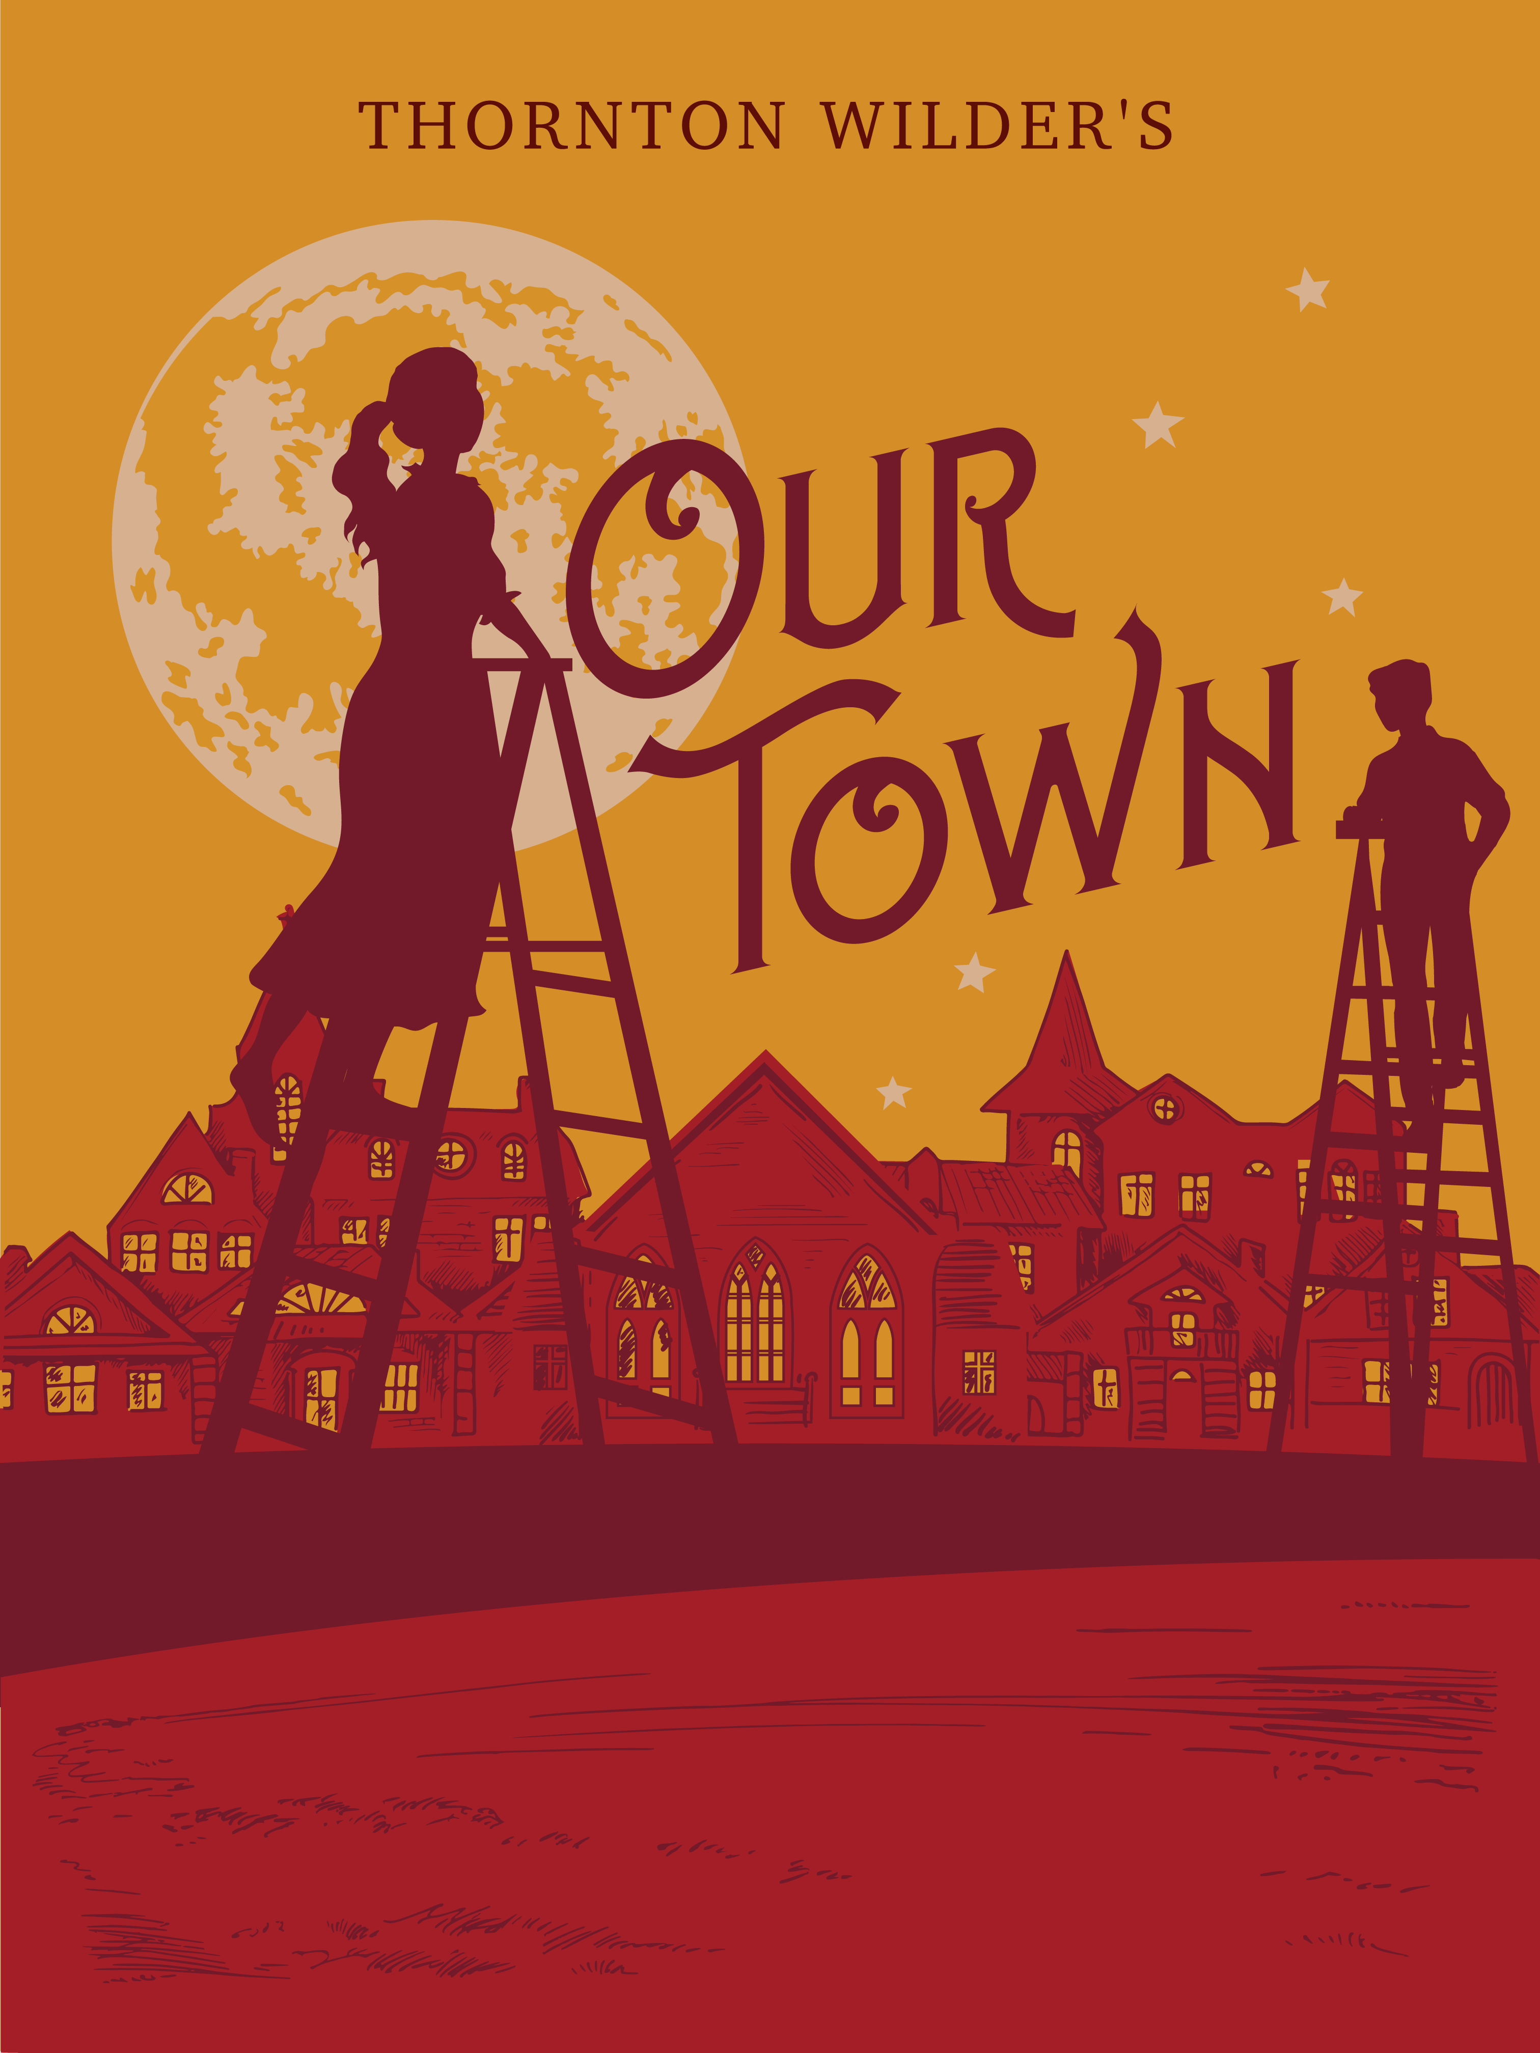
- Two clinicians discuss the doctor-patient approach with you on the occasion of neurosurgeon Henry Mars' book "Do No Harm: Stories of Life, Death, and Brain Surgery" | Using Henry Marsh's Do No Harm as a point of departure, this seminar explores authentic clinical cases and the complex decision-making processes encountered in neurosurgical practice. Rather than serving merely as a collection of medical case histories, Marsh's work offers a profound reflection on the limits of medical knowledge, the uncertainty inherent in clinical practice, and the ethical responsibilities that accompany every therapeutic intervention. The discussion addresses fundamental questions at the intersection of medicine, ethics, and the humanities:  - What does the Hippocratic principle of primum non nocere ("first, do no harm") signify in contemporary clinical practice?  - How do physicians confront the possibility of error and its ethical implications?  - Where do the boundaries lie between scientific knowledge, technical expertise, clinical judgment, and human compassion?  - How are illness, suffering, and hope experienced by patients, their families, and healthcare professionals alike?
- Painting Workshop | The workshop will explore the relationship between emotions and the arts, with the aim of examining creative expression as a means of understanding and processing emotions that arise through engagement with the humanistic values of healthcare. Through this interactive process, participants will have the opportunity to reflect on how artistic practices can foster empathy, enhance emotional awareness, and deepen understanding within medical practice. This experimental learning environment encourages the exploration of innovative connections between art and medicine, highlighting the role of creative expression in enriching the understanding of the human experience and supporting the development of compassionate healthcare professionals.

*It is planned to carry out some extracurricular activities within the framework of the course, which will be announced in due course.

Learn about our course through international literature:

- Giannari, M., Mariakaki, A., Lazari, E., Thymara, E., Kavantzas, N. G., Lazaris, A. C., & Thomopoulou, G. E. (2025). Cultivating harmony: addressing challenges and fostering positivity in the medical community. Discover Education, 4(1). https://doi.org/10.1007/s44217-025-00532-4
- Giannari, M., Botis, G. G., Lazari, E. C., Thymara, E., Kavantzas, N. G., & Lazaris, A. C. (2025). Restoring Empathy in Medical Education: The Measurable Impact of a Humanities-Based Course on Empathy. Journal of medical education and curricular development, 12, https://doi.org/10.1177/23821205251405320
- Argyrou, A.E., Lazari M.-N., Lazari E.C., et al. (2025). How can one benefit from a humanistic values medical course? UAI J Arts Humanit Soc Sci - ISSN: 3048-7692, Volume 2 Issue 10.
- Argyrou, A. E., Giannari, M., & Lazaris, A. C. (2026). Beyond external obligation: Rethinking the framework and spirit of medical education. Creative Education, 17(03), 509–522. https://doi.org/10.4236/ce.2026.173030
- Lazari, E. et al. (2023). Ethical Implications of Interactive and Experiential Medical Education. Research & Reviews: Journal of Medical and Health Sciences, 12, 1-2.

