24 ma, 24 μα, 06-06-2026, σαββατον 5-7μμ
Webex meeting recording: INM 2026-20260606 1603-1
Recording link: https://uoa.webex.com/uoa/ldr.php?RCID=1d3683ccdcd2ccf3e91d1f68da93edfb,
Password: nTFxjMc9
ΠΡΟΚΑΤΑΡΚΤΙΚΑ.
Επαναληψις από, «Fermat's Pseudo-equality Methods,»,

FUNDAMENTAL THEOREM OF CALCULUS, (FTC)
ΘΕΜΕΛΙΩΔΕΣ ΘΕΩΡΗΜΑ ΤΟΥ ΑΠΕΙΡΟΣΤΙΚΟΥ ΛΟΓΙΣΜΟΥ

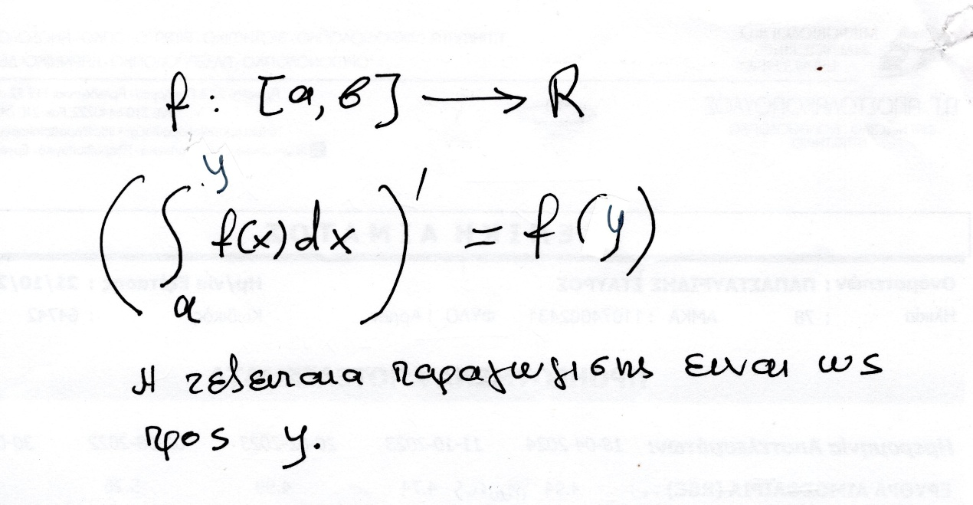
As πουμαι ότι η f είναι συνεχης, είναι θετικη,

NEWTONS PROOF, (ΚΕΝΤΡΙΚΗ ΙΔΕΑ του συγχρονου ορισμου),
ΑΠΟΔΕΙΞΗ ΤΟΥ ΝΕΥΤΩΝΑ: ΚΕΝΤΡΙΚΗ ΙΔΕΑ,
KATZ p. 554-556
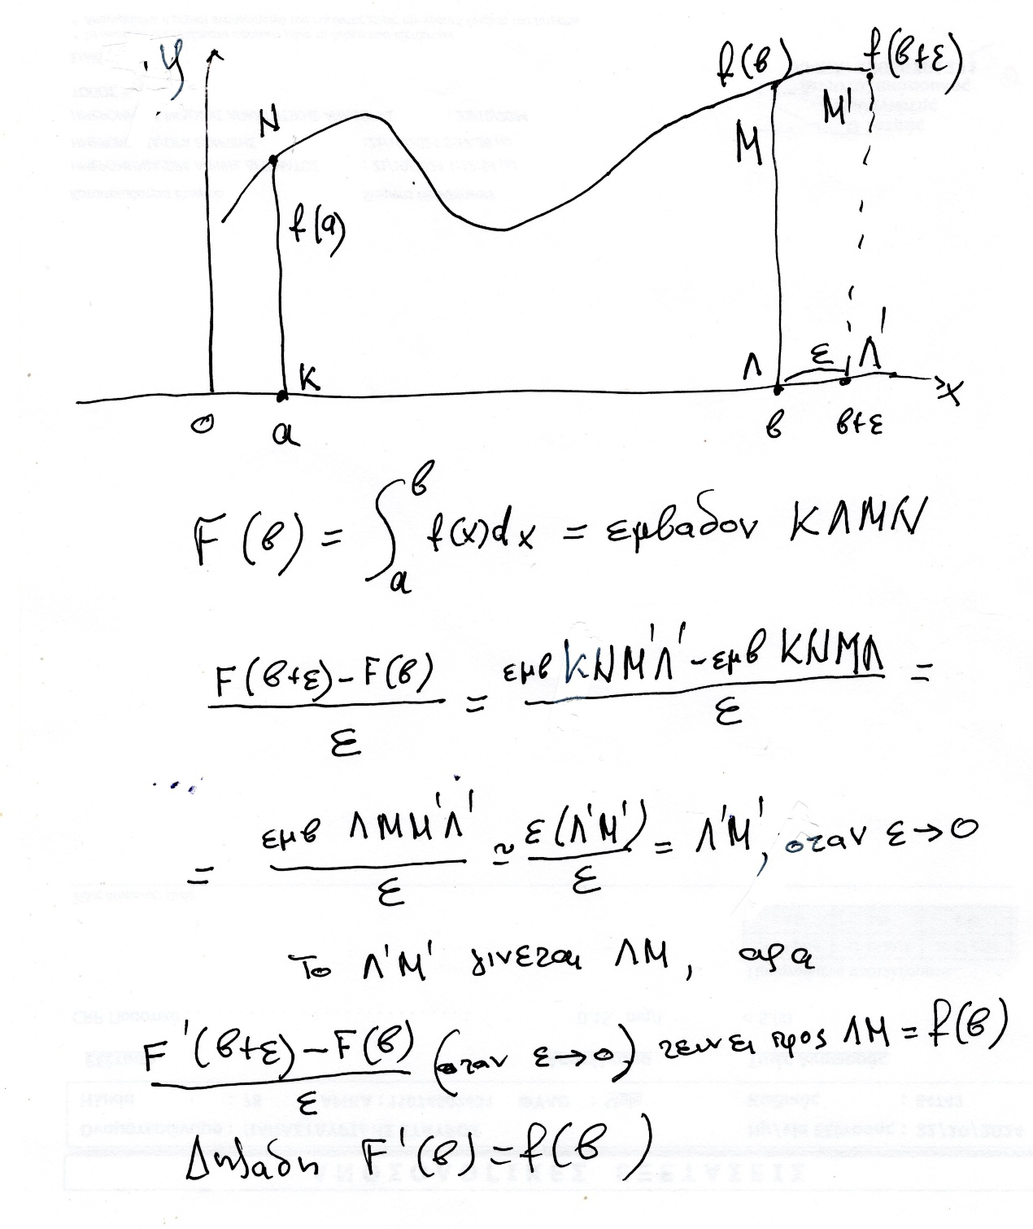

Είναι αυστηρο αυτό
Σημερα τι κανουμε ?
ΥΠΑΡΧΕΙ ΕΜΒΑΔΟΝ ?
ΕΡΩΤΗΜΑ, «γιατι δεν το σκεφτηκαν» ?
Πιο πανω ο FERMAT απεδειξεν ότι
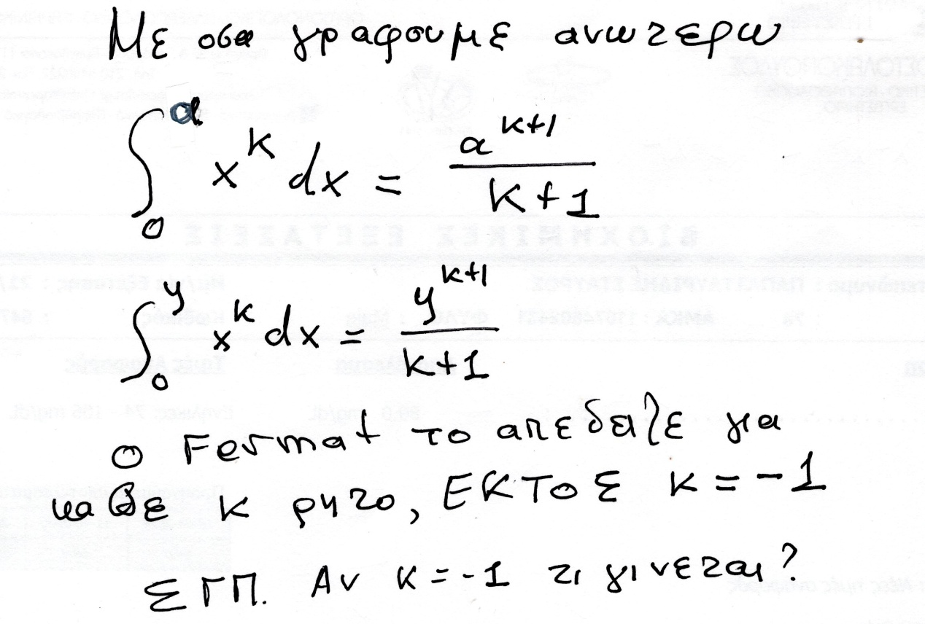
Προφανως ικανοποιειται το «η παραγωγος του ολοκληροματος είναι η αρχικη συναρτησις». Πως δεν το προσεξε κανεις ?

WHO DISCOVERED CALCULUS ?, ένα ασυνηθες φαινομενο,
ΠΟΙΟΣ ΑΝΕΚΑΛΥΨΕ ΤΟΝ ΑΠΕΙΡΟΣΤΙΚΟ ΛΟΓΙΣΜΟ ?

Οι παρακατω δημοσιευσαν αποδειξεις κ
ΒΛΕΠΕ ΚΑΤΖ σελ 534
Among the mathematicians who related the tangent problem to the area problem were Isaac Barrow (1630–1677) and James Gregory (1638–1675), both of whom decided to organize the material relating to tangents, areas, and rectification gathered in their travels through France, Italy, and the Netherlands and to present it systematically. Not surprisingly, then, the Lectiones geometricae (Geometrical Lectures) (1670) of Barrow and the Geometriae pars universalis (Universal Part of Geometry) (1668) of Gregory contained much of the same material presented in similar ways. In effect, both of these works were treatises on material today identified as calculus, but with presentations in the geometrical style each author had learned in his university study. Neither was able to translate the material into a method of computation useful for solving problems. Π.χ. Υπολογισμος ΕΜΒΑΔΩΝ και ΛΥΣΙΣ ΔΙΑΦΟΡΙΚΩΝ ΕΞΥΣΩΣΕΩΝ.
ΚΑΤΖ σελ 534-536, εκει βρισκονται οι αποδειξεις.
ISAAK BARROW, μια μικρη ιστορια,
https://mathshistory.st-andrews.ac.uk/Biographies/Barrow/,
… In 1669 Barrow resigned from the Lucasian Chair and did no further mathematical work. This allowed Newton to take over. Barrow was appointed as Royal Chaplain to Charles II at Salisbury in 1670, then, in February 1673, Charles II awarded Barrow the Mastership of Trinity declaring him to be the best scholar in England.
GREGORY, mia parathrhsis
Vera Circuli et Hyperbolae Quadratura,
WIKIPEDIA LEIBNIZ,
https://en.wikipedia.org/wiki/Gottfried_Wilhelm_Leibniz,
Calculus
Leibniz is credited, along with Sir Isaac Newton, with the discovery of calculus (differential and integral calculus). According to Leibniz's notebooks, a critical breakthrough occurred on 11 November 1675, when he employed integral calculus for the first time to find the area under the graph of a function y = f(x).[111] He introduced several notations used to this day, for instance the integral sign ∫, representing an elongated S, from the Latin word summa, and the d used for differentials, from the Latin word differentia. Leibniz did not publish anything about his calculus until 1684.[112] Leibniz expressed the inverse relation of integration and differentiation, later called the fundamental theorem of calculus, by means of a figure[113]

NEWTON,
https://en.wikipedia.org/wiki/Method_of_Fluxions,
Method of Fluxions (Latin: De Methodis Serierum et Fluxionum)[1] is a mathematical treatise by Sir Isaac Newton which served as the earliest written formulation of modern calculus. The book was completed in 1671 and posthumously published in 1736.
ΔΗΛΑΔΗ ο ΝΕΥΤΩΝ προηγηθηκε στην συλληψη, ο ΛΑΙΜΠΝΙΤΣ προηγηθηκε στην δημοσιευση

A few words about the priority controversy between Leibniz and Newton are in order here.41,
Se KATZ p. 574,
… A few words about the priority controversy between Leibniz and Newton are in order
here.41 It should be clear that although the two men discovered essentially the same rules and procedures that today are collectively called the calculus, their approaches to the subject were entirely different. Newton’s approach was through the ideas of velocity and distance while Leibniz’s was through those of differences and sums …
https://en.wikipedia.org/wiki/Method_of_Fluxions#cite_note-2,
Method of Fluxions
Sastry, S.Subramanya. "The Newton-Leibniz controversy over the invention of the calculus" (PDF). University of Wisconsin–Madison Computer Sciences User Pages.
https://pages.cs.wisc.edu/,
A. RUPERT HALL
Imperial College of Science and Technology
PHILOSOPHERS AT WAR
THE QUARREL BETWEEN NEWTON AND LEIBNIZ

Σημερα υπαρχει συμφωνια οτι ΝΕΥΤΩΝ προηγηθηκε στην συλληψη, ο ΛΑΙΜΠΝΙΤΣ προηγηθηκε στην δημοσιευση Επισης δουλεψαν ανεξαρτητως.

ΤΕΛΟΣ 2026,

