19 ΜΑ, 19 MA, 22-05-2026, παρασκευη 9-11 μμ,
Webex meeting recording: 19 ma 22-05-2026 INM 2026-20260522 2000-1
Recording link: https://uoa.webex.com/uoa/ldr.php?RCID=9a141322a8bccb4f1a505b1419c5c510,
Password: 4Phauewh
ΠΡΟΚΑΤΑΡΚΤΙΚΑ,
Δηλωσις συμμετοχης στις εξετασεισ

ΜΕΛΛΟΝΤΙΚΕΣ ΑΝΑΦΟΡΕΣ,
ΣΥΓΚΕΚΡΙΜΕΝΑ ΠΑΡΑΔΕΙΓΜΑΤΑ,
24.2.3 ΤΥΠΟΙ ΤΩΝ ΛΥΣΕΩΝ της x3 + px+q=0,
ΚΕΝΤΡΙΚΗ ΙΔΕΑ ΤΗΣ ΛΥΣΗΣ 3βαθμιας εξισωσησ
22 ΕΞΙΣΩΣΕΙΣ ΤΡΙΤΟΥ ΒΑΘΜΟΥ, 2024, 2025,
17.4 ΓΕΝΙΚΑ ΣΥΜΠΕΡΑΣΜΑΤΑ για τον ΔΥΤΙΚΟ ΠΟΛΙΤΙΣΜΟ,
SOME REMARKS ON ROME,
19.3 SCIENTIFIC REVOLUTION, ΕΠΙΣΤΗΜΟΝΙΚΗ ΕΠΑΝΑΣΤΑΣΗ, ΕΕ, (1500-1700),
[ΜΙΓΑΔΙΚΟΙ, [COMPLEX NUMBERS, ΝΑΙ 2025, 2024
ΝΕΑ ALGEBRA του 16ου αιωνα
28 ΝΕΑ ALGEBRA του 16ου αιωνα,
ΜΙΓΑΔΙΚΟΙ κλπ (κατά ΜΠΟΜΠΕΛΛΙ),
29 [ΑΝΑΛΥΤΙΚΗ ΓΕΩΜΕΤΡΙΑ, ANALYTIC GEOMETRY, 2024 #25

ΑΛΛΟΙ ΣΗΜΑΝΤΙΚΟΙ ΠΟΛΙΤΙΣΜΟΙ εν ΠΕΡΙΛΗΨΕΙ,

ΡΩΜΗ,

ΜΑΘΗΜΑΤΙΚΑ.
Δεν παρηγαγαν μαθηματικα πρωτης γραμμης,

VIRGIL, AINIAD, … “MEMENTO ROMANO”,

MEMENTO ROMANO,
http://classicalanthology.theclassicslibrary.com/2012/08/07/aeneid-6-847-853/.

Aeneid
https://en.wikipedia.org/wiki/Aeneid,
The Aeneid (/ɪˈniːɪd/ ih-NEE-id; Latin: Aenē̆is [ae̯ˈneːɪs] or [ˈae̯neɪs]) is a Latin epic poem that tells the legendary story of Aeneas, a Trojan who fled the fall of Troy and travelled to Italy, where he became the ancestor of the Romans. Written by the Roman poet Virgil between 29 and 19 BC, the Aeneid comprises 9,896 lines in dactylic hexameter.[1] The first six of the poem's twelve books tell the story of Aeneas' wanderings from Troy to Italy, and the poem's second half tells of the Trojans' ultimately victorious war upon the Latins, under whose name Aeneas and his Trojan followers are destined to be subsumed.

Aeneid 6.847-853 – Virgil’s vision of Roman greatness
https://classicalanthology.theclassicslibrary.com/2012/08/07/aeneid-6-847-853/,
Virgil’s vision of Roman greatness put into the mouth of Anchises, the dead father of Aeneas whom Aeneas travels to find in the Underworld in this book – the turning point of the poem.
Anchises points out the future heroes of Rome yet to be born, a long catalogue that is patriotic and visionary but also cautionary and sad. It culminates in this grand passage which, although outwardly (on the surface), imperialistic, also warns of the great responsibilities and dangers that go with power.
Jane Mason

Excudent alii spirantia mollius aera,
credo equidem, vivos ducent de marmore voltus,
orabunt causas melius, caelique meatus
describent radio, et surgentia sidera dicent: 850
tu regere imperio populos, Romane, memento;
hae tibi erunt artes; pacisque imponere morem,
parcere subiectis, et debellare superbos.”

Others will forge breathing bronzes more smoothly
(I believe it at any rate), and draw forth living features from marble.
They will plead law-suits better
and trace the movements Of the sky with a rod and describe the rising stars.
You, O Roman, govern the nations with your power- remember this!
These will be your arts – to impose the ways of peace,
To show mercy to the conquered and to subdue the proud.

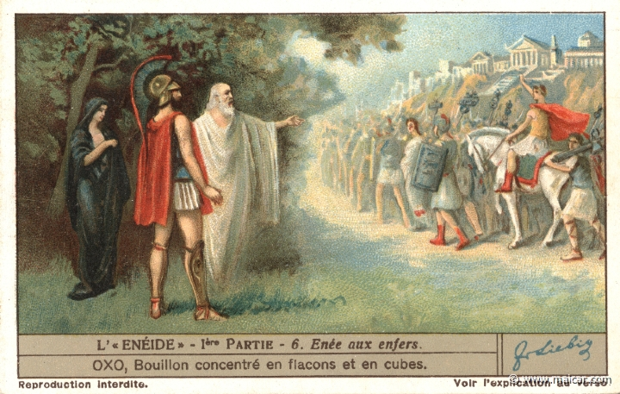
https://classicalanthology.theclassicslibrary.com/2012/08/07/aeneid-6-847-853/,
Picture from Carlos Parada, Greek Mythology Link, www.maicar.com – click here for more about Aeneas’ journey to the Underworld including an excellent map.
The above text is provided by the Perseus Digital Library and the translation is by Jane Mason.
Enfer=κολασις
Carlos Parada, Greek Mythology Link, 3τομο. Θεωρειται καλο,

ΣΥΝΕΙΣΦΟΡΑ στον ΔΥΤΙΚΟ ΠΟΛΙΤΙΣΜΟ,
ΔΙΟΙΚΗΣΙΣ ΜΕΓΑΛΗΣ ΚΛΙΜΑΚΟΣ. Από ΙΣΠΑΝΙΑ μεχρι ΜΕΣΟΠΟΤΑΜΙΑ.
ΝΟΜΟΙ. ΡΩΜΑΙΚΟ ΔΙΚΑΙΟ,
https://en.wikipedia.org/wiki/Roman_law,
Roman law is the legal system of ancient Rome, including the legal developments spanning over a thousand years of jurisprudence, from the Twelve Tables (c. 449 BC), to the Corpus Juris Civilis (AD 529) ordered by Eastern Roman emperor Justinian I. Roman law forms the basic framework for civil law, the most widely used legal system today, and the terms are sometimes used synonymously. The historical importance of Roman law is reflected by the continued use of Latin legal terminology in many legal systems influenced by it, including common law.
After the dissolution of the Western Roman Empire, the Roman law remained in effect in the Eastern Roman Empire. From the 7th century onward, the legal language in the East was Greek.
ΡΩΜΑΙΚΟ ΔΙΚΑΙΟ. Η βασις
Των νομων τις ΔΥΤΙΚΗ ΕΥΡΩΜΗΣ (πλην UNITED KINGDOM) σημερα !
1964, ΕΙΣΑΓΩΓΙΚΕΣ ΕΞΕΤΑΣΕΙΣ στην ΝΟΜΙΚΗ ΣΧΟΛΗ, λατινικα,

ΤΕΧΝΟΛΟΓΙΑ ΜΕΓΑΛΗΣ ΚΛΙΜΑΚΟΣ,

Pont du Gard, (Ο Γκαρντον ή Γκαρ (γαλλικά: Gardon ή Gard‎‎ ))
https://en.wikipedia.org/wiki/Pont_du_Gard,
The Pont du Gard is an ancient Roman aqueduct (υδραγωγειο, οδηγει το νερο), bridge built in the first century AD to carry water over 50 km (31 mi) to the Roman colony of Nemausus (Nîmes) (όχι Nice).[3] It crosses the river Gardon near the town of Vers-Pont-du-Gard in southern France. The Pont du Gard is one of the best preserved Roman aqueduct bridges. It was added to UNESCO's list of World Heritage sites in 1985 because of its exceptional preservation, historical importance, and architectural ingenuity.[4]…
…In one section, the winding route between the Pont du Gard and St Bonnet required an extraordinary degree of accuracy from the Roman engineers, who had to allow for a fall of only 7 millimetres (0.28 in) per 100 metres (330 ft) of the conduit.[10] …

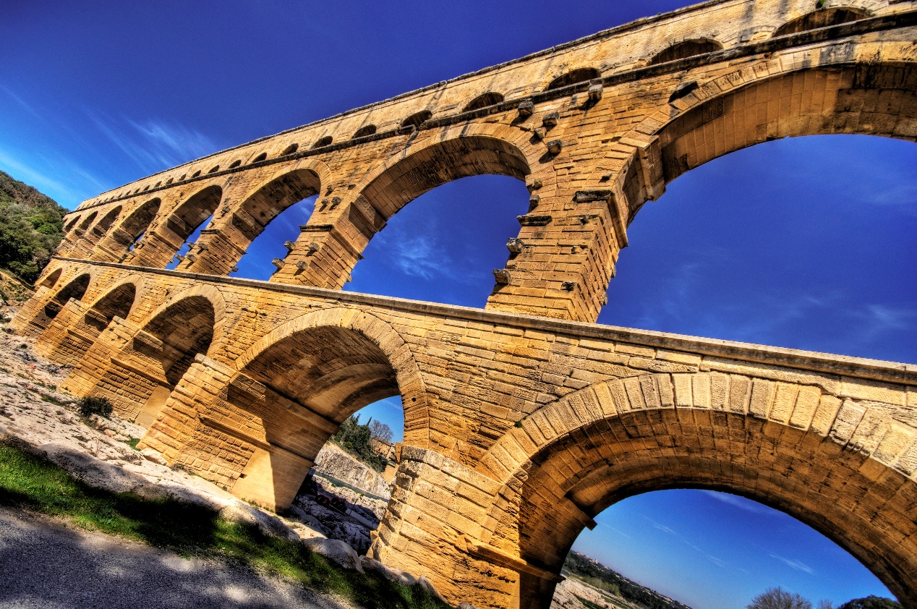
Pont du Gard's stone blocks, some of which weigh up to six tons, were precisely cut to fit together without the need for mortar (Κονιαμα).
GOOGLE AI, Pont du Gard, ποια η διαφορα υψομετρου μεταξυ των δυο ακρων ?
Εάν ενδιαφέρεστε για ολόκληρο το υδραγωγείο μήκους 50 χιλιομέτρων που τροφοδοτούσε την αρχαία πόλη της Νιμ (Nîmes), η συνολική υψομετρική διαφορά από την πηγή μέχρι τον τερματισμό ήταν μόνο 12 έως 17 μέτρα. Αυτό καταδεικνύει την απίστευτη ακρίβεια της ρωμαϊκής μηχανικής στη ροή του νερού με τη δύναμη της βαρύτητας. (

ΣΧΕΣΕΙΣ ΡΩΜΗΣ και ΕΛΛΑΔΟΣ,

The Punic Wars,
https://en.wikipedia.org/wiki/Punic_Wars,
The Punic Wars were a series of wars between 264 and 146 BC fought between the Roman Republic and Ancient Carthage. Three wars took place, on both land and sea, across the western Mediterranean region and involved a total of forty-three years of warfare.
Η ΠΑΓΙΔΑ ΤΟΥ ΘΟΥΚΙΔΥΔΗ
American political scientist Graham T. Allison

ΘΑΝΑΤΟΣ ΑΡΧΙΜΗΔΗ και ΑΠΟΛΛΩΝΙΟΥ,

Β ΚΑΡΧΗΔΟΝΙΑΚΟΣ ΠΟΛΕΜΟΣ, 218 π.Χ. έως το 202 π.Χ.,
ΘΑΝΑΤΟΣ ΑΡΧΙΜΗΔΗ, 212 πολιορκια συρακουσων,
Adrian Goldsworthy, The Punic Wars, 2000, Cassell Military Paperbacks, p. 266,
Anafores, 26 Livy 25. 27. 6–7, 28. 1–31. 11, Plutarch Marcellus 19–20.
Titus Livius (Latin: [ˈtɪtʊs ˈliːwiʊs]; 59 BC – AD 17),

The Battle of Magnesia took place in either December 190 or January 189 BC. I

Περι το 190 π.Χ. πεθαινει ο ΑΠΟΛΛΩΝΙΟΣ της ΠΕΡΓΑΜΟΥ,
ΣΧΟΛΙΟ ΣΓΠ. Τελος των ΜΕΓΑΛΩΝ ΕΛΛΗΝΩΝ ΜΑΘΗΜΑΤΙΚΩΝ, και αρχιζει η πολιτικη πτωσις των ελληνικων πολεων εωσ 31 π.Χ.

ΟΡΑΤΙΟΣ, ΚΙΚΕΡΩΝ,

Graecia capta ferum victorem cepit et artes intulit agresti Latio.
Horace, Epistles 2.1.156, in Horace : Satires, Epistles, and Ars Poetica (1929) edited and translated by H. R. Fairclough, p. 408
Μτφ. Greece, the captive, made her savage victor captive, and brought the arts into rustic Latium.

Quintus Horatius Flaccus (Classical Latin: [ˈkᶣiːn̪t̪ʊs̠ (h)ɔˈraːt̪iʊs̠ ˈfɫ̪akːʊs̠]; 8 December 65^{[1]} – 27 November 8 BC), known in the English-speaking world as Horace (/ˈhɒrɪs/), was the leading Roman lyric poet during the time of Augustus (also known as Octavian). The rhetorician Quintilian regarded his Odes as just about the only Latin lyrics worth reading: "He can be lofty sometimes, yet he is also full of charm and grace, versatile in his figures, and felicitously daring in his choice of words."^{[nb 1]}

Graeculi,

Νικήτας Δημήτριος,
https://www.lit.auth.gr/node/17,
Ο Δημήτριος Νικήτας είναι Ομότιμος Καθηγητής Λατινικής Φιλολογίας της Φιλοσοφικής Σχολής του Αριστοτελείου Πανεπιστημίου Θεσσαλονίκης.

https://pheidias.antibaro.gr/Hellas_names/graeculi-Nikitas.html,
Ο ελληνικός χαρακτηρισμός «Γραικύλος» είναι απόδοση του λατινικού χαρακτηρισμού Graeculus, ο οποίος με τη σειρά του είναι υποκοριστικό του εθνικού ονόματος Graecus που χρησιμοποιούσαν οι Ρωμαίοι για τους Ελληνες. Το λατινικό υποκοριστικό μαρτυρείται σε πενήντα περίπου χωρία λατίνων συγγραφέων, από τα χρόνια του Κικέρωνα μέχρι σχεδόν τον 4ο αιώνα μ.Χ. Το ελληνικό υποκοριστικό με εξαίρεση μια μαρτυρία του Δίωνος Κασσίου (46, 18, 1, βλ. παρακάτω), δεν εντοπίζεται στην αρχαία ελληνική και στη βυζαντινή γραμματεία ως τον 10ο αιώνα.

Αξίζει επίσης να σημειωθεί ότι το όνομα Graeculus είναι, μαζί με το όνομα Poenulus (= «Καρχηδονίσκος»), τα μόνα υποκοριστικά εθνικών χαρακτηρισμών που περιέχει η λατινική γλώσσα. Δεν είναι φυσικά τυχαίο το γεγονός ότι τα δύο αυτά υποκοριστικά αφορούν τους δύο μεγαλύτερους αντιπάλους της Ρώμης, τους οποίους υπέταξε η ρωμαϊκή λόγχη με πολύ μόχθο και αίμα.

Οπως ορθά σημειώνεται στο «βέβηλο» γράμμα που παραθέτει ο Μάριος Πλωρίτης στο «Βήμα» της Κυριακής, 7 Ιουνίου 1998, «"πατέρας" αυτού του επιθέτου (Graeculus) ήταν ο Κικέρων». Αυτό αληθεύει υπό την έννοια ότι ο διάσημος αυτός ρωμαίος πολιτικός και ρήτορας πρέπει να θωρηθεί πιθανότατα ο «ευρετής» αυτού του υποκοριστικού, το οποίο επανέρχεται στο έργο του επανειλημμένα (16 φορές!).

BYZANTION, (ΑΝΑΤΟΛΙΚΗ ΡΩΜΗ)
ΜΑΘΗΜΑΤΙΚΑ. Δεν παρηγαγαν μαθηματικα πρωτης γραμμης, (ενώ ειχαν τα βιβλια)
ΣΥΝΕΙΣΦΟΡΑ στον ΔΥΤΙΚΟ ΠΟΛΙΤΙΣΜΟ,
ΧΡΙΣΤΙΑΝΙΣΜΟΣ στην ΜΕΣΗ ΑΝΑΤΟΛΗ

ΑΡΑΒΕΣ, history of arabs, 8-13th century

History of the Arabs,
https://en.wikipedia.org/wiki/History_of_the_Arabs,

The recorded history of the Arabs begins in the mid-ninth century BC, which is the earliest known attestation of the Old Arabic language. Tradition holds that Arabs descend from Ishmael, the son of Abraham.[1] ((από την ΔΙΑΘΗΚΗ των ΕΒΡΑΙΩΝ).
The Syrian Desert is the home of the first attested "Arab" groups,[2][3] as well other Arab groups that spread in the land and existed for millennia.[4]
ΙΣΜΑΗΛ, μητερα ΑΓΑΡ,

Map of expansion of Caliphate.
https://en.wikipedia.org/wiki/History_of_the_Arabs#,
https://en.wikipedia.org/wiki/History_of_the_Arabs#/media/File:Map_of_expansion_of_Caliphate.svg,
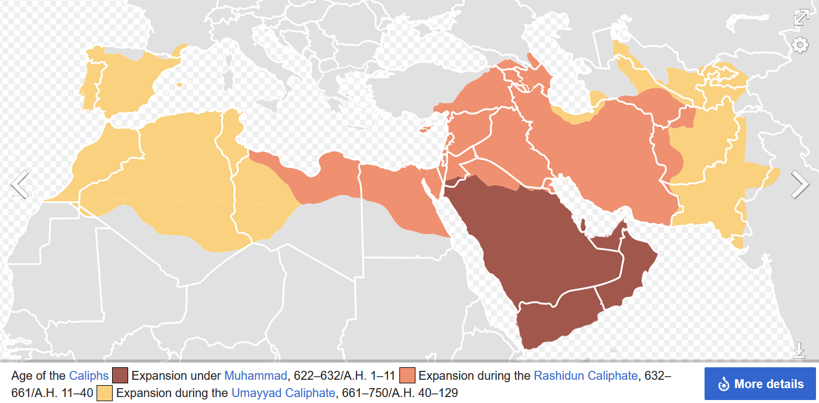

Islamic Golden Age, 8-13th century,
https://en.wikipedia.org/wiki/Islamic_Golden_Age,
The Islamic Golden Age was a period of scientific, economic and cultural flourishing in the history of Islam, traditionally dated from the 8th century to the 13th century.[1][2][3]
This period is traditionally understood to have begun during the reign of the Abbasid caliph Harun al-Rashid (786 to 809) with the inauguration of the House of Wisdom, which saw scholars from all over the Muslim world flock to Baghdad, the world's largest city by then, to translate the known world's classical knowledge into Arabic and Persian.[4] The period is traditionally said to have ended with the collapse of the Abbasid caliphate due to Mongol invasions and the Siege of Baghdad in 1258.[5]

Mathematical Words from Arabic
Katz p 269

dīxit (“he or she has said”), .
Cifra, digit , number , figure
CIPHER, code,

ARABIC ALGEBRA,

Katz p.271,
The most important contributions of the Islamic mathematicians lie in the area of algebra. They took the material already developed by the Babylonians, combined it with the classical Greek heritage of geometry, and produced a new algebra, which they proceeded to extend. By the end of the ninth century, the chief Greek mathematical classics were well known in the Islamic world. Islamic scholars studied them and wrote commentaries on them.
The most important idea they learned from their study of these Greek works was the notion of proof. (SGP and axioms, poy den akoloythhsan !), They absorbed the idea that one could not consider a mathematical problem solved unless one could demonstrate that the solution was valid. How does one demonstrate this, particularly for an algebra problem? The answer seemed clear. The only real proofs were geometric.
After all, it was geometry that was found in Greek texts, not algebra. Hence, Islamic scholars generally set themselves the tasks of justifying algebraic rules, either the ancient Babylonian ones or new ones they themselves discovered, and justifying them through geometry.

Muḥammad ibn Musa al-Khwarizmi (c. 780–850),
GOOGLE: Khwarizmi,

WIKIPEDIA Muḥammad ibn Mūsā
Muḥammad ibn Mūsā al-Khwārizmī[note 1] (Arabic: محمد بن موسى الخوارزمي; c. 780 – c. 850), or al-Khwarizmi η al Khwarizmi, (αλ Χουαριζμι), (κατά ΗΡΟΔΟΤΟΝ, ο ΧΟΡΑΣΜΙΟΣ η ΧΟΡΕΣΜΙΟΣ), was a polymath from Khwarazm, who produced vastly influential works in mathematics, astronomy, and geography. Around 820 CE, he was appointed as the astronomer and head of the library of the House of Wisdom in Baghdad.[6]: 14
GOGLE: Khwarizmi,
FULL NAME, Abu Abdallah Muḥammad ibn Mūsā al-Jwārizmī.
o ΜΩΑΜΕΘ, Ο πατερας του ΑΜΠΝΤΑΛΑΧ (Δουλου του ΘΕΟΥ), υιος του ΜΩΗΣΗ, από την ΧΟΡΑΣΜΙΑ (ο ΧΟΡΑΣΜΙΟΣ), .
SGP, ABU=father of,
e.g. Ahmed Hussein al-Sharaa[d] (born 29 October 1982) also known by his nom de guerre[e] Abu Mohammad al-Julani,
al JULANI,
SGP. Εντοπισμος με το FIND, Muqabala, The Condensed Book on the Calculation
Few details of al-Khwārizmī's life are known with certainty. Ibn al-Nadim gives his birthplace as Khwarazm, and he is generally thought to have come from this region.[26][27][28] Of Persian stock,[29][26][30][31][32] his name means 'the native of Khwarazm' (Chorasmia), a region that was part of Greater Iran,[33] and is now part of Turkmenistan, and Uzbekistan.[34]

Map of the Central Asian Republics
(Kazakhstan, Uzbekistan ...Map of the Central Asian Republics (Kazakhstan, Uzbekistan ...
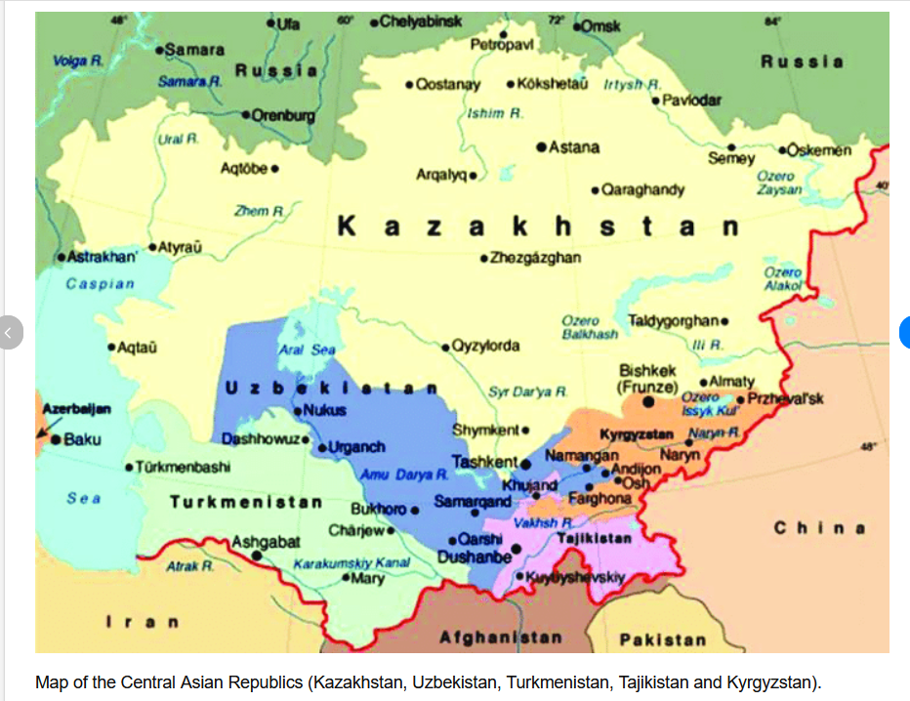
https://www.google.com/search?client=firefox-b-d&q=Turkmenistan%E2%80%93Uzbekistan++map#vhid=-_7uuRteYhptAM&vssid=l,
https://www.researchgate.net/figure/Map-of-the-Central-Asian-Republics-Kazakhstan-Uzbekistan-Turkmenistan-Tajikistan-and_fig1_341538060,

(Está en una estampilla conmemorativa de la Unión Sovietica, emitida el 6 de Septiembre del 1983. La estampilla dice su nombre y "1200 años", referente al aniversario aproximado de su nacimiento). Approximate birth 783.
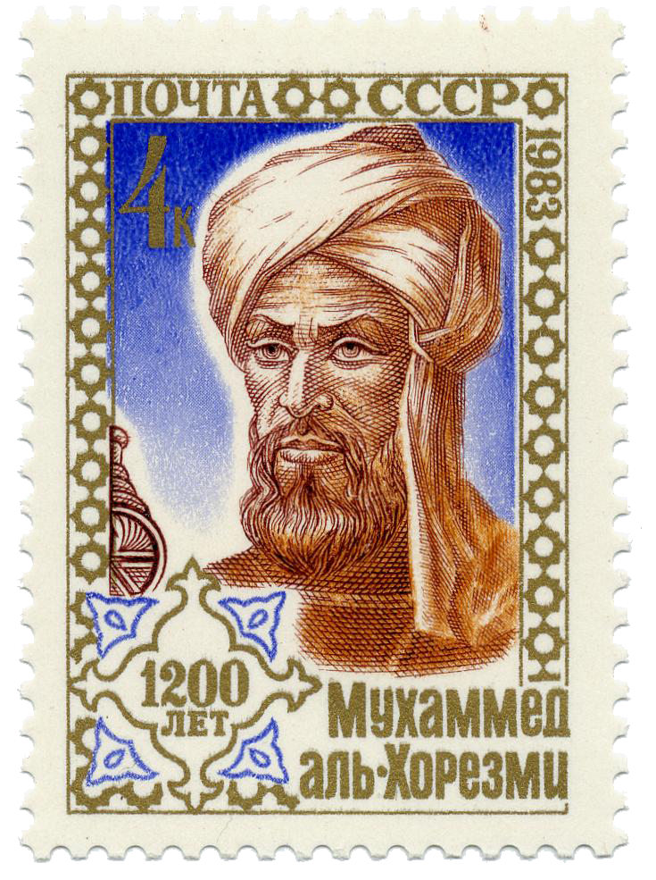
A Soviet postage stamp (issued 6 September 1983) commemorating al-Khwārizmī's (approximate) 1200th birthday.
https://en.wikipedia.org/wiki/Al-Khwarizmi,

ΒΙΒΛΙΑ του ΧΟΡΑΣΜΙΟΥ,
AI GOOGLE main books al-khwarizmi
Persian scholar Muhammad ibn Musa al-Khwarizmi authored foundational texts in mathematics, astronomy, and geography during the 9th-century Islamic Golden Age. His landmark works introduced algebra and the decimal system to the West, with his name giving root to the terms "algebra" and "algorithm".His three principal masterpieces shaped the trajectory of global science:
1. The Compendious Book on Calculation by Completion and Balancing
(Kitab al-Mukhtasar fi Hisab al-Jabr wal-Muqabala)Written around 820 AD, this is his most famous work and is considered the foundational text of algebra. It systematically presented algebra as an independent, organized discipline, providing a logical methodology for solving linear and quadratic equations.Impact: The word "algebra" is derived from al-jabr in its title. When translated into Latin in the 12th century, it introduced this mathematical science to Europe.
2. On the Calculation with Hindu Numerals,
(Kitab al-Jam'a wal-Tafreeq bil Hisab al-Hindi)Al-Khwarizmi played a crucial role in adopting and promoting the Hindu-Arabic numeral system. This text introduced the positional decimal system and the revolutionary concept of zero (from the Arabic sifr, ) to the Islamic world and Europe.Impact: The term "algorithm" originates from the Latin translation of his name (Algoritmi)

