18 ΜΑ, 18 MA, 17-05-2026, σαββατον, 5-7 μμ
Webex meeting recording: 18, 16-05-2026, INM 2026-20260516 1612-1
Recording link: https://uoa.webex.com/uoa/ldr.php?RCID=edc7af2897846ea356e17e66d2e902fd,
Password: cUGhPap3,

ΠΡΟΚΑΤΑΡΚΤΙΚΑ,
οργανωσισ

ΛΟΙΠΑ ΜΑΘΗΜΑΤΙΚΑ ΤΩΝ ΒΑΒΥΛΩΝΙΩΝ, (πλην αριθμων),

ΜΕΤΡΗΣΙΣ ΠΥΡΑΜΙΔΟΣ
GO KatzHistoryOfMathematics3rdS, p. 16, kai p. 17,

ΠΥΘΑΓΟΡΕΙΟ ΘΕΩΡΗΜΑ στην ΒΑΒΥΛΩΝΑ,

Μια «απλη ΑΠΟΔΕΙΞΗΣ» ? ΠΥΘΑΓΟΡΕΙΟΥ ΘΕΩΡΗΜΑΤΟΣ
https://en.wikipedia.org/wiki/Pythagorean_theorem#Pythagorean_proof,
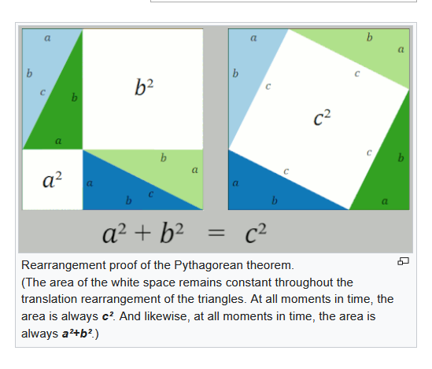

The Pythagorean proof (click to view animation)
The Pythagorean theorem was known long before Pythagoras (Πυθαγόρας; c. 570– c. 495BC), , but he may well have been the first to prove it ???.^{[2]} In any event, the proof attributed to him is very simple, (sgp. Δεν ξερουμε τι αποδειξη εδωσε ουτε ξερουμε ακριβως τι σημαινε με την λεξη «αποδειξη»), and is called a proof by rearrangement.
The two large squares shown in the figure each contain four identical triangles, and the only difference between the two large squares is that the triangles are arranged differently. Therefore, the white space within each of the two large squares must have equal area. Equating the area of the white space yields the Pythagorean theorem, Q.E.D.^{[9]}
That Pythagoras originated this very simple proof is sometimes inferred from the writings of the later Greek philosopher and mathematician Proclus (Proclus Lycius (/ˈprɒkləs laɪˈsiːəs/; 8 February 412 – 17 April 485, c. 5th century), called Proclus the Successor (Ancient Greek: Πρόκλος ὁ Διάδοχος, Próklos ho Diádokhos), was a Greek Neoplatonist philosopher, one of the last major classical philosophers of late antiquity.).^{[10]} Several other proofs of this theorem are described below, but this is known as the Pythagorean one.

Pythagorean Theorem
2021
GOTO KATZ p. 19,
One of the Babylonian square root problems was connected to the relation between the side of a square and its diagonal. That relation is a special case of the result known as the Pythagorean Theorem: In any right triangle, the sum of the areas of the squares on the legs equals the area of the square on the hypotenuse.
This theorem, named after the sixth-century bce Greek philosopher-mathematician, is arguably the most important elementary theorem in mathematics, since its consequences and generalizations have wide-ranging application. Nevertheless, it is one of the earliest theorems known to ancient civilizations. In fact, there is evidence that it was known at least 1000 years before Pythagoras (c. 570-c 495).
Pythagoras: Everyone knows his famous theorem, but not who discovered it 1000 years before him,
https://link.springer.com/article/10.1057/jt.2009.16,
go H:\B\#1oBackUp\Metaf\INM\BibliogrINM\#OnomastGreeksAncient\Pythagoras,

Pythagoras's theorem in Babylonian mathematics
Article by: J J O'Connor and E F Robertson
http://www-history.mcs.st-and.ac.uk/HistTopics/Babylonian_Pythagoras.html,

In this article we examine four Babylonian tablets which all have some connection with Pythagoras's theorem. Certainly the Babylonians were familiar with Pythagoras's theorem. A translation of a Babylonian tablet which is preserved in the British museum goes as follows:-
4 is the length and 5 the diagonal. What is the breadth (ευρος)?
Its size is not known.
4 times 4 is 16.
5 times 5 is 25.
You take 16 from 25 and there remains 9.
What times what shall I take in order to get 9 ?
3 times 3 is 9.
3 is the breadth.
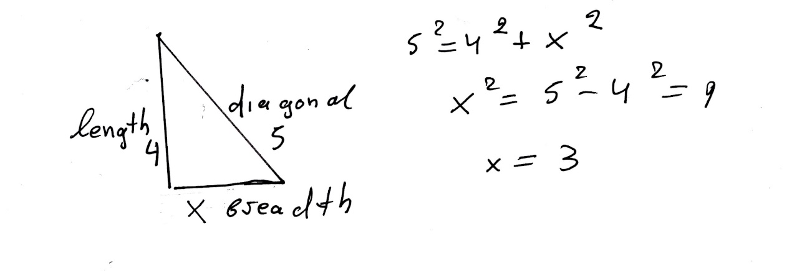
All the tablets we wish to consider in detail come from roughly the same period, namely that of the Old Babylonian Empire which flourished in Mesopotamia between 1900 BC and 1600 BC.

USE of PYTHAGOREAN THEOREM,
In OLD BABYLON,
GOTO KATZ, p. 22,
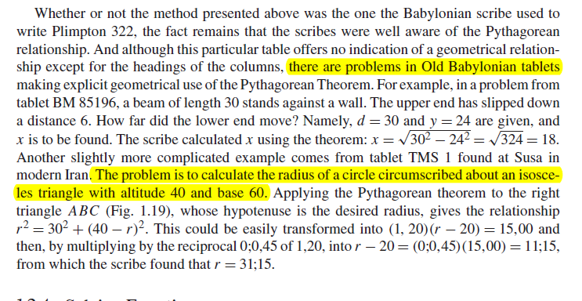

Kata p.22
Ραβδος μηκους 30, στηριζεται επι τοιχου. Το κατω ακρο γλιστραει επι του πατωματος κατά χ, οποτε το ανω ακρο εχει κατελθει κατά 6. Να βρεθει το χ.
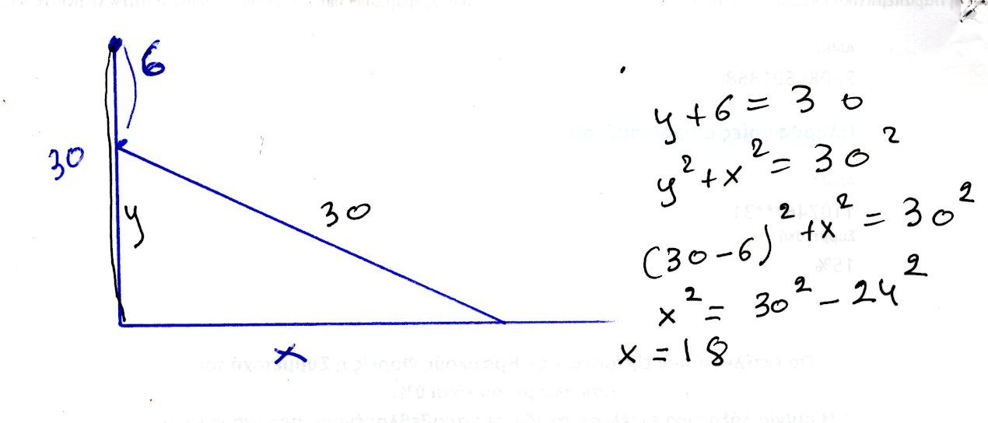

Katz p.22
Να βρεθει η ακτινα του περιγεγραμμενου κυκλου ισοσκελους τριγωνου βασης 60 και υψους 40.
KATZ p. 22
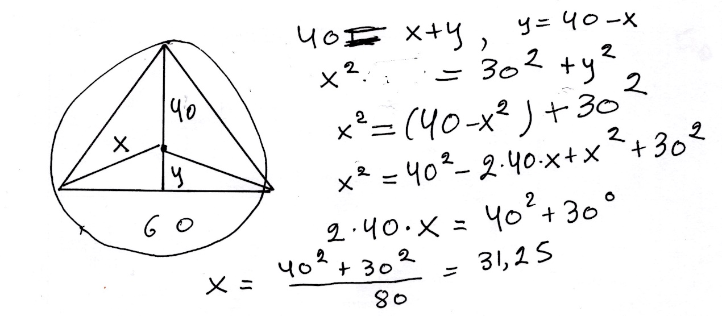

BABYLONIAN CUT and PASTE,

x+y=b, xy=c
GO KATZ p. 23 and 24,
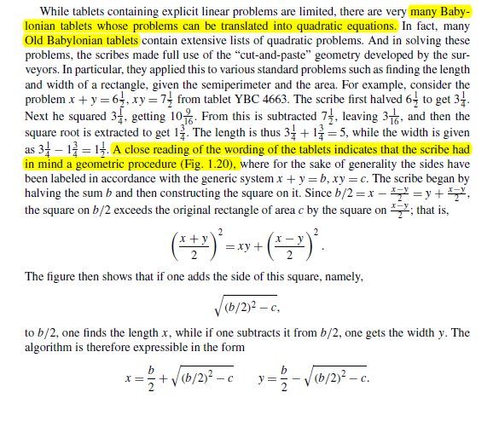

Kata go p. 24,
Σκοπος να αποδειχθη ότι αν x>y
((x+y)/2)² =xy+ ((x-y)/2))²
Πιθανη ιδεα των Βαβυλωνιων ένα γεωμετρικο σχημα.
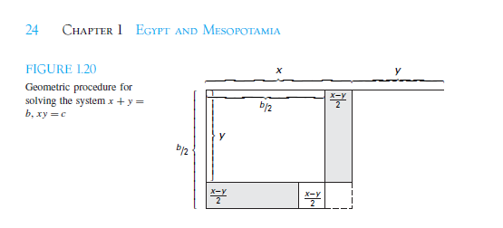

Γο KATZ p.23
Η παραπανω περιγραφη, αντιστοιχει στην σειρα ενεργειων για την εκτελεση των πραξεων, β, β/2, (β/2)²
(β/2)² –c, ( (β/2)² –c)^{1/2} . (μεθοδος ευρεσης τετραγωνικης ριζας)
ΤΟ ΜΗΚΟΣ είναι , β/2 + ( (β/2)² –c)^{1/2}
ΤΟ ΠΛΑΤΟΣ είναι β/2 - ( (β/2)² –c)^{1/2}

Κατωτερω αναλυουμε «καπως καλλιτερα», την αποδειξη του
((x+y)/2)² =xy+ ((x-y)/2))²

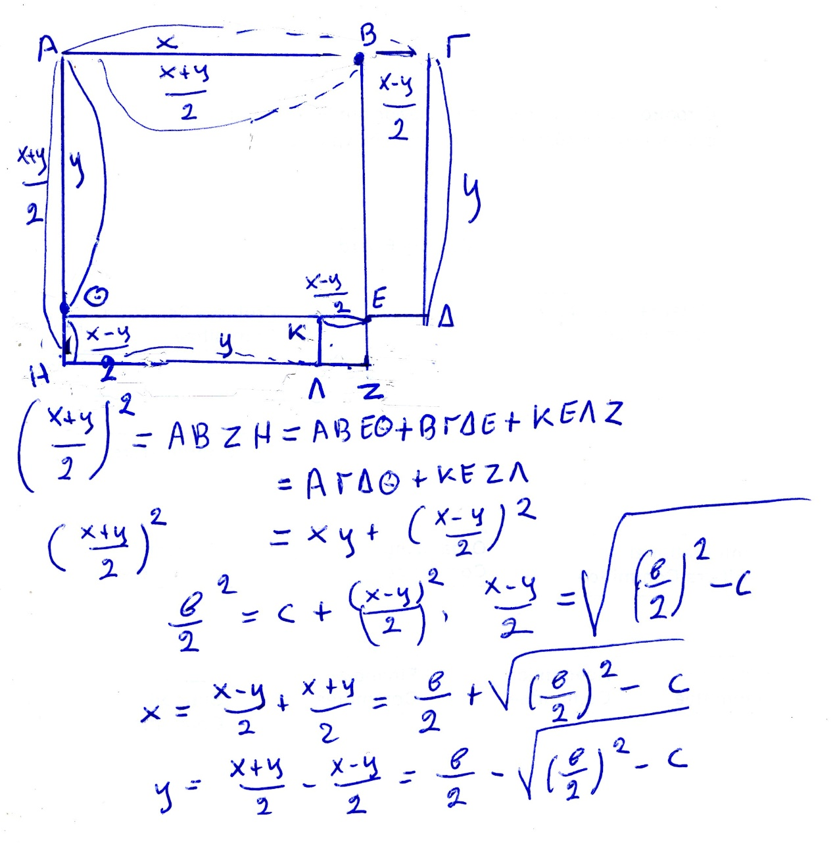

Oxi 2026, ΕΞΙΣΩΣΗΣ x² +bx=c,
KATZ p.24, 25
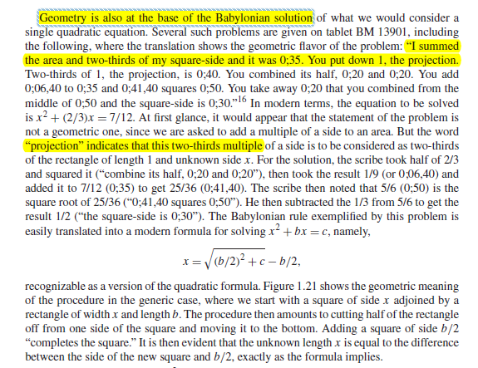
Ας δουμαι πως τα παραπανω εξηγουνται γεωμετρικα.
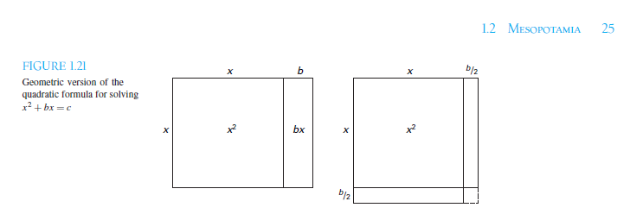

ΕΞΙΣΩΣΗ x² +bx=c,
Τα κατωτερω είναι καπως πιο απλοποιητικα.
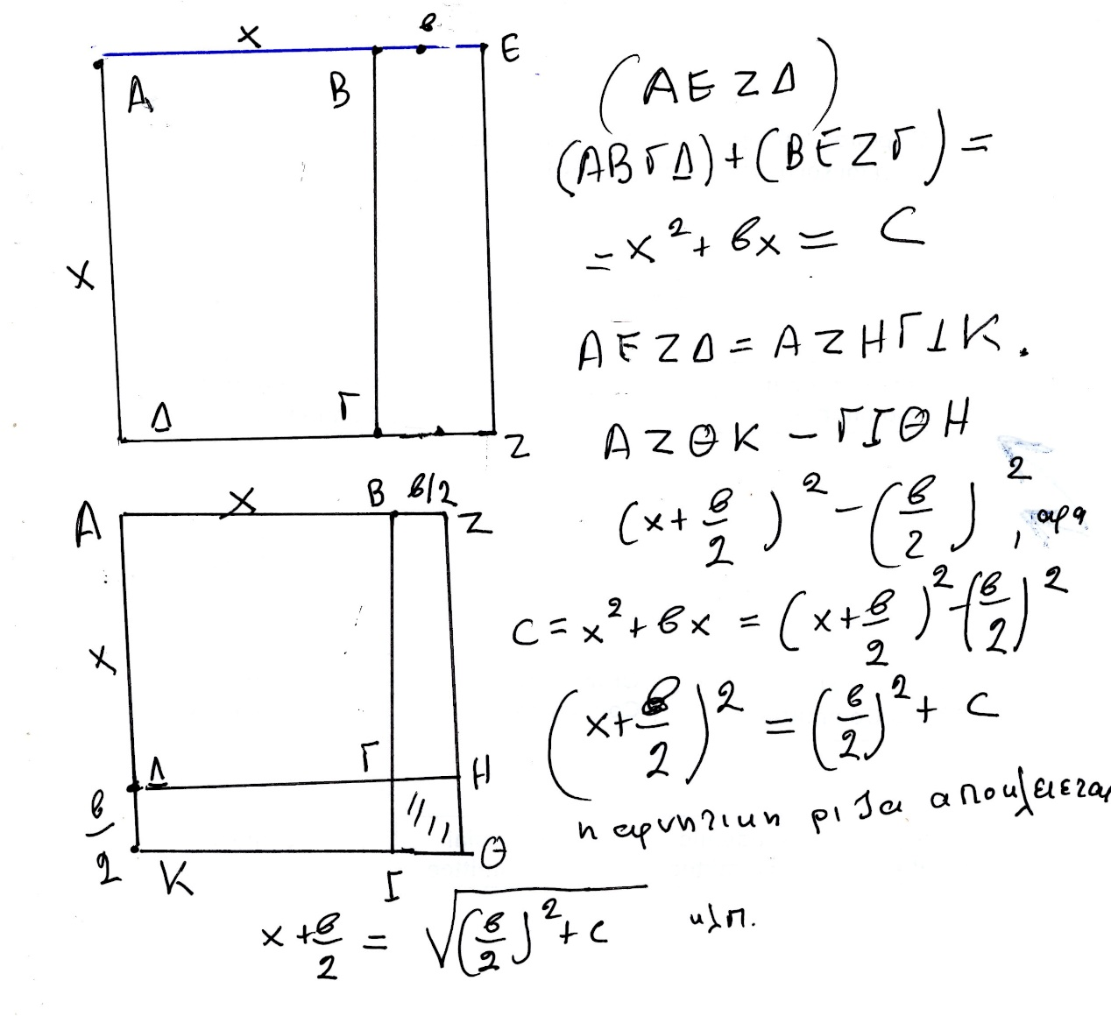

Oxi 2026, x² –bx=c
katz p. 25
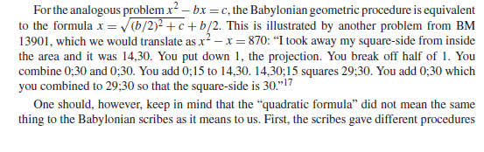
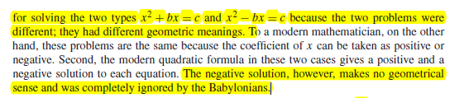

Κατωτερω δινουμε μια αποδειξη, με γεωμετρικο τροπο, CUT-PASTE, basizomenh στην γνωση των εμβαδων ορθογωνιων παραλληλογραμμων. Φαινεται ότι καπως ετσι τα εκαναν και οι ΒΑΒΥΛΩΝΙΟΙ.

ΕΞΙΣΩΣΗ, x² –bx=c
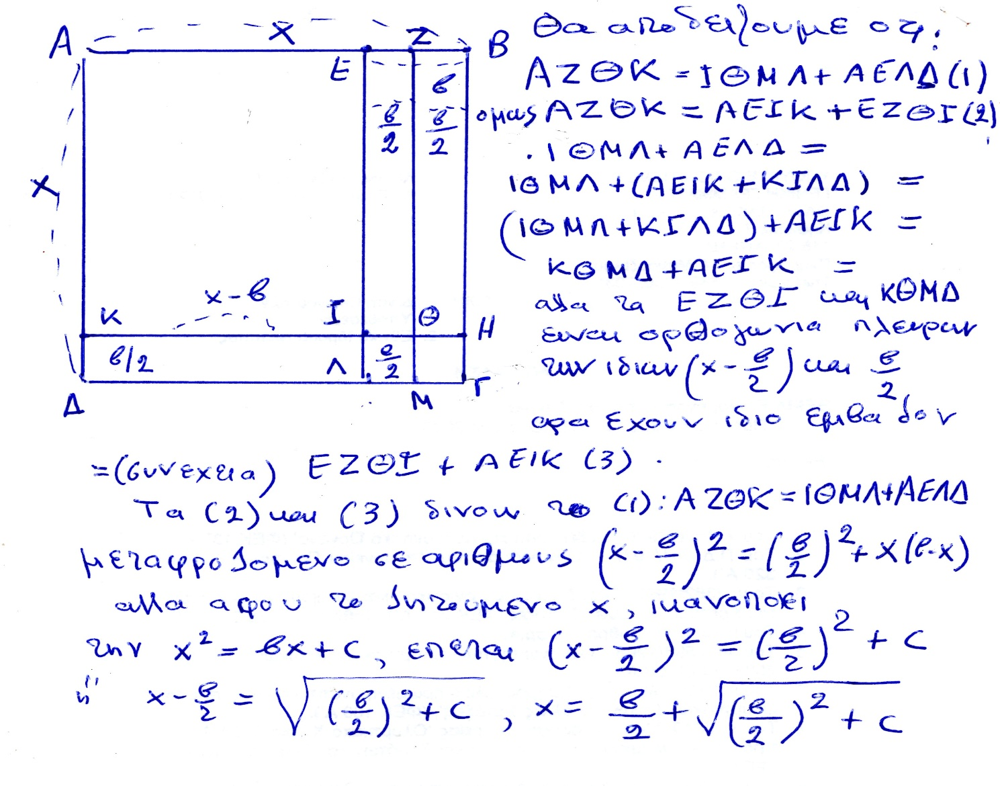

Oxi 2026, SCALING,
Katz p.25

Oxi 2026, x² –y² = (x+y).(x-y),
Να αποδειχθει γεωμετρικα, katz p.26,

CONCLUSION for BABYLONIAN MATHEMATICS,

GO KATZ p. 27, είναι μια αποψη ενδιαφερουσα,
The extant papyri and tablets containing Egyptian and Babylonian mathematics were generally teaching documents, used to transmit knowledge from one scribe to another. Their function was to provide trainee scribes with a set of example-types, problems whose solutions could be applied in other situations. Learning mathematics for these trainees was learning how to select and perhaps modify an appropriate algorithm, and then mastering the arithmetic techniques necessary to carry out the algorithm to solve a new problem. The reasoning behind the algorithms was evidently transmitted orally, so that mathematicians today are forced to speculate as to the origins. We note that although the long lists of quadratic problems on some of the Babylonian tablets were given as “real-world” problems, the problems are in fact just as contrived as the ones found in most current algebra texts. That the authors knew they were contrived is shown by the fact that, typically, all problems of a given set have the same answer. But since often the problems grew in complexity, it appears that the tablets were used to develop techniques of solution. One can speculate, therefore, that the study of mathematical problem solving, especially problems involving quadratic equations, was a method for training the minds of future leaders of the country. In otherwords, it was not really that important to solve quadratic equations—there were few real situations that required them. What was important was for the students to develop skills in solving problems in general, skills that could be used in dealing with the everyday problems that a nation’s leaders need to solve. These skills included not only following well-established procedures—algorithms—but also knowing how and when to modify the methods and how to reduce more complicated problems to ones already solved. Today’s students are often told that mathematics is studied to “train the mind.” It seems that teachers have been telling their students the same thing for the past 4000 years.

ΜΑΘΗΜΑΤΙΚΑ που ΓΝΩΡΙΖΑΝ οι ΒΑΒΥΛΩΝΙΟΙ,

Τα μαθηματικα ξεκινησαν για εφαρμογες
Για τα πιο προχωρημανα (πχ. Εξισωσεις β βαθμου, μαλλον χργσςιμοποιουντα για την παιδεια στελεχων της διοικησης.
ΑΡΙΘΜΗΤΙΚΟ ΣΥΣΤΗΜΑ ΘΕΣΕΩΣ
ΠΥΘΑΓΟΡΕΙΟ ΘΕΩΡΗΜΑ,
ΕΞΙΣΩΣΕΙΣ Β ΒΑΘΜΟΥ
Square Roots and the Pythagorean Theorem KATZ p. 17,
e.g. 2^{1/2} ,
SGP. TA της ΜΕΣΟΠΟΤΑΜΙΑΣ, MAΘHMATIKA eginan kyrios gia efarmoges. Piθanh εξαιρεση η εξισωση β βαθμου.
ΕΛΛΕΙΨΗ «ΑΛΓΕΒΡΑΣ»

ΑΙΓΥΠΤΟΣ,

ΓΕΝΙΚΟΤΗΤΕΣ

Hecataeus and Herodotus on "A Gift of the River"
Author(s): J. Gwyn Griffiths
Source: Journal of Near Eastern Studies, Vol. 25, No. 1 (Jan., 1966), pp. 57-61
Published by: University of Chicago Press
Stable URL: http://www.jstor.org/stable/543141
Accessed: 27-11-2015 08:57 UTC HECATAEUS AND HERODOTUS ON "A GIFT OF THE RIVER"1
IT may be questioned whether a geography lesson on Egypt is ever given anywhere without including the statement that "Egypt is the gift of the Nile." The earliest recorded verbal form of this statement appears in Herodotus, 2. 5:

HERODOTUS, WITH AN ENGLISH TRANSLATION BY
A. GODLKY, HON. FELLOW OF MAGDALEN COLLEGE, OXFORD
IN FOUR VOLUMES
Vol1, BOOKS I AKP II,
p. 279-282,
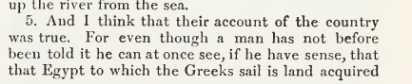
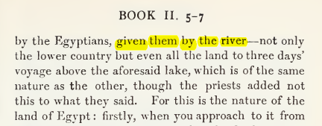

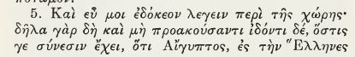
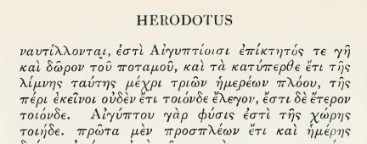

ΣΓΠ. O ΗΡΟΔΟΤΟΣ βλεπει την ΑΙΓΥΠΤΟ με σεβασμο, αλλα την θεωρει κουρασμενο πολιτισμο.

Map of ancient Egypt, showing major cities and sites of the Dynastic period (c. 3150 BC to 30 BC)
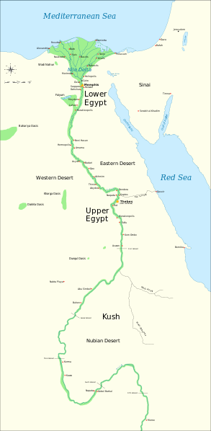
https://en.wikipedia.org/wiki/File:Ancient_Egypt_map-en.svg,
https://en.wikipedia.org/wiki/Cradle_of_civilization#/media/File:Ancient_Egypt_map-en.svg,

Όχι 2026, GOTO Katz, Victor J. A history of mathematics 3rd ed. p. 2
Agriculture emerged in the Nile Valley in Egypt close to 7000 years ago,
but the first dynasty to rule both Upper Egypt (the river valley) and Lower Egypt (the delta) dates from about 3100 bce (c 3000). The legacy of the first pharaohs included an elite of officials and priests, a luxurious court, and for the kings themselves, a role as intermediary between mortals and gods. This role fostered the development of Egypt’s monumental architecture, including the pyramids, built as royal tombs, and the great temples at Luxor and Karnak. Writing began in Egypt at about this time, and much of the earliest writing concerned accounting, primarily of various types of goods. There were several different systems of measuring, depending on the particular goods being measured. But since there were only a limited number of signs, the same signs meant different things in connection with different measuring systems. From the beginning of Egyptian writing, there were two styles, the hieroglyphic writing for monumental inscriptions and the hieratic, or cursive, writing, done with a brush and ink on papyrus.
(REMARK. First coined 1726, from French hiéroglyphique, from Latin hieroglyphicus, from Ancient Greek ἱερογλυφικός (hierogluphikós), from ἱερογλυφέω (hierogluphéō, “to represent hieroglyphically”), from ἱερός (hierós, “sacred, holy”) + γλύφω (glúphō, “to carve (κοβω), to engrave (χαραζω) , to cut out”). By surface analysis, hiero- +‎ glyphic.

Greek domination of Egypt in the centuries surrounding the beginning of our era was responsible for the disappearance of both of these native Egyptian writing forms. Fortunately, Jean Champollion (1790–1832) was able to begin the process of understanding Egyptian writing early in the nineteenth century through the help of a multilingual inscription—the Rosetta stone—in hieroglyphics and Greek as well as the later demotic writing, a form of the hieratic writing of the papyri (Fig. 1.1).
It was the scribes who fostered the development of the mathematical techniques. These government officials were crucial to ensuring the collection and distribution of goods, thus helping to provide the material basis for the pharaohs’ rule (Fig. 1.2).
Thus, evidence for the techniques comes from the education and daily work of the scribes, particularly as related in two papyri containing collections of mathematical problems with their solutions, the Rhind Mathematical Papyrus, named for the Scotsman A. H. Rhind (1833–1863) who purchased it at Luxor in 1858,
(Rhind Mathematical Papyrus. The British Museum, where the majority of the papyrus is now kept, acquired it in 1865 along with the Egyptian Mathematical Leather Roll, also owned by Henry Rhind.[2])
and the Moscow Mathematical Papyrus, purchased in 1893 by V. S. Golenishchev (d. 1947) who later sold it to the Moscow Museum of Fine Arts.
The former papyrus (RHIND) was copied about 1650 bce by the scribe A’h-mose from an original about 200 years older and is approximately 18 feet long and 13 inches high.

The latter papyrus (MOSCOW) dates from roughly the same period and is over 15 feet long, but only some 3 inches high. Unfortunately, although a good many papyri have survived the ages due to the generally dry Egyptian climate, it is the case that papyrus is very fragile. Thus, besides the two papyri mentioned, only a few short fragments of other original Egyptian mathematical papyri are still extant. These two mathematical texts inform us first of all about the types of problems that needed to be solved. The majority of problems were concerned with topics involving the administration of the state. That scribes were occupied with such tasks is shown by illustrations found on the walls of private tombs. Very often, in tombs of high officials, scribes are depicted working together, probably in accounting for cattle or produce. Similarly, there exist three dimensional models representing such scenes as the filling of granaries, and these scenes always include a scribe to record quantities. Thus, it is clear that Egyptian mathematics was developed and practiced in this practical context. One other area in which mathematics played an important rolewas architecture. Numerous remains of buildings demonstrate that mathematical techniques were used both in their design and construction. Unfortunately, there are few detailed accounts of exactly how the mathematics was used in building, so we can only speculate about many of the details. We deal with a few of these ideas below.

Όχι 2026 ΙΕΡΟΓΛΥΦΙΚΟ ΑΡΙΘΜΗΤΙΚΟ ΣΥΣΤΗΜΑ,
Katz p.3,
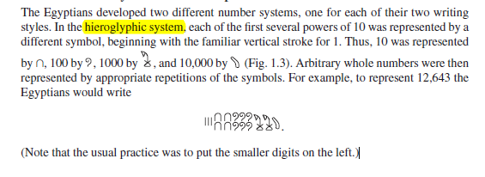

ΠΡΟΣΘΕΣΙΣ ΙΕΡΟΓΛΥΦΙΚΩΝ,
Katz p. 3,
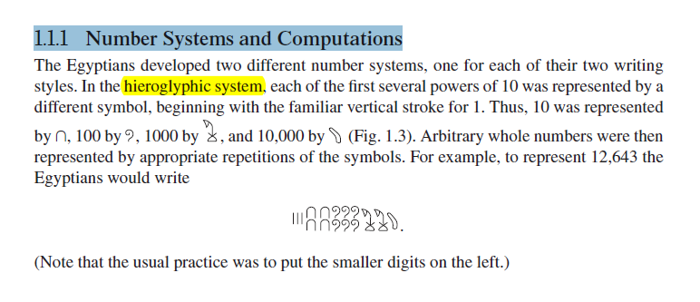
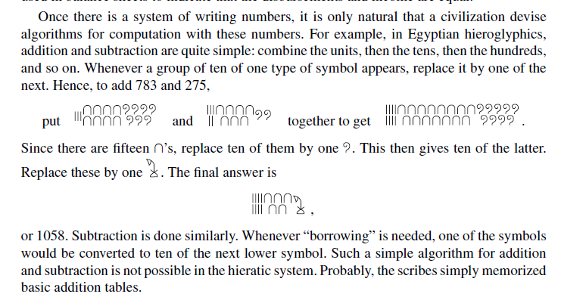

ΛΟΙΠΑ ΜΑΘΗΜΑΤΙΚΑ ΤΩΝ ΑΙΓΥΠΤΙΩΝ,
Μετρησις ογκου ΠΥΡΑΜΙΔΟΣ
ΠΥΘΑΓΟΡΕΙΟ ΘΕΩΡΗΜΑ, μαλλον

ΣΧΕΣΗΣ ΕΛΛΗΝΙΚΩΝ ΚΑΙ ΑΙΓΥΠΤΙΑΚΩΝ ΜΑΘΗΜΑΤΙΚΩΝ,

COOKE ROGER. The history of mathematics : a brief course, 3rd edition. Wiley 2013, Herodotus
7.2. GEOMETRY
The most fascinating aspect of Egyptian mathematics is the application of these computational techniques to geometry. In Section 109 of Book 2 of his History, the Greek historian Herodotus writes that King Sesostris (1971 – 1926 π.Χ.)1 dug a multitude of canals to carry water to the arid parts of Egypt. He (δηλ. ο ΗΡΟΔΟΤΟΣ) goes on to connect this Egyptian engineering with Greek geometry:
SGP. “brackish (brackish /ˈbrakɪʃ/ adjective: brackish,
(of water) slightly salty, water from wells.)

109. For this cause Egypt was intersected. This king moreover (so they said) divided the country among all the Egyptians by giving each an equal square parcel of land, and made this his source of revenue, appointing the payment of a yearly tax.
And any man who was robbed by the river of a part of his land would come to Sesostris and declare what had befallen him ; then the king would send
men to look into it and measure the space by which the land was diminished, so that thereafter it should pay in proportion to the tax originally imposed. From this, to my thinking, the Greeks learnt the art of measuring land ; the sunclock and the sundial, and the twelve divisions of the day, came to Hellas not from Egypt but from Babylonia.”
Sunclock
Sunclock
https://sunclock.ch,
Astronomical clock for sunrise, sunset, moon, temporal hours and daily and yearly rhythms.
SUNDIAL (ηλιακό ωρολόγιο), Wikipedia,
an instrument showing the time by the shadow of a pointer cast by the sun on to a plate marked with the hours of the day.
https://en.wikipedia.org/wiki/File:Melbourne_sundial_at_Flagstaff_Gardens.JPG,
Melbourne_sundial_at_Flagstaff_Gardens.JPG.

ARISTOTLE,

ARISTOTLE, KATZ p. 35
Fortunately for us, most of the early Greek mathematics we will discuss involves little calculation (!, τι θαπει αυτά ??.) As Aristotle wrote in his Metaphysics, At first, he who invented any art whatever that went beyond the common perceptions of man was naturally admired by men, not only because there was something useful in the inventions, but because he was thought wise and superior to the rest. But as more arts were invented, and some were directed to the necessities of life, others to recreation, the inventors of the latter were naturally always regarded as wiser than the inventors of the former, because their branches of knowledge did not aim at utility. Hence when all such inventions were already established, the sciences which do not aim at giving pleasure or at the necessities of life were discovered, and first in the places where men first began to have leisure. This is why the mathematical arts were founded in Egypt; for there the priestly caste was allowed to be at leisure.4. ?? Είναι ετσι ?
(ΚΑΤΖ)
Although Aristotle referred only to Egypt, he certainly believed that in Greece as well
mathematics was the province of a leisured class, people who did not deal with such mundane matters as measurement or accountancy problems. Thus, in Greece as in Egypt and Mesopotamia, mathematics of the type we will discuss in this chapter and the next was the province of a very limited group of people, virtually all of whom were part of the ruling groups. As we will see, this theoretical mathematics was to be a central part of the education of the rulers of the state.

13 ΔΙΑΛΕΞΙΣ, ΣΑΒΒΑΤΟΝ 12-04-2025,
Webex meeting recording: 13 INM-20250412 sabato lazarou
Recording link: https://uoa.webex.com/uoa/ldr.php?RCID=9522c7c4dfc5ba654e58e62d79b44b69
Password: PyPJm7Cu,

AristotleMetaphysicsRossWilliamDavid, p 3-4
English translation
Again, we do not regard any of the senses as Wisdom; yet surely these give the most authoritative knowledge of particulars. But they do not tell us the 'why' of anything-e.g. why fire is hot; they only say that it is hot.
At first he who invented any art whatever that went beyond the common perceptions of man was naturally admired by men, not only because there was something useful in the inventions, but because he was thought wise and superior to the rest. But as more arts were invented, and some were directed to the necessities of life, others to recreation, the inventors of the latter were naturally always regarded as wiser than the inventors of the former, because their branches of knowledge did not aim at utility. Hence when all such inventions were already established, the sciences which do not aim at giving pleasure or at the necessities of life were discovered, and first in the places where men first began to have leisure. This is why the mathematical arts were founded in Egypt; for there the priestly caste was allowed to be at leisure.

Greek original, Bekker page 981a, line 25
… ἔτι δὲ τῶν αἰσθήσεων οὐδεμίαν ἡγούμεθα εἶναι σοφίαν·
καίτοι κυριώταταί γ' εἰσὶν αὗται τῶν καθ' ἕκαστα γνώσεις· ἀλλ'
οὐ λέγουσι τὸ διὰ τί περὶ οὐδενός, οἷον διὰ τί θερμὸν τὸ πῦρ,
ὁποιανοῦν εὑρόντα τέχνην παρὰ τὰς κοινὰς αἰσθήσεις θαυ-
μάζεσθαι ὑπὸ τῶν ἀνθρώπων μὴ μόνον διὰ τὸ χρήσιμον
εἶναί τι τῶν εὑρεθέντων ἀλλ' ὡς σοφὸν καὶ διαφέροντα τῶν
ἄλλων· πλειόνων δ' εὑρισκομένων τεχνῶν καὶ τῶν μὲν
πρὸς τἀναγκαῖα τῶν δὲ πρὸς διαγωγὴν οὐσῶν, ἀεὶ σοφωτέ-
ρους τοὺς τοιούτους ἐκείνων ὑπολαμβάνεσθαι διὰ τὸ μὴ πρὸς
χρῆσιν εἶναι τὰς ἐπιστήμας αὐτῶν. ὅθεν ἤδη πάντων τῶν
τοιούτων κατεσκευασμένων αἱ μὴ πρὸς ἡδονὴν μηδὲ πρὸς
τἀναγκαῖα τῶν ἐπιστημῶν εὑρέθησαν, καὶ πρῶτον ἐν τούτοις
τοῖς τόποις οὗ πρῶτον ἐσχόλασαν· διὸ περὶ Αἴγυπτον αἱ μαθη-
ματικαὶ πρῶτον τέχναι συνέστησαν, ἐκεῖ γὰρ ἀφείθη σχο-
λάζειν τὸ τῶν ἱερέων ἔθνος.
«σχολάζειν τὸ τῶν ἱερέων ἔθνος.»

Proclus, THALES, KATZ, p.32
Thales was the first to go to Egypt and bring
back to Greece this study [geometry]; he
himself discovered many propositions, and
disclosed the underlying principles of many
others to his successors, in some cases his
method being more general, in others more
empirical.
—Proclus’s Summary (c. 450 ce) of
Eudemus’s History (c. 320 bce)1

Proclus Lycius (/ˈprɒkləs laɪˈsiːəs/; 8 February 412 – 17 April 485), called Proclus the Successor (Ancient Greek: Πρόκλος ὁ Διάδοχος, Próklos ho Diádokhos), was a Greek Neoplatonist philosopher, one of the last major classical philosophers of late antiquity.

ΑΡΧΑΙΑ ΕΛΛΑΣ,

ΟΙ ΤΡΕΙΣ ΒΑΣΕΙΣ του δυτικου πολιτισμου, WESTERN CIVILIZATION

ΕΒΡΑΙΚΗ ΒΙΒΛΟΣ,
ΑΙ. Στην Εβραικη ΒΙΒΛΟ ο ΜΩΥΣΗΣ συχνα συμβουλευει να βοηθατε τισ χηρεσ, τα ορφανα και τους ξενουσ, διοτι και εσεισ ησαστουν ξενοι στην ΑΙΓΥΠΤΟ. Που ακριβωσ αναφερεται αυτο ?
Η ιδέα αυτή εμφανίζεται πολλές φορές στην Εβραϊκή Βίβλο / Παλαιά Διαθήκη, ιδιαίτερα στην Τορά. Ο Μωυσής υπενθυμίζει στους Ισραηλίτες να φροντίζουν τη χήρα, το ορφανό και τον ξένο, επειδή και οι ίδιοι ήταν ξένοι και δούλοι στην Αίγυπτο.
Μερικά από τα πιο χαρακτηριστικά χωρία είναι:
- Έξοδος 22:21–23
«Τον ξένο δεν θα καταπιέζεις ούτε θα τον κακομεταχειρίζεσαι, γιατί ξένοι ήσασταν κι εσείς στη γη της Αιγύπτου.
Καμία χήρα και κανένα ορφανό δεν θα κακομεταχειρίζεστε.»
- Λευιτικό 19:33–34
«Ο ξένος που κατοικεί μαζί σας θα είναι για σας σαν γηγενής· θα τον αγαπάς σαν τον εαυτό σου, γιατί ξένοι ήσασταν στην Αίγυπτο.»
- Δευτερονόμιο 10:18–19
«Ο Θεός αποδίδει δικαιοσύνη στο ορφανό και στη χήρα και αγαπά τον ξένο…
Να αγαπάτε λοιπόν τον ξένο, γιατί ξένοι ήσασταν στη γη της Αιγύπτου.»
- Δευτερονόμιο 24:17–22
Εκεί επαναλαμβάνεται ότι δεν πρέπει να αδικούν τη χήρα, το ορφανό και τον ξένο, και κλείνει με: «Να θυμάσαι ότι ήσουν δούλος στην Αίγυπτο.»
- Δευτερονόμιο 27:19
«Καταραμένος όποιος διαστρέφει το δίκαιο του ξένου, του ορφανού και της χήρας.»
Το πιο κοντινό στη φράση που ανέφερες είναι μάλλον το Δευτερονόμιο 10:19 ή η Έξοδος 22:21–23.

ΔΕΝ ΠΑΡΗΓΑΝΑΝ ΝΕΑ ΜΑΘΗΜΑΤΙΚΑ πρωτης γραμμης

ΑΡΧΑΙΑ ΕΛΛΑΔΑ,
GOOGLE List of Greek inventions and discoveries
From Wikipedia, the free encyclopedia
Greek inventions and discoveries are objects, processes or techniques invented, innovated or discovered, partially or entirely, by Greeks.
Greek people have made major innovations to mathematics, astronomy, chemistry, engineering, architecture, and medicine. Other major Greek contributions include being the birth of Western civilization, democracy, Western literature, history,[1] Western logic, political science, physics, theatre, comedy, drama, tragedy, lyric poetry, biology, Western sculpture, Olympic Games, Western philosophy, ancient Greek law, Greek mythology, Greek food and the Greek Alphabet.[2][3]

ΓΕΝΙΚΕΣ ΕΚΤΙΜΗΣΕΙΣ ΓΙΑ ΤΗΝ ΕΛΛΗΝΙΚΗ ΔΙΑΝΟΗΣΗ,

(Joshua Cole, Carol Symes) ColeSymes p. 107
And yet the profound significance of Greek experiments
with new forms of governance and new ideas about
the world is undeniable. This can be seen with particular
clarity if we compare the Greek poleis with the empires and

kingdoms of the Bronze Age. The typical political regime of
the ancient Near Eastern world was, as we have seen, that
of a monarch supported by a powerful priesthood. In this
context, cultural achievements were mainly instruments to
enhance the prestige of rulers, and economic life was controlled
by palaces and temples. By contrast, the core values
of the Greeks were the primacy of the human male and
the principles of competition, individual achievement, and
human freedom and responsibility. (The very word for freedom—
eleutheria—cannot be translated into any ancient
Near Eastern language, not even Hebrew.)
In his history, Herodotus records a conversation between a Greek (in
this case a Spartan) and a Persian, who expresses surprise
that the Greeks should raise spears against the supposedly
benign rule of his emperor. The Spartan retorts, “You understand
how to be a slave, but you know nothing of freedom.
Had you tasted it, you would advise us to fight not only
with spears but with axes.”
How the Greeks came to turn
those spears on one another within a few generations of their united victory is a story worthy of one of their own tragedies.
Another way of appreciating the enduring importance
of Greek civilization is to recall the essential vocabulary we
have inherited from it: not only the word democracy but politics,
philosophy, theater, history. How would we think without
these concepts? The very notion of humanity comes to us
from the Greeks. For them, the fullest development of one’s
potential should be the aim of existence: every free man
is the sculptor of his own monument. This work of growing
from childishness to personhood is what the Greeks
called paideia, from which our term pedagogy is derived;
the Romans called it humanitas.
(COMMENT SGP. Pedagogy NOT? Paidagogy)
How this and other ideas
came to be disseminated beyond Greece, to be adopted by
the peoples and places of a much wider world, is the subject
of Chapter 4.
ΣΓΠ. Joshua comes from the Hebrew name "Yehoshua," meaning "God is deliverance." In the Old Testament of the Bible, Joshua was the Israelite leader who succeeded Moses and led the Hebrews to the Promised Land.

Kitto, THE Greeks, 1957.pdf. p. 176-177
Now we must turn to another feature of the Greek mind, its
firm belief in Reason. There is a pleasing, though possibly
libellous, story of a Chinese philosopher who was asked what
the Earth rested on. *A tortoise', said the philosopher. 'And
what does the tortoise rest on?' *A table.' 'And what does the
table rest on?' 'An elephant'. 'And what does the elephant rest
on?' 'Don't be inquisitive.' Whether Chinese or not, this is
emphatically not Hellenic. The Greek never doubted for a
moment that the universe is not capricious (i.e. given to sudden and unaccountable changes of mood or behaviour.) : it obeys Law and
is therefore capable of explanation. Even in pre-philosophical
Homer we find this idea, for behind the gods (though sometimes
identified with them) is a shadowy power that Homer
calls Ananke, Necessity, an Order of things which even the
gods cannot infringe. Greek Tragedy is built on the faith that
in human affairs it is Law that reigns, not chance.
WEST vs EAST,

ΣΥΜΠΛΗΡΩΜΑΤΑ
Humanitas
https://en.wikipedia.org/wiki/Humanitas,
Humanitas is a Latin noun meaning human nature, civilization, and kindness. It has uses in the Enlightenment, which are discussed below.
Classical origins of term
The Latin word humanitas corresponded to the Greek concepts of philanthrôpía (loving what makes us human) and paideia (education) which were amalgamated with a series of qualities that made up the traditional unwritten Roman code of conduct (mos maiorum).[1] Cicero (106–43 BC) used humanitas in describing the formation of an ideal speaker (orator) who he believed should be educated to possess a collection of virtues of character suitable both for an active life of public service and a decent and fulfilling private life; these would include a fund of learning acquired from the study of bonae litterae ("good letters", i.e., classical literature, especially poetry), which would also be a source of continuing cultivation and pleasure in leisure and retirement, youth and old age, and good and bad fortune.[2]

ΣΟΦΟΚΛΗΣ,
In Sophocles
THE GKEEK MIND 177
Oedipus Rex - to take rather a difficult example - it is prophesied
before Oedipus is born that he will kill his father and
marry his mother. He does these things, in complete ignorance.
But it makes nonsense of the play to interpret this as meaning
that man is the plaything of a malignant Fate. What Sophocles
means is this, that in the most complex and apparently fortuitous
combination of events there is a design, though what
it means we may not know. It is because the gods can see the
whole design that Apollo could foretell what Oedipus would
do. In Aeschylus, the Law is simpler: it is moral law. Punishment
follows Hybris as the night the day. It was because of
this firm faith in Law that Whitehead called the Greek tragic
poets, rather than the early Greek philosophers, the true
founders of scientific thinking.

GREEK NUMBERS,

KATZ p. 34,
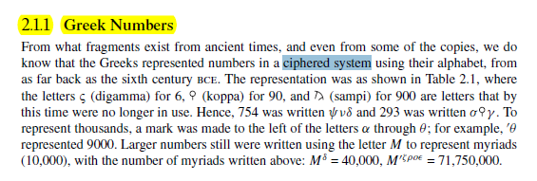
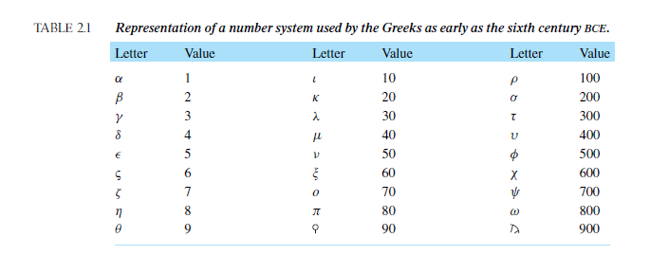
SGP. Πολύ μεγαλοι αριθμοι ΔΕΝ εκφραζονται.

https://www.britannica.com/science/numeral/Numeral-systems#ref797067,
Numeral systems
The Greeks, who entered the field much later and were influenced in their alphabet by the Phoenicians, based their first elaborate system chiefly on the initial letters of the numeral names. This was a natural thing for all early civilizations, since the custom of writing out the names for large numbers was at first quite general, and the use of an initial by way of abbreviation of a word is universal. The Greek system of abbreviations, known today as Attic numerals, appears in the records of the 5th century bce but was probably used much earlier.
?ΣΓΠ. Τα σκεφτηκε αυτά ο ΑΡΙΣΤΟΤΕΛΗΣ ?

ΣΧΟΛΙΑΣΜΟΣ ΤΩΝ ΑΡΧΑΙΩΝ ΕΛΛΗΝΙΚΩΝ ΜΑΘΗΜΑΤΙΚΩΝ,

ΚΕΝΤΡΙΚΑ ΣΗΜΕΙΑ,
ΑΠΟΔΕΙΞΗ και
ΑΞΙΩΜΑΤΑ
ΠΙΘΑΝΗ ΕΞΙΓΗΣΗ: ΝΟΜΟΣ, ΔΗΜΟΚΡΑΤΙΑ,

ΚΑΠΟΙΕΣ ΑΠΟΨΕΙΣ,

ΣΓΠ,
Καμμια άλλη ΕΠΙΣΤΗΜΟΝΙΚΗ περιοχη, δεν είναι τοσο πλησιον της ιδιας περιοχης ΣΗΜΕΡΑ, οσον είναι τα ΜΑΘΗΜΑΤΙΚΑ των ΑΡΧΑΙΩΝ ΕΛΛΗΝΩΝ,

A Mathematician’s Apology, G. H. Hardy,

p. 11,
If intellectual curiosity, professional pride, and ambition are the dominant incentives to research, then assuredly no one has a fairer chance of satisfying them than a mathematician. His subject is the most curious of all—there is none in which truth plays such odd pranks. It has the most elaborate and the most fascinating technique, and gives unrivalled openings for the display of sheer professional skill. Finally, as history proves abundantly, mathematical achievement, whatever its intrinsic worth, is the most enduring of all. We can see this even in semi-historic civilizations. The Babylonian and Assyrian civilizations have perished; Hammurabi, Sargon, and Nebuchadnezzar are empty names; yet Babylonian mathematics is still interesting, and the Babylonian scale of 60 is still used in astronomy. But of course the crucial case is that of the Greeks.
( COMMENTS SGP
“yet Babylonian mathematics is still interesting, and the Babylonian scale of 60 is still used in astronomy” )
The Greeks were the first mathematicians who are still ‘real’ to us to-day. Oriental mathematics may be an interesting curiosity, but Greek mathematics is the real thing. The Greeks first spoke a language which modern mathematicians can understand: as Littlewood said to me once, they are not clever schoolboys or ‘scholarship candidates’, but ‘Fellows of another college’. So Greek mathematics is ‘permanent’, more permanent even than Greek literature.
( COMMENTS SGP
“So Greek mathematics is ‘permanent’,”)
Archimedes will be remembered when Aeschylus is forgotten, because languages die and mathematical ideas do not. ‘Immortality’ may be a silly word, but probably a mathematician has the best chance of whatever it may mean.
ΣΓΠ. NATIONAL THEATER OLIVIER, ORESTEIA,

KATZ p. 33, greek mathematics,
As the quotation and the (probably) fictional account indicate, a new attitude toward mathematics appeared in Greece sometime before the fourth (? Εκτος )century bce. It was no longer sufficient merely to calculate numerical answers to problems. One now had to prove that the results were correct. To double a cube, that is, to find a new cube whose volume was twice that of the original one, is equivalent to determining the cube root of 2, and that was not a difficult problem numerically. The oracle, however, was not concerned with numerical calculation, but with geometric construction. That in turn depended on geometric proof by some logical argument, the earliest manifestation of such in Greece being attributed to Thales.
This change in the nature of mathematics, beginning around 600 bce, was related to the great differences between the emerging Greek civilization and those of Egypt and Babylonia, from whom the Greeks learned. The physical nature of Greece with its many mountains and islands is such that large-scale agriculture was not possible. Perhaps because of this, Greece did not develop a central government. The basic political organization was the polis, or city-state. The governments of the city-state were of every possible variety but in general controlled populations of only a few thousand. Whether the governments were democratic or monarchical, (ΣΓΠ, or ARISTOCRATIC), they were not arbitrary. Each government was ruled by law and therefore encouraged its citizens to be able to argue and debate (διαλογο) . It was perhaps out of this characteristic that there developed the necessity for proof in mathematics, that is, for argument aimed at convincing others of a particular truth.
ΠΑΠ.
ΠΝΥΚΑ, 483 ψηφισμα ΘΕΜΙΣΤΟΚΛΗ
ΔΙΚΑΣΤΗΡΙΑ, Τοποθετησεις στο ΔΙΚΑΣΤΗΡΙΟ,
ΔΙΑΛΟΓΟΙ ΣΩΚΡΑΤΟΥΣ STON DROMO, .
ΣΗΜΕΡΑ ΤΙ ΓΙΝΕΤΑΙ ?,
Because virtually every city-state had access to the sea, there was constant trade, both in Greece itself and with other civilizations. As a result, the Greeks were exposed to many different peoples and, in fact, themselves settled in areas all around the eastern Mediterranean. In addition, a rising standard of living helped to attract able people from other parts of the world. Hence, the Greeks were able to study differing answers to fundamental questions about the world. They began to create their own answers. In many areas of thought, they learned not to accept what had been handed down from ancient times. Instead, they began to ask, and to try to answer, “Why?” Greek thinkers eventually came to the realization that the world around them was knowable, that they could discover its characteristics by rational inquiry. Hence, they were anxious to discover and expound theories in such fields as mathematics, physics, biology, medicine, and politics. And althoughWestern civilization owes a great debt to Greek society in literature, art, and architecture, it is to Greek mathematics that we owe the idea of mathematical proof, an idea at the basis of modern mathematics and, by extension, at the foundation of our modern technological civilization.

ΑΠΟΨΗ ΑΡΙΣΤΟΤΕΛΗ,
ΚΑΤΖ p.35
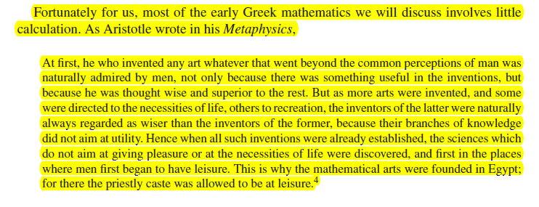
p. 49.
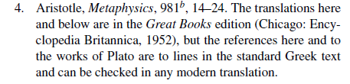
p. 36, αποψη katz
Although Aristotle referred only to Egypt, he certainly believed that in Greece as well
mathematics was the province of a leisured class, people who did not deal with such mundane matters as measurement or accountancy problems. Thus, in Greece as in Egypt and Mesopotamia, mathematics of the type we will discuss in this chapter and the next was the province of a very limited group of people, virtually all of whom were part of the ruling groups. As we will see, this theoretical mathematics was to be a central part of the education of the rulers of the state.
? τα σκεφτηκε αυτά ο ΑΡΙΣΤΟΤΕΛΗΣ,

KATZ, p. 35. ARISTOTLE,
Fortunately for us, most of the early Greek mathematics we will discuss involves little calculation.
As Aristotle wrote in his Metaphysics, At first, he who invented any art whatever that went beyond the common perceptions of man was naturally admired by men, not only because there was something useful in the inventions, but because he was thought wise and superior to the rest. But as more arts were invented, and some were directed to the necessities of life, others to recreation, the inventors of the latter were naturally always regarded as wiser than the inventors of the former, because their branches of knowledge did not aim at utility. Hence when all such inventions were already established, the sciences which do not aim at giving pleasure or at the necessities of life were discovered, and first in the places where men first began to have leisure. This is why the mathematical arts were founded in Egypt; for there the priestly caste was allowed to be at leisure
Although Aristotle referred only to Egypt, he certainly believed that in Greece as well mathematics was the province of a leisured class, people who did not deal with such mundane (χωρις ενδιαφερον), matters as measurement or accountancy problems. Thus, in Greece as in Egypt and Mesopotamia, mathematics of the type we will discuss in this chapter and the next was the province of a very limited group of people, virtually all of whom were part of the ruling groups. As we will see, this theoretical mathematics was to be a central part of the education of the rulers of the state.

NETZ,
NetzRevielNewHistoryOfGreekMathematics2022, p. 12,
Slabs, thick flat object, πλακα,
Limestone, Ασβεστόλιθος
Na do epishs 26-30, exei kai Pythagorean theorem,

GO NETZ, NetzRevielNewHistoryOfGreekMathematics2022, p. 12,

O netz axizei na to do, exei polla

ΣΥΜΠΛΗΡΩΜΑΤΑ,

A History of Mathematics/Antiquity/The Egyptians
https://en.wikisource.org/wiki/A_History_of_Mathematics/Antiquity/The_Egyptians,

Herodotus and Aristotle on Egyptian Geometry
Published online by Cambridge University Press: 27 October 2009
C. Macdonald
https://www.cambridge.org/core/journals/classical-review/article/abs/herodotus-and-aristotle-on-egyptian-geometry/90435755E5D5E6A63BCA175581F4D9B6,

Did Egypt Originate Geometry Theorem?,
https://www.nytimes.com/1991/02/14/opinion/l-did-egypt-originate-geometry-theorem-164991.html,

ΒΙΝΔΕΟ ΣΥΖΗΤΗΣΗΣ ΜΡΓΑΡΟ ΜΟΥΣΙΚΗΣ, ΟΜΙΛΙΕΣ ΠΑΠΑΣΤΑΥΡΙΔΗΣ, ΖΑΧΑΡΙΑΔΗΣ, ΤΡΑΧΑΝΑΣ, , http://www.blod.gr/lectures/Pages/viewlecture.aspx?LectureID=1089,

ΑΙΣΧΥΛΟΣ,
Athens’ City Dionysia festival in 472 BCE, with Pericles serving as choregos.
The Persians[edit]
Main article: The Persians
The earliest of his plays to survive is The Persians (Persai), performed in 472 BC and based on experiences in Aeschylus's own life, specifically the Battle of Salamis.[26] It is unique among surviving Greek tragedies in that it describes a recent historical event.[2] The Persians focuses on the popular Greek theme of hubris by blaming Persia's loss on the pride of its king.[26]
It opens with the arrival of a messenger in Susa, the Persian capital, bearing news of the catastrophic Persian defeat at Salamis to Atossa, the mother of the Persian King Xerxes. Atossa then travels to the tomb of Darius, her husband, where his ghost appears to explain the cause of the defeat. It is, he says, the result of Xerxes' hubris in building a bridge across the Hellespont, an action which angered the gods. Xerxes appears at the end of the play, not realizing the cause of his defeat, and the play closes to lamentations by Xerxes and the chorus.[27]

According to a scholium at Aristophanes ' Frogs 1028, Hiero of Syracuse at some point invited Aeschylus to reproduce The Persians in Sicily.[12]
Seventy years after the play was produced, the comic playwright Aristophanes mentions an apparent Athenian reproduction of The Persians in his Frogs (405 BCE).[13] In it, he has Aeschylus describe The Persians as "an effective sermon on the will to win. Best thing I ever wrote"; while Dionysus says that he "loved that bit where they sang about the days of the great Darius, and the chorus went like this with their hands and cried 'Wah! Wah!'" (1026–28).[14]
The Persians was popular in the Roman Empire and Byzantine Empire, who also fought wars with the Persians, and its popularity has endured in modern Greece. According to Anthony Podlecki, during a production at Athens in 1965 the audience "rose to its feet en masse and interrupted the actors' dialogue with cheers."[15]
Οι περσες,
- ΟΝΕΙΡΟ ΑΤΟΣΣΑΣ, στ. 180,
- ΔΕΝ ΕΙΝΑΙ ΔΟΥΛΟΙ, στ. 240

Humanitas
https://en.wikipedia.org/wiki/Humanitas,
Humanitas is a Latin noun meaning human nature, civilization, and kindness. It has uses in the Enlightenment, which are discussed below.
Classical origins of term
The Latin word humanitas corresponded to the Greek concepts of philanthrôpía (loving what makes us human) and paideia (education) which were amalgamated with a series of qualities that made up the traditional unwritten Roman code of conduct (mos maiorum).[1] Cicero (106–43 BC) used humanitas in describing the formation of an ideal speaker (orator) who he believed should be educated to possess a collection of virtues of character suitable both for an active life of public service and a decent and fulfilling private life; these would include a fund of learning acquired from the study of bonae litterae ("good letters", i.e., classical literature, especially poetry), which would also be a source of continuing cultivation and pleasure in leisure and retirement, youth and old age, and good and bad fortune.[2]

ΣΟΦΟΚΛΗΣ,
In Sophocles
THE GKEEK MIND 177
Oedipus Rex - to take rather a difficult example - it is prophesied
before Oedipus is born that he will kill his father and
marry his mother. He does these things, in complete ignorance.
But it makes nonsense of the play to interpret this as meaning
that man is the plaything of a malignant Fate. What Sophocles
means is this, that in the most complex and apparently fortuitous
combination of events there is a design, though what
it means we may not know. It is because the gods can see the
whole design that Apollo could foretell what Oedipus would
do. In Aeschylus, the Law is simpler: it is moral law. Punishment
follows Hybris as the night the day. It was because of
this firm faith in Law that Whitehead called the Greek tragic
poets, rather than the early Greek philosophers, the true
founders of scientific thinking.

Humanitas
https://en.wikipedia.org/wiki/Humanitas,
Humanitas is a Latin noun meaning human nature, civilization, and kindness. It has uses in the Enlightenment, which are discussed below.
Classical origins of term
The Latin word humanitas corresponded to the Greek concepts of philanthrôpía (loving what makes us human) and paideia (education) which were amalgamated with a series of qualities that made up the traditional unwritten Roman code of conduct (mos maiorum).[1] Cicero (106–43 BC) used humanitas in describing the formation of an ideal speaker (orator) who he believed should be educated to possess a collection of virtues of character suitable both for an active life of public service and a decent and fulfilling private life; these would include a fund of learning acquired from the study of bonae litterae ("good letters", i.e., classical literature, especially poetry), which would also be a source of continuing cultivation and pleasure in leisure and retirement, youth and old age, and good and bad fortune.[2]

ΣΟΦΟΚΛΗΣ,
In Sophocles
THE GKEEK MIND 177
Oedipus Rex - to take rather a difficult example - it is prophesied
before Oedipus is born that he will kill his father and
marry his mother. He does these things, in complete ignorance.
But it makes nonsense of the play to interpret this as meaning
that man is the plaything of a malignant Fate. What Sophocles
means is this, that in the most complex and apparently fortuitous
combination of events there is a design, though what
it means we may not know. It is because the gods can see the
whole design that Apollo could foretell what Oedipus would
do. In Aeschylus, the Law is simpler: it is moral law. Punishment
follows Hybris as the night the day. It was because of
this firm faith in Law that Whitehead called the Greek tragic
poets, rather than the early Greek philosophers, the true
founders of scientific thinking.

Όχι 2026, ΡΩΜΗ,
GOOGLE Legacy of the Roman Empire
The legacy of the Roman Empire has been varied and significant. The Roman Empire, built upon the legacy of other cultures, has had long-lasting influence with broad geographical reach on a great range of cultural aspects, including state institutions, law, values, religious beliefs, technological advances, engineering, (εντυποσιακα μεγεθη, όχι νεες ιδεεσ) and language .
ΔΕΝ ΠΑΡΗΓΑΝΑΝ ΝΕΑ ΜΑΘΗΜΑΤΙΚΑ πρωτης γραμμης

Quintus Horatius Flaccus
(Classical Latin: [ˈkʷiːntʊs (h)ɔˈraːtiʊs ˈfɫakːʊs]; 8 December 65 BC – 27 November 8 BC),[1] commonly known in the English-speaking world as Horace (/ˈhɒrɪs/ HORR-iss gr ΟΡΑΤΙΟΣ), was the leading Roman lyric poet during the time of Augustus (also known as Octavian). The rhetorician Quintilian regarded his Odes as the only Latin lyrics worth reading: "He can be lofty sometimes, yet he is also full of charm and grace, versatile in his figures, and felicitously daring in his choice of words."[nb

ai Google horace grecia capta,
AI Overview
"Graecia capta ferum victorem cepit" is a famous phrase by the Roman poet Horace (Epistles 2.1.156) meaning "Conquered Greece took captive her savage conqueror". It describes how, despite Rome militarily conquering Greece, Greek art, literature, and philosophy conquered Roman culture, influencing Roman art and education.
Key Aspects of the Quote:
Full Quote: "Graecia capta ferum victorem cepit et artes intulit agresti Latio" (Conquered Greece took captive her savage conqueror and brought the arts to rustic (When you think of the word rustic, think of the rural country.) Latium).
Meaning: Although Rome won the wars, they adopted the superior Greek culture, art, and philosophy.
Context: Written around 14 BC, it highlights the admiration Romans had for Greek cultural achievements, which deeply transformed Roman society.
Impact: This phrase encapsulates the Hellenization of Rome, explaining why Roman culture is heavily influenced by Greek traditions.

Publius Vergilius Maro, VIRGIL, VERGIL,
(Classical Latin: [ˈpuːbliʊs wɛrˈɡɪliʊs ˈmaroː]; 15 October 70 BC – 21 September 19 BC), usually called Virgil or Vergil (/ˈvɜːrdʒɪl/ VUR-jil) in English, was an ancient Roman poet of the Augustan period. He composed three of the most famous poems in Latin literature: the Eclogues (or Bucolics), the Georgics, and the epic Aeneid. Some minor poems, collected in the Appendix Vergiliana, were attributed to him in ancient times, but modern scholars regard these as spurious, with the possible exception of some short pieces.

VIRGIL, AINIAD, … “MEMENTO ROMANO”,

MEMENTO ROMANO,
http://classicalanthology.theclassicslibrary.com/2012/08/07/aeneid-6-847-853/.

Aeneid
https://en.wikipedia.org/wiki/Aeneid,
The Aeneid (/ɪˈniːɪd/ ih-NEE-id; Latin: Aenē̆is [ae̯ˈneːɪs] or [ˈae̯neɪs]) is a Latin epic poem that tells the legendary story of Aeneas, a Trojan who fled the fall of Troy and travelled to Italy, where he became the ancestor of the Romans. Written by the Roman poet Virgil between 29 and 19 BC, the Aeneid comprises 9,896 lines in dactylic hexameter.[1] The first six of the poem's twelve books tell the story of Aeneas' wanderings from Troy to Italy, and the poem's second half tells of the Trojans' ultimately victorious war upon the Latins, under whose name Aeneas and his Trojan followers are destined to be subsumed.

Aeneid 6.847-853 – Virgil’s vision of Roman greatness
https://classicalanthology.theclassicslibrary.com/2012/08/07/aeneid-6-847-853/,
Virgil’s vision of Roman greatness put into the mouth of Anchises, the dead father of Aeneas whom Aeneas travels to find in the Underworld in this book – the turning point of the poem.
Anchises points out the future heroes of Rome yet to be born, a long catalogue that is patriotic and visionary but also cautionary and sad. It culminates in this grand passage which, although outwardly (on the surface), imperialistic, also warns of the great responsibilities and dangers that go with power.
Jane Mason

Excudent alii spirantia mollius aera,
credo equidem, vivos ducent de marmore voltus,
orabunt causas melius, caelique meatus
describent radio, et surgentia sidera dicent: 850
tu regere imperio populos, Romane, memento;
hae tibi erunt artes; pacisque imponere morem,
parcere subiectis, et debellare superbos.”

Others will forge breathing bronzes more smoothly
(I believe it at any rate), and draw forth living features from marble.
They will plead law-suits better
and trace the movements Of the sky with a rod and describe the rising stars.
You, O Roman, govern the nations with your power- remember this!
These will be your arts – to impose the ways of peace,
To show mercy to the conquered and to subdue the proud.

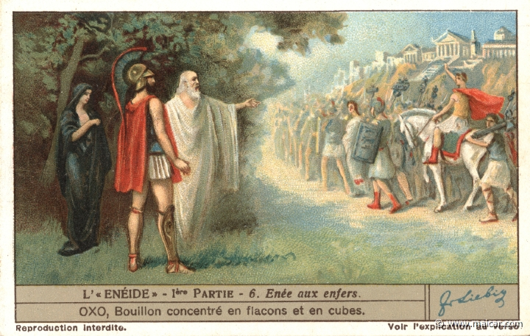
https://classicalanthology.theclassicslibrary.com/2012/08/07/aeneid-6-847-853/,
Picture from Carlos Parada, Greek Mythology Link, www.maicar.com – click here for more about Aeneas’ journey to the Underworld including an excellent map.
The above text is provided by the Perseus Digital Library and the translation is by Jane Mason.
Enfer=κολασις
Carlos Parada, Greek Mythology Link, 3τομο. Θεωρειται καλο,

Graeculi

Νικήτας Δημήτριος,
https://www.lit.auth.gr/node/17,
Ο Δημήτριος Νικήτας είναι Ομότιμος Καθηγητής Λατινικής Φιλολογίας της Φιλοσοφικής Σχολής του Αριστοτελείου Πανεπιστημίου Θεσσαλονίκης.

https://pheidias.antibaro.gr/Hellas_names/graeculi-Nikitas.html,
Ο ελληνικός χαρακτηρισμός «Γραικύλος» είναι απόδοση του λατινικού χαρακτηρισμού Graeculus, ο οποίος με τη σειρά του είναι υποκοριστικό του εθνικού ονόματος Graecus που χρησιμοποιούσαν οι Ρωμαίοι για τους Ελληνες. Το λατινικό υποκοριστικό μαρτυρείται σε πενήντα περίπου χωρία λατίνων συγγραφέων, από τα χρόνια του Κικέρωνα μέχρι σχεδόν τον 4ο αιώνα μ.Χ. Το ελληνικό υποκοριστικό με εξαίρεση μια μαρτυρία του Δίωνος Κασσίου (46, 18, 1, βλ. παρακάτω), δεν εντοπίζεται στην αρχαία ελληνική και στη βυζαντινή γραμματεία ως τον 10ο αιώνα.

Αξίζει επίσης να σημειωθεί ότι το όνομα Graeculus είναι, μαζί με το όνομα Poenulus (= «Καρχηδονίσκος»), τα μόνα υποκοριστικά εθνικών χαρακτηρισμών που περιέχει η λατινική γλώσσα. Δεν είναι φυσικά τυχαίο το γεγονός ότι τα δύο αυτά υποκοριστικά αφορούν τους δύο μεγαλύτερους αντιπάλους της Ρώμης, τους οποίους υπέταξε η ρωμαϊκή λόγχη με πολύ μόχθο και αίμα.

Οπως ορθά σημειώνεται στο «βέβηλο» γράμμα που παραθέτει ο Μάριος Πλωρίτης στο «Βήμα» της Κυριακής, 7 Ιουνίου 1998, «"πατέρας" αυτού του επιθέτου (Graeculus) ήταν ο Κικέρων». Αυτό αληθεύει υπό την έννοια ότι ο διάσημος αυτός ρωμαίος πολιτικός και ρήτορας πρέπει να θωρηθεί πιθανότατα ο «ευρετής» αυτού του υποκοριστικού, το οποίο επανέρχεται στο έργο του επανειλημμένα (16 φορές!).

Cicero and the Greeks
https://www.worldhistory.biz/sundries/31218-4-cicero-and-the-greeks.html,
… Admiration for the cultural achievements of classical Greece was one side of this ambivalent attitude. The other was a feeling of superiority towards their Greek contemporaries who were, after all, their provincial subjects and whom they often regarded with contempt. …
Cicero often expresses a Roman sense of superiority over the Greeks. In a letter to his brother Quintus he warns him to be careful in his choice of Greek friends; …

GuiteHaroldCicerosAttitudeToTheGreeks,
Paper,

ROMAN MATHEMATICS,

GENERALITIES,
KATZ, p. 157,
5.3.1 Roman Mathematics
Was there “Roman mathematics,” or was all the mathematics accomplished under the aegis of the Roman Empire part of “Greek mathematics”? The great orator Cicero admitted that the Romans were not interested in mathematics: “The Greeks held the geometer in the highest honor; accordingly, nothing made more brilliant progress among them than mathematics. But we have established as the limit of this art its usefulness in measuring and counting.”13 But Cicero himself, as a magistrate and landowner, was certainly numerate enough to understand accounts and detect frauds. So, although it is certainly true that there was no Roman Euclid or Archimedes, in fact the Romans did have somewhat more to do with mathematics than “measuring and counting.” One person whose writings (in Latin) display a solid knowledge of mathematics is Vitruvius (first century bce). In his famous work, On Architecture, he wrote that architects needed to have a comprehensive liberal education, including topics from draftsmanship to astronomy. In particular, he noted: “Geometry, in turn, offers many aids to architecture, and first among them, it hands down the technique of compass and rule, which enables the onsite layout of the plan as well as the placement of set-squares, levels, and lines. Likewise, through knowledge of optics, windows are properly designed so as to face particular regions of heaven. Through arithmetic the expenses of buildings are totaled up, and the principles of measurement are developed, the difficult issues of symmetry are resolved by geometric principles and methods.”14 But although Vitruvius recommended such knowledge for architects, On Architecture itself contains only a little mathematics.
The Roman Empire was famous for its surveyors. They laid out roads and aqueducts throughout a huge territory, many of which still survive. But an inspection of the extant surveying manuals shows that the Roman surveyors used only very elementary mathematics.

… This is obviously quite an elementary method, but the records do not show the use of more sophisticated mathematics in surveying.
This is particularly surprising, since Greek mathematicians had developed better methods of indirect measurement. As we have seen, Hipparchus’s and Ptolemy’s trigonometry enabled the Greeks to “measure” triangles in the heavens as well as those on the earth related to occurrences in the heavens. And it would appear that these same methods would enable one to solve ordinary triangles on earth in order to make indirect measurements of distance and height. It would seem natural that, at least after the time of Hipparchus, the Greeks and Romans would use trigonometrical methods, that is, methods involving the table of chords. But the available historical evidence gives us no reason to believe that they did so.

13. Cicero, Tusculan Disputations (Cambridge: Harvard University
Press, 1927), I, p. 2.
14. Vitruvius, Ten Books on Architecture, Ingrid Rowland and
Thomas Howe, eds. (Cambridge: Cambridge University
Press, 1999), p. 22.
Hipparchus (/hɪˈpɑːrkəs/; Greek: Ἵππαρχος, Hípparkhos; c. 190 – c. 120 BC) was a Greek astronomer, geographer, and mathematician. He is considered the founder of trigonometry,[1]

Ptolemy, Claudius Ptolemy (/ˈtɒləmi/; Ancient Greek: Πτολεμαῖος, Ptolemaios; Latin: Claudius Ptolemaeus; c. 100 – c. 170 AD)[1] was an Alexandrian mathematician, astronomer, astrologer, geographer, and music theorist[2] who wrote about a dozen scientific treatises, three of which were important to later Byzantine, Islamic, and Western European science.
The first was his astronomical treatise now known as the Almagest, originally entitled Mathematical Treatise (Greek: Μαθηματικὴ Σύνταξις, Mathēmatikḗ Syntaxis).
… The third is the astrological treatise in which he attempted to adapt horoscopic astrology to the Aristotelian natural philosophy of his day. This is sometimes known as the Apotelesmatika (Greek: Αποτελεσματικά, lit. 'On the Effects') but more commonly known as the Tetrábiblos, from the Koine Greek meaning "Four Books", or by its Latin equivalent Quadripartite.
… The Catholic Church promoted his work, which included the only mathematically sound geocentric model of the Solar System, and unlike most Greek mathematicians, Ptolemy's writings (foremost the Almagest) never ceased to be copied or commented upon, both in late antiquity and in the Middle Ages.[3] However, it is likely that only a few truly mastered the mathematics necessary to understand his works, as evidenced particularly by the many abridged and watered-down introductions to Ptolemy's astronomy that were popular among the Arabs and Byzantines.[4][5] His work on epicycles has come to symbolize a very complex theoretical model built in order to explain a false assumption.

ROMAN NUMERALS, περιληψη

ΣΥΜΒΟΛΑ,
Einaic CIPHERED system,

ΑΡΙΘΜΟΙ 1-10,
I, II, III, IV, V, VI, VII, VIII, IX, X.

Einaic CIPHERED system
11=XI,

ΒΑΣΙΚΑ ΣΥΜΒΟΛΑ για αριθμους 1-3999,
I V X L C D M
1 5 10 50 100 500 1000

Einaic CIPHERED system,
11=XI, 16=XVI, 18=XVIII, 108=CVIII,

Subtractive Notation,
Subtractive Notation,[5] where the LOWER symbol (I) is subtracted from the HIGHER one. Thus 4 is written IV (instead of IIII), and
19 is written 19 is written XIX (instead of XVIIII).
8 is written VIII, and IIX
H eisagvgh aytoy toy kanona egine gia na grafontai aριθμοι με λιγοτερα συμβολα. Όμως αυτος ο εχτρα κανονας δυσκολευει την προσθεση, μονοσημαντο γραφης, αναγνωριση του μεγαλυτερου, .
To 3 grafetai III alla kai IIV.

ROMAN NUMERALA 1-1000
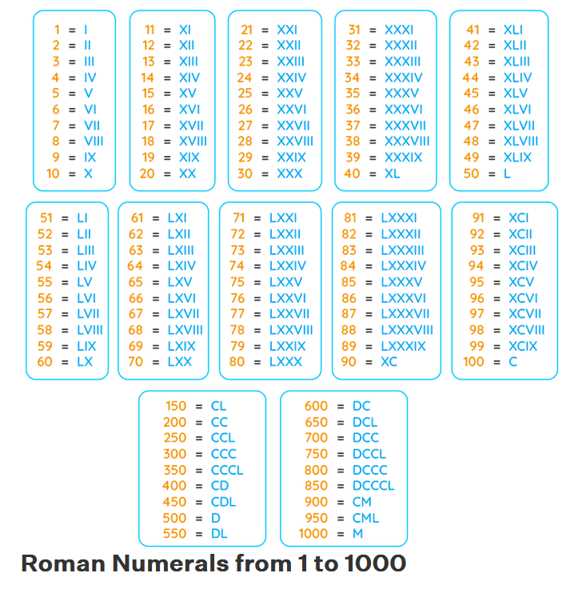

ΠΑΡΑΔΕΙΓΜΑΤΑ,
39 = XXX + IX = XXXIX.
246 = CC + XL + VI = CCXLVI.
789 = DCC + LXXX + IX = DCCLXXXIX.
2,421 = MM + CD + XX + I = MMCDXXI.

ROMAN LAW

