17 ΜΑ, 17 MA, 15-05-2026, ΠΑΡΑΣΚΕΥΗ,
Webex meeting recording: 17, 15-05-2026 INM 2026-20260515 2007-1
Recording link: https://uoa.webex.com/uoa/ldr.php?RCID=24ecc4d1cced47b649b84f3cef12db1e,
Password: FpCUKcj8
ΠΡΟΚΑΤΑΡΚΤΙΚΑ,
οργανωσισ

ΛΟΙΠΑ ΜΑΘΗΜΑΤΙΚΑ ΤΩΝ ΒΑΒΥΛΩΝΙΩΝ, (πλην αριθμων),

ΜΕΤΡΗΣΙΣ ΠΥΡΑΜΙΔΟΣ
GO KatzHistoryOfMathematics3rdS, p. 16, kai p. 17,

ΠΥΘΑΓΟΡΕΙΟ ΘΕΩΡΗΜΑ στην ΒΑΒΥΛΩΝΑ,

Μια «απλη ΑΠΟΔΕΙΞΗΣ» ? ΠΥΘΑΓΟΡΕΙΟΥ ΘΕΩΡΗΜΑΤΟΣ
https://en.wikipedia.org/wiki/Pythagorean_theorem#Pythagorean_proof,
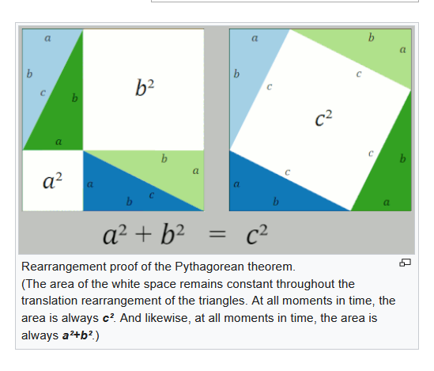

The Pythagorean proof (click to view animation)
The Pythagorean theorem was known long before Pythagoras (Πυθαγόρας; c. 570– c. 495BC), , but he may well have been the first to prove it ???.^{[2]} In any event, the proof attributed to him is very simple, (sgp. Δεν ξερουμε τι αποδειξη εδωσε ουτε ξερουμε ακριβως τι σημαινε με την λεξη «αποδειξη»), and is called a proof by rearrangement.
The two large squares shown in the figure each contain four identical triangles, and the only difference between the two large squares is that the triangles are arranged differently. Therefore, the white space within each of the two large squares must have equal area. Equating the area of the white space yields the Pythagorean theorem, Q.E.D.^{[9]}
That Pythagoras originated this very simple proof is sometimes inferred from the writings of the later Greek philosopher and mathematician Proclus (Proclus Lycius (/ˈprɒkləs laɪˈsiːəs/; 8 February 412 – 17 April 485, c. 5th century), called Proclus the Successor (Ancient Greek: Πρόκλος ὁ Διάδοχος, Próklos ho Diádokhos), was a Greek Neoplatonist philosopher, one of the last major classical philosophers of late antiquity.).^{[10]} Several other proofs of this theorem are described below, but this is known as the Pythagorean one.

Pythagorean Theorem
2021
GOTO KATZ p. 19,
One of the Babylonian square root problems was connected to the relation between the side of a square and its diagonal. That relation is a special case of the result known as the Pythagorean Theorem: In any right triangle, the sum of the areas of the squares on the legs equals the area of the square on the hypotenuse.
This theorem, named after the sixth-century bce Greek philosopher-mathematician, is arguably the most important elementary theorem in mathematics, since its consequences and generalizations have wide-ranging application. Nevertheless, it is one of the earliest theorems known to ancient civilizations. In fact, there is evidence that it was known at least 1000 years before Pythagoras (c. 570-c 495).
Pythagoras: Everyone knows his famous theorem, but not who discovered it 1000 years before him,
https://link.springer.com/article/10.1057/jt.2009.16,
go H:\B\#1oBackUp\Metaf\INM\BibliogrINM\#OnomastGreeksAncient\Pythagoras,

Pythagoras's theorem in Babylonian mathematics
Article by: J J O'Connor and E F Robertson
http://www-history.mcs.st-and.ac.uk/HistTopics/Babylonian_Pythagoras.html,

In this article we examine four Babylonian tablets which all have some connection with Pythagoras's theorem. Certainly the Babylonians were familiar with Pythagoras's theorem. A translation of a Babylonian tablet which is preserved in the British museum goes as follows:-
4 is the length and 5 the diagonal. What is the breadth (ευρος)?
Its size is not known.
4 times 4 is 16.
5 times 5 is 25.
You take 16 from 25 and there remains 9.
What times what shall I take in order to get 9 ?
3 times 3 is 9.
3 is the breadth.
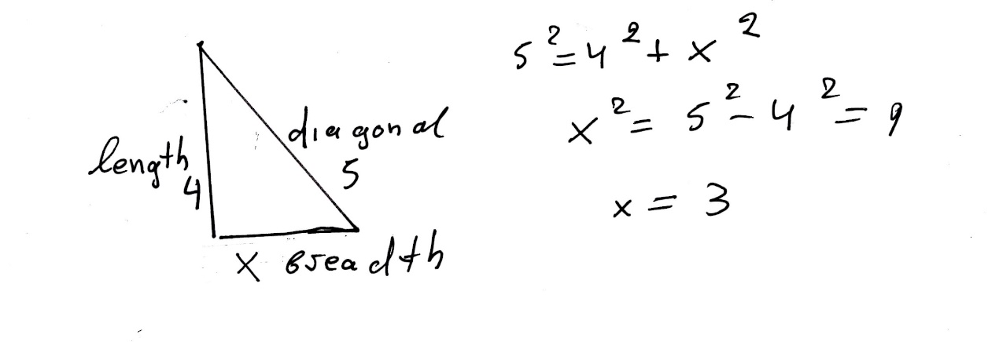
All the tablets we wish to consider in detail come from roughly the same period, namely that of the Old Babylonian Empire which flourished in Mesopotamia between 1900 BC and 1600 BC.

USE of PYTHAGOREAN THEOREM,
In OLD BABYLON,
GOTO KATZ, p. 22,
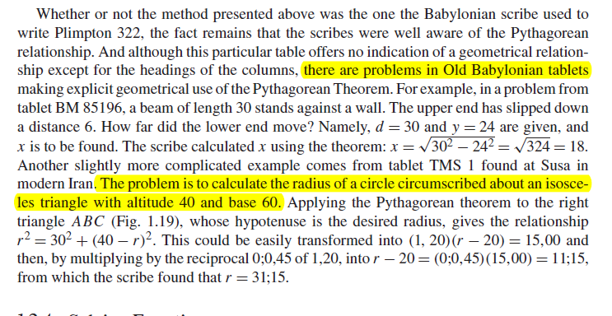

Kata p.22
Ραβδος μηκους 30, στηριζεται επι τοιχου. Το κατω ακρο γλιστραει επι του πατωματος κατά χ, οποτε το ανω ακρο εχει κατελθει κατά 6. Να βρεθει το χ.
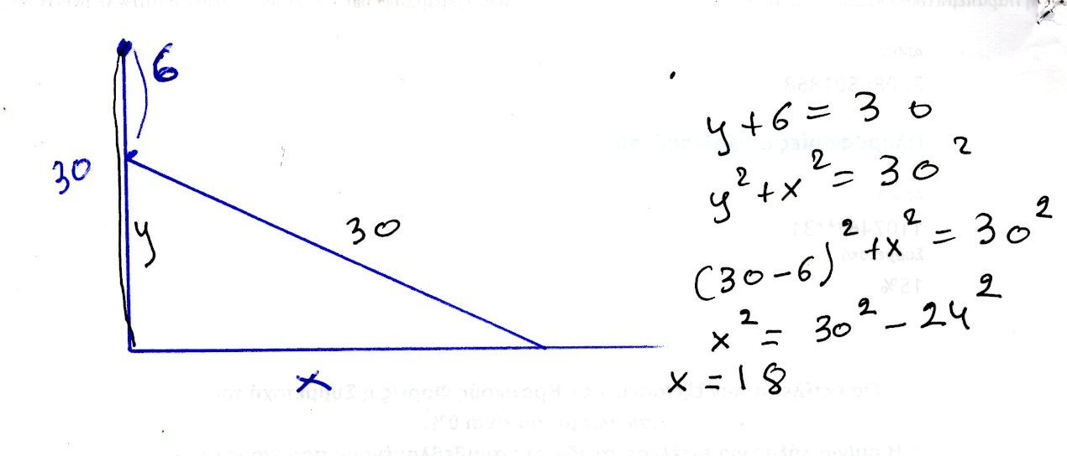

Katz p.22
Να βρεθει η ακτινα του περιγεγραμμενου κυκλου ισοσκελους τριγωνου βασης 60 και υψους 40.
KATZ p. 22
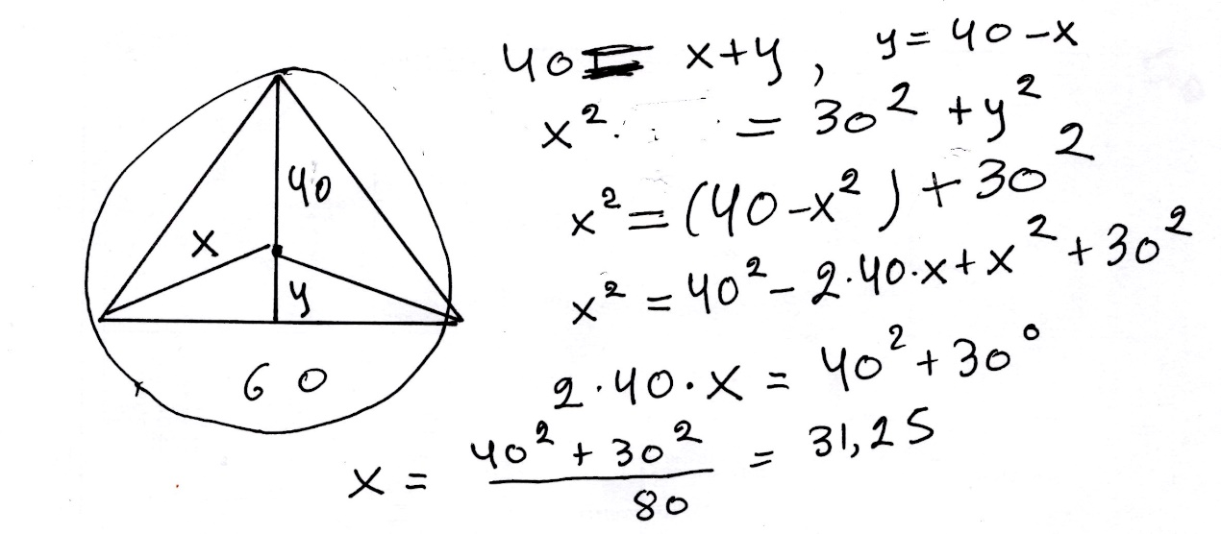

BABYLONIAN CUT and PASTE,

x+y=b, xy=c
GO KATZ p. 23 and 24,
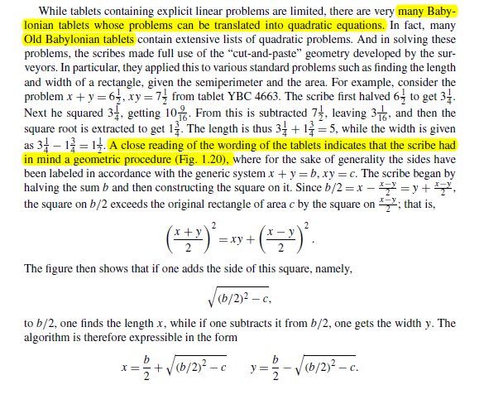

Kata go p. 24,
Σκοπος να αποδειχθη ότι αν x>y
((x+y)/2)² =xy+ ((x-y)/2))²
Πιθανη ιδεα των Βαβυλωνιων ένα γεωμετρικο σχημα.
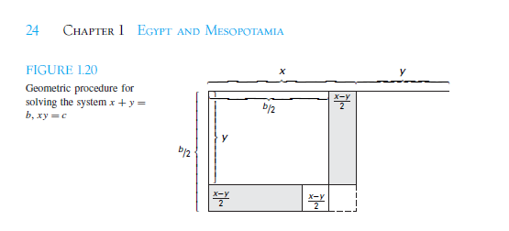

Γο KATZ p.23
Η παραπανω περιγραφη, αντιστοιχει στην σειρα ενεργειων για την εκτελεση των πραξεων, β, β/2, (β/2)²
(β/2)² –c, ( (β/2)² –c)^{1/2} . (μεθοδος ευρεσης τετραγωνικης ριζας)
ΤΟ ΜΗΚΟΣ είναι , β/2 + ( (β/2)² –c)^{1/2}
ΤΟ ΠΛΑΤΟΣ είναι β/2 - ( (β/2)² –c)^{1/2}

Κατωτερω αναλυουμε «καπως καλλιτερα», την αποδειξη του
((x+y)/2)² =xy+ ((x-y)/2))²

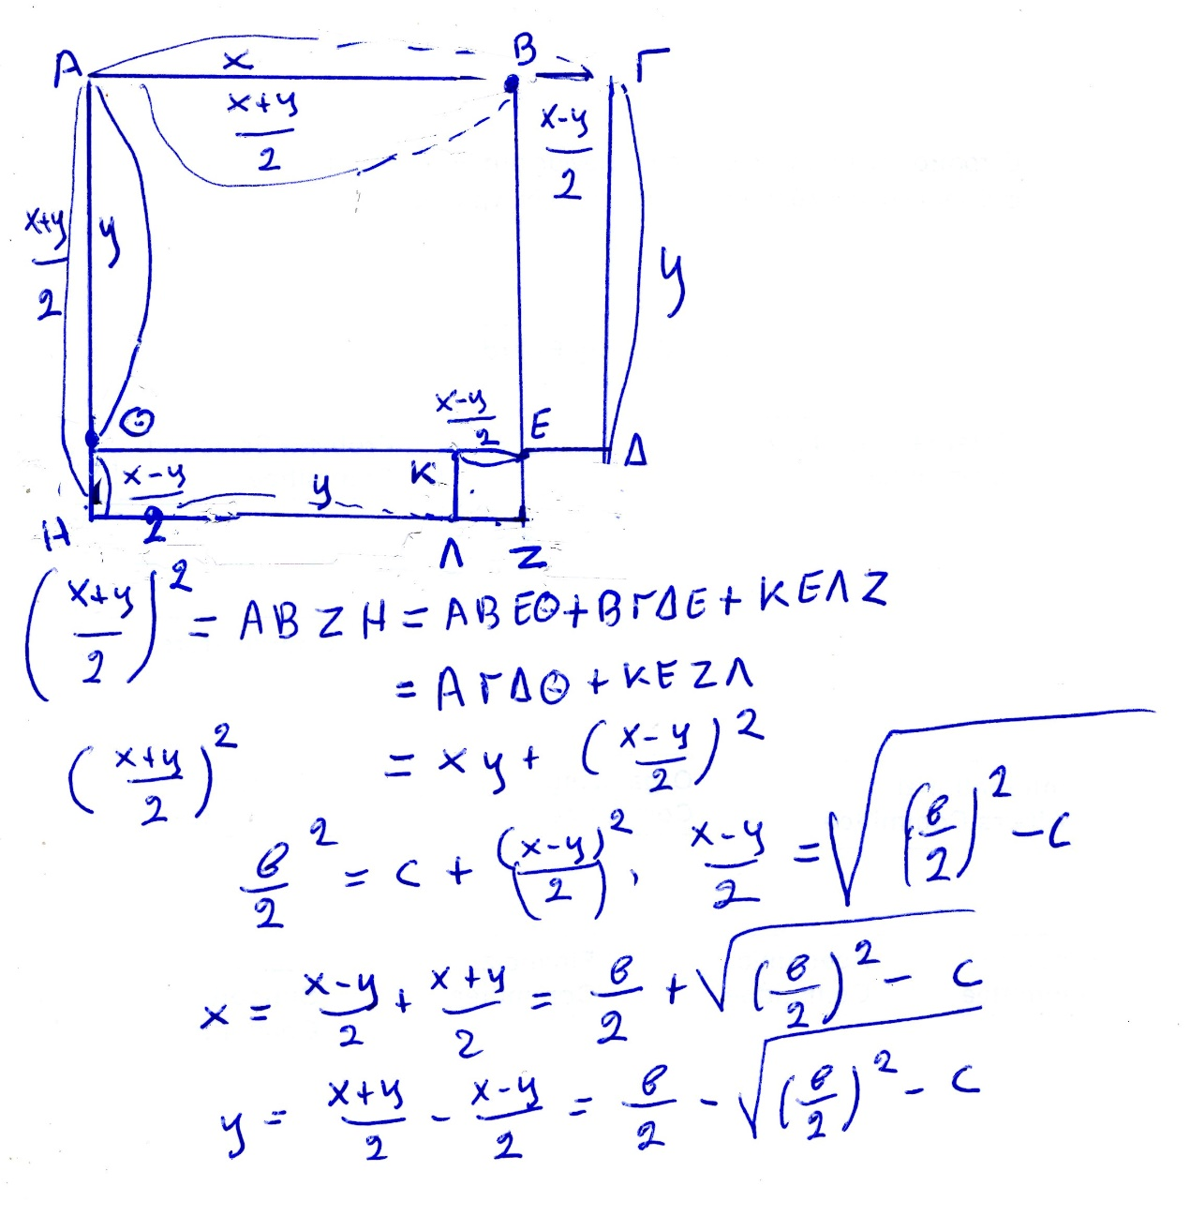

Oxi 2026, ΕΞΙΣΩΣΗΣ x² +bx=c,
KATZ p.24, 25
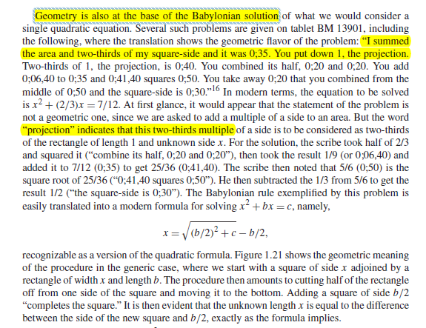
Ας δουμαι πως τα παραπανω εξηγουνται γεωμετρικα.
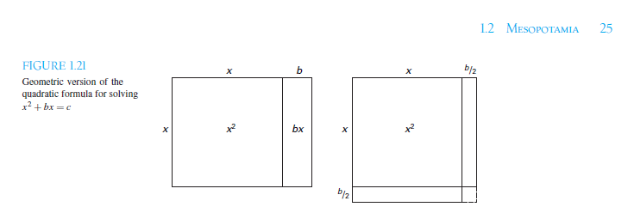

ΕΞΙΣΩΣΗ x² +bx=c,
Τα κατωτερω είναι καπως πιο απλοποιητικα.
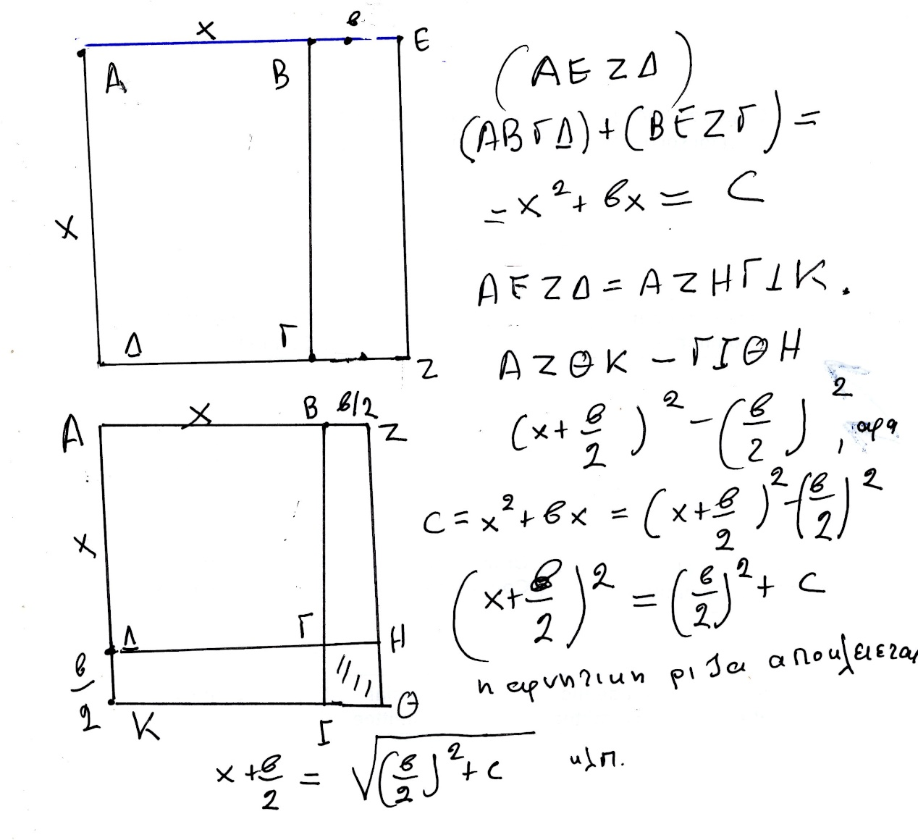

Oxi 2026, x² –bx=c
katz p. 25
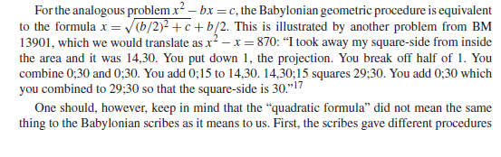
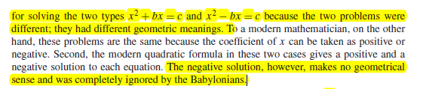

Κατωτερω δινουμε μια αποδειξη, με γεωμετρικο τροπο, CUT-PASTE, basizomenh στην γνωση των εμβαδων ορθογωνιων παραλληλογραμμων. Φαινεται ότι καπως ετσι τα εκαναν και οι ΒΑΒΥΛΩΝΙΟΙ.

ΕΞΙΣΩΣΗ, x² –bx=c
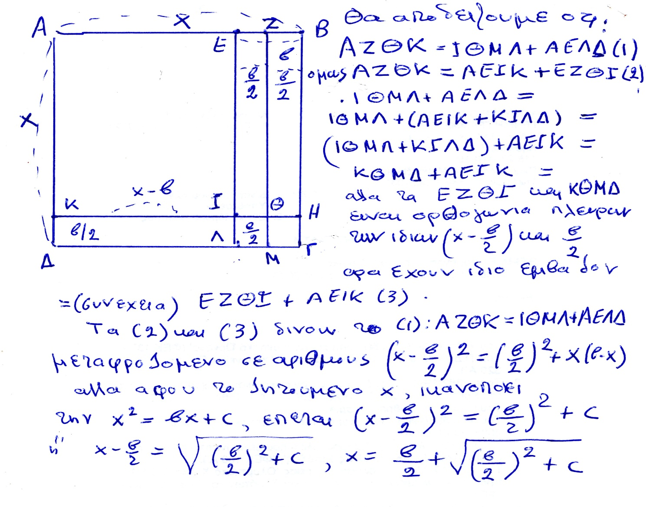

Oxi 2026, SCALING,
Katz p.25

Oxi 2026, x² –y² = (x+y).(x-y),
Να αποδειχθει γεωμετρικα, katz p.26,

CONCLUSION for BABYLONIAN MATHEMATICS,

GO KATZ p. 27, είναι μια αποψη ενδιαφερουσα,
The extant papyri and tablets containing Egyptian and Babylonian mathematics were generally teaching documents, used to transmit knowledge from one scribe to another. Their function was to provide trainee scribes with a set of example-types, problems whose solutions could be applied in other situations. Learning mathematics for these trainees was learning how to select and perhaps modify an appropriate algorithm, and then mastering the arithmetic techniques necessary to carry out the algorithm to solve a new problem. The reasoning behind the algorithms was evidently transmitted orally, so that mathematicians today are forced to speculate as to the origins. We note that although the long lists of quadratic problems on some of the Babylonian tablets were given as “real-world” problems, the problems are in fact just as contrived as the ones found in most current algebra texts. That the authors knew they were contrived is shown by the fact that, typically, all problems of a given set have the same answer. But since often the problems grew in complexity, it appears that the tablets were used to develop techniques of solution. One can speculate, therefore, that the study of mathematical problem solving, especially problems involving quadratic equations, was a method for training the minds of future leaders of the country. In otherwords, it was not really that important to solve quadratic equations—there were few real situations that required them. What was important was for the students to develop skills in solving problems in general, skills that could be used in dealing with the everyday problems that a nation’s leaders need to solve. These skills included not only following well-established procedures—algorithms—but also knowing how and when to modify the methods and how to reduce more complicated problems to ones already solved. Today’s students are often told that mathematics is studied to “train the mind.” It seems that teachers have been telling their students the same thing for the past 4000 years.

ΜΑΘΗΜΑΤΙΚΑ που ΓΝΩΡΙΖΑΝ οι ΒΑΒΥΛΩΝΙΟΙ,

Τα μαθηματικα ξεκινησαν για εφαρμογες
Για τα πιο προχωρημανα (πχ. Εξισωσεις β βαθμου, μαλλον χργσςιμοποιουντα για την παιδεια στελεχων της διοικησης.
ΑΡΙΘΜΗΤΙΚΟ ΣΥΣΤΗΜΑ ΘΕΣΕΩΣ
ΠΥΘΑΓΟΡΕΙΟ ΘΕΩΡΗΜΑ,
ΕΞΙΣΩΣΕΙΣ Β ΒΑΘΜΟΥ
Square Roots and the Pythagorean Theorem KATZ p. 17,
e.g. 2^{1/2} ,
SGP. TA της ΜΕΣΟΠΟΤΑΜΙΑΣ, MAΘHMATIKA eginan kyrios gia efarmoges. Piθanh εξαιρεση η εξισωση β βαθμου.
ΕΛΛΕΙΨΗ «ΑΛΓΕΒΡΑΣ»

ΑΙΓΥΠΤΟΣ,

ΓΕΝΙΚΟΤΗΤΕΣ

Hecataeus and Herodotus on "A Gift of the River"
Author(s): J. Gwyn Griffiths
Source: Journal of Near Eastern Studies, Vol. 25, No. 1 (Jan., 1966), pp. 57-61
Published by: University of Chicago Press
Stable URL: http://www.jstor.org/stable/543141
Accessed: 27-11-2015 08:57 UTC HECATAEUS AND HERODOTUS ON "A GIFT OF THE RIVER"1
IT may be questioned whether a geography lesson on Egypt is ever given anywhere without including the statement that "Egypt is the gift of the Nile." The earliest recorded verbal form of this statement appears in Herodotus, 2. 5:

HERODOTUS, WITH AN ENGLISH TRANSLATION BY
A. GODLKY, HON. FELLOW OF MAGDALEN COLLEGE, OXFORD
IN FOUR VOLUMES
Vol1, BOOKS I AKP II,
p. 279-282,
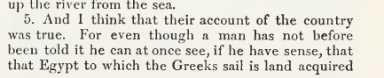
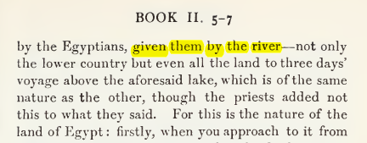

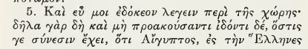
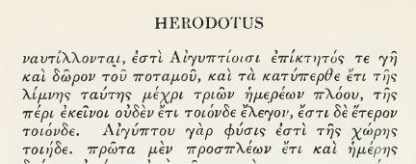

ΣΓΠ. O ΗΡΟΔΟΤΟΣ βλεπει την ΑΙΓΥΠΤΟ με σεβασμο, αλλα την θεωρει κουρασμενο πολιτισμο.

Map of ancient Egypt, showing major cities and sites of the Dynastic period (c. 3150 BC to 30 BC)
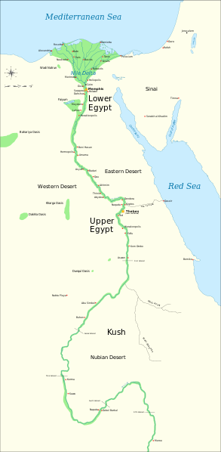
https://en.wikipedia.org/wiki/File:Ancient_Egypt_map-en.svg,
https://en.wikipedia.org/wiki/Cradle_of_civilization#/media/File:Ancient_Egypt_map-en.svg,

Όχι 2026, GOTO Katz, Victor J. A history of mathematics 3rd ed. p. 2
Agriculture emerged in the Nile Valley in Egypt close to 7000 years ago,
but the first dynasty to rule both Upper Egypt (the river valley) and Lower Egypt (the delta) dates from about 3100 bce (c 3000). The legacy of the first pharaohs included an elite of officials and priests, a luxurious court, and for the kings themselves, a role as intermediary between mortals and gods. This role fostered the development of Egypt’s monumental architecture, including the pyramids, built as royal tombs, and the great temples at Luxor and Karnak. Writing began in Egypt at about this time, and much of the earliest writing concerned accounting, primarily of various types of goods. There were several different systems of measuring, depending on the particular goods being measured. But since there were only a limited number of signs, the same signs meant different things in connection with different measuring systems. From the beginning of Egyptian writing, there were two styles, the hieroglyphic writing for monumental inscriptions and the hieratic, or cursive, writing, done with a brush and ink on papyrus.
(REMARK. First coined 1726, from French hiéroglyphique, from Latin hieroglyphicus, from Ancient Greek ἱερογλυφικός (hierogluphikós), from ἱερογλυφέω (hierogluphéō, “to represent hieroglyphically”), from ἱερός (hierós, “sacred, holy”) + γλύφω (glúphō, “to carve (κοβω), to engrave (χαραζω) , to cut out”). By surface analysis, hiero- +‎ glyphic.

Greek domination of Egypt in the centuries surrounding the beginning of our era was responsible for the disappearance of both of these native Egyptian writing forms. Fortunately, Jean Champollion (1790–1832) was able to begin the process of understanding Egyptian writing early in the nineteenth century through the help of a multilingual inscription—the Rosetta stone—in hieroglyphics and Greek as well as the later demotic writing, a form of the hieratic writing of the papyri (Fig. 1.1).
It was the scribes who fostered the development of the mathematical techniques. These government officials were crucial to ensuring the collection and distribution of goods, thus helping to provide the material basis for the pharaohs’ rule (Fig. 1.2).
Thus, evidence for the techniques comes from the education and daily work of the scribes, particularly as related in two papyri containing collections of mathematical problems with their solutions, the Rhind Mathematical Papyrus, named for the Scotsman A. H. Rhind (1833–1863) who purchased it at Luxor in 1858,
(Rhind Mathematical Papyrus. The British Museum, where the majority of the papyrus is now kept, acquired it in 1865 along with the Egyptian Mathematical Leather Roll, also owned by Henry Rhind.[2])
and the Moscow Mathematical Papyrus, purchased in 1893 by V. S. Golenishchev (d. 1947) who later sold it to the Moscow Museum of Fine Arts.
The former papyrus (RHIND) was copied about 1650 bce by the scribe A’h-mose from an original about 200 years older and is approximately 18 feet long and 13 inches high.

The latter papyrus (MOSCOW) dates from roughly the same period and is over 15 feet long, but only some 3 inches high. Unfortunately, although a good many papyri have survived the ages due to the generally dry Egyptian climate, it is the case that papyrus is very fragile. Thus, besides the two papyri mentioned, only a few short fragments of other original Egyptian mathematical papyri are still extant. These two mathematical texts inform us first of all about the types of problems that needed to be solved. The majority of problems were concerned with topics involving the administration of the state. That scribes were occupied with such tasks is shown by illustrations found on the walls of private tombs. Very often, in tombs of high officials, scribes are depicted working together, probably in accounting for cattle or produce. Similarly, there exist three dimensional models representing such scenes as the filling of granaries, and these scenes always include a scribe to record quantities. Thus, it is clear that Egyptian mathematics was developed and practiced in this practical context. One other area in which mathematics played an important rolewas architecture. Numerous remains of buildings demonstrate that mathematical techniques were used both in their design and construction. Unfortunately, there are few detailed accounts of exactly how the mathematics was used in building, so we can only speculate about many of the details. We deal with a few of these ideas below.

Όχι 2026 ΙΕΡΟΓΛΥΦΙΚΟ ΑΡΙΘΜΗΤΙΚΟ ΣΥΣΤΗΜΑ,
Katz p.3,
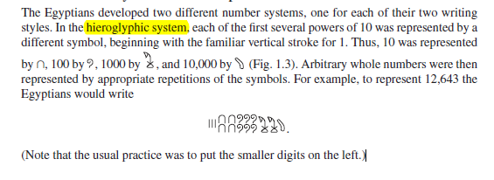

ΠΡΟΣΘΕΣΙΣ ΙΕΡΟΓΛΥΦΙΚΩΝ,
Katz p. 3,
