16 ma, 16 ma, 09-05-2026, ΣΑΒΒΑΤΟΝ,
Webex meeting recording: 16, 09-05-2026 INM 2026-20260510 0151-1
Recording link: https://uoa.webex.com/uoa/ldr.php?RCID=8310a3ea3b8d5c91d4f0607df0b23107,
Password: MaPZ65s3
ΠΡΟΚΑΤΑΡΚΤΙΚΑ,
ΕΞΕΤΑΣΗΣ,
Ότι κειμενα θελετε, ανοικτα βιντεο,

A Mathematician’s Apology, G. H. Hardy, : Hammurabi has perished ?

ΣΧΟΛΙΑ,
ΣΓΠ «3 best british mathematicians, HARDY, LITTLEWOOD and HARDY, LITTLEWOOD»,

p. 11,
If intellectual curiosity, professional pride, and ambition are the dominant incentives to research, then assuredly no one has a fairer chance of satisfying them than a mathematician. His subject is the most curious of all—there is none in which truth plays such odd pranks. It has the most elaborate and the most fascinating technique, and gives unrivalled openings for the display of sheer professional skill. Finally, as history proves abundantly, mathematical achievement, whatever its intrinsic worth, is the most enduring of all. We can see this even in semi-historic civilizations. The Babylonian and Assyrian civilizations have perished; Hammurabi, Sargon, and Nebuchadnezzar (σγπ ΝΑΜΠΟΥΚΟ η ΝΑΒΟΥΧΟΔΟΝΟΣΟΡ Β’ )) are empty names; yet Babylonian mathematics is still interesting, and the Babylonian scale of 60 is still used in astronomy.
But of course the crucial case is that of the Greeks.
The Greeks were the first mathematicians who are still ‘real’ to us to-day. Oriental mathematics may be an interesting curiosity, but Greek mathematics is the real thing. The Greeks first spoke a language which modern mathematicians can understand: as Littlewood said to me once, they are not clever schoolboys or ‘scholarship candidates’, but ‘Fellows of another college’. So Greek mathematics is ‘permanent’, more permanent even than Greek literature. Archimedes will be remembered when Aeschylus is forgotten, because languages die and mathematical ideas do not. ‘Immortality’ may be a silly word, but probably a mathematician
has the best chance of whatever it may mean.

ΕΠΙΣΤΗΜΕΣ ΣΤΗΝ ΜΕΣΟΠΟΤΑΜΙΑ,

ΑΣΤΡΟΝΟΜΙΑ ΒΑΒΥΛΩΝΙΩΝ,
ΜΟΙΡΕΣ, ΛΕΠΤΑ, ΔΕΥΤΕΡΟΛΕΠΤΑ, κλπ
??? ΠΡΟΒΛΕΨΕΙΣ ΕΚΛΗΨΕΩΝ ΣΕΛΗΝΗΣ,
Journal for the History of Astronomy
Lunar Eclipse Times Predicted by the Babylonians
J. M. Steele, F. R. Stephenson
First Published May 1, 1997 Research Article
https://en.wikipedia.org/wiki/History_of_astronomy#cite_ref-dp1998_17-0, History of astronomy
Astronomy is the oldest of the natural sciences, dating back to antiquity, with its origins in the religious, mythological, cosmological, calendrical, and astrological beliefs and practices of prehistory: vestiges of these are still found in astrology, a discipline long interwoven with public and governmental astronomy, and not completely disentangled from it until a few centuries ago in the Western World (see astrology and astronomy). In some cultures, astronomical data was used for astrological prognostication.

Ancient astronomers were able to differentiate between stars and planets, as stars remain relatively fixed over the centuries while planets will move an appreciable amount during a comparatively short time.

The origins of Western astronomy can be found in Mesopotamia, the "land between the rivers" Tigris and Euphrates, where the ancient kingdoms of Sumer, Assyria, and Babylonia were located.
A form of writing known as cuneiform (ΣΦΗΝΟΕΙΔΗΣ), emerged among the Sumerians around 3500–3000 BC. Our knowledge of Sumerian astronomy is indirect, via the earliest Babylonian star catalogues dating from about 1200 BC. The fact that many star names appear in Sumerian suggests a continuity reaching into the Early Bronze Age. Astral theology, which gave planetary gods an important role in Mesopotamian mythology and religion, began with the Sumerians. They also used a sexagesimal (base 60) place-value number system, which simplified the task of recording very large and very small numbers. The modern practice of dividing a circle into 360 degrees, of 60 minutes each, began with the Sumerians. For more information, see the articles on Babylonian numerals and mathematics.

Babylonian astronomy was the basis for much of what was done in Greek and Hellenistic astronomy, in classical Indian astronomy, in Sassanian Iran, in Byzantium, in Syria, in Islamic astronomy, in Central Asia, and in Western Europe.( Pingree, David (1998), "Legacies in Astronomy and Celestial Omens", in Dalley, Stephanie, The Legacy of Mesopotamia, Oxford University Press, pp. 125–137, ISBN 0-19-814946-8.)

ΑΡΙΘΜΟΙ βαβυλωνιων,

INFO
Cuneus (ΣΦΗΝΑ), comprises the Latin root of cuneiform, which means wedge (ΣΦΗΝΑ, ΣΦΗΝΟΕΙΔΗΣ ΓΡΑΦΗ), ). A triangular reed (ΚΑΛΑΜΟΣ) or stylus was used to form cuneiform signs in wet clay. Clay tablets (πλακιδιον η πινακιδα, από πηλο), were then dried in the sun to permanently fix the writing (Fairbank, 1970). Sumerian cuneiform existed as the first written language.

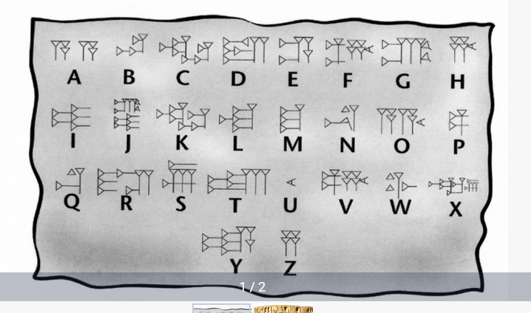
Cuneiform script - world’s first ever writing system,
https://azertag.az/en/xeber/Cuneiform_script___worlds_first_ever_writing_system-2106473,

Cuneiform script,
Go BURTON p. 20
BURTON, p. 24,

ΒΑΒΥΛΩΝΙΑΚΟΙ ΑΡΙΘΜΟΙ,

Babylonian numerals
https://mathshistory.st-andrews.ac.uk/HistTopics/Babylonian_numerals/,
The Babylonian civilisation in Mesopotamia replaced the Sumerian civilisation and the Akkadian civilisation. We give a little historical background to these events in our article Babylonian mathematics. Certainly in terms of their number system the Babylonians inherited ideas from the Sumerians and from the Akkadians. From the number systems of these earlier peoples came the base of 60, that is the sexagesimal system. Yet neither the Sumerian nor the Akkadian system was a positional system and this advance by the Babylonians was undoubtedly their greatest achievement in terms of developing the number system. Some would argue that it was their biggest achievement in mathematics.

Often when told that the Babylonian number system was base 60 people's first reaction is: what a lot of special number symbols they must have had to learn. Now of course this comment is based on knowledge of our own decimal system which is a positional system with nine special symbols and a zero symbol to denote an empty place. However, rather than have to learn 10 symbols as we do to use our decimal numbers, the Babylonians only had to learn two symbols to produce their base 60 positional system.

Now although the Babylonian system was a positional base 60 system, it had some vestiges of a base 10 system within it. This is because the 59 numbers, which go into one of the places of the system, were built from a 'unit' symbol and a 'ten' symbol.

Here are the 59 symbols built from these two symbols
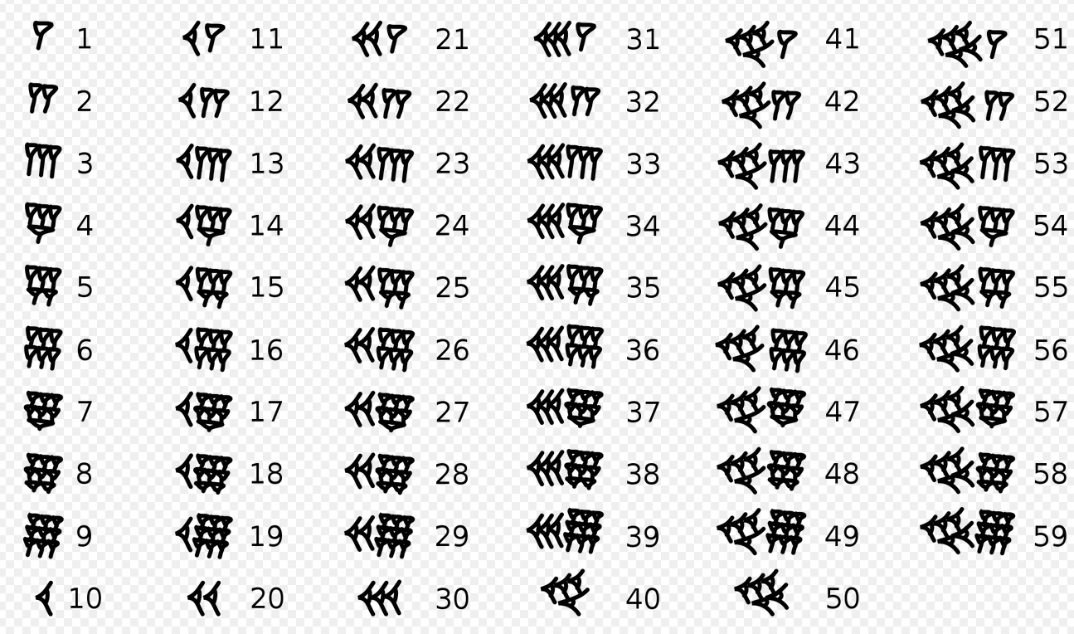

Here is 1,57,46,40 in Babylonian numerals, and 424000 decimal
