15 ΜΑΘΗΜΑ, 15 MATHMA, PARASKEYH 08-05-2026,
Webex meeting recording: 15, 08-05-2026 INM 2026-20260509 2331-1
Recording link: https://uoa.webex.com/uoa/ldr.php?RCID=323de32b34fe4da79f5e3e50f2e3e34e,
Password: eMTMwwR8
ΠΡΟΚΑΤΑΡΚΤΙΚΑ,
Δυνατοτητα υποβολης εργασιας εκπροθεσμα ?
Εξετασης Παρασκευη 26 ιουνιου ?
Αυριανη Προχειρη Εξετασεις, . Χτησις κειμενου
1001LyshSGPTimianhKaratheodorySynenteukshTouEinstein

ΜΕΣΟΠΟΤΑΜΙΑ, OLD BABYLON,

ΓΕΝΙΚΗ ΘΕΩΡΗΣΗ τησ ΜΕΣΟΠΟΤΑΜΙΑΣ,
GOTO KATZ p.10,
The Mesopotamian civilization is perhaps a bit older than the Egyptian, having developed in the Tigris and Euphrates River valley beginning sometime in the fifth millennium bce. Many different governments ruled this region over the centuries.

Initially, there were many small city-states, but then the area was unified under a dynasty from Akkad, which lasted from approximately 2350 to 2150 bce. Shortly thereafter, the Third Dynasty of Ur rapidly expanded until it controlled most of southern Mesopotamia. This dynasty produced a very centralized bureaucratic state. In particular, it created a large system of scribal schools to train members of the bureaucracy. Although the Ur Dynasty collapsed around 2000 bce, the small city-states that succeeded it still demanded numerate scribes.

Sumer civilization,
GOOGLE soymer civilization, AI
Sumerian civilization, located in southern Mesopotamia (modern-day Iraq), was the earliest known civilization, emerging during the 5th–4th millennium BC. Known for creating the first cities—including Uruk and Ur—they invented cuneiform writing, the wheel, and a sexagesimal time system. Sumerians developed advanced agriculture, irrigation, and a city-state structure governed by kings.
Cuneiform,
Cuneus. latin wedge, σφηνα,
Google Cuneiform, AI
Cuneiform is the oldest known form of writing, developed by the Sumerians in Mesopotamia (modern-day Iraq) around 3,200 BC. It is characterized by wedge-shaped marks pressed into soft clay tablets using a reed stylus. Initially used for record-keeping, it evolved over 3,000 years to record literature, law codes, and trade.

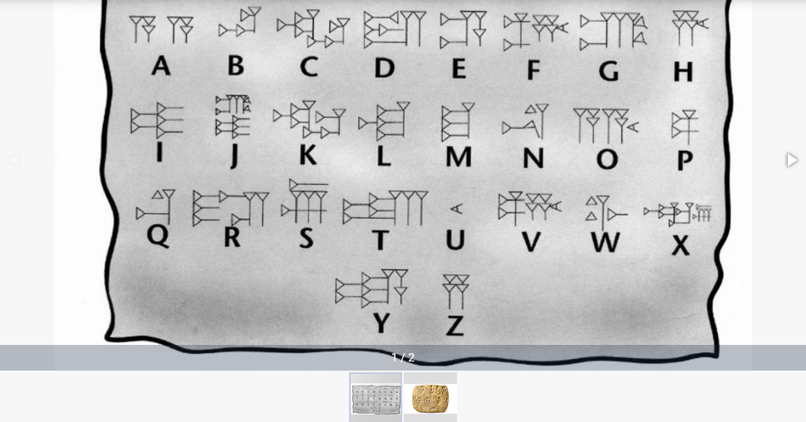

Gilgamesh,
GOOGLE sumer civilization Gilgamesh AI,
Gilgamesh was a (μαλλον) historical king of the Sumerian city-state of Uruk who ruled circa 2800–2500 BC and was later deified, becoming the hero of the Epic of Gilgamesh, the world's oldest known work of literature. He is credited with building Uruk’s massive city walls and is celebrated in tales of friendship, mortality, and power (εξουσια).

The Epic of Gilgamesh
Origin: The stories began as independent Sumerian poems (c. 2100 BCE) and were later combined and expanded into Akkadian versions.
Plot: The epic follows Gilgamesh and his friend Enkidu on journeys to defy monsters (Humbaba, the Bull of Heaven) and his subsequent, futile quest for immortality after Enkidu’s death.
Themes: It addresses the human condition, the inevitability of death, the importance of legacy, and the role of a leader
ΣΓΠ. Θεωρειται ότι επιρρεασε τον ΟΜΗΡΟ, π.χ. δοξα «αφθιτον κλεος»,
και την Εβραικη Βιβλο (Χριστιανικη Παλαια Διαθηκη (π.χ. κατακλυσμος,).

Hammurabi, ΧΑΜΟΥΡΑΜΠΙ, ΝΟΜΟΘΕΤΗΣ, ΠΟΛΙΤΙΚΟΣ,
Κκ ΧΑΜΜΟΥΡΑΜΠΙ,

GOTO KATZ p.10,
By 1750 bce, (περιπου 1800π.Χ), Hammurabi, the ruler of (old) Babylon, one of these city-states, had expanded his rule to much of Mesopotamia and instituted a legal system to help regulate his empire (Fig. 1.6).

Hammurabi also spelled Hammurapi, was the sixth Amorite king of the Old Babylonian Empire, reigning from c. 1792 to c. 1750 BC.

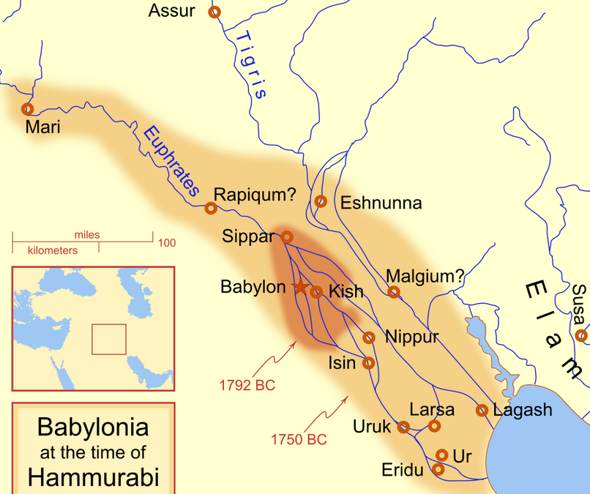
Map showing the Babylonian territory upon Hammurabi's ascension in c. 1792 BC and upon his death in c. 1750 BC. https://en.wikipedia.org/wiki/Hammurabi,
PERSIAN GULF,
Strait (πορθμος, στενα) of Hormuz.
STRAIT, a narrow passage of water connecting two seas or two other large areas of water.
Ο πορθμός είναι ναυτικός γεωγραφικός όρος, με τον οποίο χαρακτηρίζεται η φυσική στενή λωρίδα θάλασσας που χωρίζοντας δύο στεριές ενώνει δύο μεγαλύτερες θάλασσες. Είναι ιδιαίτερος όρος του αμφίγειου. Οι πορθμοί άλλοτε είναι πολύ μακρείς και άλλοτε δαιδαλώδεις. https://el.wikipedia.org/wiki/%CE%A0%CE%BF%CF%81%CE%B8%CE%BC%CF%8C%CF%82,

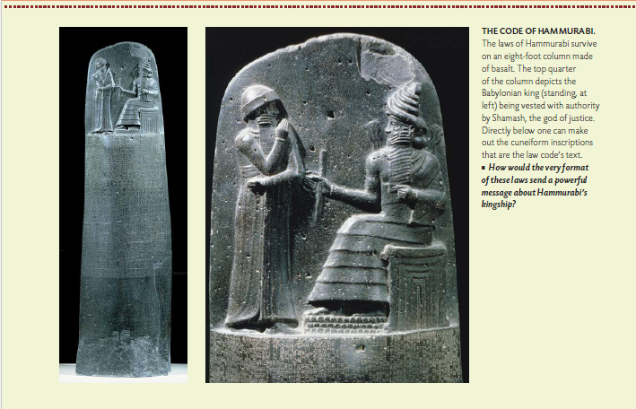
ColeSymes, p 18,
Hammurabi (standing) receiving his royal insignia from Shamash θεος δικαιοσυνης (or possibly Marduk, ο μειζων θεοσ)
Code of Hammurabi, king of Babylon; front, bas-relief.
Bas-relief. Relief sculpture—sculpture that projects in varying degrees from a two-dimensional background—has a distinguished history dating back over 20,000 years in Eastern and Western cultures. Alto-relievo (high relief) approaches three dimensions while bas-relief (low relief) at times is more akin to two-dimensional drawing.
The term relief is from the Latin verb relevare, to raise (lit. to lift back). To create a sculpture in relief is to give the impression that the sculpted material has been raised above the background plane.

https://en.wikipedia.org/wiki/Hammurabi,
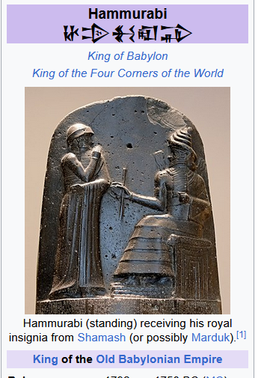

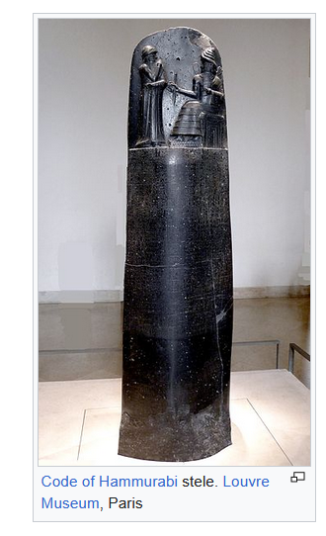
https://en.wikipedia.org/wiki/Hammurabi,
Code of Hammurabi stele. Louvre Museum, Paris. https://en.wikipedia.org/wiki/Hammurabi,

Because of Hammurabi's reputation as a lawgiver, his depiction can be found in law buildings throughout the world. Hammurabi is one of the 23 lawgivers depicted in marble bas-reliefs in the chamber of the U.S. House of Representatives in the United States Capitol.[34] A frieze by Adolph Weinman depicting the "great lawgivers of history", including Hammurabi, is on the south wall of the U.S. Supreme Court building.[35][36]. https://en.wikipedia.org/wiki/Hammurabi,

23 lawgivers depicted in marble bas-reliefs in the chamber of the U.S. House of Representatives in the United States Capitol,
https://www.aoc.gov/explore-capitol-campus/art/relief-portrait-plaques-lawgivers,
The 23 marble relief portraits over the gallery doors of the House Chamber in the U.S. Capitol depict historical figures noted for their work in establishing the principles that underlie American law. They were installed when the chamber was remodeled in 1949-1950. Created in bas relief of white Vermont marble by seven different sculptors, the plaques each measure 28 inches in diameter.
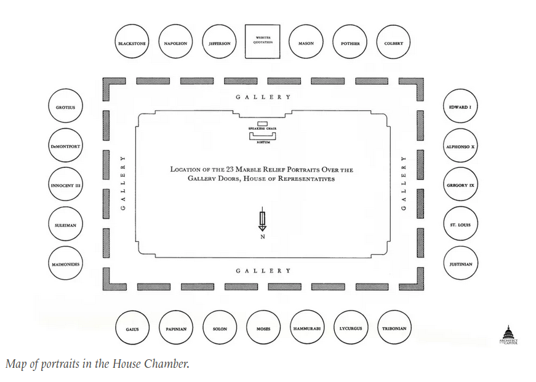
The 11 profiles in the eastern half of the chamber face left and the 11 in the western half face right, so that all look towards the full-face relief of Moses in the center of the north wall.

The subjects of the reliefs were chosen by scholars from the University of Pennsylvania and the Columbia Historical Society of Washington, D.C., in consultation with authoritative staff members of the Library of Congress. The selection was approved by a special committee of five Members of the House of Representatives and the Architect of the Capitol.

The plaster models for these reliefs are on display on the walls in the Rayburn House Office Building subway terminal.
LIST OF THE 23,
Alfonso X
Edward I
Gaius
George Mason
Gregory IX
Hammurabi
Hugo Grotius
Innocent III
Jean Baptiste Colbert
Justinian I
Lycurgus
Maimonides
Moses
Napoleon I
Papinian
Robert Joseph Pothier
Saint Louis
Simon de Montfort
Solon
Suleiman
Thomas Jefferson. All men were created equal !
https://en.wikipedia.org/wiki/All_men_are_created_equal,
Thomas Jefferson during the beginning of the Revolutionary War in 1776.[1] It reads:
"We hold these truths to be self-evident, that all men are created equal, that they are endowed by their Creator with certain unalienable Rights, that among these are Life, Liberty and the pursuit of Happiness."
Tribonian
Sir William Blackstone,

ΚΕΝΤΡΙΚΕΣ ΑΡΧΕΣ,
οφθαλμόν αντί οφθαλμού
π.χ. αν σκοτωσεις το παιδι του γειτονα, klp klp
ΓΥΝΑΙΚΕΣ και φτωχοι, ανδρεσ…

ΕΠΙΡΡΟΗ στην ΕΒΡΑΙΚΗ ΒΙΒΛΟ,
GOOGLE οφθαλμος αντι οφθαλμου
AI Overview
Η φράση «οφθαλμόν αντί οφθαλμού» αποτελεί βιβλική αρχή δικαιοσύνης (από τον Μωσαϊκό Νόμο) που σημαίνει αναλογική ανταπόδοση: η τιμωρία πρέπει να είναι ίση με το αδίκημα (μάτι αντί για μάτι, δόντι αντί για δόντι). Σκοπός της ήταν να περιορίσει την υπερβολική εκδίκηση, αν και συχνά παρερμηνεύεται ως δικαιολογία για αντεκδίκηση.
Βασικά Στοιχεία:
Προέλευση: Βιβλική αναφορά (Λευιτικόν 24:20, Εξοδος 21:24).
Σημασία: Ίση ανταπόδοση. Ορίζει ότι η ποινή πρέπει να είναι ανάλογη της ζημιάς που προκλήθηκε, αποτρέποντας την κλιμάκωση της βίας.
Πλαίσιο: Στην Παλαιά Διαθήκη λειτουργούσε ως νομικός κανόνας για την απονομή δικαιοσύνης.
Αντίθεση: Στην Καινή Διαθήκη, ο Ιησούς στην Επί του Όρους Ομιλία διδάσκει την υπέρβαση αυτής της αρχής με τη συγχώρεση.
Χρήση: Σήμερα χρησιμοποιείται μεταφορικά για να περιγράψει την αντεκδίκηση, ενώ είναι και τίτλος διαφόρων καλλιτεχνικών έργων (π.χ. ταινίες).

https://www.ekklisiaonline.gr/arxontariki/ofthalmo-anti-ofthalmoy-kai-odonta-anti-odontos-einai-dynaton/,
απόψη της EKKΛΗCIA ON LINE,
Του καθηγητή Νικολάου Μπρατσιώτη Από ομιλία στο Σεμινάριο Ορθοδόξου Πίστεως

ΣΗΜΕΡΑ ΤΙ ΙΣΧΥΕΙ ?
Σκοπος της ποινης είναι η επανενταξη στην κοινωνια.

HAMMURABI ΠΟΛΙΤΙΚΟΣ,

ColeSymes, p. 18
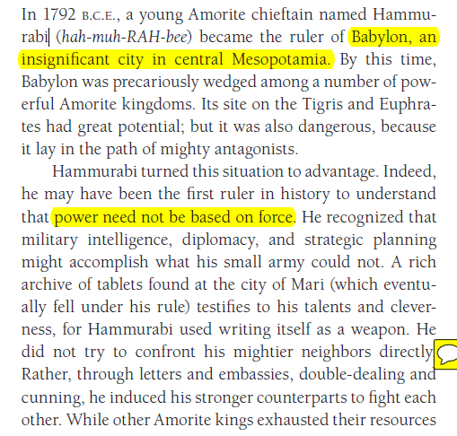
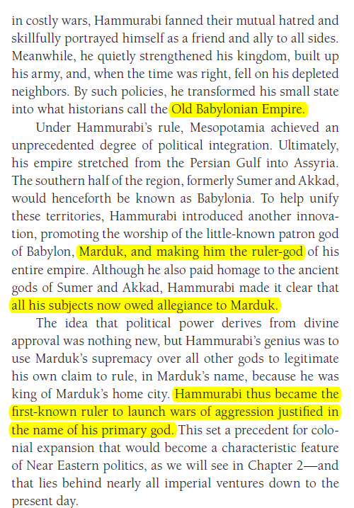
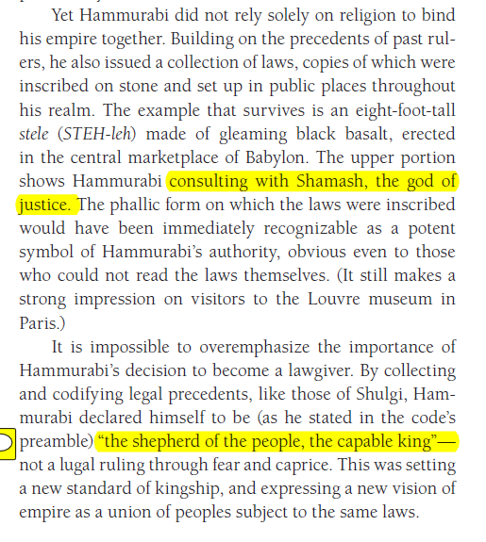

CODE OF HAMMURABI
https://en.wikipedia.org/wiki/Code_of_Hammurabi,
The Code of Hammurabi is a well-preserved Babylonian code of law of ancient Mesopotamia, dated back to about 1754 BCE (Middle Chronology). It is one of the oldest deciphered writings of significant length in the world. The sixth Babylonian king, Hammurabi, enacted the code. A partial copy exists on a 2.25 metre (7.5 ft) stone stele. It consists of 282 laws, with scaled punishments, adjusting "an eye for an eye, a tooth for a tooth" (lex talionis)[1] (talionis, retaliation ), as graded depending on social status, of slave versus free, man or woman.[2]

https://en.wikipedia.org/wiki/Hammurabi,
Hammurabi is best known for having issued the Code of Hammurabi, which he claimed to have received from Shamash, the Babylonian god of justice. Unlike earlier Sumerian law codes, such as the Code of Ur-Nammu, which had focused on compensating the victim of the crime, (είναι δικαιοτερο ?) the Law of Hammurabi was one of the first law codes to place greater emphasis on the physical punishment of the perpetrator. It prescribed specific penalties for each crime and is among the first codes to establish the presumption of innocence. They were intended to limit what a wronged person was permitted to do in retribution. The Code of Hammurabi and the Law of Moses in the Torah contain numerous similarities.

