09 μαθημα, 09 MATHHMA, 27-03-2026, ΠΑΡΑΣΚΕΥΗ, 9-11μμ,
Webex meeting recording: 09 math INM 2026-20260327 2107-1
Recording link: https://uoa.webex.com/uoa/ldr.php?RCID=20901dcad6f414dc445729aeda0d4a95,
Password: UqfYcmq8,
ΠΡΟΚΑΤΑΡΚΤΙΚΑ,
Ενημερωση για κάθε σαββατο
Μεθαυριο προθεσμια για την 1008, thn trith προθεσμια για εργασια 1001.
Εμφαση στην διαμορφοση, λαθος, κακογραμμενο και γιατι.
ΕΠΑΝΑΛΗΨΗΣ, «ΠΕΡΙΛΗΨΗΣ»

The Concept of CIVILIZATION,

Last Glacial Period, (ICE AGE, ΕΠΟΧΗ ΤΩΝ ΠΑΓΕΤΩΝΩΝ), Period (c. 115,000–10,00 B.C.),
AI. The last glacial age, or Last Glacial Period (c. 115,000–10,00 B.C.), was the most recent cold phase in Earth's history, characterized by massive ice sheet expansion and lower sea levels. It peaked during the Last Glacial Maximum (around 24,500–18,000 years ago), with temperatures 6-10 celsius colder than today, featuring significant human adaptation to extreme environments.
COLESYMES p.3
To the peoples of the ancient world, the characteristic benefits of
civilization—stability and safety, government, art, literature,
science—were always products of city life. The very
word civilization derives from the Latin word civis, “city.”, (πολις, πολιτισμοσ).
Cities, however, became possible only as a result of innovations
that began around the end of the last Ice Age, about 11,000 BC, and that came to fruition in Mesopotamia 3,000 BC. The history of civilization is therefore a short one.
Within the study of humanity, which reaches back to the genus Homo in Africa, some 1.7 million years ago, it is merely a blip on the radar screen.
Futhermore within the history of Homo sapiens, the subspecies to which we all
belong and which evolved about 40,000 years ago, civilization is a very recent development.
ΣΓΠ. Ο HOMO SAPIENS που εφυγε από το ΚΕΡΑΣ ΤΗΣ ΑΦΡΙΚΗΣ c. 300,000 and 200,000 years ago (BC), μεχρι c. 40000, απεκτησε την Behavioral modernity, involving the development of language, figurative art (describes artwork particularly paintings and sculptures that is clearly derived from real object), and early forms of religion (etc.) is taken to have arisen before 40,000 years ago,
The study of early civilizations is both fascinating
and challenging. Historians still do not understand why
the first-known cities should have developed in the region
between the Tigris and the Euphrates Rivers, in what is
now Iraq. Once developed, however, the basic patterns of
urban life quickly spread to other parts of the Near East,
both by imitation and by conquest (η κατι «ενδιαμεσο»).
A network of trading connections linked these early cities, but intense competition
for resources made alliances among them fragile. Then,
around the middle of the second millennium B.C.E. (that is,
“Before the Common Era,” equivalent to the Christian dating
system B.C., “Before Christ”), emerging powers began to
shape these fiercely independent cities into empires.

ΚΥΝΗΓΟΙ, Τροφοσυλεκτες (HUNTERS GATHERERS), εως 8000 πΧ,
AI Overview
Hunter-gatherers are societies that obtain food primarily by foraging, fishing, and hunting wild animals rather than relying on agriculture, a lifestyle that was universal until approximately 8,000 BCE. These, usually nomadic, communities lived in small, egalitarian groups, utilizing tools made from stone, bone, and wood to adapt to diverse environments across the globe.
ΣΓΠ. Δουλοι,
COLESYMES Page 5,
However, archaeology has shown that in the last
phase of the Paleolithic Era, (εωσ c. 10.000 π.Χ.), around 40,000 B.C.E., the pace
of human development began to accelerate dramatically.
Human populations in Africa expanded, suggesting that
people were better nourished, perhaps as a result of new
technologies. In Europe, species Homo sapiens
began to produce finely crafted and more effective tools
such as fishhooks, arrowheads, and sewing needles made from wood, antler, and bone. The most astonishing evidence of this change was produced by these new tools: cave
paintings like those at Lascaux and Chauvet (France)—
those at Chauvet were discovered only in 1994—some
of which may be 30,000 years old. These amazing scenes
were purposefully painted in recesses where acoustic resonance
is greatest, and were probably intended to be experienced
as part of multimedia musical ceremonies. Flutes (ελλ. ΦΛΑΟΥΤΟ)
made from bone and ivory, dating to around 33,000 B.C.E.,
were found in a cave in southern Germany in 2008.) This
is almost certain evidence for the development of language.
…
Despite these extraordinary changes, the basic patterns
of human life altered very little during this era. Virtually
all human societies consisted of hunter-gatherers, bands
of a few dozen people who moved incessantly in search of
food. As a result of this constant movement, these groups
have left no continuous archaeological record. Yet we can
discern some of the social, economic, and political structures
that make these subsistence societies different from those that can be called “civilizations.”
Early humans had no domestic animals to transport goods, so they could have
no significant material possessions aside from basic tools.
And because they could not accumulate goods over time,
the distinctions of rank and status created by disparities
in wealth could not develop. Hierarchical structures were
therefore uncommon. (Ουτε ΔΟΥΛΟΙ), When conflicts arose among members
of a group or resources became scarce, the solution was probably to divide and separate.
Although scholars once assumed that men did the
hunting and women the gathering, such gendered presumptions do not reflect the complex realities of modern hunter-gatherer societies and they are probably not applicable to the Paleolithic Period, either.
It is more likely that all members of a band (except for the very young and very
old) engaged in the basic activity of acquiring food.

THE BUILDING BLOCKS OF CIVILIZATION
What changes allowed some hunter-gatherer societies to
settle and build civilizations? Around 11,000 B.C.E., very
evident developments brought about by changes in the climate
led to the development of managed food production,
which in turn fostered settlements that could trade with
one another, both locally and over long distances. For the
first time, it became possible for individuals and communities
to accumulate and store wealth on a large scale. The
results were far-reaching. Communities became more stable,
and human interactions more complex. Specialization
developed, along with distinctions of status and rank. Both
the rapidity and the radical implications of these changes
have given this era its name: the Neolithic Revolution.

Paleolithic
https://en.wikipedia.org/wiki/Paleolithic,
The Paleolithic or Palaeolithic (εωσ c. 10.000 π.Χ.) (/ˌpeɪlioʊˈlɪθɪk, ˌpæli-/ PAY-lee-oh-LITH-ik, PAL-ee-), also called the Old Stone Age (from Ancient Greek παλαιός (palaiós) 'old' and λίθος (líthos) 'stone'), is a period in human prehistory that is distinguished by the original development of stone tools, and which represents almost the entire period of human prehistoric technology. It extends from the earliest known use of stone tools by hominins, c. 3.3 million years ago, to the end of the Pleistocene, c. 11,650 cal BP.[1]

Neolithic Revolution, ΝΕΟΛΙΘΙΚΗ ΕΠΑΝΑΣΤΑΣΙΣ, Agricultural Revolution,(ΑΓΡΟΤΙΚΗ ΕΠΑΝΑΣΤΑΣΗ),
https://en.wikipedia.org/wiki/Neolithic_Revolution#In_the_Fertile_Crescent, AI
Neolithic Revolution c. 10.000 BCE
The Neolithic Revolution, Agricultural Revolution, or First Agricultural Revolution was the wide-scale transition of many human cultures during the Neolithic period from a lifestyle of Hunting and Gathering (ΚΥΝΗΓΟΙ ΚΑΙ ΤΡΟΦΟΣΥΛΛΕΚΤΕΣ), to one of agriculture and settlement, making an increasingly larger population possible.[1] These settled communities permitted humans to observe and experiment with plants to learn how they grew and developed.[2] This new knowledge led to the domestication of plants.[2][3]
AI, Neolithic Revolution, starting around 8,000–10,000 years ago,
Archaeological data indicates that the domestication of various types of plants and animals happened in separate locations worldwide, starting in the geological epoch of the Holocene[4]
The Holocene is (Ολόκαινος εποχή ) the current geological epoch. It began approximately 11,650 cal years Before Present ( c. 9701 BCE), after the Last Glacial Period, ...
AI, Neolithic Revolution c. 10.000 BCE)
.[5] It was the world's first historically verifiable revolution in agriculture. The Neolithic Revolution greatly narrowed the diversity of foods available, resulting in a downturn in the quality of human nutrition.[6]

The Neolithic Revolution involved far more than the adoption of a limited set of food-producing techniques. During the next millennia it would transform the small and mobile groups of hunter-gatherers that had hitherto dominated human pre-history into sedentary (non-nomadic) societies based in built-up villages and towns. These societies radically modified their natural environment by means of specialized food-crop cultivation, with activities such as irrigation and deforestation which allowed the production of surplus food. Other developments found very widely are the domestication of animals, pottery, polished stone tools, and rectangular houses.

These developments, sometimes called the Neolithic package, provided the basis for centralized administrations and political structures, hierarchical ideologies, depersonalized systems of knowledge (e.g. writing), densely populated settlements, specialization and division of labour, more trade, the development of non-portable art and architecture, and property ownership.

The relationship of the above-mentioned Neolithic characteristics to the onset of agriculture, their sequence of emergence, and empirical relation to each other at various Neolithic sites remains the subject of academic debate, and varies from place to place, rather than being the outcome of universal laws of social evolution.[8][9] The Levant saw the earliest developments of the Neolithic Revolution from around 10,000 BCE, followed by sites in the wider Fertile Crescent.
GO “CRESCENT, Maps”
ΣΧΟΛΙΟΝ. ΠΕΡΙ ΤΟ 10000π.Χ. στην ΜΕΣΗ ΑΝΑΤΟΛΗ, εγιναν ουσιαστικα ταυτοχρονα
ΜΟΝΙΜΕΣ ΕΓΚΑΤΑΣΤΑΣΕΙΣ, ΓΕΩΡΓΙΚΗ ΕΠΑΝΑΣΤΑΣΙΣ, ΝΕΟΛΙΘΙΚΗ ΠΕΡΙΟΔΟΣ me βελτιομενα εργαλεια,

earliest known civilization developed in Sumer
The earliest known civilization developed in Sumer in southern Mesopotamia (c. 6,500 before present, η c. 4500 π.χ.); its emergence also heralded the beginning of the Bronze Age.[7]

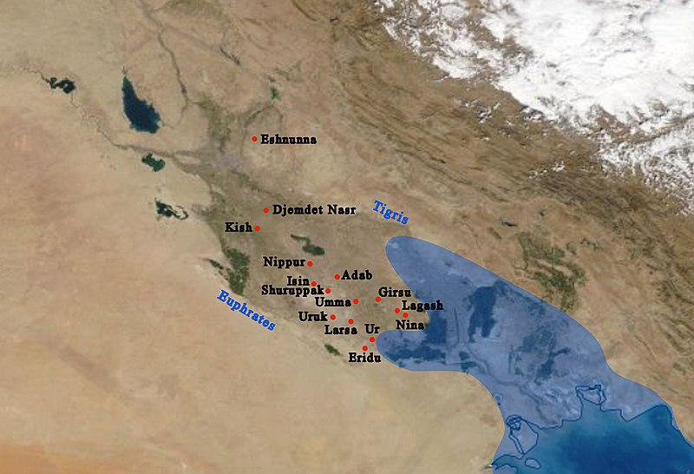
The general location on a modern map, and main cities of Sumer with ancient coastline. The coastline nearly reached Ur in ancient times.

A Sumerian harvester's sickle, dated to 3,000 BC
https://en.m.wikipedia.org/wiki/File:ClaySumerianSickle.jpg,
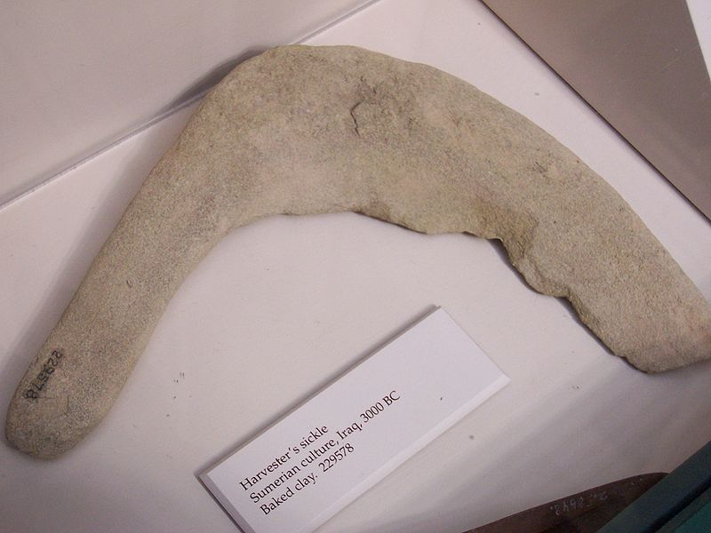

Bronze Age (~3500 BCE),
BRONZE, (ΜΠΡΟΥΝΤΖΟΣ, ΟΡΕΙΧΑΛΚΟΣ),

Bronze, (copper+tin)
Wikipedia, https://en.wikipedia.org/wiki/Bronze,
Bronze (ΟΡΕΙΧΑΛΚΟ, δηλ χαλκος από τα βουνα) is an alloy (κραμα), consisting primarily of copper (χαλκος), commonly with about 12–12.5% tin (κασσιτερος, λατινικά: stannum, συμβολο Sn ),
and often with the addition of other metals (including aluminium, manganese, nickel, or zinc (ψευδαργυρος, συμβολο Zn, ΤΣΙΓΚΟΣ), and sometimes non-metals, such as phosphorus, or metalloids such as arsenic or silicon. These additions produce a range of alloys (ΚΡΑΜΑ), that may be harder than copper alone, or have other useful properties, such as strength, ductility, or machinability.

Ductility is
a physical property of materials, particularly metals, that describes their capacity to be stretched, drawn, or deformed into thin wires or shapes without breaking.
Machinability refers to the relative ease with which a metal or material can be cut, shaped, or finished by machine tools to a desired surface quality. High-machinability materials permit faster cutting speeds, lower power usage, and longer tool life, directly reducing manufacturing costs and improving efficiency.

The archaeological period in which bronze was the hardest metal in widespread use is known as the Bronze Age. The beginning of the Bronze Age in western Eurasia and India is conventionally dated to the mid-4th millennium BCE (~3500 BCE), and to the early 2nd millennium BCE in China;[1] elsewhere it gradually spread across regions.
SGP
Οι ηρωες του ΟΜΗΡΟΥ ειχαν οπλα από ΟΡΕΙΧΑΛΚΟ (BRONZE)
ΟΙ ΡΩΜΗ κατεκτησαν ΑΓΓΛΙΑ, λογω κοιτασματων ΚΑΣΣΙΤΕΡΟΥ

The Bronze Age was followed by the Iron Age starting from about 1300 BCE and reaching most of Eurasia by about 500 BCE, although bronze continued to be much more widely used than it is in modern times.

BRASS,
a yellow alloy of copper and zinc.

Historical artworks were often made of brasses (??? ΟΡΕΙΧΑΛΚΟΣ, copper and zinc (Ψευδάργυρος) ) and bronzes with different compositions. Bronze (ΜΠΡΟΥΝΤΖΟΣ, is an different alloy (κραμα), consisting primarily of copper (χαλκος), tin (κασσιτεροσ) ),
Modern museum and scholarly descriptions of older artworks increasingly use the generalized term "copper alloy"(ΚΡΑΜΑ ΧΑΛΚΟΥ), instead.[2],
ΣΓΠ. BRASS (copper and zinc (Ψευδάργυρος), αμφιβολου μεταφρασης στην ελληνικην.

IRON AGE, c. 1200 – c. 550 BC,
ΣΙΔΗΡΟΣ Φθηνοτερο από ΧΑΛΚΟ, καταλληλοτερος για ΟΠΛΑ.

ΜΑΧΗ ΜΑΡΑΘΩΝΑ 490 πΧ,
στην μαχη του μαραθωνα υπηρχαν σιδηρα οπλα ?
Στη μάχη του Μαραθώνα (490 π.Χ.), τα όπλα ήταν κυρίως
ορειχάλκινα (μπρούντζινα), αλλά ο σίδηρος είχε ήδη αρχίσει να χρησιμοποιείται για τις αιχμές και τις λεπίδες.
Παρόλο που η εποχή του Σιδήρου είχε ξεκινήσει αιώνες πριν, ο ορείχαλκος παρέμενε το κυρίαρχο υλικό για την αμυντική πανοπλία λόγω της αντοχής του στη διάβρωση και της ευκολίας στη χύτευση. Συγκεκριμένα:

Επιθετικά όπλα: Οι λεπίδες των ξιφών (ξίφος ή κοπίς) και οι αιχμές των δοράτων των οπλιτών ήταν συχνά κατασκευασμένες από σίδηρο, καθώς ήταν σκληρότερος και κρατούσε καλύτερα την κόψη του σε σχέση με τον ορείχαλκο.
Αμυντικός εξοπλισμός: Η πανοπλία (θώρακας), η περικεφαλαία και η ασπίδα των Ελλήνων οπλιτών συνέχιζαν να κατασκευάζονται από ορείχαλκο.
Περσικός εξοπλισμός: Οι Πέρσες χρησιμοποιούσαν επίσης σιδερένια όπλα (όπως εγχειρίδια και αιχμές βελών), αλλά η θωράκισή τους ήταν ελαφρύτερη, συχνά από δέρμα ή ύφασμα, γεγονός που έδωσε πλεονέκτημα στους βαριά οπλισμένους Έλληνες.
ΣΓΠ. Οι περσες ειχαν τοξα και ιππικο.

TIMELINE,
Homo sapiens dispersed from Africa in several waves, from possibly as early as 250,000 years ago, and certainly by 130,000 years ago.
Homo sapiens Behavioral modernity,
is taken to have arisen before 40,000 years ago,
Behavioral modernity, :
involving the development of language, figurative art (describes artwork particularly paintings and sculptures that is clearly derived from real object), and early forms of religion
abstract thinking, planning in depth, music and dance, exploitation of large game, and blade technology, (etc.) is taken to have arisen before 40,000 years ago,

Last Glacial Period, (ICE AGE, ΕΠΟΧΗ ΤΩΝ ΠΑΓΕΤΩΝΩΝ), Period (c. 115,000–10,00 B.C.),
Paleolithic or Palaeolithic (εωσ c. 10.000 π.Χ.)
ΚΥΝΗΓΟΙ, Τροφοσυλεκτες (HUNTERS GATHERERS), εως c. 8000 πΧ,
Neolithic Revolution, starting around 8,000–10,000 years ago,
The Neolithic Revolution involved far more than the adoption of a limited set of food-producing techniques. During the next millennia it would transform the small and mobile groups of hunter-gatherers that had hitherto dominated human pre-history into sedentary (non-nomadic) societies based in built-up villages and towns. These societies radically modified their natural environment by means of specialized food-crop cultivation, with activities such as irrigation and deforestation which allowed the production of surplus food. Other developments found very widely are the domestication of animals, pottery, polished stone tools, and rectangular houses.
c. 4500 π.χ. SUMER
The earliest known civilization developed in Sumer in southern Mesopotamia
The Bronze Age (roughly 3300–1200 BCE) was a pivotal era following the Stone Age,
IRON AGE, c. 1200 – c. 550 BC,

