21 ΔΙΑΛΕΞΙΣ,
Κυριακη, 25-05-2025
Webex meeting recording: 21 INM-20250525 1508-1
Recording link: https://uoa.webex.com/uoa/ldr.php?RCID=4170d3f98b204b08925f50e4ef6f5f76
Password: wKBDCxp9

ΠΛΗΡΟΦΟΡΙΕΣ,
Υπ οψιν, 6004LyshLengthOfBisector, 8001LYSEISApaloifhDeuterouOrou,

[ΑΝΑΛΥΤΙΚΗ ΓΕΩΜΕΤΡΙΑ, ANALYTIC GEOMETRY, 2024 #25,

Pierre de Fermat, BIO

https://en.wikipedia.org/wiki/Pierre_de_Fermat,

Pierre de Fermat (French: [pjɛʁ də fɛʁma];
between 31 October and 6 December 1607[a] – 12 January 1665) was a French mathematician who is given credit for early developments that led to infinitesimal calculus, including his technique of adequality. In particular, he is recognized for his discovery of an original method of finding the greatest and the smallest ordinates of curved lines, which is analogous to that of differential calculus, then unknown, and his research into number theory. He made notable contributions to analytic geometry, probability, and optics.
COMMENT. Unappropriate, very weak, .
He is best known for his Fermat's principle for light propagation and his Fermat's Last Theorem in number theory, which he described in a note at the margin of a copy of Diophantus' Arithmetica. He was also a lawyer[3], (judge) at the Parlement (courts), of Toulouse, France.
ΣΓΠ. ΜΑΖΥ με τον ΚΑΡΤΕΣΙΟ, είναι οι κυριοι θεμελιωτες της ΑΝΑΛΥΤΙΚΗΣ ΓΕΩΜΕΤΡΙΑΣ.

Biography

Fermat was born in 1607 in Beaumont-de-Lomagne, France—the late 15th-century mansion where Fermat was born is now a museum. He was from Gascony, where his father, Dominique Fermat, was a wealthy leather merchant and served three one-year terms as one of the four consuls of Beaumont-de-Lomagne. His mother was Claire de Long.[2] Pierre had one brother and two sisters and was almost certainly brought up in the town of his birth.[citation needed]

He attended the University of Orléans from 1623 and received a bachelor in civil law in 1626, before moving to Bordeaux. In Bordeaux, he began his first serious mathematical researches, and in 1629 he gave a copy of his restoration of Apollonius's De Locis Planis to one of the mathematicians there. Certainly, in Bordeaux he was in contact with Beaugrand and during this time he produced important work on maxima and minima which he gave to Étienne d'Espagnet who clearly shared mathematical interests with Fermat. There he became much influenced by the work of François Viète.[4]

In 1630, he bought the office of a councilor at the Parlement de Toulouse, one of the High Courts of Judicature in France, and was sworn in by the Grand Chambre in May 1631. He held this office for the rest of his life. Fermat thereby became entitled to change his name from Pierre Fermat to Pierre de Fermat. On 1 June 1631, Fermat married Louise de Long, a fourth cousin of his mother Claire de Fermat (née de Long). The Fermats had eight children, five of whom survived to adulthood: Clément-Samuel, Jean, Claire, Catherine, and Louise.[5][6][7]
SGP. COLBERT,
ΣΓΠ. Τοπος γεννησης Beaumont-de-Lomagne

Fluent in six languages (French, Latin, Occitan, classical Greek, Italian and Spanish), Fermat was praised for his written verse in several languages and his advice was eagerly sought regarding the emendation ((editorial change, correction),), of Greek texts. He communicated most of his work in letters to friends, often with little or no proof of his theorems. In some of these letters to his friends, he explored many of the fundamental ideas of calculus before Newton or Leibniz. Fermat was a trained lawyer making mathematics more of a hobby than a profession. Nevertheless, he made important contributions to analytical geometry, probability, number theory and calculus.[8] Secrecy was common in European mathematical circles at the time. This naturally led to priority disputes with contemporaries such as Descartes and Wallis.[9]
COMMENTS on “hobby”,
Anders Hald writes that, "The basis of Fermat's mathematics was the classical Greek treatises combined with Vieta's new algebraic methods."[10]

FERMAT the “AMATEUR”,
Who was Fermat?
https://simonsingh.net/books/fermats-last-theorem/who-was-fermat/,
Pierre de Fermat is one of the top ten greatest mathematicians in history. Alongside Blaise Pascal, he established the foundations of probability theory, which is the mathematics of gambling, risk and change. Also, when Newton was asked where he got the idea of calculus from, he credited “Monsieur Fermat’s method of drawing tangents”. Already it is clear that Fermat has changed the world we live in, because everybody from insurance companies to stock markets use probability theory and everybody from architects to NASA use calculus.
But Fermat’s greatest ideas are in the area of number theory, a subject which has virtually no practical applications. Number theory is the purest form of mathematics, concerned with the study of whole numbers, the relationships between them, and the patterns they form.
By the way, Fermat lived in the 17th century near Toulouse in southwest France, and his day job was as a judge dealing with some of the nastiest cases imaginable, including the condemnation of priests to be burned at the stake. Judges were generally discouraged from socialising within the community in order to avoid a conflict of interests, so Fermat would spend his evenings hidden in his study, pursuing his mathematical interests. He was a truly amateur academic and E.T. Bell called him the Prince of Amateurs. However, when Julian Coolidge wrote Mathematics of Great Amateurs, he excluded Fermat on the grounds that he was ‘so really great that he should count as a professional.’

SGP, η αλλοι αραγε τι ησαν, ??

RENE DESCARTES, DESCARTES RENE,

https://en.wikipedia.org/wiki/Ren%C3%A9_Descartes,
René Descartes (/deɪˈkɑːrt/ or UK: /ˈdeɪkɑːrt/; French: [ʁəne dekaʁt] (listen); Latinized: Renatus Cartesius;^{[note 3][17]} 31 March 1596 – 11 February 1650)^{[18][19][20]: 58} was a French philosopher, scientist, and mathematician, widely considered a seminal figure in the emergence of modern philosophy and science. Mathematics was central to his method of inquiry, and he connected the previously separate fields of geometry and algebra into analytic geometry. Descartes spent much of his working life in the Dutch Republic, initially serving the Dutch States Army, later becoming a central intellectual of the Dutch Golden Age.^{[21]} Although he served a Protestant state and was later counted as a Deist by critics, Descartes was Roman Catholic.^{[22][23]}

Early life

The house where Descartes was born in La Haye en Touraine
René Descartes was born in La Haye en Touraine, Province of Touraine (now Descartes, Indre-et-Loire), France, on 31 March 1596.^{[28]} René Descartes was conceived about halfway through August 1595. His mother, Jeanne Brochard, died a few days after giving birth to a still-born child in May 1597.^{[29][28]} Descartes' father, Joachim, was a member of the Parlement of Brittany at Rennes.^{[30]: 22} René lived with his grandmother and with his great-uncle. Although the Descartes family was Roman Catholic, the Poitou region was controlled by the Protestant Huguenots.^{[31]} In 1607, late because of his fragile health, he entered the Jesuit Collège Royal Henry-Le-Grand at La Flèche,^{[32][33]} where he was introduced to mathematics and physics, including Galileo's work.^{[34][35]} While there, Descartes first encountered hermetic mysticism. After graduation in 1614, he studied for two years (1615–16) at the University of Poitiers, earning a Baccalauréat and Licence in canon and civil law in 1616,^{[34]} in accordance with his father's wishes that he should become a lawyer.^{[36]} From there, he moved to Paris.
In Discourse on the Method, Descartes recalls:^{[37]: 20–21}

In accordance with his ambition to become a professional military officer in 1618, Descartes joined, as a mercenary, (μισθοφορος), the Protestant Dutch States Army in Breda under the command of Maurice of Nassau,^{[34]} and undertook a formal study of military engineering, as established by Simon Stevin.^{[38]: 66} Descartes, therefore, received much encouragement in Breda to advance his knowledge of mathematics.^{[34]}

While in the service of the Catholic Duke Maximilian of Bavaria from 1619,^{[41]} Descartes was present at the Battle of the White Mountain near Prague, in November 1620.^{[42][43]}

France
In 1620, Descartes left the army. He visited Basilica della Santa Casa in Loreto, then visited various countries before returning to France, and during the next few years, he spent time in Paris. It was there that he composed his first essay on method: Regulae ad Directionem Ingenii (Rules for the Direction of the Mind).[40] He arrived in La Haye in 1623, selling all of his property to invest in bonds, which provided a comfortable income for the rest of his life.[38]: 132 [49]: 94 Descartes was present at the siege of La Rochelle by Cardinal Richelieu in 1627.[49]:
SGP. FERMAT, d ARTANIAN.

Netherlands
Descartes returned to the Dutch Republic in 1628.^{[45]} In April 1629, he joined the University of Franeker, studying under Adriaan Metius, either living with a Catholic family or renting the Sjaerdemaslot. The next year, under the name "Poitevin", he enrolled at Leiden University, which at the time was a Protestant University.^{[52]} He studied both mathematics with Jacobus Golius, who confronted him with Pappus's hexagon theorem, and astronomy with Martin Hortensius.^{[53]} In October 1630, he had a falling-out with Beeckman, whom he accused of plagiarizing some of his ideas. In Amsterdam, he had a relationship with a servant girl, Helena Jans van der Strom, with whom he had a daughter, Francine, who was born in 1635 in Deventer. She was baptized a Protestant^{[54][55]} and died of scarlet fever at the age of 5.

Despite frequent moves,^{[note 6]} he wrote all of his major work during his 20-plus years in the Netherlands, initiating a revolution in mathematics and philosophy.^{[note 7]} In 1633, Galileo was condemned by the Italian Inquisition, and Descartes abandoned plans to publish Treatise on the World, his work of the previous four years. Nevertheless, in 1637, he published parts of this work in three essays:^{[60]} "Les Météores" (The Meteors), "La Dioptrique" (Dioptrics) and La Géométrie (Geometry), preceded by an introduction, his famous Discours de la méthode (Discourse on the Method).^{[60]}
In it, Descartes lays out four rules of thought, meant to ensure that our knowledge rests upon a firm foundation:^{[61]}

In La Géométrie, Descartes exploited the discoveries he made with Pierre de Fermat. This later became known as Cartesian Geometry.^{[62]}
https://www.britannica.com/biography/Pierre-de-Fermat
Because Fermat’s Introduction to Loci was published posthumously in 1679, the exploitation of their discovery, initiated in Descartes’s Géométrie of 1637, has since been known as Cartesian geometry.
SGP MahoneyMathematicalCareer, FERMAT 1636, DESCARTES 1637.
https://en.wikipedia.org/wiki/Frans_van_Schooten,
Van Schooten's 1649 Latin translation of and commentary on Descartes' Géométrie was valuable in that it made the work comprehensible to the broader mathematical community, and thus was responsible for the spread of analytic geometry to the world.

Death
Descartes arranged to give lessons to Queen Christina after her birthday, three times a week at 5 am, in her cold and draughty castle. However, by 15 January 1650 the Queen actually met with Descartes only four or five times.^{[72]} It soon became clear they did not like each other; she did not care for his mechanical philosophy, nor did he share her interest in Ancient Greek language and literature.^{[72]} On 1 February 1650, he contracted pneumonia and died on 11 February at Chanut.^{[76]}
As a Catholic^{[84][85][86]} in a Protestant nation, he was interred in a graveyard used mainly for orphans in Adolf Fredriks kyrka in Stockholm. His manuscripts came into the possession of Claude Clerselier, Chanut's brother-in-law, and "a devout Catholic who has begun the process of turning Descartes into a saint by cutting, adding and publishing his letters selectively."^{[87][88]: 137–154} In 1663, the Pope placed Descartes' works on the Index of Prohibited Books. In 1666, sixteen years after his death, his remains were taken to France and buried in Saint-Étienne-du-Mont. In 1671, Louis XIV prohibited all lectures in Cartesianism. Although the National Convention in 1792 had planned to transfer his remains to the Panthéon, he was reburied in the Abbey of Saint-Germain-des-Prés in 1819, missing a finger and the skull.^{[note 8]} His skull is on display in the Musée de l'Homme in Paris.^{[89]}

[ΑΝΑΛΥΤΙΚΗ ΓΕΩΜΕΤΡΙΑ του ΛΥΚΕΙΟΥ,

ΜΑΘΗΜΑΤΙΚΑ Β΄ ΤΑΞΗ ΓΕΝΙΚΟΥ ΛΥΚΕΙΟΥ Ομάδα Προσανατολισμού Θετικών Σπουδών
Κωδικός Βιβλίου: 0-22-0168, ISBN 978-960-06-2423-6
Αρχειο MathBLykeiouBMAnalytGeom.pdf,
Σελ 30,
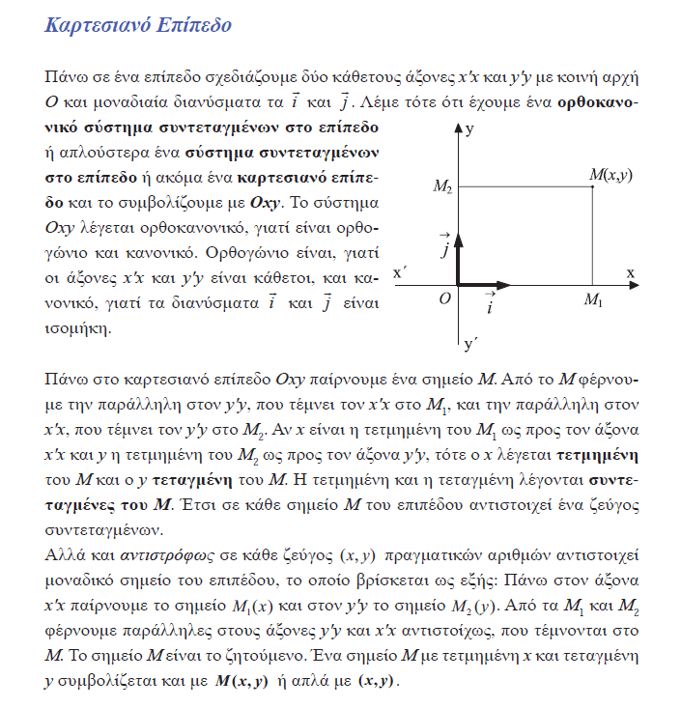

Σελ. 33
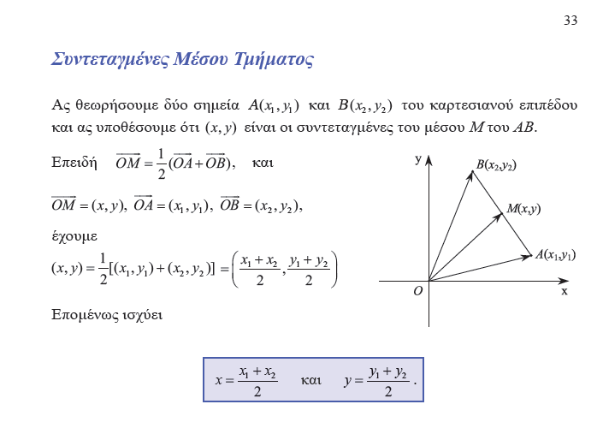
Σελ. 35,
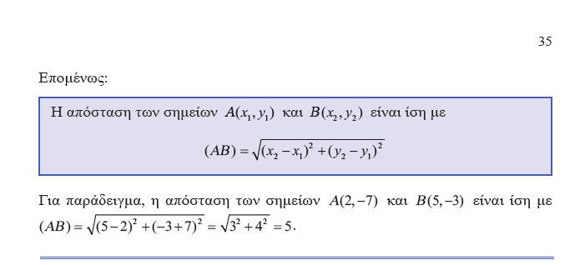

σελ. 66
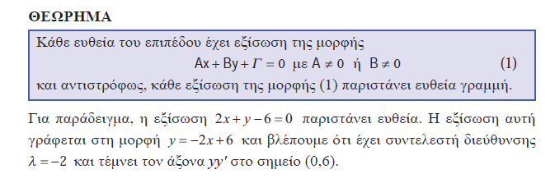
Σελ. 70
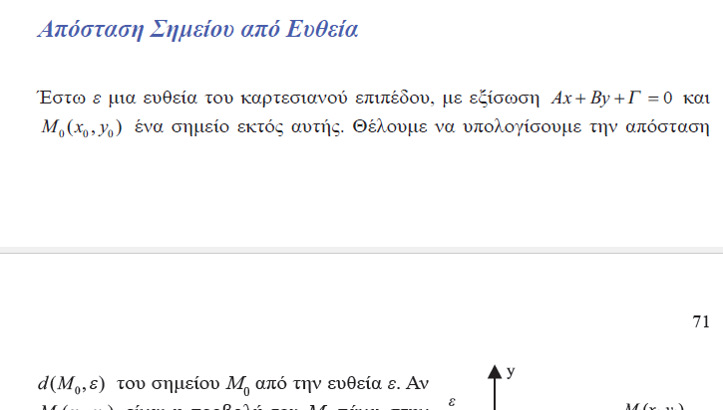

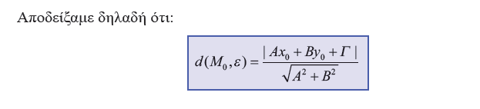

Σελ. 85
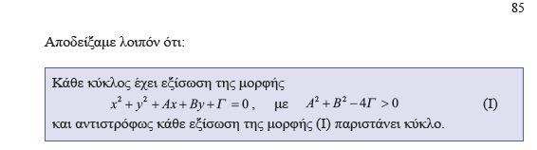
Συγκεκεριμενα
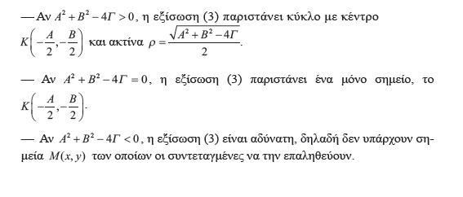

ΕΞΙΣΩΣΗ β ΒΑΘΜΟΥ, ΕΞΙΣΩΣΙΣ ΚΩΝΙΚΩΝ ΤΟΜΩΝ,

SIMMONS , CALCULUS WITH ANALYTIC GEOMETRY,
SECOND EDITION GEORGE F. SIMMONS
Colorado College, Colorado Springs
THE McGRAW-HILL COMPANIES, INC.
New York St. Louis San Francisco Auckland Bogota Caracas Lisbon London
Ekei υπαρχει και η αποδειξη
Conic SECTION is one of the following
is a circle, a parabola, an ellipse, a hyperbola,
a point, the empty set, a single line, or a pair of lines
p. 552
The general equation of the second degree in x and y is
Ax² + Bxy + Cy² + Dx + Ey + F = 0, (1)
where at least one of the coefficients A, B, C is different from zero. The latter requirement, of course, guarantees that the degree of the equation really is 2, rather than 1 or 0.

p. 553
The graph of every second-degree equation of the form (1) is a circle, a parabola, an ellipse, a hyperbola,
a point, the empty set, a single line, or a pair of lines.

Επισης βλεπε Conic section
https://en.wikipedia.org/wiki/Conic_section#CITEREFProtterMorrey1970,

Το ΘΕΩΡΗΜΑ του ΑΠΟΛΛΩΝΙΟΥ, ΘΕΩΡΗΜΑ ΤΩΝ ΔΙΑΜΕΣΩΝ,
KATZ p. 457

Apollonius's theorem,
https://en.wikipedia.org/wiki/Apollonius%27s_theorem,
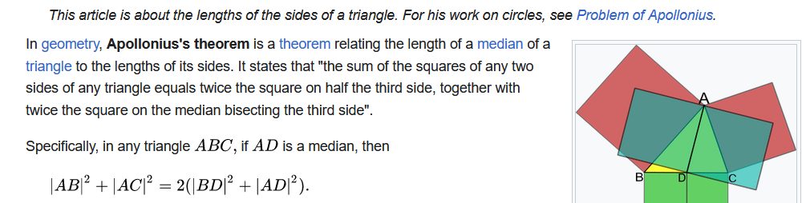
ΣΓΠ. Εμφαση σε αθροισμα τετραγωνων.
ΣΧΟΛΙΟΝ ΣΓ

https://allen.in/jee/maths/apollonius-theorem,
γεωμετρικη αποδειξη, ,
https://brilliant.org/wiki/apollonius-theorem/,
γεωμετρικη αποδειξη,

ΓΕΝΙΚΕΥΣΗ ΑΠΟΛΛΩΝΙΟΥ ΘΕΩΡΗΜΑΤΟΣ,

,

ΘΕΜΑ
Έστωσαν Α₁ , Α₂,….Α_{Κ} σημεία του επιπέδου και β,α₁,α₂,…,α_{κ}>0 πραγματικοί αριθμοί
Να βρεθεί ο γ.τ των σημείων Μ ώστε α₁(ΜΑ₁)²+…..+α_{κ}(ΜΑ_{Κ})²=β
ΑΠΑΝΤΗΣΗ
Ας θεωρήσουμε τα σημεία Α₁(x₁,y₁) , Α₂(x₂,y₂),….,Α_{Κ}(x_{κ},y_{κ}) του επιπέδου και β,α₁,α₂,…,α_{κ}>0 πραγματικοί αριθμοί
Αν Μ(x,y) τυχαίο σημείο του επιπέδου ώστε να ισχύει
α₁(ΜΑ₁)²+…..+α_{κ}(ΜΑ_{Κ})²=β τότε
α₁((x-x₁)²+(y-y₁)²)+ α₂((x-x₂)²+(y-y₂)²)+….+ α_{κ}((x-x_{κ})²+(y-y_{κ})²)=β⇔
α₁(x²-2xx₁+x₁²)+ α₁(y²-2yy₁+y₁²)+………+ α_{k}(x²-2xx_{k}+x_{k}²)+ α_{k}(y²-2yy_{k}+y_{k}²)-β=0⇔
(α₁+….α_{κ})x²+((α₁+….α_{κ})y²-2(α₁x₁+…+α_{κ}x_{κ})x-2(α₁y₁+…+α_{κ}y_{κ})y+(α₁x₁²+…+α_{κ}x_{κ}²+α₁y₁²+…+α_{κ}y_{κ}²-β)=0
Διαιρώντας με το α₁+….α_{κ}≠0(α₁,α₂,…,α_{κ}>0) προκύπτει
x²+y²-2$\frac{α_{1}x_{1}+…+a_{κ}x_{κ}}{α_{1}+….α_{κ}}x-2\frac{α_{1}y_{1}+…+a_{κ}y_{κ}}{α_{1}+….α_{κ}}y+\frac{α_{1}{x_{1}}^{2}+…+a_{κ}{x_{κ}}^{2}-β}{α_{1}+….α_{κ}}$ = 0 (1)
Αν θεωρήσουμε Α=$-2\frac{α_{1}x_{1}+…{+a}_{κ}x_{κ}}{α_{1}+….α_{κ}}$ , Β=$-2\frac{α_{1}y_{1}+…{+a}_{κ}y_{κ}}{α_{1}+….α_{κ}}$ , Γ=$\frac{α_{1}{x_{1}}^{2}+…{+a}_{κ}{x_{κ}}^{2}-β}{α_{1}+….α_{κ}}$
Τότε η (1) γίνεται x²+y²+Ax+By+Γ=0, η οποία αποτελεί εξίσωση κύκλου μόνο αν ικανοποιείται η συνθήκη Α²+Β²-4Γ>0
Επομένως :
- Αν Α²+Β²-4Γ>0 με Α=$-2\frac{α_{1}x_{1}+…{+a}_{κ}x_{κ}}{α_{1}+….α_{κ}}$ , Β=$-2\frac{α_{1}y_{1}+…{+a}_{κ}y_{κ}}{α_{1}+….α_{κ}}$ , Γ=$\frac{α_{1}{x_{1}}^{2}+…+a_{κ}{x_{κ}}^{2}-β}{α_{1}+….α_{κ}}$
τότε ο γεωμετρικός τόπος των σημείων Μ είναι κύκλος με κέντρο Κ$(-\frac{Α}{2},-\frac{Β}{2})$ και ακτίνα ρ=$\frac{\sqrt{Α^{2}+Β^{2}-4Γ}}{2}$
COMMENT. To kentro toy kykloy αναξαρτητο του β, .
- Αν Α²+Β²-4Γ=0 με Α=$-2\frac{α_{1}x_{1}+…a_{κ}x_{κ}}{α_{1}+….α_{κ}}$ , Β=$-2\frac{α_{1}y_{1}+…a_{κ}y_{κ}}{α_{1}+….α_{κ}}$ , Γ=$\frac{α_{1}{x_{1}}^{2}+…a_{κ}{x_{κ}}^{2}-β}{α_{1}+….α_{κ}}$ τότε ρ=0
τότε ο γεωμετρικός τόπος των σημείων Μ είναι το σημείο $(-\frac{Α}{2},-\frac{Β}{2})$ (δηλ. ο κύκλος εκφυλίζεται σε σημείο )
- Αν Α²+Β²-4Γ<0 τότε η (1) είναι αδύνατη στους πραγματικούς αριθμούς

ΠΑΡΑΛΛΑΓΗ 4^{ων} ΔΥΝΑΜΕΩΝ,

