08 ΔΙΑΛΕΞΙΣ, 23-03-2025,
Webex meeting recording: 08 INM-20250323 kyriakh
Password: eKE8qbqt
Recording link: https://uoa.webex.com/uoa/ldr.php?RCID=7e1bc50f2b83b9d67d6c5cb91739ff45,

ΠΡΟΚΑΤΑΡΚΤΙΚΑ,
Na melετηθουν από το βιβλιο του Α ΓΙΑΝΝΟΠΟΥΛΟΥ, ΑΠΕΙΡΟΣΤΙΚΟΣ ΛΟΓΙΣΜΟΣ τομος Α.

ΓΕΝΙΚΑ ΣΥΜΠΕΡΑΣΜΑΤΑ περι πολιτισμων,

ΚΟΙΝΕΣ ΙΔΙΟΤHΤΕΣ ΠΟΛΙΤΙΣΜΩΝ,
Συνηθως ενας μεγαλος ποταμος,
STAPLE FOOD, φυτικον,
ΕΡΩΤΗΜΑ: γιατι ανεπτυχθησαν οπου ανεπτυχθησαν ?,

ΑΝΩΤΕΡΟΙ και ΚΑΤΩΤΕΡΟΙ ΠΟΛΙΤΙΣΜΟΙ, 2025,

ΔΕΝ υπαρχουν ΑΝΩΤΕΡΟΙ και ΚΑΤΩΤΕΡΟΙ ΛΑΟΙ,

ΔΥΤΙΚΟΣ ΠΟΛΙΤΙΣΜΟΣ, ΚΙΝΕΖΙΚΟΣ ΠΟΛΙΤΙΣΜΟΣ
Ο κυριος αντιπαλος του ΔΥΤΙΚΟΥ ΠΟΛΙΤΙΣΜΟΥ.
ΜΑΡΚΟ ΠΟΛΟ,
JD Vance, «πολος δυναμης»,

Διατι περι πολιτισμων στο μαθημα ΙΝΜ, ?
OI μαθηματικoi προιον ενός πολιτισμου

UNIVERSAL LAWS,
ΥΠΑΡΧΟΥΝ ΝΟΜΟΙ ΣΤΗΝ ΙΣΤΟΡΙΑ ?
ColeSymes, p. 18

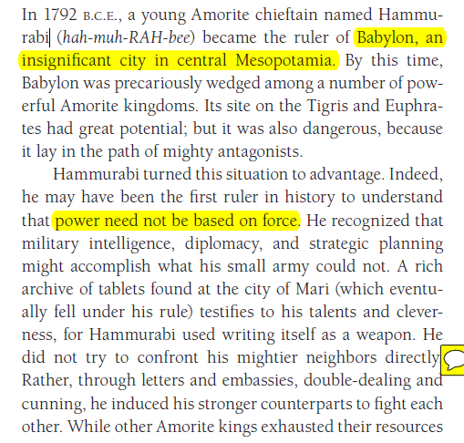

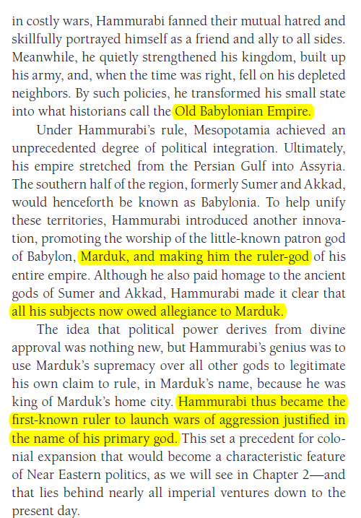

CONCLUSIONS Cole-Symes p. 36 ch1
CONCLUSION
While the story of Babel records the legendary loss of a shared
language, this chapter shows that people of the distant past
can still communicate with us. The marks they have left on
the landscape, the remains of their daily lives, their written
records, and their very bodies make it possible for historians
to piece together evidence and to make sense of it. And every
year new sources come to light, meaning that we have to
be ready to revise—constantly—our understanding of what
happened in the past.
Although this chapter has emphasized the differences
between the early civilizations of Mesopotamia and
Egypt, it is worth noting some significant similarities.
Both developed the fundamental technologies of writing
at about the same time, and this facilitated political alliances,
long-distance trade, and the transmission of vital
information to ??? posterity. During the third millennium,
both underwent a process of political consolidation, an
elaboration of religious ritual, and a melding of spiritual
and political leadership. Both engaged in massive building
and irrigation projects, and both commanded material
and human resources on an enormous scale. At the
same time, each of these civilizations cultivated an inward
focus. Although they had some contact with each other,
and some transfers of information and technology probably
took place, there were few significant political or cultural
interactions. For the most part, they inhabited separate
worlds. This relative isolation was about to change, however.
The next millennium (3000-2000) would see the emergence of
large-scale, land-based empires in the Near East that would
transform life in Mesopotamia, Egypt, and the lands that
lay between them. These are the developments we examine
in Chapter 2.

ΕΡΩΤΗΣΗ για λιγους ?
ΣΑΡΚΟΒΟΡΑ ΒΡΩΣΙΜΑ υπαρχουν ?

GLOSSARY,
Transliterated, to represent or spell in the characters of another alphabet
Arguably=a statement is very possibly true even if it is not certainly true, πιθανοτατα,
Fertile Cresent, ευφορος ημισελινοσ
Crescent, croissant,

Τα Μαθηματικα των ΑΡΙΘΜΗΤΙΚΩΝ ΣΥΣΤΗΜΑΤΩΝ,
,

ΓΕΝΙΚΟΤΗΤΕΣ,
Τα παρακατω είναι από το βιβλιο του Α ΓΙΑΝΝΟΠΟΥΛΟΥ, ΑΠΕΙΡΟΣΤΙΚΟΣ ΛΟΓΙΣΜΟΣ τομος Α.
Giannop p. 2
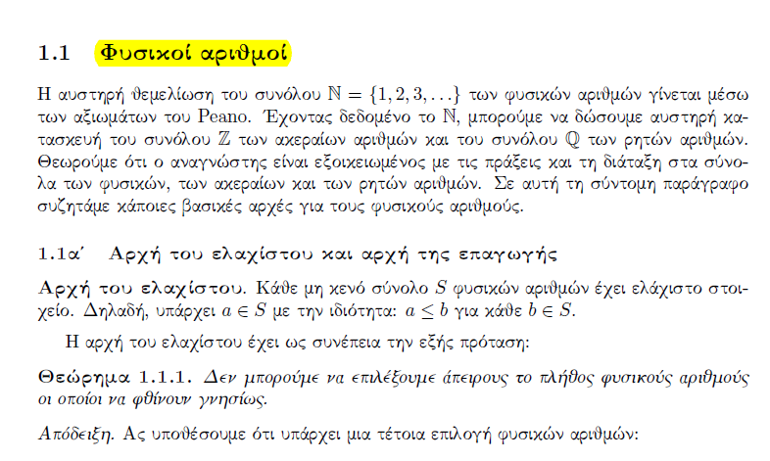

ΟΡΙΣΜΟΣ. Ζ⁺ είναι NU{0},

Giannop p. 2
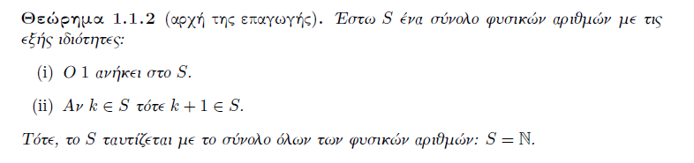
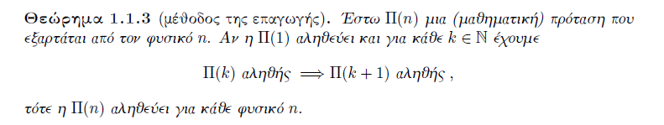
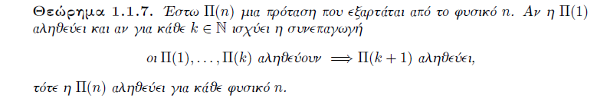
To παραπανω θεώρημα το ονομαζουμε «ΕΠΑΓΩΓΗ του ΕΛΑΧΙΣΤΟΥ»,

ΤΑΥΤΟΤΗΤΑ ΤΗΣ ΔΙΑΙΡΕΣΗΣ, ΤΑΥΤΟΤΗΤΑ του ΕΥΚΛΕΙΔΗ,

GIANOP p. 5

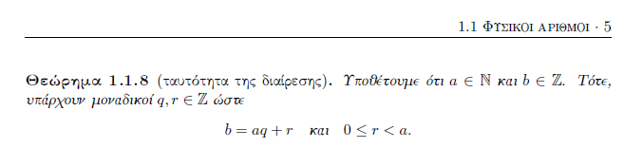
ΑΠΟΔΕΙΞΙΣ ΥΠΑΡΞΗΣ.

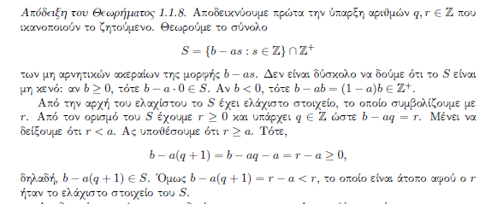
ΑΠΟΔΕΙΞΙΣ ΜΟΝΟΣΗΜΑΝΤΟΥ,
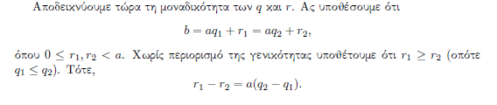
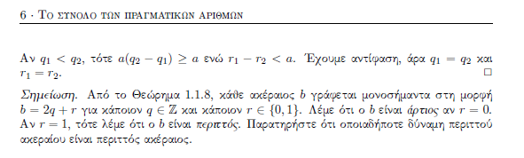
Τα παραπανω ΔΕΝ ευρισκουν τα q, r, απλως αποδεικνουν ότι υπαρχουν.

