ΚΟΡΜΠΑΚΗΣ ΗΛΙΑΣ
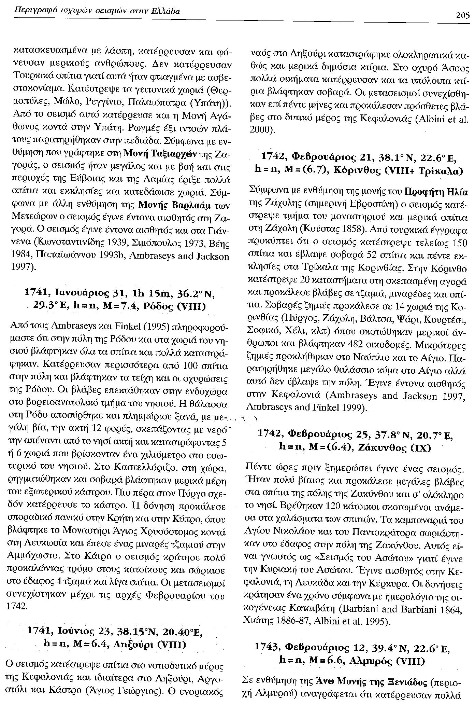 | 1949 Jul 23, Chios Isl., Greece  An earthquake with an epicentre at sea near the islets of Oenousae, between the island of Chios and the Cesme peninsula. It caused heavy damage to the north part of the island and to the opposite coast of Cesme and Karaburun in Turkey. In Chios damage was heavy, particularly in the north part of the island in the Kardamila region, where 450 houses collapsed, 2,000 were seriously damaged, 3 people were killed and about 50 were injured. In the town of Chios itself about 100 houses were totally ruined and were 500 seriously damaged. A fire, which followed the earthquake added, to the damage. On the peninsula of Karaburun, opposite Chios, 40 houses collapsed and about 800 were damaged beyond repair with the loss of seven lives. In all, in Turkey, about 2,200 houses were damaged. Widespread but minor damage extended to the island of Psara and to mainland Turkey as far inland as Vurla, Izmir and Foca.The shock was strong in the islands of Lesvos and Samos. A belated aftershock on 23 November, added to the damage.
ΛΥΚΟΥΔΗΣ ΛΕΩΝΙΔΑΣ
1932 Sep 29, Volvi, Greece

Preceded by many strong foreshocks, this earthquake caused extensive damage in the region of Lake Volvi, about 45 km north west of the epicentre of the earthquake of 26 September. The villages of Kria Nera, Avgi, Mavruida, Lanza, Stefanina, Nuda and particularly Sochos, Arethusa and Askos were badly damaged. These villages are situated along a narrow graben about 30 km long and 8 km wide, north of Lake Volvi, that follows the valley of Vromolimnes and its small lakes and ponds. Damage was done also outside this zone: at Megali Volvi, Lutra and at other villages on the shore of the lake, as well as in the epicentral region of the earthquake of 26 September, where a few damaged houses were ruined. In Thessaloniki many houses suffered plaster cracks or minor structural damage and a few old buildings, such as the the Agriculture Bank, the Metropolis and two schools became uninhabitable. Some damage was also reported from Nigrita, Langadas, Kilkis and Seres. The shock was felt as far as Florina, Karditsa and Almiros in Greece, in south east Macedonia and south west Bulgaria. Aftershock continued up to the beginning of November. Some of them, of magnitude 5.5 increased the epicentral region to the south to include the region of Lake Volvi.

ΠΑΝΑΓΙΩΤΟΠΟΥΛΟΥ ΜΙΧΑΕΛΑ
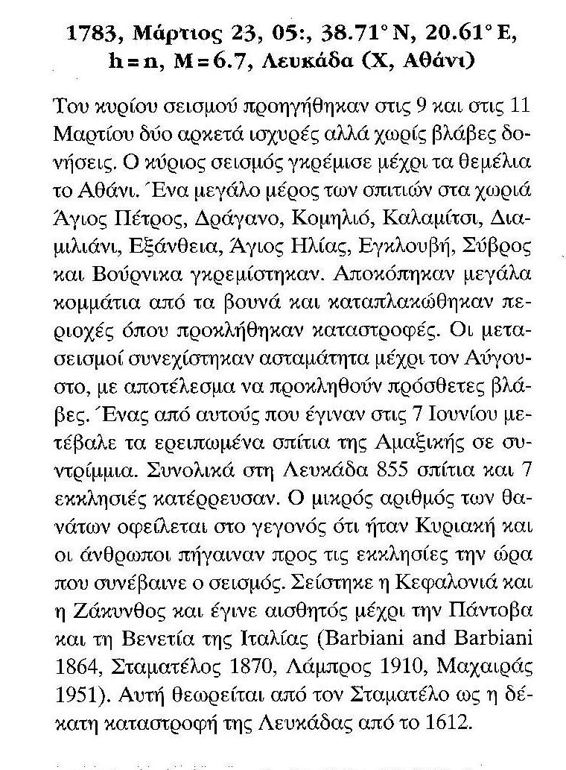 | 1956 Jul 9 , Amorgos Isl., Greece  A large magnitude earthquake in the Aegean sea with an epicentre between the islands of Amorgos and Astypalea caused serious damage particularly to the islands of Santorin and Amorgos. The neighbouring islands of Anafi, Astipalea, Ios, Kalimnos, Leros, Lipsos Naxos, Paros, and Patmos were also damaged. In these islands the earthquake killed more than 50 people and injured about 100, destroying 530 houses. About 1,500 were ruined and 2,000 were damaged. The shock was felt within an abnormally small area: it was not felt beyond Skpelos, Kalabaka, Egio, Tripolis, Githio, Crete, Rhodes, Izmir and Mitilini, affecting an area of a radius of only 290 km. The earthquake was followed by large aftershocks.
ΠΡΟΒΑΤΑΣ ΑΛΚΙΝΟΟΣ
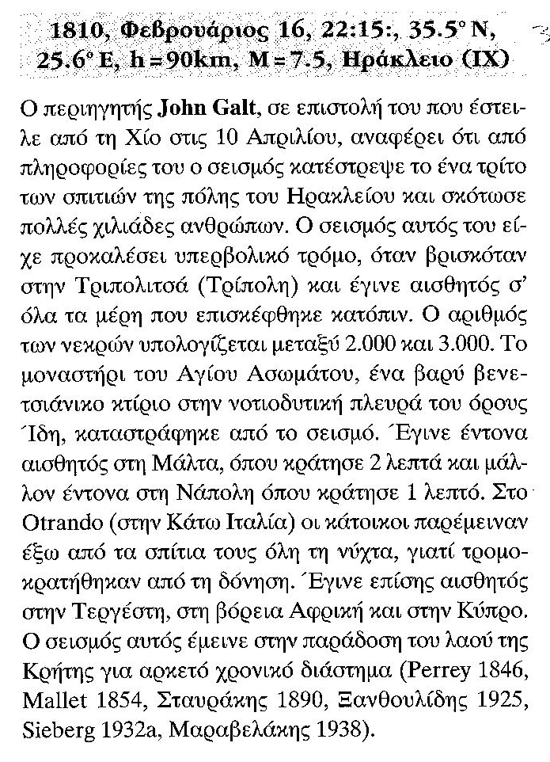 | 1927 Jul 1, Peloponnese, Greece  This was a lower crust earthquake with an epicentre on the south-east coast of Peloponnese. It caused heavy damage which was concentrated on the east coast of the Gulf of Mesinia along the west facing slopes of Mt. Taygetos. Between Avia, Arna and Areopolis almost all villages were ruined and hundreds of houses collapsed without casualties. Rockfalls blocked country roads, mainly in the region between Avia and Lefktro. The earthquake was widely felt. It was rather strong in other parts of Peloponnese and on western Crete. It was felt on mainland Greece, at Corfu, Preveza and throughout Epirus, on the Aegean islands, and at Catania and Mineo in eastern Sicily, where it was rather strong. It was perceptible in Alexandria, Cairo and throughout Lower Egypt. The shock was not associated with a seismic sea wave and no abnormal fluctuation of the sea was reported from the tide station at Kalamata. The earthquake was not preceded or followed by significant activity.
ΣΜΠΟΝΙΑΣ ΔΗΜΗΤΡΗΣ
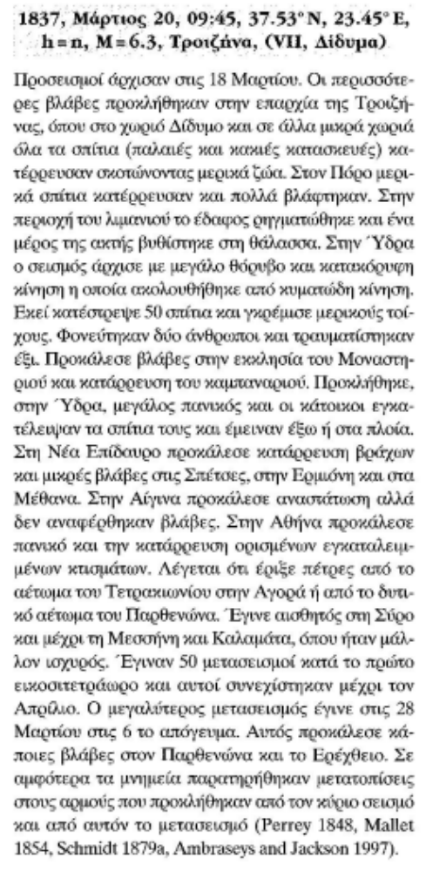 | 1921 Sep 13, Amvrakia, Greece  This earthquake affected the south coast of the Gulf of Amvrakia in western Greece. The villages of Zaverta, Konidari and Palimbey were ruined without casualties. At Karavasaras (Amfilochia), on the marshy south coast of the Gulf, a few houses collapsed and many were damaged and the quay settled excessively. At Valtos (Lutro) and Vlicha all houses were damaged and a few collapsed. Minor damage was reported from a number of localities on thick alluvial sites, such as Preveza, Lefkas and Messolongi. The shock was felt on Paxi, at Parga, Metsovo, Trikala, Nafpaktos and at Zante; it was perceptible in Volos and Dimitsana. It was followed by many small aftershocks.
ΤΕΜΠΕΛΟΓΛΟΥ ΔΗΜΗΤΡΗΣ
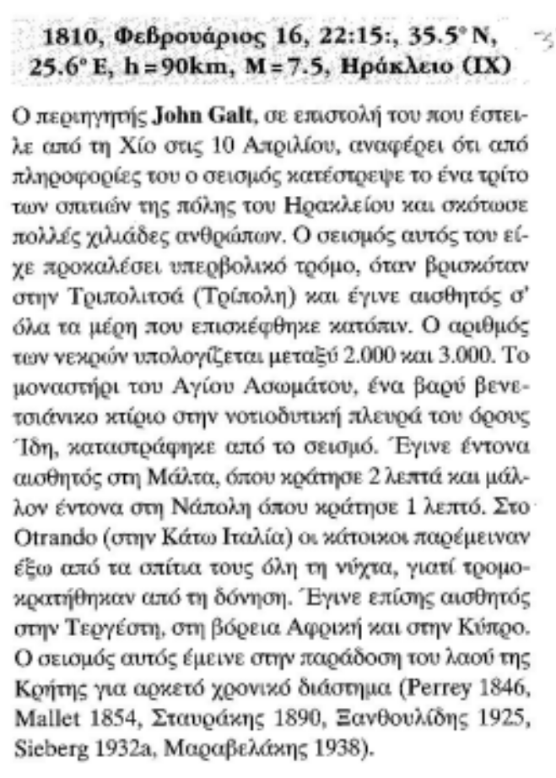 | 1930 Feb 14, N of Crete, Greece  An intermediate depth earthquake with an epicentre in the Aegean Sea north of Crete. It was strong in the central part of the island. At Hania an old house collapsed, plaster fell off many houses and a few dilapidated walls were damaged. Damage was also reported from Sellia and from the district of Apokoronou in the west as well as from Rethimno where many houses were cracked. Also in the district of Milopotamos and at Anogea rural houses were damaged. Further east at Iraklio a few houses were damaged, some were cracked and chimneys toppled. Damage was more serious on the coastal plains of Pediada. The villages of Skalani, Aitania and Vathia were almost totally destroyed without casualties and Episkopi and Guves were heavily damaged. Minor damage extended to the south as far as Hudetsi and Damania. On the rest of the island damage was negligible. The shock was felt on a few islands of the Aegean Sea, in Peloponnese as far as Santorin, Naxos Samos, Siros, Athens, Corinth, Metsovo and Corfu, but not in central Creece. The earthquake was perceptible over a large area: in Cyprus, in the Nile delta at Alexandria and Cairo, in Sicily at Mineo where it was strong, in the regions of Syracuse and Lecce, at Taranto and Catania.
ΤΡΙΑΝΤΑΦΥΛΛΑΚΗ ΜΑΡΙΑ
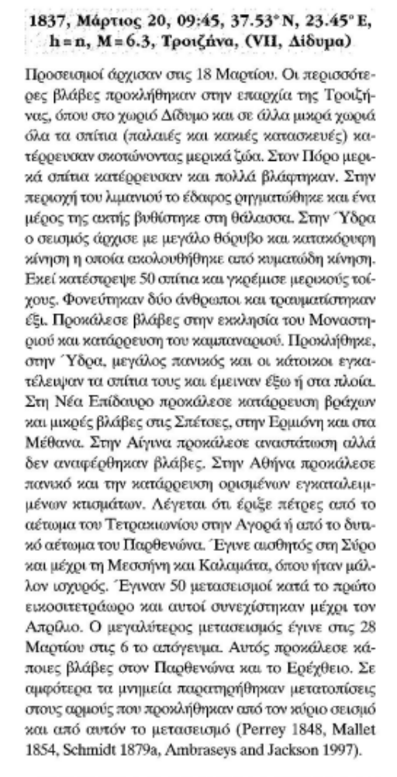 | 1933 Apr 23, Cos Isl, Greece  A damaging earthquake with an epicentre in the Gulf of Kerme. On the island of Cos, in the old town of Cos many houses were destroyed and 74 people were killed, while none of the more recently constructed reinforced concrete buildings in the town suffered significant damage. There is no evidence that the old city walls and fort suffered any damage. Particularly serious was damage to houses along the waterfront. Villages on the island suffered less. The total losses on Cos were 119 people were killed, 400 were injured and 5,000 homeless. On Nisiros 138 houses collapsed with some loss of life. On the Asiatic side, on the Resadiye peninsula, Dadya (Tasca) was totally destroyed and Cumali, Datca (Resadiye), Bodrum and adjacent villages were damaged. In this region three more villages, which are not named, were totally destroyed and people were injured, but details are not available. The shock was strongly felt in the region of Mugla where a few houses were damaged. Minor damage extended as far as the new part of Denizli. The earthquake was felt in Santorini but not further west. It was followed by many aftershocks.

