1st WEEK – 27.10.2023

- Introduction to the Workshop – Getting to know the students
- Eclass familiarization – setting the framework
- LISTENING & SPEAKING/WRITING: “SWOT Analysis”, “10 Effective Skills Managers Should Have”

2nd WEEK – 03.11.2023
- READING / SPEAKING / LISTENING / WRITING: “English for Business Studies” – Unit 1/Management (printed form)
- LISTENING & WRITING: “10 Effective Skills Managers Should Have”
- BEC Practice: https://www.cambridgeenglish.org/exams-and-tests/qualifications/business/

3rd WEEK – 10.11.2023
- READING / SPEAKING / LISTENING / WRITING: “English for Business Studies” – Unit 1/Management
- BEC Practice: https://www.cambridgeenglish.org/exams-and-tests/qualifications/business/ - only the Listening section
- VOCABULARY: Vocabulary Practice 1 – uploaded in the Vocabulary Practice Resources of our eclass, have a hard copy for Friday to be done in class & “Business Vocabulary in Use”/Parts 6 and 7
- LISTENING: “Types of Organisational Structure” & “Effective Principles of Management by Peter Drucker”
- WRITING: writing formal emails

4th WEEK – 24.11.2023
- READING / SPEAKING / LISTENING / WRITING: “English for Business Studies” – Unit 1, 3 & 6/” Management”, “Company Structure” & “Women in Business”
- SPEAKING: Role Play from Unit 6 “Women in Business”
- LISTENING: Listening Practice about company structure & Listening tasks from Units 1, 2 & 6
- VOCABULARY: Vocabulary Practice 2 & “Check your Vocabulary for Business and Administration”, pp. 62-64
5th WEEK – 01.12.2023
- SPEAKING: Role Play from Unit 6 “Women in Business”
- VOCABULARY: “Check your Vocabulary for Business and Administration”, pp. 9-12
- LISTENING: Listening Practice about company structure & Listening tasks from Units 1, 2 & 6
- READING / SPEAKING / LISTENING / WRITING: “English for Business Studies” – Unit 1, 3 & 6/” Management”, “Company Structure” & “Women in Business
6th WEEK – 08.12.2023
- LISTENING: Listening Practice about company structure [has been uploaded in our eclass since Week 3] & Listening tasks from Units 1, 2 & 6
- READING / SPEAKING / LISTENING / WRITING: “English for Business Studies” – Unit 1, 3 & 6/” Management”, “Company Structure” & “Women in Business”
- WRITING: discussion on how to write formal letters
- VOCABULARY: “Check your English Vocabulary for Business and Administration” [pp. 25-27, Letters]
7th WEEK – 15.12.2023
- WRITING: discussion on how to write formal letters
- VOCABULARY: “Check your English Vocabulary for Business and Administration” [pp. 16-17, Formal words] - “Business Vocabulary in Use”/Parts 8,9 & 10
- READING / SPEAKING / LISTENING / WRITING: “English for Business Studies” – Unit 1, 3 & 6/” Management”, “Company Structure” & “Women in Business”
- LISTENING: Listening Practice about company structure [has been uploaded in our eclass since Week 3
8th WEEK – 22.12.2023
- LISTENING: Listening Practice about company structure [has been uploaded in our eclass since Week 3)
9th WEEK – 12.01.2024
- READING / SPEAKING / LISTENING / WRITING: “English for Business Studies” – Unit 6/ “Women in Business”
- VOCABULARY: “Check your English Vocabulary for Business and Administration” [pp. 23-24 & 65-66]
- LISTENING/VIDEOS: Listening Practice about C-suite
10th WEEK – 12.01.2024
BEC Higher Practice
12th WEEK – 16.02.2024
- READING / SPEAKING / LISTENING / WRITING: “English for Business Studies” – Unit 11, 12 & 13/” Products”, “Marketing” & “Advertising”
- VOCABULARY: “Check your English Vocabulary for Business and Administration” [pp. 13-4, 15, 31, 44-45 “Earnings, rewards and profits 1-2”, “Numbers and symbols”, “Sales and Marketing 1”.

13th WEEK – 23.02.2024
- READING / SPEAKING / LISTENING / WRITING: “English for Business Studies” – Unit 11, 12 & 13/” Products”, “Marketing” & “Advertising”
- Work on Interviews
14th WEEK – 01.03.2024
- READING / SPEAKING / LISTENING / WRITING: “English for Business Studies” – Unit 11, 12 & 13/” Products”, “Marketing” & “Advertising”
- WRITING: discussion on how to write business reports [Unit 11 / p. 63]
- VOCABULARY: Collins Cobuild, Business Vocabulary in Practice, Topic 9 – Marketing & Topic 2 Business and Businesses
15th WEEK – 08.03.2024
- VOCABULARY: “Check your English Vocabulary for Business and Administration” [pp. 49-52 “Similar Meanings 1 & 2”.
- LISTENING/VIDEOS: Listening Practice about Glocalisation and CSR
- VOCABULARY: Business Vocabulary in Practice, 10 -12, Organisations
16th WEEK – 15.03.2024
How to make effective presentations

----------------------------
HOMEWORK

- LISTENING & WRITING: “10 Effective Skills Managers Should Have” listen and write a summary [video link uploaded on Week 1 Videos & Links]
- BEC Practice: https://www.cambridgeenglish.org/exams-and-tests/qualifications/business/ - only the listening uploaded in eclass (BEC Practice Listening 23112023/eclass)
- VOCABULARY: “Check your English Vocabulary for Business and Administration” [pp. 39-43, Recruitment 1-3]
- VOCABULARY: Vocabulary Practice 1 – uploaded in the Vocabulary Practice Resources of our eclass & “Business Vocabulary in Use” (e mailed to you by Anastasia) /Parts 6 and 7
- WRITING: in the Writing Practice Resources re-write the “writing formal mails” file into a formal mail.
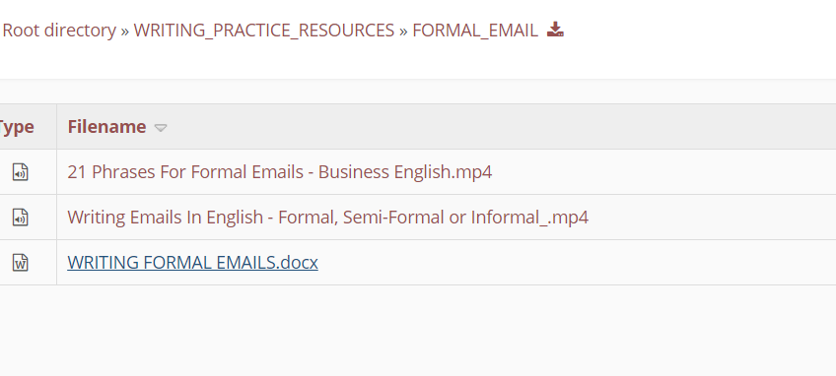
- VOCABULARY: Vocabulary Practice 2 & “Check your Vocabulary for Business and Administration”, pp. 62-64, pp. 9-12
- WRITING: we discussed the format of writing formal/semi-formal/informal emails and paragraphs- in the Writing Resources section of our eclass, click on the FORMAL_MAIL & WRITING_PARAGRAPHS path, watch the relevant videos and prepare the writing tasks indicated in this table.
- WRITING: write a formal email in out last class we formed groups and we worked on the role play from Unit 6 “Women in Business” [see Speaking Resources in our eclass]. The conclusions/suggestions were written on the whiteboard and they have to be used as the basis for writing a formal informative email from the CEO of the company to the other Depts.

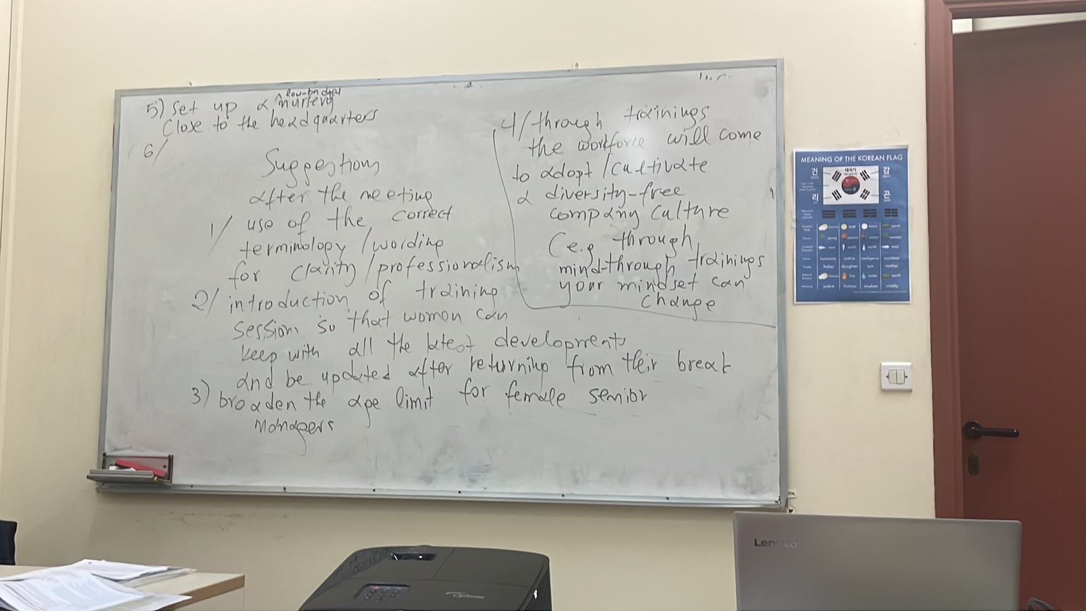

VOCABULARY: p.28, “Meetings and presentations:
WIKINOMICS: watch the video and write a short summary

