THE AMERICAN LEGENDS “HALL OF JOURNAL FAME”
2023-24

Olga Apatsidou (1563202100016)
Manifest Destiny

Upon reading “Manifest Destiny” I would be lying if I said that I was even remotely surprised by the greed, the unquenchable thirst for gain that was present in the text. It truly is remarkable to see how atrocities like the Wounded Knee massacre and others were excused, or better brushed over, in the name of this sure-to-be accomplished “prophecy”. I particularly find it incredibly ironic how the -assumingly- white speaker calls the Americans (as in the whites murderers, colonizers, and rapists- or simply settlers) “the race of democratic liberty” when their own delusional belief of a great nation, the new Garden of Eden, is quite literally built on and over the bodies of the hunted down and killed Native Americans and black slaves, simply put, people who were stripped away of their liberty and democratic values. The prophecy, this writing on the wall which is oh-so-clear to the white settlers, is an excuse for them to proceed with the genocide of the Natives and it is truly infuriating to read about how they thought that an imperialistic agenda based on exploitation and execution could ever be justified by anyone, let alone the God that they believe in. Even though the text does not particularly touch on the subject of religion, I believe it’d be foolish of me to not chime in and suggest that religion, and in this case the puritanical version of Christianity, rots the mind of people and accentuates the differences between nations. This very obviously results in hostility between those groups and therefore unthinkable acts of violence are then excused because there’s an underlying superiority complex established and genocide truly means nothing in the eyes of the perpetrators. Not only that, but it can also be observed that besides the superiority complex plaguing the settlers, they also feel like they’re some sort of saviors or saints. With that mindset they feel obligated to evangelize the “brutes”, the “uncivilized” Natives and, as a consequence, those who do not conform to the values that are forced upon them, are viewed as obstacles or devils that get between the completion of the divine work that was bestowed upon the whites by God Himself. Moreover, because the differences of the nations are highlighted and brought to their attention, each traditional custom and practice of the Natives is viewed as a danger. A great example is that of the Wounded Knee massacre, where the Natives were dancing in order to bring prosperity and keep their hopes up and the settlers thought of that as a weird but certainly threatening action and so they killed them. It is clear then that in order to execute the plan of Manifest Destiny every obstacle, that is the Natives, is to be exterminated. It really was an infuriating read; I hate men
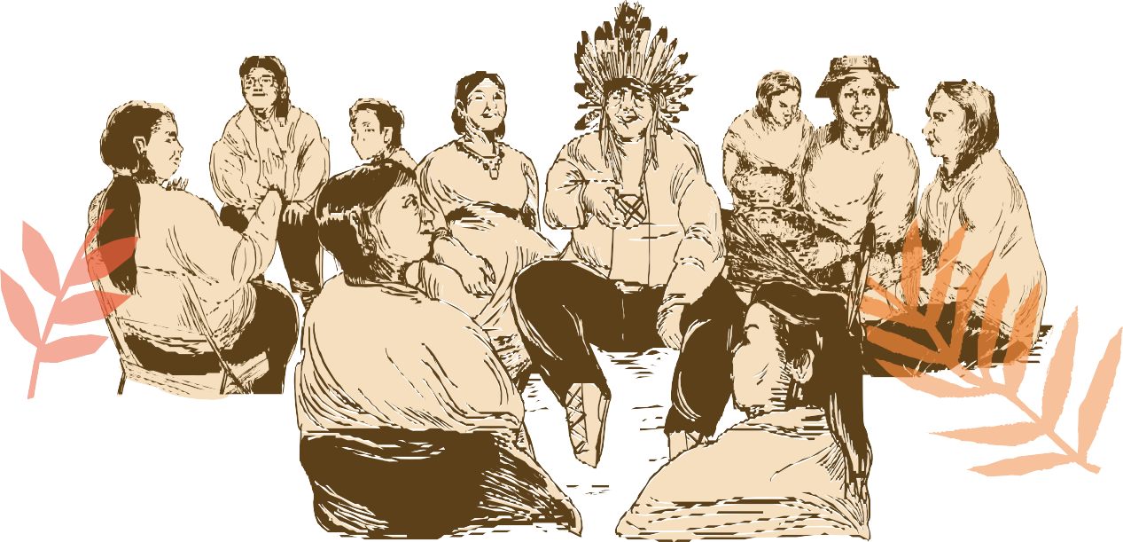

Custer’s last Stand Song

Well, I begin this journal by confessing my Schopenhauerian feelings of bleakness towards humanity. Justification for these sentiments arises from the abundance of horror and anguish in history caused by power injustices and inequalities. An example that fits the bill is George Armstrong Custer's ostensible heroism, which, to my mind, appears dismal yet disturbingly familiar.
The question naturally arises: why is a man named George, Armstrong, or Custer (none of these names seem fitting) celebrated as a legendary hero for asserting authority over peoples and tribes who had lived in harmony with and sustained the very same lands for thousands of years? It is impossible for me to explore this question without considering the existence of an entire historical and cultural narrative that glorifies and elevates historical figures into heroes or legends.
Stuart Hall, for instance, maintains that dominant narratives are constructed to reinforce certain ideologies and that “politics are inseparable from popular culture” (18). It turns out, thus, that portraying the “blond-haired Custer” as a hero fighting against the “savage Sioux” and “gloating redskins” (Leeming and Page 110) is not a mere historical recount but part of the cultural narrative that established power and reinforced the mistreatment of indigenous populations.
In a similar vein, Said’s work on Orientalism offers us some valuable insight into how the construction of “otherness” and “savagery” in these narratives dehumanized indigenous peoples, further justifying their mistreatment. While swimming in these waters, we are reminded that narratives such as Custer’s bravery and valour in battle often serve as means of derogation and marginalization to justify government policies, such as the Indian Removal Act. In addition to garnering public support, heroic narrations often concealed the U.S. government’s violation of treaties and the ruthless encroachment of European settlers onto tribal lands. It appears that heroic narratives obscured the injustice of these actions and disguised the economic pressures behind the quest for valuable resources like gold, timber, and fertile land (Bowes).
To take Custer as a stark example, he was a key catalyst for the events in the Black Hills, known as Paha Sapa in the Lakota language. These hills held profound cultural, spiritual, and historical significance for Native American tribes. They were considered sacred, serving as a spiritual world, a place for ceremonies and vision quests, and a source of essential natural resources, including water, timber, and traditional hunting and gathering sustenance. The Black Hills Expedition of 1874, led by George Armstrong Custer, provoked the Gold Rush, contributing to Native Americans losing control over this sacred region, thereby marking a devastating disruption of their cultural and spiritual connection to the land (Palais). The irony of history, however, led the “blond-haired Custer” who “held the land” to be hailed as “a hero with his dead” (Leeming and Page 110).
However, (in a blessing for the reader's catharsis) David Adams Leeming and Jake Page, following the citation of the song about Custer, assert emphatically that “Cheyenne and Arapaho, with all Indian resisters of American oppression, are the collective heroes here” (110). By juxtaposing the two versions of “Custer’s Last Stand”, the editors force us to reassess and reexamine the concept of heroism itself. This duality in Custer's portrayal suggests that when stepping into the realm of myths and legends, we should take time to reflect on why and under what circumstances communities venerate heroes. Concurrently, it is essential to take into account their adversaries — that is, who these shunned villains are and the reason why they are considered the wrongdoers or the “others”.

Works Cited
Bowes, John P. “American Indian Removal beyond the Removal Act.” Native American and Indigenous Studies, vol. 1, no. 1, 2014, pp. 65–87. JSTOR, https://doi.org/10.5749/natiindistudj.1.1.0065.
Leeming, David Adams, and Jake Page. Myths, Legends, and Folktales of America: An Anthology. Oxford University Press, 2000.
Palais, Hyman. “Some Aspects of the Black Hills Gold Rush Compared with the California Gold Rush.” Pacific Historical Review, vol. 15, no. 1, 1946, pp. 59–67. JSTOR, https://doi.org/10.2307/3635035
Procter, James. Stuart Hall. Routledge, 2004.
Said, Edward W. Orientalism. Vintage Books, 2004.

Nikoletta Michou (1563202100134)
Hiawatha and Mudjekeewis

“Hiawatha and Mudjekeewis” was quite enjoyable to read. From the first few lines you know this epic concerns a kind of typical hero where emphasis is laid on his physical strength and powers, like for example Hercules. However even though he is very skilled both because of his physical attributes and his knowledge in craftsmanship, he is also a master of magic himself which is not that typical. Usually ‘heroes’ rely solely on their physical powers and intelligence to triumph and accomplish great deeds or get magical help from others.
When his grandmother tells Hiawatha of his mother and how his father is the reason of her death, he immediately becomes enraged and decides to face his father. I always love when heroes have an emotional side and are not just empty muscular shells or just meat suits filled with self-righteousness. In fact in this moment, there is nothing heroic about Hiawatha. He wants to avenge his mother’s death by taking revenge on his father, without caring about how great he is or what he has achieved in the past or that his father welcomes him with open arms.
The lines about Hiawatha getting ready for his trip reminded me of Adrienne Rich’s “Diving into the wreck”. Rich’s speaker as well as Hiawatha go on a heroic quest, they put on “armour” in order to embark on a physically and emotionally difficult journey, and they both learn things and come to realizations at the end of it.
When Hiawatha meets his father they appear to get on well but in reality he still wants to kill him. The wrestling with his father that lasted three days, made me think of the concept of humans wrestling against God or God’s will. Fighting against the divine and struggling to win over higher powers is often part of the spiritual journey many people go on. There is a type of violence in wanting to know things about yourself, the world or the powers that be and you have to be prepared to go through and face that violence.
After wrestling, Mudjekeewis reveals to his son that the wrestling was just a test for him to prove his courage and he proceeds to assign him the task of being a protector for the people and killing anything that is harmful and evil. Section 46 of “Song of Myself” by Walt Whitman in which he tells the reader, a”son” to keep enjoying life, to keep on his journey. be brave and explore the world that awaits him, has a similar tone with this part. For example, the sense of destiny in Hiawatha’s story could be found in Whitman’s “It is not far, it is within reach, Perhaps you have been on it since you were born and did not know, Perhaps it is everywhere on water and on land”
Trying to kill Mudjekeewis was futile from the beginning but he still wanted Hiawatha to try to decide if he is worthy and courageous. This aspect but also the nature of their whole relationship made me think of the way different Father-Son relationships are depicted in the Bible. God and Jesus, God and Abraham, Abraham and Isaac, even the story of the prodigal Son. Forgiveness, expectations, “doing what is right” and the sense of duty are key words and concepts in these stories. Similarly in this story, the bitter part of it turns sweet when Hiawatha accepts his father’s immortality and power, obeys him and follows his orders. He does what he “has to do” and the anguish he felt is extinguished. All these stories teach us to trust our father no matter what, that there is always a plan and you just need to be patient for it to be revealed to you. When it does, you will be rewarded. But is that really fair? And do you have a choice in the matter or are you forced to follow the path your Father has laid for you? Since I could probably write an entire essay on these questions as well as on Father-Son relationships in religion, I think I should probably not get that much into it right now and just stop here… Is it obvious that I was raised religious?

Mar Tzanetou (1563202100203)
Black Elk Speaks

The Wounded Knee Massacre is a topic we have already discussed in class, and yet as terrible as that discussion was, reading the account of an Indigenous man who was there to witness it was even more gut-wrenching. As I type this, I am at a loss of words of how to describe the dark, ominous feeling that the beginning of the account gave me. Is it because I already know what the man will see? It feels a bit like a book of fiction, where you can see the crumbs the author lays out for the reader to pick up on and prepare for the oncoming tragedy that the characters are unaware of. But this isn’t fiction. Real people died there, a whole culture brutally and unnecessarily butchered for, as Black Elk says at the end of his narration, ‘simply trying to run away’.
What is there to say about such a senseless massacre committed in the name of the Christian God, a God that I was taught preaches unity and peace? How could it be anyone’s ‘destiny’ to practice such atrocities in the name of faith or to bring glory to their state? What exactly did the white colonisers ‘manifest’ by slaughtering so many innocents and wiping an entire culture off the face of the earth, for the supposed crime of simply being different? Having a different skin colour, believing in different deities, and worshipping the land that birthed and sustained them?
Unfamiliar as I am with the American landscape, I can scarcely picture the details of the place called Wounded Knee Creek. But what I can clearly see, are lifeless, ravaged bodies lying in white snow painted red with their blood. Infants clinging to their dead mothers, and little boys being forced to kill to save themselves and as many of their people as they could. Those boys lived, at least, to carry on the memory and legacy of their kind and those who were so cruelly lost that day, to the guns of people who claimed to be on the right side of history. Well, they might have been victorious, that’s for sure, but they were the monsters, and that is the plain and simple truth. Because only monsters turn their guns on those who have never wronged them, on defenceless women and children, and on people who have trusted them and sought their help and shelter.
White American Christians claimed at the time that Native Americans were savages, idolaters without ‘culture’ or ‘civilisation’, that should have been purged from the face of the earth for the sake of the Christian God, on Christmas. Yet all I see is the ‘good, God-abiding Christians’ slaughtering innocents, while it is those very ‘uncivilised savages’ that focus on prayer and on the desire for peace and coexistence with the men who have taken over their land. Black Elk devotes time and effort into donning his ceremonial attire and taking with him his people’s sacred bow to protect him and his fellows in what was to come. And in a way, he believes he indeed was protected. However, he still wishes he were dead, rather than live on in a world that no longer had a place for him and his people, and that sought his suffering and destruction. And who can blame him? I, too, would have rather died instead of having to see my people and my culture being so brutally and senselessly wiped out, for no reason other than greed and prejudice.
In all honesty, I have no idea how to end this entry. There’s no good prevailing over evil in this story, and there’s no moral to be had. All I know is that in reality, the heroes rarely vanquish the monster, and that those who dub themselves the hero are often the monsters themselves.
And this time, the monsters won.

Phoebe Smith (1563202300268)
Johnny Appleseed

When reading the stories, my first thoughts concerned the phrase “frontier lives.” What does that mean? How does an American define their life as one belonging to the expansion of their country? It seems to me like well-executed propaganda, a way to carry pride for exploring what is not yours and presenting it as a righteous and romantic endeavor.
Secondly, the use of the word picturesque reminded me of an essay by William Gilpin I read for a class on environment in art - he defined it as an overwhelming kind of beauty. The value of picturesque beauty is not in its "smoothness" but more in ruggedness–and while Gilpin described these in terms of aesthetics in painting, it is true also in this story: the sites visited by Johnny are described as picturesque back when it was written, but "with their wild surroundings and the primal silence, they must have been tenfold more so", meaning that the writers share Gilpin's view on what beauty means, that it is more abundant in the absence of human interference, untouched and wild. This is countered with painting Johnny’s deeds of planting apple seeds as good: how can these two things be true at once? Human interference seems to be in direct conflict with the appreciation of natural abundance.
This is highlighted when one thinks of the damage done by frontier activities. Johnny Appleseed at first glance might seem like an antithesis of the stereotypical explorer: he gave his clothes away to the poor (even though he himself did not have much money), he possessed a "gentle goodness", was caring to girls he met, he didn't harm anyone, he was a vegetarian, and yet he didn’t understand that what he was doing was wrong: his good deeds were determined by God and Swedenborg, but not by an anti-imperialist mind.
Martyrdom has an element of selfishness embedded within, as a woman in William Carlos Williams's story Mind and Body puts it accurately: "You're not too good, are you? People like that make me tired. Martyrs too, they're perverted, I detest them. I tell them they're the most selfish people on earth. Nobody wants them to be martyrs but themselves. They do it because it gives them pleasure." Ultimately, he did good because he desired the primitive Christian’s lifestyle: there is no straightforward morality in being a martyr. As it was mentioned toward the end of the story, his seemingly random planting of dog fennel turned out to be hurtful to farmers: perhaps the tale of Johnny Appleseed is not heroic but cautionary.

Alexandros Tzartzas (1563202100250)
First thoughts on Johnny Appleseed

In Johnny Appleseed, it’s interesting to note how his legend is, on the one hand, a personification of the settlers, and their establishment in America, whilst also being a deviation from them. For instance, it could be said that Johnny Appleseed, in planting various orchards under treacherous conditions, personifies the struggles of the first settlers to establish themselves in an unknown land, to build their first dwellings and survive. Moreover, he may be regarded as industrious, as being concerned with good husbandry, just as the settlers were, not just in the agricultural sense of the word, but also in the broader, managerial sense.
Yet Johnny Appleseed also deviates from the archetypal trajectory of the Puritans, or rather, the white settlers. To begin with, he seems to straddle the two camps, such as when he warns settlers of incoming native American fighters. On the other hand, though, he doesn’t actively involve himself in the hostilities between the two sides, and elicits the respect of native Americans, because of his ability to endure pain, among other things.
Johnny Appleseed’s position, namely his embodiment of, and deviation from, the trajectory of the settlers, is also exemplified by another important element, that of religion. In this vein, it’s interesting to note - apart from his belief that he has been imbued with a kind of divine inspiration to spread the teachings of God - his specific interpretation of religion, as well as how he promotes it. On this latter part, where he personifies the Puritans is his combination of religious mission with commerce: as an apostle of Emanuel Swedenborg, he devises a system of distributing the latter’s teachings, by dividing up the text and distributing it so that as many people as possible become acquainted with it. In so doing, Johnny Appleseed is also an enterprising publisher, devising a system of serialization. Yet on the other, he seems to stand apart from his fellow settlers. Indeed, his endeavor of planting orchards, what he perceives as spreading the gift offered by the Almighty, is one he pursues alone. In that sense, he’s a trailblazer, and trailblazers are, oftentimes, alone in what they do. More importantly, though, and as mentioned earlier, it’s his interpretation of religion, of Christianity, which makes him stand apart. Though like many other settlers, he believes that the world and what it contains is preordained by God, he seems to be unique in his view that all sentient beings, besides humans, should not be touched; that plants and insects, for instance, are God’s property, and that to fell trees or kill insects is sinful.
But besides that, Johnny Appleseed may be promoting a kind of symbiosis, a way of living with nature, which, ironically, may link him with native Americans’ cyclical conception of life, and the importance of preserving nature. However, this particular interpretation of the world draws the amusement and perplexion of others around him, especially his fellow settlers. More importantly, though, it deviates from what Puritans did, namely using raw materials and natural resources, for human purposes, to build a kind of New Canaan, once they had managed to survive.
In that sense, his view of the world, seen through a kind of religious hermeneusis, was also unique, though that didn’t prevent him from captivating his fellow settlers when preaching all those virtues.
What this last point encapsulates, then, along with the previous ones, is that Johnny Appleseed’s is an interesting case, personifying and defying the trajectory of the settlers at once.

Nikoletta Michou (1563202100134)
Johnny Appleseed, the Christ figure of American Folklore

Johnny Appleseed, a simple wanderer of the Western frontier is a figure that stands out in American Folklore. In fact his seemingly simple and inconspicuous nature is what renders him distinct and special. Reading about his life story, it is impossible not to notice all the parallels and the traits that paint a picture of him as a Christ figure.
The initials of his real name, which is Jonathan Chapman, J. C., mirror those of Jesus Christ which immediately adds a layer of symbolism to his story and his personality. Johnny Appleseed was a wanderer that spent years of his life looking for fertile soil and planting apple seeds across the frontier, making it his life mission to selflessly offer back to the world. This act of sowing seeds serves as a parallel to Christ’s parable which emphasizes the significance of starting small, nurturing what you have and ending up with a nourishing and bountiful harvest. In the case of Jesus the seeds represent the Gospel and the good soil is the people that listen to the message of God and implement it in their lives. Moreover, the spreading of the apple seeds combined with the dissemination of the faith, religious beliefs and prophetic message to people he met throughout his journeys, resembles Christ’s mission on earth to spread the Word of his divine Father.
Both figures led nomadic lives and did not have permanent residence when they were most active in their work. John traverses the wilderness for years just like Jesus wandered, as described in the New Testament, through a number of places like Galilee, Judea, Samaria and Jerusalem. Even in his appearance Johnny resembled Christ. He walked barefoot and his attire was described to be simple, echoing the humility of Christ. Both figures deliberately rejected material adornments and earthly pleasures.
Johnny’s stance towards the venomous snakes is proof of his unwavering faith and becomes a symbol of his trust in God. His lack of fear of snakes, which often symbolize evil, temptation and deceit could be interpreted as a metaphor for his spiritual strength and confidence in the face of God and the protective cloak his faith casts over him, even when he faces wickedness and malevolence. In a similar way, Jesus, devoid of fear, faces evil and temptation all throughout his life but remains resilient because of his virtue and divine righteousness and ends up defeating death and evil through his resurrection. At the same time, Johnny’s refusal to harm the snakes demonstrates all-encompassing compassion and love for all creation which is another key trait of Jesus.
Everyone admired and respected Johnny, recognized and appreciated the work he did. They were impressed by him and fascinated by his charismatic nature. In all his modesty and commonality they sensed the kindness of his soul, his untypical benevolence and tenderness and wanted to be around him and follow his teachings, just like people around Jesus did all throughout his journey on Earth.
Another parallel between the two figures is that of the spiritual marriage. Johnny claimed that two female angels told him that they would get married in Heaven. The thematic analogy observed here is that of the divine union of Jesus with the Church. Both weddings are spiritual, metaphorical unions that represent a connection that goes beyond earthly matters and physical relations and attachment.
Ultimately, Johnny’s lifestyle was in general filled with hardships, privation and well-endured pain, but also selflessness, humility compassion and generosity. His way of life alludes to Jesus’ story and life trials, his journey of self sacrifice and martyrdom which proved to be the fulfillment of his divine mission, leading to eternal glory for Himself and believers.

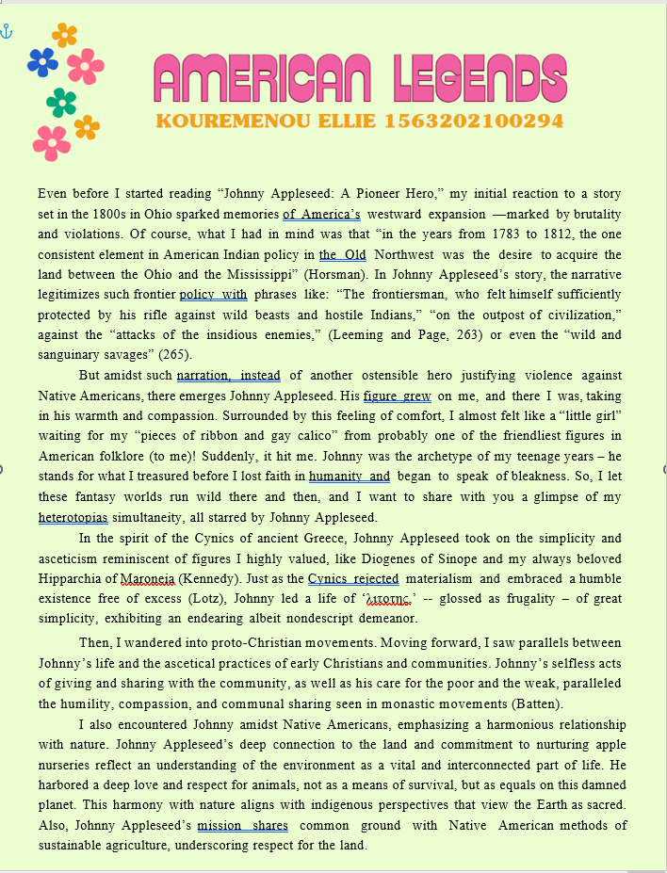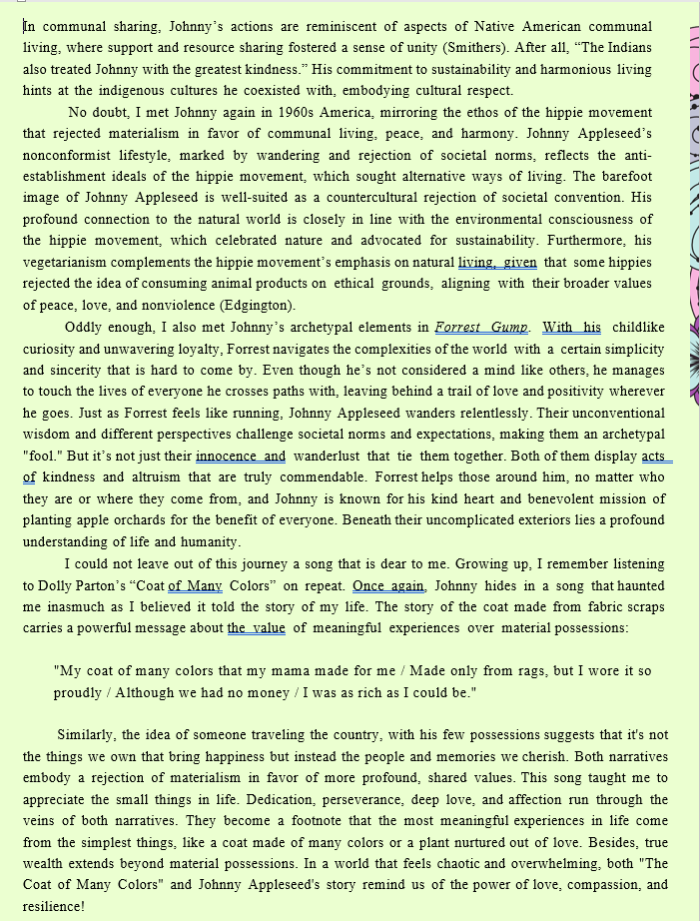

Christina Sotiropoulou (1563202000295)
The Saga of Joe Magarac: Steelman

The US was called “The Land of the Free” and its trademark among new immigrants, who in the late 19th and early 20th century wanted to go and make a living in this quickly developing land, was that the country was supposed to accept with no discrimination the different cultures and nationalities. It is interesting that the same people would not see the elephant in the room: the genocide of the native Americans and the slavery of the African Americans, who by that time were supposed to be reclaiming their freedom after the abolishing of slavery by President Lincoln.
Nevertheless, ships full of immigrants were arriving from Europe and Asia, and it was typical that each country had something special to offer workwise to the new land. For example, Greek people created restaurants with Greek -mediterranean- cuisine; there were also many mariners, as well as a couple of shipping tycoons. I realise by reading this piece about the Saga of Joe Magarac, that the Slavs were at the time, and in particular the “Hunkies”, the Hungarians, experts in steel work.
Reading about the word “Magarac” and its explanation, I cannot but think of the Greek word “Malakas”. Judging from how it became one of the most typical Greek words that the world knows, along with “Kalimera” and “Souvlaki”, it seems like those words would stand out to people who didn’t understand Greek, just like “Magarac” stood out to the narrator of this piece, a fellow steel worker coming from a different cultural background. The fact that the workers themselves created a persona with the surname Magarac and added to it a very typical American first name, like “Joe”, makes me think of how this word would stand out even to the Hungarians themselves, and how they must have made jokes about it.
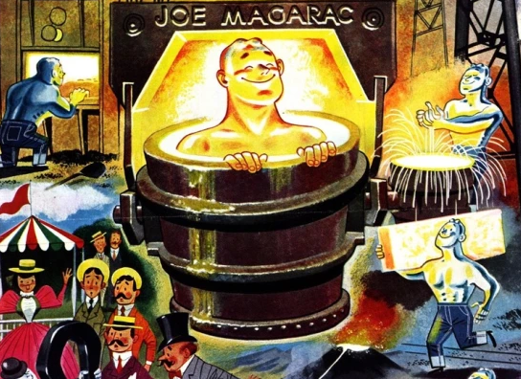
They went as far as to create their own saga, with stories about “Joe Magarac” who was actually a connotation for each and every one of them. This name brings to mind the names “John Doe” and “Jane Doe” for persons unknown that also connotate one of us who got lost and out of the herd, in a way. However, Joe Magarac is described by the narrator as a hero-steel worker with a legendary work ethic, totally integrated to the immigrant lifestyle of the Hungarians in the US and the environment. Its’ like they created a new cultural product to express their identity in this new way of living. Joe Magarac was attributed super work powers, like being steel himself and being melted and poured into each and every one construction beam that was created in those steel mills. His accent was the only thing to give away his differentiated origins, but his name would be a synonym to the best steel work and to the creation of every steel construction in the land. The narrator has put a story that seems like the end of the life of Joe Magarac, which gives inspiration to the Hungarian workers and their sons, that would later follow on Joe Magaracs footsteps and become the best steelworkers themselves.
I quite envy this mentality of the Hungarian immigrants. I would say, it's a pity we don’t have a restauranteur named John Malakas, who would jump into the oven and feed himself to his customers as the best dish they ever had, and would similarly inspire the new identity of the Greek-American citizens in the US. However, the word “Malakas” itself would actually not be able to connote a healthy work ethic, but rather a revolt against working long hours.

Georgia Theodosia Marini (1563202100123)
Billy the Kid

Reading stories about legendary gunslingers and outlaws of the “Wild” American West, in this particular instance Billy the Kid and Jesse James, always sends my mind in a bit of a daze, and I am left unable to settle on how I feel exactly. In recent years my first line of thought always seems to be preceded by a feeling of indignation at the idea of this heroic gunslinger. The concept appears to me so uniquely American and littered with values of the Patriarchy and white supremacy all over it. The legendary gunslinger, fastest draw in town, that one they say, word on the street is he can kill you with a look, he can “shoot faster than his shadow’, women want him, men want to be him, what a legend indeed. The mythological status of such a “larger than life” figure seems very on par with a lot of traits America presented during its development, the obsession with hyperbole and “big” concepts, the gunslinger is the best, the greatest, the bravest, the fastest. It is also indicative of American individualism and a very ruthless and “survival of the fittest” oriented mentality, especially considering the main appeal of such figures is people projecting on to them. People’s first reason for liking this gunslinger, or disliking them for that matter, is connected to the fantasy of being them. You either like him because you wish you were in his shoes, and deep down probably believe that you can be one day, or you mislike and envy him for a similar reason. As such, people do not admire first and foremost the outlaw’s selfless nature or offers to the community, it seems to be kind of agreed upon that it is him, not the people around him reaping the benefits from his unconventional lifestyle. He is an excellent example of people fantasising not about truly being helpful but about being the “best”, top of the food chain, this man seizes the day, takes what he wants without giving anything in return and asks no questions. It is about being “great” not about being good, a power fantasy under the veil of a heroic one, also displaying the misapprehension that a lot of men living in the patriarchy are raised under, that the path to heroism is paved with great acts of violence. In popular culture the Gunslinger often readily walks into town, a different and promising stranger, inciting the alarm and interest of the locals, a “big iron on his hip” maybe, he gets in a gunfight with a rival and he changes the tide of the times, leaving the place better than he found it, what a hero…Or is he? The town is all shot up, the buildings full of bullet holes, half the bottles at the saloon are broken and the people are once again hiding in their houses, the barman cartoonishly under the bar, his large mirror and chandelier both shattered at comically appropriate time intervals during the events. (I might have been influenced a bit too much by Lucky Luke here). The point is, the town has been ransacked and he walks away feeling terribly pleased with himself and his “selflessness”, and the lot of us who read the story often feel inclined to agree with him. Romanticising violence aside, there is also the matter of the self-imposed mythological narrative found in American ideals that we’ve previously discussed in class. The Americans are the chosen people, right? So why can’t every American fantasise about being the chosen one, the gunslinger of legend? The world is their oyster after all, they own everything they lay eyes to, the American Adam, the American dream, paradise at the “New” world, no matter that many other indigenous people inhabited it before us, they’re the work of the devil, for obviously as a white American man I am the pinnacle of humanity and henceforth ordained by god himself to be as destructive as my heroic delusional heart desires. I am different, I am superior, my hands only ever reach to rip things out, never to offer or accept an offering, but that is for the best! I owe nothing to anyone but God, and I am not weak, I do not need anything handed to me, I forge my own destiny.
So usually, this is the reaction such a story might invoke in me, however I am not planning on being entirely negative and bitter, as these stories are actually very dear to my heart for an entirely different reason. Upon reading the stories of Billy the Kid-although-in this aspect Jesse James’ reputation is a clearer example, I did go through the thinking process I described above, I rolled my eyes and scrunched my nose when reading the accounts saying Billy was, of course, the bravest because of the way he rolled a cigarette. However, there is another layer to these stories, one that is very different than the motif of selfishness I previously spoke, or more accurately ranted, about. We see the pattern of these people being turned into Robin Hood-esque figures. The benevolent outlaw, the gentleman thief, the dashing rogue. Often, the way I go about unpacking this trope when encountering it is two-fold. This tendency of attaching positive qualities to a figure whose distinguishing feature is disregard for the law and societal conventions could show the peoples’ frustration with living in such capitalistic society, creating this deus ex machina figure who, while he could very well just feed into their dog-eat-dog lifestyle and only care for themselves, by virtue of being the “top dog”, instead chooses to alleviate the peoples’ burdens and help them. This could be an expression of the common folks’ desire to turn society on its head, a way for them to cope with actually very much not enjoying this man eating “paradise” they’ve been conditioned to worship, that in fact makes one work themselves into the dirt and only offers comfort to the few at the expense of the many. They cannot however always articulate this outright, so it is found in stories.
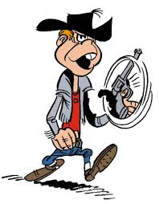
The second aspect is more prominent with Billy the Kid than Jesse James, and it follows a similar line of thought, only it mostly focuses on the puritanical aspect of American society, in their attaching charming qualities to a character that could symbolise temptation and is in some texts described as an “impish figure”. It could imply frustration with Puritan-established limitations of life in associating positive traits with a devil-lik figure. Of course, the fact being that Billy was an outlaw, this could be used as the exact opposite, a cautionary tale against this heathen with a bad influence that Implies that people who are liberated of social and religious conventions can only be conspiring with the devil. On another note, this detachment and rejection of society, this inherent quality of being different often found in such legendary figures (its individualistic nature aside) can also be identified as a manifestation of being “other”. This might be another reason behind why people project on those characters and why they idealise them, and often add the element of them being an underdog of humble beginnings in their mythos, even when it is not necessarily accurate to the original story. People in the margins are eager to see themselves represented and latch onto the elements of these legends that imply that this fabled hero was also othered.
Additionally, I’d like to reference the stark contrast found in these stories between their atmosphere and their themes, in a way. In most depictions of the wild west in popular culture the aesthetic that dominates the medium is one of poverty and lingering disease, muddy shoes and rotten teeth, worn and torn leather, a thin veil of dust engulfing everything. And yet the figures and events that take place are often idealised, tales of heroism and great betrayals, illicit love affairs or robberies that will go down in history. The crude and cruel band of outlaws in question is presented both in its depravity (often trying to tackle issues such as the nature of man and weather cruelty is inherent) and heroism, in fact it is often implied that heroism exists within said depravity. It might be this tendency of Wild West stories to somehow try to convey the worst of human nature in the cruel world they put together, but also glamourising that world at the same time. It reminds me a bit of the genre of Cyberbunk and its High tech-Low life dichotomy in its themes and aesthetics. (In this case it would sound like low life high hopes? I admit I am not the best at catchphrases). Lastly, I’d like to make a note of the treatment of women as a prize and their objectification, and often fetishisation as well, in such stories, because I can never refrain from mentioning women regarding any matter.

Georgia Theodosia Marini (1563202100123)
Calamity Jane

Calamity Jane is quite the character. One can already notice it in the name "Calamity", not the most discreet moniker for a legendary figure. Reading the texts provided about her is quite an interesting experience and makes me, once more, have quite conflicting lines of thought. At first, she seems to fit in perfectly with all of the other legendary gunslingers in the syllabus, as far as the way that her feats and character are described. A “larger than life” character perfectly encapsulating the typical gunslinger mythos and the American spirit, brash, brave, unmatched with a gun, defying social norms.
However, the fact that this particular gunslinger is a woman adds multiple layers to the conversation; aspects which were previously absent when discussing, for example, Billy the kid, are now fundamental to the discourse. The customary role for a woman to fill in stories about gunslingers is always a dehumanised and secondary one. Sexualised and treated as an object, relegated to the background, treated as a step stool for the male protagonist to progress in his legend or portrayed as a prize to be won, perhaps a symbol of social status. Often male gunslingers may encounter a female character and show them mercy, where upon the woman becomes a plot device to showcase the man’s dual nature, his "hidden heart of gold" despite his outlaw status. Women characters shown harbouring romantic feelings for the male gunslinger also serve as both a reason for other men to want to project themselves onto these characters (for men to want to be him women have to want him after all) and also some form of "reassurance" that, no matter how wicked a man is, he is still be worthy of a woman’s love. There is clearly a lot of entitlement in this thinking process, with men thinking they are owed romantic affection from women regardless of what they are like as people, a point of great anger for me personally, which has, tragically, hardly faded in modern society, but I digress. In none of those stories does a woman set foot outside the very strict limits society has imposed upon her, never is she the protagonist of the story, picking up that shiny revolver and pair of spurs and riding off on a mighty steed into the sunset after emerging victorious. Well, Calamity Jane does precisely that. Instead of the love interest or the mother she reclaims agency and becomes the protagonist of her own story, she is herself the rash and reckless Gunslinger with the impossible feats under her belt, the endless string of lovers, and overall, the legend. The existence of a female gunslinger also perfectly suits the interpretation of such characters being, among other things, a representation of “other”, due to their challenging of social conventions, an aspect which is instantly intensified the moment such a figure is also a woman. The publics reverence of them might be exhibiting the common folks desire to escape the shackles of society.
Now at no point will I attempt to deny the importance of this, and because of the reason previously mentioned I can look upon this character with great fondness, but I find there is some more nuance to this story that makes me feel a bit more conflicted. Despite the originally empowering aspect of seeing a woman exist as the centre of the narrative for once, it is in my opinion pivotal to recognise that the aforementioned narrative within which this character finds herself is one very deeply rooted in the patriarchy and white supremacy. First and foremost, this is more easily spotted in the fact that many more historically accurate sources might describe Calamity Jane as non-conventionally attractive for the time, yet more fiction-oriented ones, like the story of how she got her name, make a point of describing her physical appearance in great detail highlighting the fact she is very attractive to the male gaze. That story is after all relayed to us from a male point of view, as I imagine a lot of stories and dime novels about her were, seeing as they were most likely written by men. It is, of course, dreadfully important for the reader to be aware she looked very appealing to men while she was committing murder in a shoot-out, God forbid that slips our notice, the first question that came to mind upon reading this was “How many inches is her waist though? Please, I must know.” Not to mention that, in the sources that give a more realistic review of her appearance, she is severely criticised for it; after all to them is woman’s primary purpose is to be an accessory to and be desired by men (and care about the latter very much herself), a legendary figure who does neither must have appeared as mortifying, they could either hate her for it or change the story to fit their ideals. Ironic that a story about a gunslinger is changed to be more adhering to societal norms for it be popular with a wider demographic. This element of the patriarchy is still present in modern day, and as far as Calamity Jane herself goes, most portrayals of her in popular culture insist on presenting her as much more feminine and conventionally attractive than she was recorded to be.
Another element that makes it that much more obvious that this legend is not exempt from the social pressures of the time, would be the clear elements of white supremacy and American imperialism. In one of the stories Calamity Jane claims that she will only sleep with white Anglo-Saxons and uses an ethnic slur that refers to people from Mexico. In the story of how she acquired her name she saves a general by killing a group of native Americans that were chasing him, the natives are quite literally mentioned to be servants of the devil. It is perhaps impossible for such a legend to escape these harmful elements, since the very Archetype of the Gunslinger can be so deeply rooted in American Exceptionalism. Thus, I do not know how much I can truly think of such a story as empowering, after all the goal is for an oppressive system, such as the patriarchy, to be deconstructed, not for a woman to manage to thrive within the system by also oppressing others. The point is not to see someone being oppressed and say “Women should be able to do that too”, it is to erase that system entirely. I suppose it is possible for a middle ground to exist, meaning that a legend like Calamity Jane can feel liberating in some manner but still be far from perfect, it is, to be fair: a product of its time (although stories that present such contradictions/this mindset are sadly still being written today). Lastly, a thought that came to me when I was reading and I thought I’d share, at some point in the texts Calamity Jane is quoted as saying something along the lines of "I am the one that gave you life, and now I can take it back". A very particular choice of words, it is interesting to see how often the fear of being "drawn back" into the womb and killed/castrated by the mother is present in texts men have written about women.

Alexandros Tzartzas (1563202100250)
First thoughts on Buffalo Bill

Buffalo Bill’s legend is associated with various themes: the legend of the frontier, the battle between Native Americans and white Americans, publicity and popular entertainment, among others. It’s interesting to observe when reading the texts that Buffalo Bill wasn’t just the product of the legend of the frontier, but also played a role in shaping it, which highlights that legends aren’t static, but that they evolve over time, and other subsequent influences can shape them along the way. Hence, there may be a cyclical, dynamic nature to them.
When looking at the battle between Native Americans and white Americans, one of the reasons why Buffalo Bill was made legendary - by his fellow white Americans, it must be said - was because of the role he played in fighting Native Americans in the Sitting Bull war, and killing the chief Yellow Hand in a duel. The death of General Custer by native Americans lingered in the background: it was because Buffalo Bill was seen to be avenging General Custer that he was celebrated by his fellow white Americans.
What’s also interesting about Buffalo Bill’s legend is that it was aided and catalyzed by publicity, popular entertainment, and spectacle, as opposed to emerging by chance. Indeed, one of the texts mentions how “unlike those popular heroes who grow in folklore fortuitously, Buffalo Bill was the subject of the deliberate and skilful use of publicity”. Moreover, it was as his life and career were taking shape that dime novelist Prentiss Ingraham penned some two-hundred books on him, and thus contributed to raising his profile; never mind the various theatrical plays about Buffalo Bill, in the late-19th century, as well as the publicity he received when Major John M. Burke publicized the former’s duel with Yellow Hand in 1876. And the penultimate event of Buffalo Bill’s life was the West, Rocky Mountain, and Prairie Exhibition, which he starred in. Is he the 19th-century Western incarnation of the celebrity [or a precursor of the Kardashians, whereby self-promotion is deliberately used as a vehicle for fame]? Either way, it must also be said that the public showed up, and/or bought the dime novels written about him, so perhaps his story was ‘best-seller material’ to begin with.
This begets the important role that the circus and spectacle played in Buffalo Bill’s story. In my view, it has more to do with those elements, rather than the idea of the freak show: even though seemingly impossible, or rather, stunningly difficult feats took place, these relate more closely with fair-style popular entertainment. At the end of the show, spectators are asked to visit the Wild West camp, thus creating a fair-like environment. In the opening prelude before the monologue begins, it’s interesting to note how W.F. Cody - whose alias is ‘Buffalo Bill’ - isn’t just the legendary personage, but also the chief marketer of his own legend/performance, given the inscriptions “The whole [spectacle] invented and arranged by W.F. Cody”, and “W.F. Cody and N. Salisbury, proprietors and managers”. This ties to the previous idea that Buffalo Bill’s legend didn’t take shape by chance, but was driven by market forces, closely tied to the forces of spectacle, entertainment, and publicity.

Oliver Cuervo Álvarez (1563202300252)
Pecos Bill
Pecos Bill belongs to a series of legends in US folklore surrounding mythical figures that represented one specific industry or iconic profession of the American land. Paul Bunyan for the lumberjacks, Henry James for the steel-driven men, Joe Magarac for the iron industry workers, and Pecos Bill for the cowboys. And the stories of Pecos Bill share characteristics with all of them. Paul Bunyan stories were told in the other end of the country, but they still have in common the absolutely ludicrous, exaggerated stories, that deviate completely from reality or even plausibility.
Indeed, the myth of Pecos Bill is one associated with labour, in some way all these worker mythical figures serve to dignify the ordinary lifestyle shared by many at some point in the American land. The labour related folklore also makes apparent that there is no distance between Americans and their myths. Their industries, their everyday occupations and the people around them are subject to become living folklore. Their self-consciousness as a nation and their conviction that they were making history was prone to that: the American settlers were aware that they were building themselves, their own culture and history as they did it. They had been telling tales of themselves even before they arrived in the land. The remains of this show still in Pecos Bill stories, were even the manner in which a cowboy catches cows with a rope deserves an etiological explanation.
The manner in which some of these stories are written seems to be a mockery of historical literature: the text adopts the style of and actual historical or even scientific tone, and uses it to describe absolutely ridiculous, made-up facts. The narrator tells us, for example, that “it is a matter of record that he dug the Río Grande one dry year when he grew tired of packin´ water from the Gulf of Mexico”. And then he goes on to say that “according to the most veracious historians”, Pecos Bill was born more or less when Texas was “discovered”. Of course, Pecos Bill was not a real person and Texas was hardly discovered, but rather became independent. However, this is the text´s way of linking the mythical cowboy to the state.
I believe the use of this pseudohistorical expressions shows the southern pride present in all the text, as well as a subtle anti-intellectualism. It is a mockery of the north, which is perceived as more educated. The sentiment is confirmed in the ending of the stories, when Pecos Bill dies in the only way he really could: laughing at a Yankee. The shallow understanding of life in the Wild West by a northerner was of course hilarious to Pecos Bill.
In other stories extremely masculinised environments and professions, the tone seems to me endlessly darker. Fear of the savage, the uncivilized within us is often one of the main topics. Violence, specially towards women, is the norm, as well as alcoholism and a general display of a decadent, dangerous and unkind society. Pecos Bill however, truly differs in this sense from other men of the wild west. He is more wholesome than violent towards the world around him. His alcoholism is played for laughs, and the gruesome things he does, he does towards himself. In fact, his legend seems to have a fondness for having him consume inedible, disgusting things.
The stories also unite Pecos Bill (and therefore, every Texan), to the land by having him live as a coyote for some time. He became one with the nature of the place, and furthermore he was in a way raised by the land. If we compare this instance with earlier texts, we shall perceive a kind of development: the European newcomers finally feel attached to the land and make peace with it. Not only do they not fear its effects upon them, or what might dwell in it, but they even recognise themselves as a part of it. Furthermore, when Pecos says that he must be a coyote and not a human because he howls and has fleas, the man who found him answers that that proves nothing: “most Texans do”. In this I find self-mockery as well. Yes, they are rough people, they are not as sophisticated as the city people of the north, but nor do they wish to be. The aspect of them that is uncouth is not something to be scared of anymore, but rather proud of. And Pecos Bill is the perfect vessel for this southern pride.

