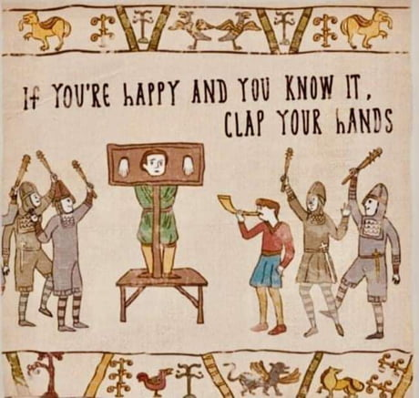
MEDIEVAL LITERATURE

7th semester elective
Dr. Christina Dokou
Academic year: 2025-26
Thursdays, 12:00-15:00, Room 822
E-class: eClass ΕΚΠΑ | Medieval Literature (uoa.gr)
Office hours: Thursdays 15:15-16:15 and Fridays 12:15-13:15, Office 703

Course description:
Welcome to the Dark Ages—quite a colorful time, actually, which we will attempt to shed light to in this introductory seminar! The aim of this course is to approach the European Middle Ages through a number of key English texts of the early, middle, and late period, in modern English translation. We will focus on both the formal aesthetic particularities of medieval literature, as well as its thematic idiosyncrasies, so foreign to us albeit so influential to the literary and cultural ages that followed since: the interplay between a strict religious worldview and a carnivalesque secularism; the construction of the socio-philosophical codes of fatalism and chivalry; the complex yet misunderstood role of women; and the formation of cultural idols. Through this brief but important selection of must-know texts, we will hopefully dispel common misconceptions about the Middle Ages while learning the truth behind them. Readings will be long, and often hard to identify with contextually; but the world they reveal is a fascinating one, and certainly worth knowing! At the end of the semester, students will be asked to evaluate this course via anonymous electronic questionnaires.
Although the instructor will provide introductory and analytical lectures for each item, your strong participation is indispensable for the implementation and assimilation of this course. Should any problems arise during the semester, please see the instructor as early as possible.

Coursework includes:
- Weekly readings and participation
- Three (3) class journals on the dates designated on the schedule below. Each journal should be a 1-page minimum reaction papers, written right after your readings and reflecting your own personal thoughts on, or analyses of, one of the texts assigned for the given date. Mere summaries will not count as submissions. Journals must be typed, with 1.5 space and 12-pt. font regular letters. Please, no cover pages or plastic sheaths (spare the environment!). You are responsible for missed class material and journals: in case of absence on a journal date, either submit your paper early, or electronically. A hard copy of your journal should also be present at the start of the class on their due date, as students may be asked to read aloud their entries for the benefit of their peers. Journals selected by the instructor (whole or parts) may also be posted on the website for peer-sharing, with the author’s permission. Plagiarism will not be tolerated. Journals are collectively worth two (2) final grade points (best two out of three grades).
- A final written exam, worth 8 points.
- There is also the option of a final research paper, worth 2 points, 1.800-2.000 words, with at least 10 items of bibliography (including your main text), due on the day of the final exam in ELECTRONIC form (1.5 space, 12-pt. font, latest MLA citation style—available at https://owl.english.purdue.edu/owl/resource/747/01/), in either a Word or an OpenOffice file. The scanned first page of each paper source must be submitted for the final draft (in a unified PDF file) to be considered valid. The paper will either analyze an aspect of a medieval text not included in the syllabus (in the case of large texts included in the syllabus, this can mean omitted parts of those texts) from a modern theoretical point of view, or can compare/contrast an original text with a later qualitative literary adaptation. Theses must be submitted beforehand for instructor approval. All parts of the paper must be submitted on time and in valid form for the final project to be considered. ANY plagiarism discovered will result in an automatic and terminal fail for the project.

Texts:
All primary texts and selected secondary texts for helpful optional reading are available on e-class. You are expected to have read the designated texts before coming to class each week.ţ

Class schedule:
Date | Session Theme | Texts
2/10 | Introduction: The Middle Ages | To be provided in class
9/10 | Old English/ Anglo-Saxon poetry | “The Wanderer” (Hostetter transl.)  OPTIONAL TEXT: Exeter MS info on “The Wanderer”
16/10 | The English (?) epic | Beowulf (Chickering transl.): Introduction and ll. 1-1062  OPT. TEXT: Tolkien, “Beowulf: The Monsters and the Critics”
23/10 | The role of women | Beowulf, ll. 1063-2195; FIRST JOURNAL
30/10 | The Twilight of the Idols | Beowulf, ll. 2196-end.
6/11 | Middle English: Religion and life | “The Pearl” Corbett “Introduction” from Ridland transl.; Watson transl. stanzas 1-6, 9-12, 14-16, 19-25, 28-35, 40, 51, 66, 76-81, 83-87, 97-end; RES. PAPER THESIS DUE  OPT. TEXT: Dokou and Sakelliou translation and article
13/11 | Chivalry and the knight’s quest | Sir Gawain and the Green Knight: Stone transl. pp. 286-314 (ll. 1125)  OPT. TEXT: “Sir Gawain—Medieval Romance” site info
20/11 | Old and new worlds | Sir Gawain and the Green Knight: pp. 314-end; SECOND JOURNAL; NOTE! read missing stanzas from the Tolkien or the Boroff translations.
27/11 | The Arthurian Legend: from epic to romance | Mallory, Le Morte d’Arthur, Book 1, chapters I-VII, XIX, XXV, XXVII; Book 2, chapters I-IV; Book 3, chapters I-IV; Book 4, ch. I, VI-XVI; Book 6, ch. X, XII, XVII-XVIII; Book 10, ch. XXIV
4/12 | Rex Quondam, Rexque Futurus | Mallory, Book 11, ch. I-X; Book 12, ch. IV-VI; Book 13, ch.1-VIII; Book 17, ch. XVIII-XXIII; Book 18, ch.I; Book 20, ch. I-X, XXI-XXII; Book 21, ch. I-VII
11/12 | Chaucer: portrait-master of a nation | Chaucer: “Translator’s “Introduction” and ll. 1-34 of “The Prologue”; “Words between the Host and the Miller” and “The Miller’s Tale”; THIRD JOURNAL  OPT. TEXT: The Harvard Chaucer Website (see “Resources”)
18/12 | The carnivalesque: signs of change | Chaucer: “The Wife of Bath Prologue” and “The Wife of Bath’s Tale”  OPT. TEXT: The Harvard Chaucer Website (see “Resources”)
8/1/2025 | The Morality Pla(y)gue | Everyman and “Introduction” at Everyman with other interludes (gutenberg.org)
EXAM DAY |  | RESEARCH PAPER DUE

