MEDIEVAL LITERATURE 2025-26
JOURNAL HALL OF FAME

Iliana Salvaridi (1563202200178)
Maternal Instinct in Beowulf
“For the hand that rocks the cradle
Is the hand that rules the world.” – William Blake, 1865.
From the very first moment of Grendel’s mother’s introduction, I began making comparisons between her and Queen Wealhtheow. Obviously, the very first thought formed in my mind was that one of them represents Good and the other represents Evil. However, the more I think about them, the more I realise that is not entirely the case.
On the one hand, Queen Wealhtheow, in the bright Heorot hall, offering treasures, drinks, and hospitality to the brave warriors that aided the Danes in their time of need as a means to maintain peace and unity, acts not only within the bounds of her societal role as a queen, an ideal noblewoman, but also as a diplomat, making it evident that she also has political influence in her kingdom as a peace-keeping, moderating force. She has a name, her own identity, and is not defined by others; she has a voice that embodies female power without threatening the patriarchal system in Beowulf’s world.

Grendel’s mother, on the other hand, remains unnamed and voiceless throughout the entirety of the poem and is defined only by her son and her actions. She is denied an identity, something which symbolizes her exclusion and marginalisation from society— obviously, since she is not exactly human. Although never explicitly being described as a monster, her qualities and actions are viewed as monstrous because they do not conform to the social and gender hierarchy of the world. Seeking vengeance for her son, she resorts to violence and faces Beowulf herself, an act that would be deemed heroic if she were a man. However, because she is a woman, it is viewed as monstrous, since she is acting outside society and its rigid gender order. Her actions threaten male control directly. This inhumane and ostracised portrayal of her is perpetuated by the fact that she dwells in a dark, murky mere that is cut off completely from human society.
Despite all their differences, these two women are united by their foreignness and motherhood. It goes without saying that Grendel’s mother is an outsider. She lives and acts outside of society and is not of the human species. The Queen is also a foreigner, seeing as she is not Danish and she married into the Scylding family to ensure peace between tribes. Thus, in their culture, one appears only to exact vengeance, and the other exists to maintain peace. However, their primary role is that of the mother. Wealhtheow requests that Beowulf take care of her sons and advocates for their right to the throne; her passing of the mead cup to him is a symbol of allegiance and obligation, thus ensuring their protection through her peace-weaving, diplomatic qualities. Grendel’s grieving mother takes direct action to protect her family, to avenge her son’s death, through physical strength; after all, she only exists to defend her son’s life, even after his passing. Though their efforts have different outcomes, their maternal instinct intertwines them, making them—at least, in my eyes—two sides of the same coin.

Stella Margiori (1563202200118)
Beowulf, Part II
After reading the second combat scene in Beowulf, many questions were raised regarding the romanticization of battle, as well as the representation of the pagan tribes, additionally in relation to God. The hero of the story now has already re-payed his debt to Hrothgar, yet he goes back to fight another monster without wanting to receive any reward for it. As he clearly states, fame after death for him is the biggest reward. In my opinion, this has to do with men’s obsession with war, clinging to the idea of fame after death and chasing after it. Beowulf, though noble, is an example of that. For me, it steams from the belief of that time, which is still prominent today, that dying in battle-someone else’s battle-is an honorable death. As Beowulf tells the story of his adventures, he describes killing Grendel, as “dancing with him in the hall’’. By replacing fighting with dancing, an art, romanticizes the brutality of the bloodshed in battle. It also specifically stated that Beowulf shows no care for his life (“Then Beowulf showed no care for his life, put on his armor”), which we can debate if it’s just his nobility showing or it’s just a way to highlight the way patriarchy makes men believe that wanting to die in battle and not caring for your life is normal, noble and just. In this context, there’s a comparison done with Unferth, who doesn’t want to risk his life, insinuating his cowardice. Beowulf is a hero, Unferth isn’t, because heroism is a characteristic that few people have. Although, being a hero and starting to romanticize bloodshed, as well as not caring for your life, seems to be the one and the same in this poem.
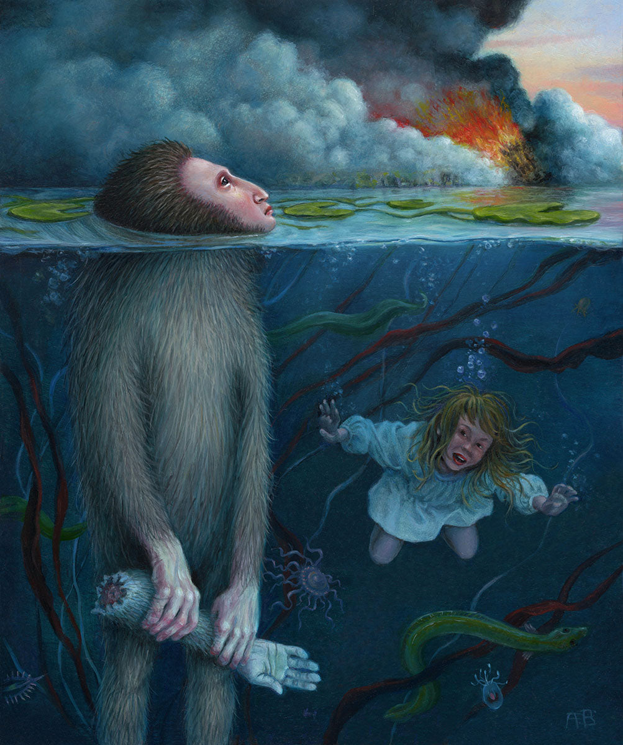
Another modern reading of this, would be the following: God seems to be very selective of the peoples he chooses to grace with his gifts. Clearly, the monsters, which are a parallel to the pagan tribes, aren’t one of those peoples. To me, this is very apparent in the way the lake is described, the one which Grendel and his mother lived in. It’s described as the mouth of hell (lines 1354-1373), comparing Grendel and his mother to demons, which has many negative connotations about the colonized tribes, viewing them as something evil. Grendel’s mother resides in a cave, showcasing how society has truly cast her and her people off. Her reaction to having her child murdered seems to be pretty justified, sneaking into the hall, killing one of the warriors there and then fighting her child’s killer. Yet, she is called alien, since of course revenge isn’t a Christian value, and an animal, specifically a “she-wolf’’. The same isn’t true for Beowulf, the chosen one of God, who apparently shows mercy to Beowulf, when he almost dies in that cave, but not to Grendel and his family, insinuating that God is also casting them off. Also, when Beowulf becomes brutal and takes revenge for the killing of some Thanes, by chopping off and already dead Grendel’s head, that’s seen as a fair act. A speech later in that poem reveals to us that if one is chosen by God, he should stay humble but he can also forget about the worries of mortal existence. That isn’t the case for other creatures in the poem, since they die by the hand of Beowulf who is the one God chooses, not them (lines 1725-36). In conclusion, God only takes the side of the people who possess Christian values, making him a very unfair God, which is ironic, since one theme of the poem is how Beowulf seems to be fair to the monsters while fighting them. But we can’t really talk about fairness here, since the opposite side is doomed by the start, specifically doomed by God.

Leonidas Chrysikakis (1563202200225)
Beowulf ll.1063 – 2195
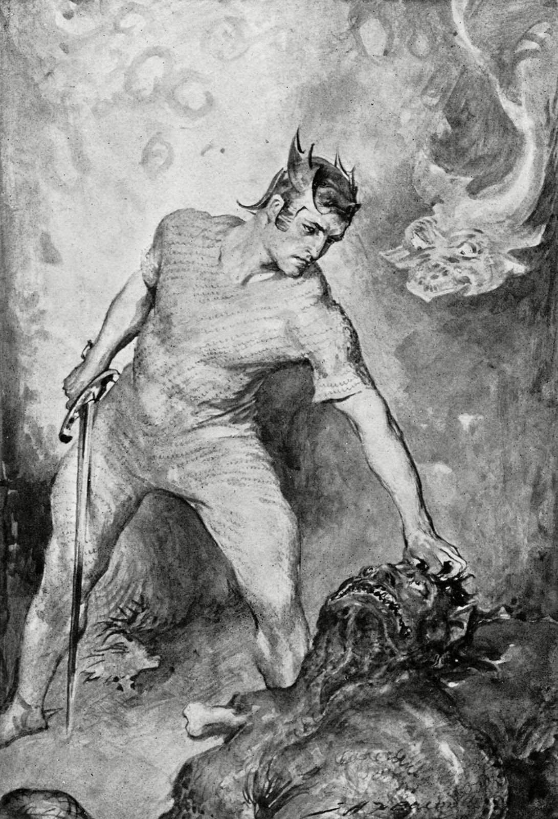
The first thoughts that spring to mind after continuing to read Beowulf is how positive masculinity is portrayed within the poem, specifically what it means to be a leader of men and a warrior in Norse culture. The two ideals, portrayed by King Hrothgar and Beowulf respectively, can be said to be instructive to men of the time, making the poem didactic.
In the character of the king of the Scyldings we see a wise man burdened by age. Hrothgar is referred to throughout the poem as old and past his physical prime, yet exalted for his wisdom and generous rule. Even though his reign has been plagued continually by Grendel’s attacks, he has maintained his dignity and authority in the eyes of his people and of the poet, the blame being shifted to the incompetence of his thanes in doing their duty. His wisdom is best exemplified in his prudent character. Knowing that he is outmatched by the monster he does not seek a glorious death in a vain attempt to gain victory by attacking the monster, which would by all means grant him entrance to Valhalla. Instead, he sticks to his duties as a lord, never blaming his subordinates. Hrothgar demonstrates how virtue is needed for a leader of men in safeguarding the lives of his people, which rest upon him for order, survival and prosperity.
Similarly, Beowulf embodies the archetype of the noble warrior. In a culture largely based around war, bloodshed and oaths, Beowulf is closer to the realm of the gods than that of men. The perfect mythical warrior, balancing indomitable strength with a nobility which seems almost impossible for a mortal man. He lacks the human faults which are actually more prevalent in Grendel’s panic and malice. Of course, in our modern interpretations, from a literary standpoint, Beowulf might be deemed as a “Mary Sue” character, unrealistic in his infallibility and ultimately boring. But I see Beowulf as something completely different. To his contemporaries, Beowulf would function as an ideal to strive for, a mythical character which would embody the desires of warrior culture while also aligning with the relatively new Christian values. Beowulf is the kind of warrior that the men of his time would claim to be descendants of.
To modern audiences, Beowulf is a prime example of the male power fantasy which modern society sorely lacks. Beowulf’s positive masculinity does not lie in his monstrous grip but in his ability to face every challenge appropriately even to his own possible detriment. He stands completely opposite to modern man who lacks connection to his roots and culture and who to a vast degree if not wholly, engages with life on a purely utilitarian level. Beowulf did not seek to help Hrothgar and the Scyldings for the sake of wealth and glory but due to his connection to Hrothgar through the culture they share. In fact, Hrothgar did not even summon him to slay Grendel. His own personal interpretation of the demands of Norse culture led him to his fight with the beast. Beowulf rejecting material security for the sake of spiritual ideals is the kind of romanticism young men are in need of. Therefore, in my eyes Beowulf is a great depiction of male ideals which acted as necessary goals in a culture where men’s mistakes undoubtedly shaped the future of whole ethnic groups, tribes, and nations. Written in beautiful prose, it provided, and still does provide, men with a direction to strive towards in order to be better.

Maria Stavroulopoulou (1563202200248)
Beowulf, Part II
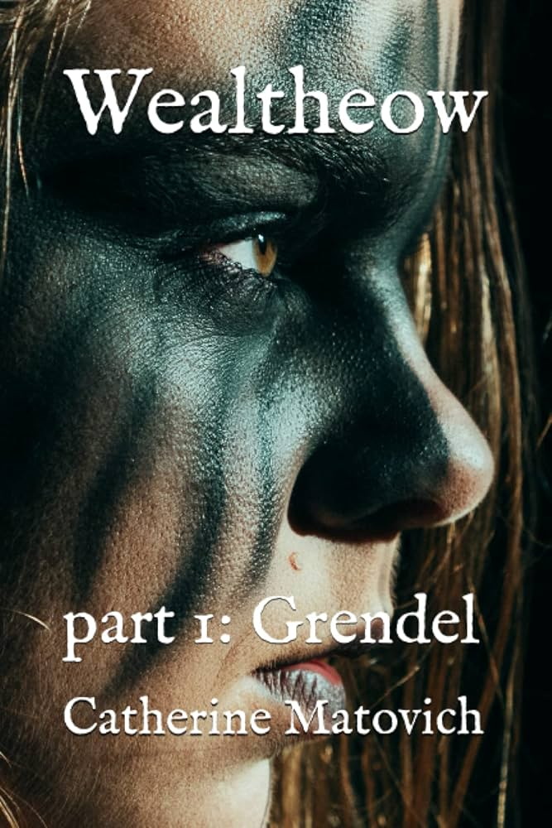
This extract of Beowulf begins with the scop narrating an episode about a blood feud. The motif of the blood feud is used throughout the poem and it is basically stated that one cannot resolve a blood feud with marriage. The roles of women in the story intertwine here as they are, directly or indirectly, compared and contrasted to one another. To begin with, the nested story contains Queen Hildeburh whose family, specifically her son, brother and husband, were murdered as the result of a blood feud. Her story foreshadows the appearance of Grendel’s mother and her desire for revenge, unlike Hildeburh who seems to be passively returned to her homeland by the warriors. This episode also foreshadows, perhaps less imminently, the murder of Queen Wealtheow’s sons, despite her efforts to protect them. This episode is brought back at the end of this part when Beowulf returns home and recounts his tale, mentioning the coming “peace weaver” marriage of Hrothgar’s daughter to their blood enemies. Hildeburh was also in such a marriage that ended in disaster, which Beowulf predicts will happen this time as well. The agency of women is brought into question here. While Hildeburh exacts no revenge herself, Grendel’s mother takes it upon herself to have vengeance, for this she is viewed as monstrous, crossing the boundaries of femininity. She is fearsome yet she is not even graced with her own name. Wealtheow on the other hand makes moves to protect her sons and we see she is a cunning political figure, moreso than her husband, yet it will still not be enough. The Queen of the Geats, Hygd, is viewed just as highly as Wealtheow and is juxtaposed with Queen Modthrytho, who is said to have “committed a terrible crime” of pride, resulting in many men’s deaths and was sent away in yet another “peace weaver” marriage, but this made her more gentle, noble and loving. This suggests that any woman can be “tamed” through marriage, and it is not viewed as the punishment it undoubtedly would have been to be sent to a foreign land to marry an enemy.
Another interesting point about this part is the re-emergence of the pattern of Beowulf returning what was done to him, responding in kind. First, Grendel’s mother cannot hurt him because of his armor, but neither can he pierce her with his own sword. He uses his grip and so does she, even overpowering him, but once she uses a knife he uses a legendary sword. In the same way that she displayed the head of the thane she killed on the cliff, he cuts off her head as well as Grendel’s, repaying her twofold, the severed head reminiscent of the severed hand. Lastly, when Beowulf is about to leave the land of the Danes, the guard who had greeted him coldly upon entry who Beowulf handled diplomatically, now greeted him with respect and politeness, to which Beowulf responded by gifting him a sword. The theme of repaying kindness with kindness and cruelty with cruelty is evident. The early Christian references throughout the epic, and this part in particular, may reinforce or undermine this messaging. Repaying kindness with kindness is supposedly a “Christian virtue”, but so is “turning the other cheek” instead of responding to cruelty and resisting it, like a warrior should. Pride or “hubris” is the downfall of a warrior or any man, as is evidenced by the Biblical narrative inserted in the story. There is “good”, and there’s “evil”, which necessarily must be slaughtered. Christian and old pagan warrior values and tales mix in this story, exemplifying the transitionary period into early Christianity.

Vassiliki Benou (1563202200132)
Beowulf: The Making of a Hero
Reading Beowulf and specifically the second combat had me thinking a lot on themes like manhood, masculinity and the Christian values presented in the epic poem. This second part resembles a lot the first one. Αgain, they sleep. And then a monster comes to disturb their peace again. Grendel’s mother now, seeking revenge for her murdered son, kills the king’s kinsman and of course Beowulf has to step in and save the day again because, for some reason, men just refuse to live a peaceful life, see Achilles.
We see again these very “manly”, hero-like qualities that are a must for every man who wants to be remembered who wants to be a hero. Throughout the poem we see a repeated tendency of men -Beowulf in particular- showing no care for his life whatsoever. This hero complex I would call it, this self-sacrificial tendency elevates Beowulf to a great man, a role model of a hero and later on a God-like figure. The author very vividly compares and contrasts Beowulf with other men/heroes in the poem as for example, Unferth who gives his own sword to Beowulf “the better swordsman” because he is not, in fact, as brave and “manly” as Beowulf. Beowulf is a hero, one the never hesitates to do what he must and set his life in danger for the lives of others in contrast to Unferth who did not dare risk his life, so his name will not be sung by the poets as Beowulf’s will. We see again the long-lasting notion of fame and death, fame after death, fame before death. The connection between fame and death as the only and most important quality a man must acquire in life.
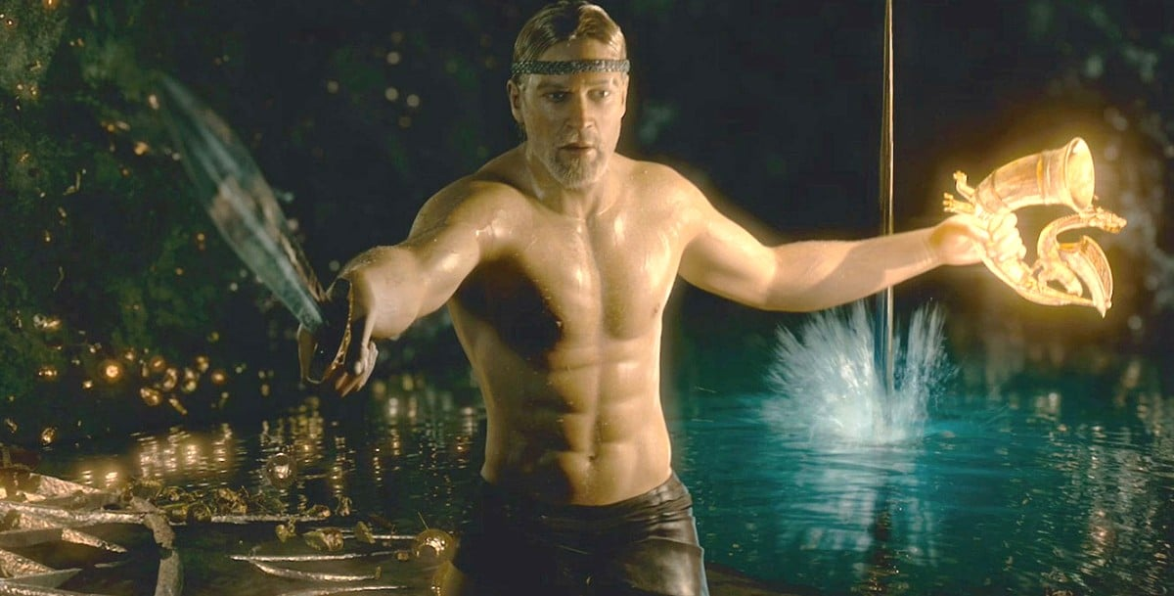
All these values however have a negative connotation for the Christian audience as well, don’t they? They do not go hand in hand with the Christian values so we should somehow… reshape them in a way that pleases everybody. Yes, Beowulf is a hero and he seeks fame. But he is chosen by God, protected by God, saved by God. God is always there but only for the hero never the monster. Let’s not forget that the monster is a woman, first of all, so she’s a “witch”, an “alien” and an outcast. She seeks revenge for her son which is under no circumstances a Christian value, so she must die by the hand of the good and just hero. But isn’t Beowulf also taking revenge for Æschere’s murder? Certainly. So, the two somehow mirror each other, no? Well, Hrothgar is certainly not ready for this conversation. But certainly, certainly, Beowulf is different. He fits the Christian stereotype. He must. He took revenge for the king’s kinsman, to protect the dead man’s honor which, in a male-dominated world, is a more “sacred” cause than a mother seeking justice for her son’s murder which, if we’re honest, is still the case today. And of course, let’s not forget that Beowulf, also, left all the treasures back in the cave (for some reason) because he certainly isn’t arrogant and ungrateful and certainly not chasing after money. He did it for his people and his beloved king and not to gain anything out of it, from the bottom of his heart. He’s God’s chosen and he used his God-given gifts for good, for honor. For his people and he’s nothing like this ungrateful Heremod who did not in fact use God’s gifts for good, as Hrothgar very wisely said.
To sum it up, while reading this second part of the poem, I couldn’t but think of it as a paradox. How Beowulf is slowly building his hero-like persona, doing all sorts of “manly” things, setting very clearly the standard, how masculinity should be in order to be praised and idolized by everyone.

Theodora Anna Spai (1563202200185)
Beowulf (lines 1063-2195)
First of all, I must instantly get something out of my chest: why on EARTH did Grendel’s mother keep the ONLY thing that was capable of killing her within visible arm’s reach in her secret lair? And where is the scholarly debate on THAT?! Girl, ORGANISE your room!!!
Okay, now that we got that out of the way (somehow it bugged me a little, though I cannot say I actually rooted for her), let’s calmly discuss Beowulf’s monsters. A monster story indeed, evil creatures indeed, but I can’t help but notice that these same evil creatures distinctly possess human features that subtly distinguish them from the portrayal of, say, an entirely mindless raving blob of evil flesh. What struck me in the second part, and there was even a footnote highlighting it, was Grendel’s mother's reaction to her son’s killing as revenge–clearly following the human convention of the blood-feud. She does not seek out to attack solely because of her monstrous urges for murder and destruction, rather she aims for revenge, however aggressive her reaction might come across as. Similarly, in part 1, Grendel showcases some human features: he is triggered by the sound of laughter and merriment in Heorot and is driven to these (fully unjustified though, don’t get me wrong) brutal, serial killings by what we could potentially read as jealousy, or at least a more complex kind of anger. He also feels fear, he is not battle-mad like typical folkloric monsters: the instant he encounters threatening opposition at the hands of Beowulf, he wants to flee. I am not sure I could make a case to defend him (nor is this my aim), but it is nevertheless fascinating that these monsters are not nameless and possess distinct features–oppposite to a long catalogue of stereotypical monsters that appear in folklore and myths. They are usually mere stand-ins for evil, basic outlines of a threat that the heroes must overcome. I wouldn’t say that the narrator/author strove deliberately to humanise Grendel and Mum to achieve depth, but, as we discussed last time in class, it could very well be that the geo-political context of the time Beowulf was written has been organically infused within the text itself. The monsters–said to be cursed from birth, descendants of the biblical Cain–have the potential to be read as stand-ins for the primitive Briton tribes that had inhabited England before the Saxons conquered the land, imposing their rule. Is it a biblical monster or just a cultural Other, different, misunderstood, obscure, yet uncannily human? To look away from their human features–the fear, the drive for revenge at the murder of kin, the jealousy, even the gloominess–is, perhaps, to deny visibility to this cultural Other, this struggling, oppressed Other, stand-in for a dying culture which still fights back.
Even without this historical reading, this humanity in the monsters is difficult to ignore. What if they serve as mirrors, representing exactly that which can go wrong in human character; self-servitude, brutal revenge, cruelty, bloody feuds that last generations, malice…wait…all this ALREADY went wrong within and beyond Beowulf’s story; there are constant references, allusions and foregrounding for characters within this mythic/historic universe, committing these exact wrongdoings–from betrayals to going corrupt. So there is humanity within the monsters and monstrosity within the humans. Or perhaps, one could say, these two are interchangeable, existing as a spectrum, and Beowulf is a story grappling with the marriage of both ends–and especially with its aftermath. After all, isn’t Beowulf himself a cartoonish blend of both, the ultimate virtuous human–generous, brave, charismatic–blessed with inhuman physical capabilities–almost, that is to say, a little bit monstrous?
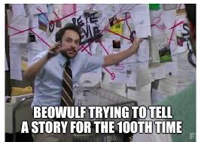
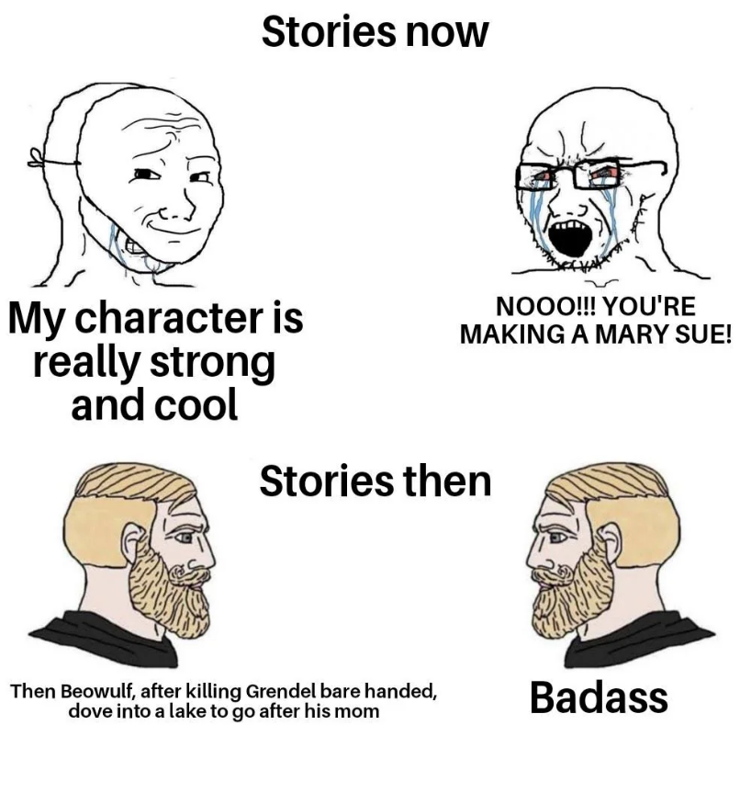

Dimitra Laskari (1563202200101)
The Mother, The Posthuman Son and the Warrior Spirit
Undoubtedly, the second part of the “Beowulf” poem continues the motif of challenges that highlight certain virtues of the main character who ultimately serves as the embodiment of the “good Christian soldier” ideal, albeit with some monstrous characteristics; It is a tale created to inspire men of the time to follow in the steps of Beowulf. However, this time, he will face a monster whose wrath and blood-thirst are driven by a very justifiable reason: she is a mother avenging her son.
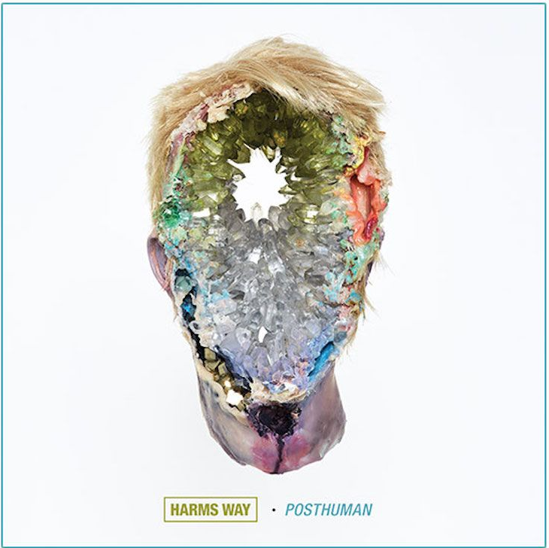
To touch upon the first subject, which is Beowulf’s mere nature, it is understandable that the character needs to possess some superhuman abilities -such as his “grim grasp”, in order to be able to slay every monster he comes across. Though, from a posthumanist perspective, Beowulf easily strikes as a hybrid form of human and either something divine or something monstrous. This is because he does not depend on weapons to defeat his enemies, he chooses equal battles, he is not tempted by wealth or fame that are known to spoil men’s motives and despite being aware of his physical superiority he doesn’t belittle or dominate others. He however can and will mutilate, kill and brutalize (as was the case with him “decorating” the hall with Grendel’s arm) - typically a monster’s actions. So, why is the “good Christian soldier” model not a typical human? Why is he so different from the other capable yet helpless thanes? Probably because of the timeless need of a saviour. No matter how many cautionary tales and role-models people are presented with, they will always long for someone exceptional to come save them. The most prominent example of this kind, the Posthuman saviour, is Jesus himself; and a number of links can be made between the two figures. Both are willing to die for humanity (for different reasons nevertheless), both have a set of devout followers that are under their protection and most of all, both return to their father figures at the end of the tale. As is written in the poem, everything is a loan and such a loan was Beowulf to Hrothgar who loved him as his own son and owed the safety of his land to him. At the end of the day, Beowulf had his own theoden at home and had to return to him. To conclude, at the time the poem was written, in the midst of raids and conflict, a passive saviour like Jesus couldn’t serve as an inspiration for the people. It had to be someone with nobility but also pure warrior spirit; It had to be Beowulf.
The second aspect of this part of the poem that is worth discussing is the monster Beowulf has to slay—Grendel’s mother, the unnamed “water-witch”. In contrast to her son whose motive for rampaging through Heorot was pure hatred for humans, Grendel’s mother is driven by revenge. Beowulf killed her only relative, her only offspring, ironically to take revenge as well. One can argue that in this light the two characters mirror each other, both with an “eye for an eye” mentality. What is interesting is that this is a female figure who, although doomed to anonymity, is the realization of a mother’s wrath. She also doubles Wealtheow in this way who, while not being a monster, is a very protective mother that will do anything to secure her sons’ future. Thus, it seems like the poem does not strip Grendel’s mother of her protective instincts. On the other hand, the “water-witch” bears no resemblance to Wealtheow in terms of femininity and one can say that she even is the subversion of it. Her monstrosity is given by nature; her ferocity is given by the loss of her son. In this way the monster-mother is emasculated and appears even more threatening than Grendel as in order to slay her, Beowulf must use a sword forged by giants since his own couldn’t penetrate her skin. Her possessing such masculine characteristics as a maternal figure totally subverts the classical stereotypes and highlights Hrothgar’s unexpectedly feminine side. He is a paternal figure to his thanes and to Beowulf, though when his beloved chief thane is killed by Grendel’s mother he becomes devastated. He is in deep grief and due to his old age he depends on Beowulf to avenge Aeschere’s death. It appears that in this tale Hrothgar acts as a “damsel in distress,” while Grendel’s mother is a tragic figure and a true warrior.

Marietta Brintziki (1563202100149)
Mothers and Sons: The Mother Figure in Beowulf

I believe a strong woman may be stronger than a man, particularly if she happens to have love in her heart. I guess
a loving woman is indestructible.
--John Steinbeck, East of Eden

The panther was chosen as their [Black Panthers] symbol. It is a beautiful, black animal which never attacks, but defends itself ferociously.
--Black Panthers (1968), dir. Agnès Varda

Motherhood is often obscured in the grand epic of Beowulf. The role of the mother, albeit important in every society and culture since the dawn of time, seems to take a backseat in front of the grandeur of the gore-filled, heroic battles that make up Beowulf. Its female characters seem more like a fine detail of a grand painting, like the presence of the women in the mead-halls, or whenever their presence takes up a considerable amount of lines, their identity is obscured, at least when compared to the lengthy genealogies provided for the men of the story. However, the role of the women of Beowulf, particularly the role of the mothers, has much more influence and dynamism, at least more than it appears at a first glance, from Wealhtheow’s cunning calls to Beowulf to protect her sons in days to come, to Grendel’s mother’s bloody revenge. On many points, Wealhtheow and Grendel’s mother seem to correspond in their motherly instinct to care and protect their sons from the violence that haunts the narrative of the story, but, as they differ in status and nature, the lengths of their ability to protect seem to vary. In this essay, I will argue how Grendel’s ‘monstrous’ and ‘Othered’ nature allows her to exceed the limits of traditional gender roles and avenge her son’s death in ways that Wealhtheow is restricted.
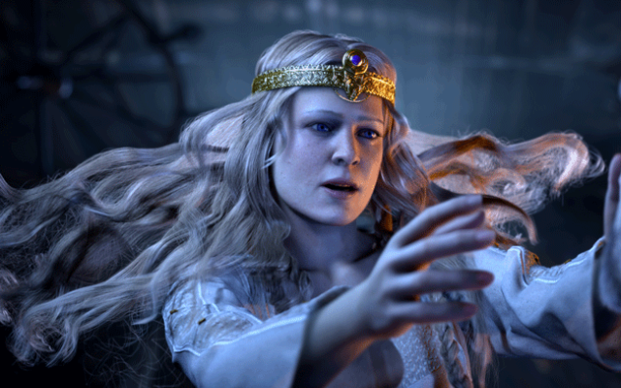
First of all, it is important to highlight that, albeit Wealhtheow’s limitations to resort to violence in the face of danger due to her role as a queen and woman in a Medieval society, she manages to use her power and influence resourcefully and with great tact. As she perhaps senses Hrothulf’s imminent treachery, and what that would mean for her sons, she cleverly ensures to ally herself with a powerful warrior who will act as a protector in future toils. From this perspective Wealhtheow manages to successfully fulfil two roles: the role of the insightful, diplomatic queen, and the role of the protective mother.
However, Wealhtheow’s protection is in many aspects limited. She relies on the good will of a powerful man, whose court lies beyond Hrothgar’s kingdom and whose help will most likely arrive too late. In contrast to Wealhtheow, Grendel’s mother, albeit does not manage to save her son’s life, she does manage to step into the shoes of the avenger, a role occupied exclusively by male fighters. When most women in the Middle Ages were expected to move latently and cunningly around vengeance, or to not do anything at all, Grendel’s mother is bestowed a role that Wealhtheow would have never been allowed to occupy. In the poem, the revenge of Grendel’s mother is portrayed as an amalgam of motherly grief and beastly lust for bloodshed. Upon a closer reading, though, the response which Grendel’s mother has to her son’s death is no different to the response that Beowulf has to the deaths of Hrothgar’s thanes, or to the response of any male fighter whose fellow warriors have died in the hands of another man. As Grendel’s mother is perceived by the characters as an ‘Other’, the threshold for expected behaviours opens greatly for her.
Additionally, the symbolism which surrounds Grendel’s mother seems to also point to a motherly nature more than a monstrous one. Her den, a cave underneath the waters of a lake, oddly resembles the amniotic sac of a pregnant belly; Her attack of Beowulf, a ‘deadly’ embrace is a mixture of her desire to crush the enemy, as well as of the common image of motherly affection, a hug. Finally, it is important to note that Grendel’s mother seems to mostly reside in her den, the domestic sphere, and shows no desire for bloodshed, up until her son’s death. This fact does not only contrast the idea of Grendel’s mother as a bloodthirsty creature, but is also a testament to her naturally peaceful nature.
Albeit overlooked and underrepresented, women in Beowulf showcase a diverse cast of characters, with the most notable being those of the mothers. Cunning and courageous, the mothers, specifically Wealhtheow and Grendel’s mother, exemplify the most noble desire for protection as well as vengeance. As Wealhtheow experiences both social and gender limitations, her ability to protect is limited in comparison to the shunned, nameless, “merewif mihtig”, Grendel’s mother, whose acts of vengeance, albeit seen as the whims of a monstrous creature, are in fact a manifestation of motherly grief. As both of these women move in the narrative of the story in the shadows, not concerning themselves with battle or bloodshed, unless provoked, they prove that the mother ‘never attacks, but defends herself (and her children) ferociously’.

Pavlina Karakasi (1563202200074)
Sir Gawain and the Green Knight (part two)
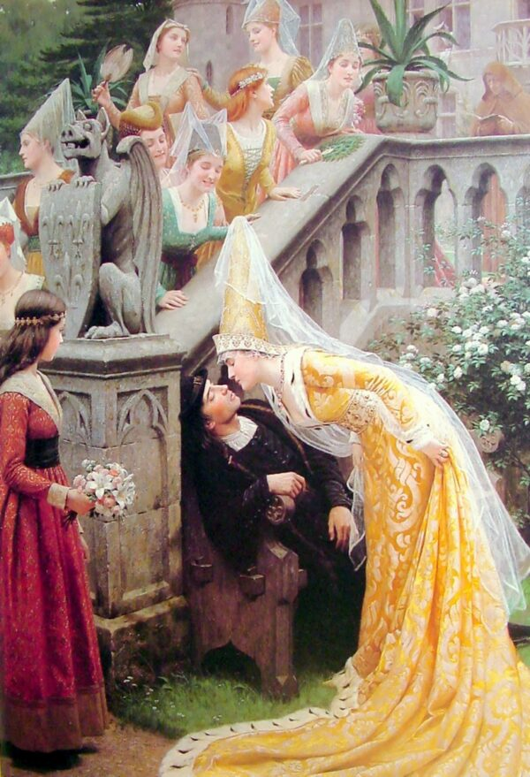
What struck me as interesting was how Gawain very nearly would have escaped from the Green Knight’s axe without even a scratch if his very human instinct to live wasn’t so strong. It seems paradoxical that his helpless desire for life in his final morning with the Green Knight’s wife manifested by his acceptance of the gift of the girdle that would supposedly save him from having his head cut off, would be what ultimately harms him when he faces off against his rival. Knightly courtesy and truth will only take him so far; in the face of death all men (and women) cower. This is also evident by Sir Gawain’s “cowardly” flinch at the Green Knight’s first attempt at striking him with his axe. Until now we have only seen the courteous and brave side of our protagonist, but when he chooses to take the girdle in secret and succumbs to his own desperate hopes for survival (even over the lustful seduction of a beautiful woman, imagine that!), he is revealed to be as human as any of us non-knights. Another testament to his humanity is the fact that he believed everything that the “lord’s” wife told him without second thought just because she was a beautiful woman who showed him interest… I understand that this was part of the Green Knight’s (or Morgan le Fay’s actually) plot to seduce the courtly knight into betraying his ideals. And what a plot it was! Everybody underestimates the women, and then blames them for bringing destruction on them. Which is what Gawain does too. He blames all his shame and grief onto the woman when he is the one who chose to believe her. But the seduction plot ties very well with the Celtic pagan tradition and the magic powers of the goddess Morgan le Fay. The woman who deceived Gawain is at the same time in a symbolic way Mother Nature who undermines the Christian, knightly creeds, as she is more ancient than either and at the heart of every living thing on Earth. She is the only enemy that can’t be defeated, as she is both life and death. Gawain attempts to trick her from killing him using the girdle, but he soon realizes that he just fell in the goddess’s trap due to his pride. And it makes sense that this is the only challenge that the famously bravest knight of the Round Table can not win, as he too remains human after all and no match for the forces of nature.
Thankfully, sir Gawain humbly learns his lesson on the fallacies of overestimating his pride and knightly values as is proven by his decision to keep the green and gold girdle as a token reminding him of his own humanity and thus susceptibility to all kinds of errors of judgment. Not only that, but the entirety of the Round Table adopted a kind of girdle after their beloved Gawain, a baldric with a bright green band that became part of their status as knights. Therefore, Mother Nature becomes a part of the knightly tradition, however conflicting.
Also the motif of kingdoms betrayed by a single weak person that was introduced at the beginning of the poem becomes relevant again in the second part when Gawain’s wish for life ironically almost costs Camelot both their bravest knight of the Round Table and the famed courtesy and truth of their creed. Without those two elements, Camelot could very well fall. But sir Gawain, despite his initial failure, survives the challenge and is redeemed in the eyes of the Green Knight and therefore Mother Nature. Another allusion to this same motif that also ties well with the Arthurian legend is the Green Knight’s admittance of the witch Morgan le Fay wanting to terrorize to death Arthur’s wife Guinevere by making her envoy’s appearance so strikingly opposing to “courtly” society. This intention could be an ominous foreshadowing of the queen’s future betrayal of Arthur in her affair with Lancelot that does indeed bring about the fall of Camelot. At the same time, it could be an indication of great resentment on the witch’s part for her half-sibling’s courtly frivolence that manifests as pure hate for his prized queen. Or even a ploy to try to bring her over to her own “kingdom” in death, just like the Green Knight offers Gawain to join his aunt’s household near the end of the story. Alas, Guinevere and Sir Gawain both firmly choose to remain in Arthur’s court, at least for now.

Vassiliki Benou (1563202200132)
They don’t write men like Sir Gawain anymore!
Sir Gawain and the Green Knight, to me, symbolizes the hero’s journey to knighthood, to become a good and honorable knight. This is the goal of the journey to begin with, to prove that he is true to his words and honorable. However, that journey did not end the way he originally thought it would.
Throughout the poem, especially from part three till the end, there is a repeated motif with the number three. The beautiful woman tempted him three times, the lord hunted three times, and the Green Knight made to behead him three times. That pattern with number three reminded me of the Bible in which this motif is also very common, as for example the Holy trinity. However, my first thought while reading it was Peter who, as Jesus predicted, denied him three times when he got captured. Then, when morning came and he realized his that Jesus’s prophesy came true, he wept bitterly. Same is the case of Sir Gawain who denied the lady’s favors three time but also betrayed the lord by withholding the girdle his wife gifted him and then visited the chapel and confessed his sin.
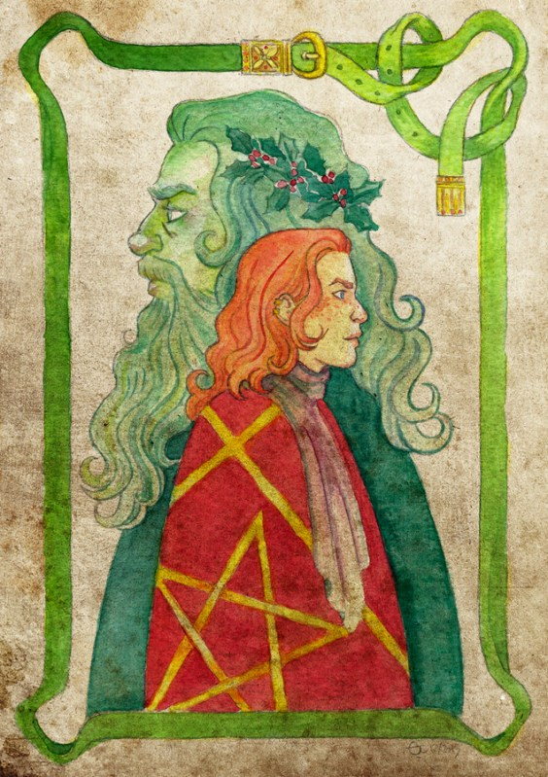
So, in a way, number three symbolizes his failure and imperfection -let’s not forget that after each failure he received a ‘token’ to remind him of it- but also repentance. It is, in my opinion, a very human thing, failure is important for success, the end of an era and the beginning of a new one even more so if we think that the green, golden girdle he received as a gift from the lady became a symbol of failure but also a symbol of honor proving that all people, even the best knights are fallible and human (and now apparently all knights in Camelot have to wear a green and golden sash for moral support but anyway). The Green Knight himself, in the last part of the poem, is represented as another Jesus, we could say. He tests Sir Gawain and despite his eventual failure he forgives and respects him because he can see the knight’s true value and honor.
Gawain’s true honor is also proven during the last part, if we think of it as a phallic symbol. If we think of decapitation as a symbol of castration and the fact that Sir Gawain’s journey was a journey that would end with him losing his head and that eventually he didn’t, I would argue that it’s proof of his honor. He did not lose his head, he was not castrated, because he did not lose his truth and his honor. He failed, he repented and he rose from his own ashes.
As for as the lady in the poem, we see a lady who appears as a very sensual, sexual being, a temptress. She is used by the Green Knight to test Gawain, presenting a deeply patriarchal idea of the woman as a seductress who’s responsible for every man’s failure. Like another Adam and Eve, she’s the one accused for Gawain’s failure. Sir Gawain himself is the one who ends up whining of how women are cunning and dangerous and brings up great men like Adam, Solomon etc. who’s failure was nothing more but a product of women’s deceitfulness. However, simultaneously she’s presented as a hunter, as a predator who hunts a prey. In a way, the roles are… reversed. Usually, we see the woman as the prey, hunted by a man, a very common imagery in Petrarchan courtly love. But now, we see the woman herself as the hunter who tries to woo the ‘maiden’ into her bed. In a sense, her husband’s hunting and her own attempts to lure Sir Gawain mirror each other and at the end both catch their own prey.
Summing up, the poem presents the journey of a knight to success, showing that the only way to become great and honorable is through hardship and difficult choices and failures but also with faith, truth, honor and repentance. Sir Gawain is not just any knight, he is a role model of a man and a hero, a man who, despite the hardships and mistakes, keeps his truth and his honor. Yes, I think he’s a very cool guy.

Nikolaos Zamparas (1563202200058)
SIR GAWAIN AND THE GREEN KNIGHT
After concluding my reading on Sir Gawain and the Green Knight, I was left with many things to consider, some of which I will attempt to discuss here. The first thing that is evident upon reading this poem is the sophisticated verse that also characterizes the Pearl, that was of course written by the same unknown poet. What I find intriguing and worth noting is the complexity of the structures used but also the many elaborate points that are made through Sir Gawain’s story. Sir Gawain is first and foremost a tale of knighthood and the values underlying it, but also a critique of the time on the corrupted dimension of the “knights’ institution”
That is my first point. Sir Gawain embodies as a character all the values and ideological dimensions of an ideal knight, an honorable man and of course a good Christian. He is the most powerful of the Roundtable Knights, he is humble and he is kind, qualities that we were introduced to from the first part of the story and are even portrayed on his attire (i.e. the shield with the pentagel- the five virtues). A characteristic instance is the way he portrays himself, as the “weakest in the court” and in many ways serves as the catalyst for the initiation of his adventure. Gawain is in many ways the perfect knight, he is a “spoudaios’ character in the Aristotelian sense, which makes him be the good example for the readers of the story. But what happens when such a great character finds himself in trouble and in grave danger? If the great Gawain is in danger of losing his life what hope is there for less great characters? I believe that such a moral message is raised by the mysterious poet of the story. Gawain’s greatness was discussed and on a more surface level he serves as the epitome of Knighthood, an example of how a knight should be, perhaps a word of warning to the many knights that often acted as hired brutes for the powerful regime/ monarch rather than defenders of the weak. In this regard Sir Gawain is a moral tale also.
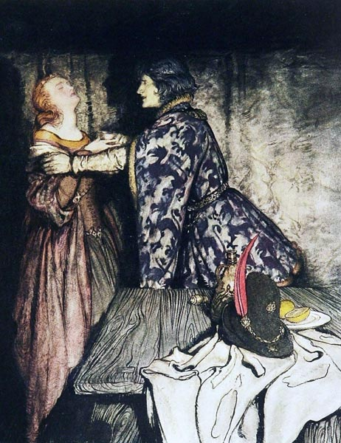
However, it is not only the virtues of knighthood that are illustrated in the example of Sir Gawain. Gawain is very frequently the victim of his own virtues in the first part of the story. During his stay in the mysterious castle in the middle of the forest, he is subjected to a game by lord Bertilac. His hunting game in exchange of Gawain giving him whatever he has received that same day. Central in this part of the story is also the wife of the lord, the Lady of the castle (described as “fairer than Guinevere”) that constantly tempts Gawain. She is not so much a personification of the deadly sin of Temptation, rather a means by which Gawain must test his honor and virtue, she has a didactic role for our honorable protagonist. It is interesting to note how the intensity of the flirting scenes rises from day to day, almost as a reflection of the intensity of the hunting game of the Castle’s lord. The boar and the fox are pursued while Gawain fights a battle of will and resilience to stay true to his values. Just as the lord is always successful on his hunting, so is Gawain when faced with temptation. Close as he may be to breaking point he never gives in, with a characteristic instance being when he “at last he must needs either refuse her with offence or her favors there take”. Despite that, he delivers the kisses given to him by the lady with the lord stating that this gift is much greater than the prey he brings back from his hunting, perhaps also a subtle critique over materiality (illustrated by the hunting game). The only thing that is not given is the belt that the lady gives Gawain and in many ways his lifeline in the ordeal of the Green Knight. Interestingly, though he initially refuses eventually he takes it after he learns that it will protect him. Finally, I think that in many ways we could argue that Gawain is in many ways similar to Beowulf, particularly in his faith to God. However, even someone as great as Gawain, is shown to be afraid of death, after all that’s why he takes the belt which we could argue is indeed a dishonorable act. Gawain is a Christian Hero, a good man and a great knight, but at the end of the day he remains human.
Having talked about Gawain as a character it is also interesting to see how he also follows the traditional “cycle” of the heroic quest. Most notably, in the second half of the story he faces the “all time low” with him almost giving in to the Lady. Interestingly the same act that constitutes his fall, the taking of the belt, is the very element that eventually makes him a better man and a great knight. And that brings us to the long-awaited meeting with his challenger. If there was any notion of the “plot twist” in Medieval times, then certainly the Gawain/ Pearl poet very effectively included it in the poem. Upon encountering the Green Knight, it is revealed that all along he had been the lord of the castle that Gawain spent the last few days. Interestingly, when Gawain lowers his head to be struck by the Knight the hit is not delivered directly. Three attempts are made, with Gawain flinching in the first hit. This pattern is very similar to the three hunting parties that the king organized as well as the three attempts the lady made to seduce Gawain. The challenge of the Green Knight was meant to test Gawain’s virtue and courage. The story shows that even someone that embodies the spirit of Knighthood can be challenged and fall in great danger. But Gawain rises through the challenge and succeeds in his quest, turning into a transformed hero in typical heroic quest fashion. Gawain’s greatness does not just illustrate what the perfect knight should be, it also serves as a critique against the less chivalric examples of knighthood that unfortunately were the rule in many kingdoms during Medieval times. Faith is also a central question. Gawain is constantly faced with temptation but also characters (e.g. his guide) that try to discourage him to seek the Green Knight. However, he never backs down, he always moves forward that very clearly illustrates how the sense of honor is the great power that guides great heroes to their success.

Stavros Sgontzos (1563202200249)
“Sir Gawain and the Green Knight”, pp. 314-end
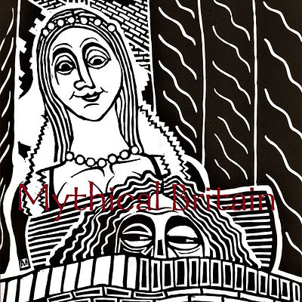
Reading the third and fourth parts of Sir Gawain and the Green Knight turned out to be an exceptionally enjoyable experience due to the unique way in which their plot challenges the protagonist. Instead of an action-packed adventure where Gawain has to continuously prove his physical might against supernatural monsters, similarly to Beowulf's quests, this story mostly seems to be about testing the moral character of a true knight. In particular, Bertilak's magical castle in the third part serves as the battleground where Gawain must demonstrate the second half of his knighthood, that is to say his courtesy. Gawain's "adversary" in this place is not some bloodthirsty creature set out to rip him to shreds, but rather an attractive young lady who repeatedly visits his bedside and attempts to seduce him through overtly flirtatious dialogue. No matter how many times she practically throws herself at our protagonist, Gawain insists on avoiding any sexual impropriety for the simple reason that he perceives such behaviour to be an assault to his knightly honor. He tries to refuse her romantic advances in the most courteous manner possible by modestly accepting her compliments while downplaying himself. In fact, consenting to her kisses is the closest thing he does to performing a sexual act for her. It is important to note that Gawain does not restrain himself here because of any suspicion regarding the whole bizarre situation or anything. Although we later discover that everything in the castle was pre-orchestrated as a grand trial of his character, Gawain chooses to resist the lady just because he finds the notion of sexually engaging with her to be an improper violation of his virtues. Generally, Gawain is such a reserved and kind guest during his stay at the castle that the contrast between his dialogue scenes and the lord's hunting scenes is almost comical to me – the brave knight who personally assumed the responsibility of confronting the green metaphysical menace is residing in a castle and being a sweetheart to everyone, whereas the lord himself is completely slaughtering animals outside.
Naturally, I believe this to be fully intentional as it showcases why Gawain is an excellent example of the quintessential Arthurian knight. The key characteristics of a true knight include courtesy and gentleness, the possession of power in itself is insufficient. Gawain is the strongest knight of the Round Table because of the "softer" side he presents while inside the castle, not in spite of it. Additionally, Gawain's decision to privately confess his sins to a priest at the end of the story's third part shows yet again how much his values define his knightly role. At this point, he acknowledges the low probability of surviving his encounter with the Green Knight and repents all the occasions where he failed to uphold his virtues so he can ensure a peaceful death. Preparing for his demise, Gawain places significance on the moral qualities he displayed in life and regrets not having been even better.
It is here that I should proceed with the fourth and final part of Gawain's tale. I was initially under the impression that this would finally be the turning point where we'd see some action, since the time had come for Gawain to face off against the Green Knight. I thought that the third part was all about the courtesy, so the fourth part would surely concern the aspects of knighthood that immediately come to mind – bravery and readiness for battle. After all, Gawain dismisses his guide's suggestion to flee the Green Chapel and is determined to let the Green Knight strike him as was promised the year before. This sounds like things are about to get physical! However, the poet managed to subvert my expectations once more. The Green Knight revealing what the protagonist's real trial was back at the castle, and the single neck wound he gave him for failing to hand over the green girdle cemented the fact that this story never was just about warriors crossing swords – and it was this moment that inspired me to write this journal. Of course, Gawain doesn't grow conceited once he is told the truth. On the contrary, he is outraged at himself for having failed to honor the trade agreement he'd made with Bertilak and vows to look at his neck scar as a constant reminder. Even though he made it out of this debacle alive and managed to befriend Bertilak, he is beside himself due to a singular moral failing that discredits his knighthood as far as he's concerned. His peers are quite entertained by this outcome, but he takes his offense extremely seriously. Overall, I was pleasantly surprised by Sir Gawain and the Green Knight and its intriguing portrayal of knighthood. I was considerably influenced by my reading of Beowulf prior to this, ergo I expected a badass protagonist ready to pummel absolutely everyone. Instead, I was genuinely happy to see that sensitivity and kindness were also seen as sources of power and not looked down upon as inferior to brute strength. Gawain embodies that perfectly: his disposition is so gentle and positive that he comes across as the underdog in his own story, but we understand why he is actually the strongest of all the Arthurian knights by the end.

Iliana Salvaridi (1563202200178)
The Number Three and Christianity in Sir Gawain and the Green Knight
Throughout the entirety of Sir Gawain and the Green Knight, the number three makes recurring appearances, which to the modern reader may seem insignificant. However, I am certain that for the author and his medieval contemporary audience, the lingering presence of this particular number was nothing short of considerable.
This occurrence of triads is a clear allusion to and symbolism of Christianity, as the number three is frequently mentioned in the Bible. The Holy Trinity, the three Magi that came bearing gifts for the newborn Jesus, Jonah in the whale’s belly for three days and three nights, the three temptations of Christ, and the resurrection of Jesus on the third day. Patterns like these would be easily recognizable in 14th-century England, which was Christian. As each of these biblical accounts represents a trial of sorts, it becomes transparent to the reader that our protagonist will be tested himself, not only physically but also morally.
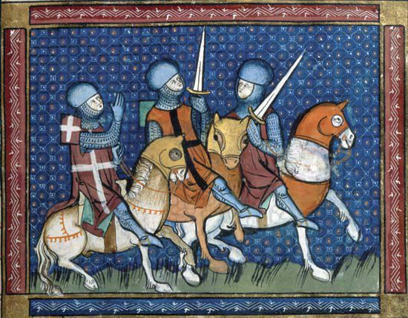
The poem’s first trio, the days Sir Gawain spends in Lord Bertilak’s home, participating in an exchange-of-winnings game, perfectly encapsulates this. Bertilak goes on a hunt every day while his wife tries to seduce their guest. The three animals that the lord of the house brings back—the innocent deer, the fierce boar, the cunning fox—mirror the increased difficulty of Lady Bertilak’s advances that Gawain has to face each day. The saying “third time’s the charm” seems to be fulfilled in this poem, alas, partially, when, on her last attempt to seduce him, the hostess gifts Sir Gawain a girdle and convinces him to conceal its existence from Bertilak, thus leading to a moral slip for failing to abide by the rules of the game on his part.
Later, Gawain arrives at the Green Chapel, the third major setting found in the text—the others being Camelot and Bertilak’s house. It is at this third location that the protagonist will conclude the beheading game by receiving three blows from the Green Knight’s axe. The first and second swings do no harm to Sir Gawain since he was honest with his host the first two days. The third lightly injures him on the neck as a result of his moral failure to present the girdle. Just like a Christian confession, he acknowledges and repents for his sin, he is punished leniently for it, and, instead of being condemned, he is forgiven, and his goodness is affirmed by the Green Knight saying he has been cleansed of his ill deeds, as if he never committed any since his birth (lines 2391-2394).
It seems to me that without the presence of the divine number three there would barely be a plot to this poem. The triads transform a simple chivalric quest into a trial of morality and self-humility, a test to prove if Sir Gawain is truly fit for knighthood.

Marietta Brintziki (1563202100149)
Death and mirrors of death in Sir Gawain and the Green Knight

“Antonius Block: Who are you?
Death: I am Death.
Antonius Block: Have you come for me?
Death: I have long walked by your side.
Antonius Block: So I have noticed.
Death: Are you ready?
Antonius Block: My body is ready, but I am not.”
-- The Seventh Seal (1957), dir. Ingmar Bergman

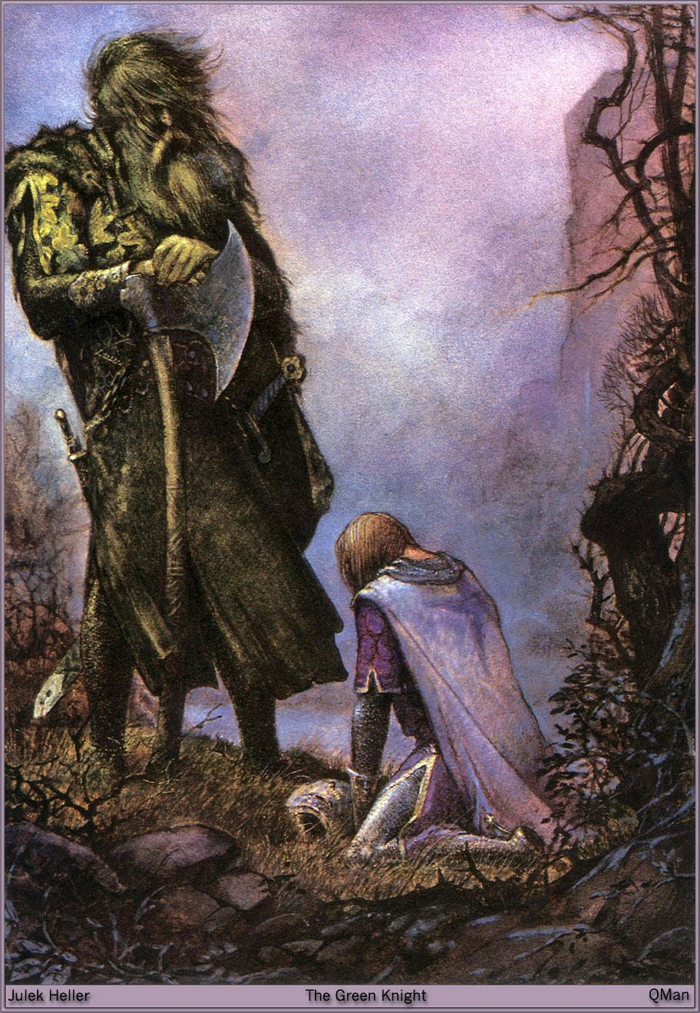
In a 1968 interview with the BBC, J. R. R. Tolkien famously said the following quote: “Human stories are practically always about one thing, really, aren't they? Death. The inevitability of death.”, which he then followed with the following quote by Simone De Beauvoir: 'There is no such thing as a natural death. Nothing that ever happens to man is natural, since his presence calls the whole world into question. All men must die, but for every man his death is an accident, and even if he knows it he would sense to it an unjustifiable violation.'. He then concluded by adding, “Well, you may agree with the words or not, but those are the key spring of The Lord Of The Rings.”. Whether death is truly the one common thread in all of human literature, as Tolkien suggests, or not, at the very least the human fear and knowledge of death is certainly instilled in most human stories. One of these stories is that of Sir Gawain and the Green Knight, a narrative about a knight who is to meet his inevitable end, right at the ‘death’ (or, rebirth) of a year. As Gawain embarks on his supernatural, knightly quest, he is met with many ‘mirrors’ of death, either direct mirrors, such as the celebrations of the New Year, or indirect mirrors, such as his three mornings with the lady. In this essay, I will attempt to locate and analyse the many parallels of death that can be found throughout the story of Sir Gawain and the Green Knight in order to highlight its primary focus on human or non-human mortality. The narrative of Sir Gawain and the Green Knight is haunted from death from its very beginning. As the story begins and the setting unfolds, we are given the place, but most importantly, the time during which our story is set: during Christmas Time, in anticipation of the New Year. From its very beginning, the story already starts with a celebration of death, even of an abstracted concept. However, the parallel does not end there. As the story of Gawain I would argue is primarily a story of death, the majority of the tale, taking place a year later after the festivities of the first fit, is also enacted during the end of the next year, thereby exclusively turning our focus on the concept of the ‘end’. The short, but poetic descriptions of the passing of the seasons in the beginning of the second fit closely resemble the phases, the waxing and waning, of human life.
Apart from the narrative setting, another ‘mirror’ of death is Gawain’s stay at the court of Bertilak, specifically his mornings with Lady Bertilak and the parallel hunt of Lord Bertilak, which both include elements of death, the former on a metaphorical level and the latter in a more literal level. In order to present my analysis in a coherent manner, I will be analysing the two events separately.

First of all, the number of mornings spent in the castle is not a random choice from the behalf of the poet. The human life is usually split into three major phases: infancy, adulthood, seniority. I argue that these phases are present in an indirect manner in both the bedroom and the hunt scenes. During his first morning with Lady Bertilak, Gawain familiarises himself with her company and what is to come in the ensuing mornings. This familiarisation is similar to an infant’s familiarisation with its surroundings and its gradual understanding of the world. The second morning is trickier than the first. Lady Bertilak presses Gawain with her advances and thereby heightens the sexual tensions between the two, thus allowing Gawain to move from the stage of infancy to adulthood, when one’s surroundings are no longer simply becoming familiar, but are familiar due to experience, the latter being the most defining characteristic of adulthood. Lastly, in the third morning, Lady Bertilak has a new offering to Gawain other than kisses: her girdle. The girdle was a sash or belt that kept a person’s clothes and undergarments intact on their body. By offering her girdle to him, the poet makes strong implications to a sexual act taking place between the two characters which would end in the ‘petite mort/little death’, a euphemism for an orgasm that is linked to the notion of death, thereby linking Gawain to the final stage of life, seniority.

Although the act of Lord Bertilak’s hunting is already linked to death, as there is direct violence inflicted upon the animals resulting in death, the choice of animals the poet makes can also be likened to the three stages of human life. The first morning, Lord Bertilak’s game is a deer, characterised by its swiftness and vivacity, two traits that would be commonly used to describe youth. In the second morning, the animal Lord Bertilak hunts is a boar “of unbelievable size”, characterised not only by its strength, but also by its vitality, the two common aspects of the least frail period of a human’s life, the stage of adulthood. Finally, on the third day, Lord Bertilak’s choice of game is a fox, an animal that is synonymous with cunning and tricks. As the human body starts to give out towards the end of its life, the bodily strength is replaced by the mind, thereby linking the fox with the final stage of human life, seniority.

Finally, I would like to make a brief mention to Gawain’s own mirror, the Green Knight himself. As Gawain embarks on this fatal, year-long game with the Green Knight, the two are placed in the interchangeable positions of executioner/executed, the one who sentences to death and the one who receives it. The ‘game’ in itself, as it asks of Gawain to confront his own death by the end of it, is none other than the game of life, which will always inevitably have a fatal end. The Green Knight, a man physically overridden with greenery, like a corpse in a grave, is the equivalent of the Grim Reaper, following and haunting Gawain from Arthur’s court, to his stay in Bertilak’s castle (disguised as Bertilak), perhaps even as his guide to the Green Chapel where he is to conclude the game. And despite Gawain’s ability to evade death in the end through his ‘nicking’, the scar and sash act, as Gawain puts it, as “burden[s]” of his own “cowardice and covetousness” - in other words as marks for his own mortal fear of death that one day he won’t be able to escape.

As the narrative is filled with death and its many mirrors and faces, the story of Sir Gawain and the Green Knight becomes a parable of the human fear for one’s own end. By embarking on this supernatural quest and being confronted with death, both directly and indirectly, Gawain ultimately cannot bring himself to face death in an idealistic, heroic way, thereby making him one of the most ‘human’ characters in all of literature.

Maria Stavroulopoulou (1563202200248)
Sir Gawain and The Green Knight
When reading the second part of The Green Knight, one thing kept capturing my interest, the subversion of gendered expectations and the potent sexuality with homoerotic undertones, or rather overtones. The scene of Lord Bertilak hunting deer is clearly compared to his wife “hunting” Gawain. We would think this is rather unusual for a proper medieval lady, but it fits with the knightly romance tradition, where the lady has the dominant role in the relationship and the knight cannot do anything but obey, a female power fantasy of the time, if you will. The motif of Gawain being “prey” is furthered by the beheading of the boar, much like Gawain expects will happen to him, his oncoming “castration”, the loss of his honour and life. Sexuality here is something “natural” that is contrasted to chastity and honour, which is the “civilized” ideal in the rising English and Christian culture.
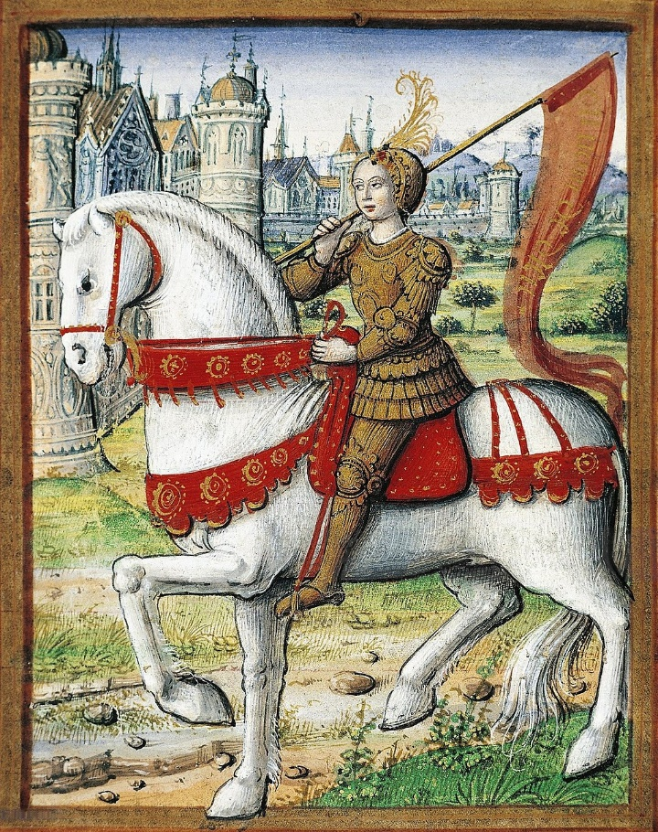
The exchange of kisses between Gawain and the lady of the house leading to Gawain kissing Bertilak is very interesting, especially knowing Bertilak engineered this whole situation himself, because there’s definitely a completely heterosexual explanation for devising a whole game to kiss another man, right? Modern audiences tend to have this idea that homosexuality would get you burned at the stake, but that is not strictly the case, though they would not use our terms, they seem to have been very aware of the possibility of homosexuality and playing around with sexuality and gender in fiction to create “daring”, unusual and funny situations is a very old tradition. The criminalization of homosexuality itself in Europe was forwarded slowly by the Christian – Catholic Church, with many allusions appearing in Arthurian and other knightly tales that involved predominantly or exclusively men, less so between women unfortunately, as the lives of women were mostly thought of as not important enough to write about on their own.
Another sexual reference that highlights this point and foreshadows Bertilak’s reveal as The Green Knight is the girdle of green and gold silk girdle that the lady gifts to Gawain. Gawain has already been tempted three times, the stakes constantly rising, and this is the most explicit attempt yet. He has to exemplify virtue and stay true to his word but falls just slightly short, his fear for his own life taking over. The Christian ideal of guilt and penance for “sins” and the knightly obsession with virtue colliding when Bertilak tells Gawain he hopes the gifts were worth what he gave for them, meaning his honour.
The idea that perhaps it is not all about virtue in every single moment and being unflinching in the face of danger even when you know it will cost you your life, but about learning from your mistakes and choosing honour in the end comes with the last confrontation between Gawain and the Green Knight, when all is revealed. There is certainly a didactic tone in this last part, as this was all a test devised by Morgan for Arthur’s court: the Knight reassures Gawain that his faltering was not the end of the world, though Gawain still sees the girdle and his behaviour as a mark of shame that he will carry to remind him to be virtuous for the rest of time.
As an epilogue I would like to briefly talk about the 2021 movie version, as it was what got me interested in this story years ago, so be warned, there be spoilers ahead! In the movie version, Gawain is not the honourable knight we all know and love, but rather one who must be “taught” virtue. Morgan is his mother rather than his aunt, with the usual conflating of her and Morgause, and she is the one who originally gifts Gawain the girdle. In this way it becomes a story about a mother trying to teach her unruly son to be truthful and dutiful, so she tries to protect him, the oedipal undertones not lost on us. Many original misadventures befall Gawain and test his virtue, though when he reaches Bertilak’s castle, sexuality plays a more explicit part and is connected clearly to the girdle, with Gawain having sex with with Bertilak’s wife for it, though only exchanging a kiss with Bertilak at the lord’s urging. The movie unexpectedly downplays the homoerotic tension that is so prominent in the original, which does make for a delightful surprise when reading the source material but one would think the 21st century audience would be more receptive to it. The third original prey, the fox, which may symbolize wits over brawn, is Gawain’s companion in the movie and given back to him by Bertilak as his one and only gift. What is most shocking about the movie is the ending, with Gawain seeing the life he could live if he deceived the knight and, deciding against it, removes the girdle and accepts his responsibility, making peace with his death. This ending changes the original message significantly, though it might just fit this version of Gawain, who is much closer to the modern man and perhaps to the historically accurate knights of old, than to an idealized and romanticized shining beacon of virtue.

Stella Margiori (1563202200118)
Sir Gawain and the Green Knight
I must admit, I was thoroughly confused while reading the second part of the poem. I was confused even when it came to an end. Besides the fact that the Gawain poet is a master with words, he is also beyond amazing at creating a compelling plot, because, despite the fact that I understood very little at first, I was hooked. Now, regarding the themes themselves. What stuck out to me was that this poem is a testament on manhood and knighthood by extension. The Green Knight is testing sir Gawain on how good of a knight/man he is (manhood and knighthood are one and the same in this poem) and the Camelot knight fails. This failure is the reason sir Gawain finally seems more human to the reader. Throughout the first part, he is the paragon of honor and morality, but he falls for temptation by kissing the beautiful woman in the castle-although one could say he’s in a way being fair in this case as well, since he returns said kisses to the lord-and then taking her girdle. These scenes combined with the scene during which he flinches when the Green Knight lifts his axe to behead him or when he gets angry at him when he keeps delaying his death (an emotion sir Gawain had never displayed throughout the poem before), show how Sir Gawain is human at the end of the day, who is afraid of his imminent death and who also has human desires. So, he’s brought down to a more human level, making him more relatable to the reader, because, in my opinion, no one can relate to a paragon of 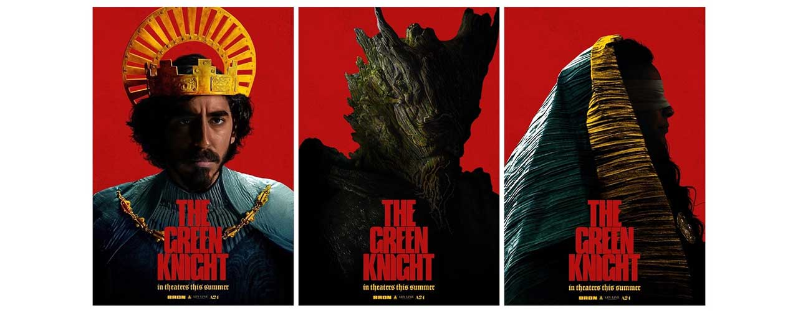virtue, which seems almost non-human. The Green Knight forgives him, when sir Gawain shows humility and regret, because he’s just a mortal at the end of the day who will make mistakes, but still tries to stick to his honor, by admitting what he did wrong. It’s very possible to me that if Sir Gawain hadn’t apologized, that things might have gone differently for him. Regarding his adventure in the castle, Sir Gawain follows the typical heroic path, as described by Joseph Cambell. He meets the powerful Goddess-avatar who tempts him and he undergoes a metaphorical death. In this case, we are referring to the death of his honor. He proceeds to be reborn by meeting the Green Knight, realizing his mistakes and trying to atone for them, by recognizing his faults and always carrying with him the girdle, the symbol of his failure. What’s interesting here, is that the number 3 is constantly repeated throughout the whole poem. He remains at the castle 3 days, which is also the number of days Jesus stayed dead before being reborn. This isn’t random, since Sir Gawain died during these 3 days at the castle, in a metaphorical sense as I said, before meeting the Green Knight the fourth day and being reborn. The number three is also the number of times the woman at the castle tried to tempt him and the number of times the Green Knight tried to hit him with the axe. The Green Knight tested sir Gawain on how many times he would try to hit him before reacting, as he similarly tested him by sending his wife three times to him to see if he would succumb to the temptation. The axe scene mirrors the test of the Green Knight. For me, that scene is also the Green Knight mocking sir Gawain for his failure at said test. Lastly, the number three could be reflecting the common saying of “once is a mistake, two times is a coincidence and three times is a pattern”. The reader was very suspicious, knowing that an event occurring three times can’t be accidental, which is something sir Gawain ignored, so we were concerned for the protagonist. Proof of that is the color of the griddle, which is green, a warning to Sir Gawain that this woman is very much related to the Green Knight, during which the reader realized once and for all that the castle scheme is a trap and our protagonist fell for it.
The woman’s role in this part is something I personally have conflicting emotions about. Morgan Le Fay is a powerful enchantress who drives the plot of the poem. Smart as well as cunning. Nevertheless, I am not very fond of the trope of women being reduced to a temptation, as it happens in the end. It’s clearly stated that Sir Gawain blames Morgan Le Fay, mentioning other male figures who have been fooled by a woman. This is an Adam and Eve kind of symbolism, implying that the female figure is to be blamed for the failure of the man, and in this case, for Sir Gawain’s failure. The latter admits his mistakes and he takes some blame for his actions, but the biblical-misogynistic if you ask me- connotations are hard to miss. Sir Gawain wasn’t really forced to kiss that woman, he did it on his own accord, therefore, his own human desires are at fault, not the woman. He made his choice. Although, we could say that sex here is presented as something kind of violent and predatory, juxtaposed with the hunting scenes of Lord Bertilak, hunting and mutilating animals, with thorough descriptions of blood and gore. Since these are juxtaposed and purposely put in between the attempts of the lady to seduce Sir Gawain, the predatory nature of the woman is shown. She hunts and preys on him like Lord Bertilak and his soldiers are preying on the helpless deer. The deer also symbolizes innocence, so the choice of animal might not be random here. If sexual acts and violent acts aren’t separated here, is it possible that sex is an act of aggression as well here? If we say that’s the case, the connotations about Sir Gawain’s consent during this whole ordeal are very strange and convoluted. This metaphor reminds me a lot of a courtly love poem, “Whoso List to Hunt” by Sir Thomas Wyatt, who was comparing his lover to a deer that he’s constantly hunting. The connotations there are also very predatory, sexuality and violence being one and the same.

Theodora Anna Spai (1563202200185)
On Sir Gawain and the Green Knight, ll. 1125-end: Lady Bertilak…are you decent?
She was “an urgent wooer”, a temptress, a trap and test for our hero’s virtue. He resisted and wittily evaded her, except for one small misstep, which ended up marking him forever…I am probably not the first person to argue this, and I certainly won’t be the last, but I will nonetheless make my attempt to read Lady Bertilak as a medieval femme fatale, a prototype, if you will, of the literary trope that flourished in later centuries (though admittedly its existence dates far back in biblical times, which I will touch upon later on). It obviously comes as no surprise the Lady is the subject of such an analysis, the appearance of her character in the story is solely devoted to her quest in tempting Gawain sexually and when the plot moves on to the final confrontation with the titular Green Knight, she never actively appears again. However, the impact of her character–her success in making Gawain fail–is starkly present, even when it’s time to roll the credits (they pass a law for the green girdle, for god’s sake!). It is thus not a stretch to claim that Lady Bertilak–and her many faces–is arguably the real star of the movie poem.
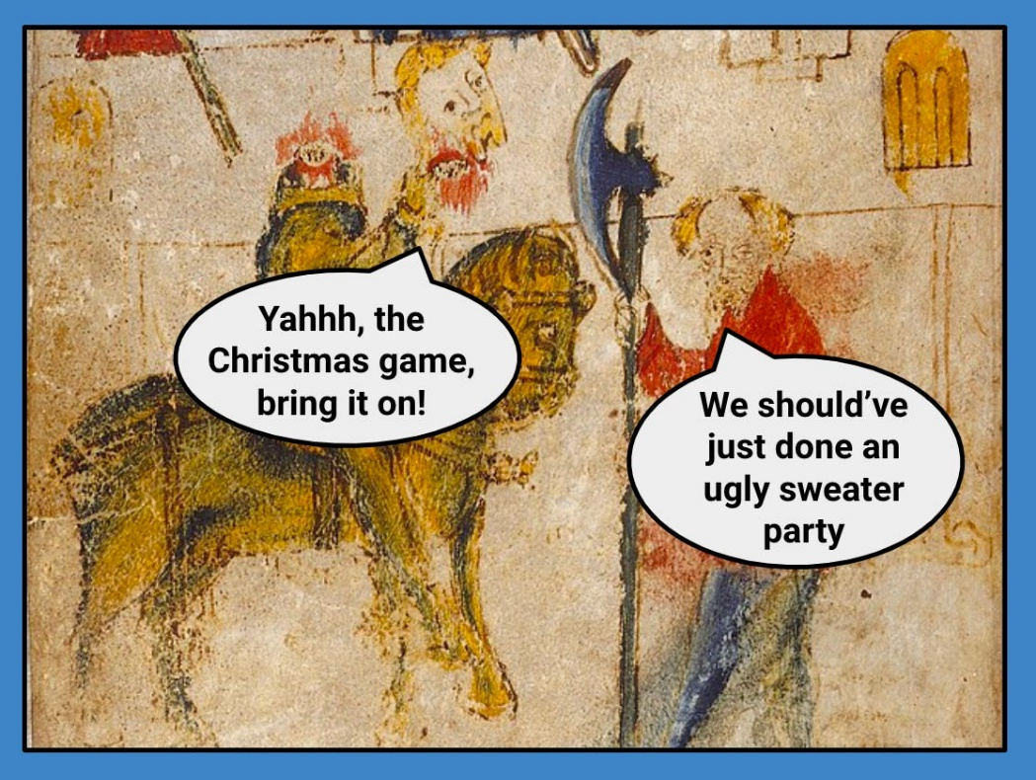
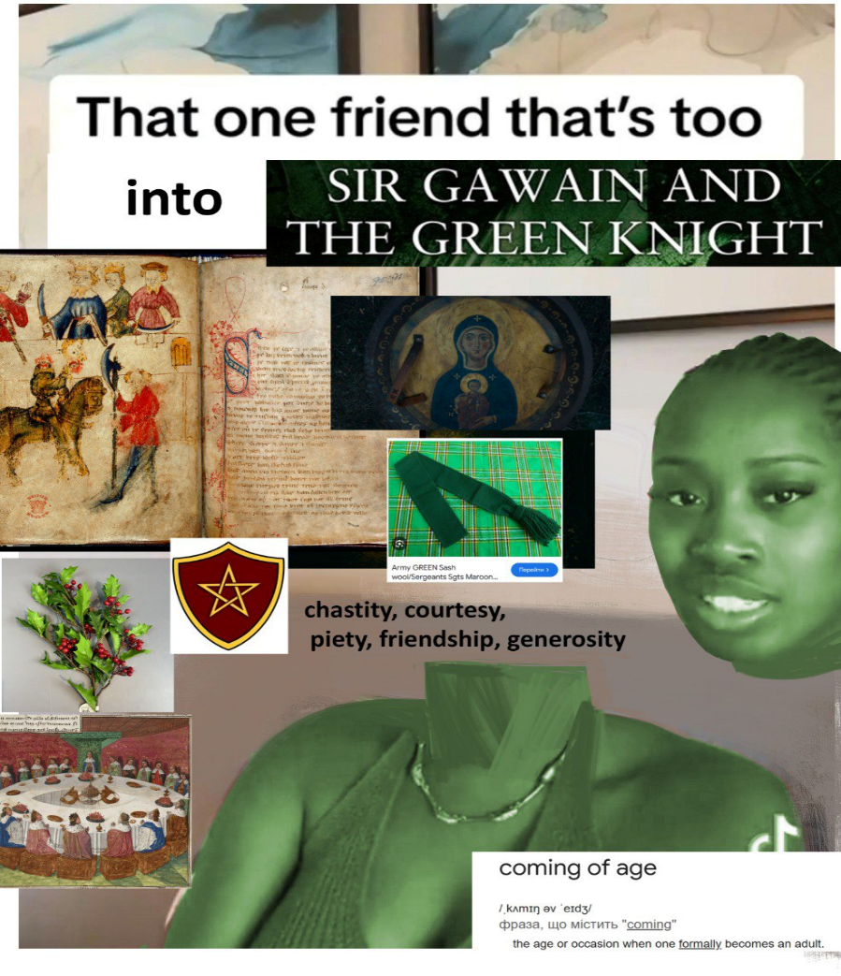
Okay, bear with me. You know what Lady Bertilak’s character reminded me of? I just couldn’t shake off how she reminded me of the infamous femmes fatales from film noirs, à la Rita Hayworth or Barbara Stanwyck (I’m thinking Gilda and Double Indemnity, yes I am actually an Old Hollywood nerd). You must think I am digressing…but, really, consider what I am suggesting: we have, like in the films noir mentioned above, an extremely alluring, sexy woman, whom the hero cannot quite figure out but is irresistibly attracted to. She is very married, yet she openly flirts with and attempts to seduce the hero in an intense sexual manner, while her husband either remains blissfully oblivious or accidentally plays an encouraging role in the match (think of Lord Bertilak’s curious encouragement in the lines of “PLEASE KEEP COMPANY TO MY SEXY WIFE”). She possesses a handy repertoire of sexual innuendos and witty banter in her pocket, making you wonder how such a seemingly well-bred young lady of high class could have possibly even learnt such perversion, let alone daring to voice it aloud. Exhibit A: Lady B does not only sneak on snoozing Gawain but, as soon as he wakes up, she jokes about how apt an opportunity it would be to tie him up and use him as her plaything (that’s a kink, girl). He plays and jokes along, so as not to offend her, but it is pretty clear that Gawain is taken aback by her intensely forward manner. Not exactly what you would expect from a stereotypical medieval princess, right? Our Lady B is NOT your average looking-out-the-window-wistfully-waiting-for-my-knight maiden. She’s out to get him and will stop at nothing until she does. Film noir femme fatales are similar in this aspect, relentlessly pursuing their prey (the hero), until he falls victim to her sharp red freshly-manicured claws. Exhibit B: She really, really does not take no for an answer. Gawain has to employ every witty trick in the book to match her banter and evade her advances, all without coming across as discourteous and ungrateful, which could cause a falling-out with his generous host and damage his reputation as the most virtuous of knights. She practically demands pleasure from him, referencing his reputation as “him who pleases all”. It is clear what she is after, and even if Gawain did not wish to remain chaste, courtly convention would have him declare he is undeserving of her praise and favour, and this is exactly what he does, by stating that it would be an honour to be at her services, if only he was worthy of it (the same argumentation that he employs when he undertakes the Green Knight’s challenge in the place of King Arthur). Like the classic femme fatale, however, Lady B won’t depart without having marked her territory, and she teases Gawain for not begging to kiss her, until his witty reversal of her words ends up in her kissing him. Talk about a dominatrix…Quite scandalous.
Their two next nightly interactions play out similarly to the first, charged by sexual tension that comes off as both funny and slightly suspicious and sinister. Gawain, like a true film noir protagonist, is quite receptive to the femme fatale’s advances, instead of taking action on his own; they even banter about it, when she points out that he could easily force himself on her if he wished, but he valiantly declares his knightly code would never allow him to fall so low as to attack and force his advances on a lady (her disappointment is evident). Another two, three kisses received and it’s all duly returned to the host. However, I’m calling her a femme fatale–deadly woman–for a reason, and it is because she eventually manages to locate Gawain’s achilles heel; which turns out to be his life, not sex with a gorgeous woman. After she tempts him with her gorgeous half-naked body and her gorgeous ring, her gorgeous, green, life-saving girdle is what finally causes Gawain to give into temptation and take something from her, which he proceeds to purposefully hide from her husband. Femme fatales notoriously lead to the hero’s undoing, by implicating him in a sinister scheme that tests his virtue and goodness, until he is usually proven faulty and human and all that jazz. In this fashion, Gawain is exposed as not-so-entirely virtuous and bound to his oath, for his ultimate will to live surpasses his chivalry and culminates in him lying to his host and breaking his vow of honour. When the evil-ish scheme to test his character is revealed to him and Lady B is exposed as a ploy, Gawain is so ashamed and abject, that he makes a dramatic speech about his downfall, and he devotes a curious amount of lines on how his fall was instigated by the hand of a woman. He also references biblical temptresses with what can only be described as generational passion and bitterness. From Delilah and Bathsheba to Lady Bertilak and finally Gilda…men were faced with their own internal insufficiencies because of them and whether they were mere instruments or evil-planners themselves, none of them were decent, that's for sure!
On a final note, I would like to briefly mention that Lady Bertilak is, of course, more than a mere femme fatale. In fact, she bears many faces, the maiden/lover and the ugly crone that is revealed to be Morgan le Fey, the mastermind behind the evil scheme. Sir Gawain is filled with symbols and semiotics that allude to feminine power, from female genitalia to mother nature itself. By extension, therefore, there is a stark and persistent undertone in support of the mother goddess cult, a primal deity worshipped by old Celtic tribes driven to inexistence by the Saxons. Nature and the feminine divine permeate, bright and green, the poem, and stand in opposition to Gawain’s bitter condemnation of the feminine power of temptation. This feels a bit less misogynistic than the later treatment and development of the femme fatale trope that had deep patriarchal roots and was utilised more or less to condemn the power of feminine sexuality and expression. The power of Lady Bertilak/Morgan le Fay to expose Gawain and the shallowness of the knightly code he subscribes to is, ultimately, not entirely condemned, rather it is subtly celebrated as a natural force of justice, which brings a young immature knight to self-discovery.

