MEDIEVAL LITERATURE

JOURNAL HALL OF FAME

2024-25

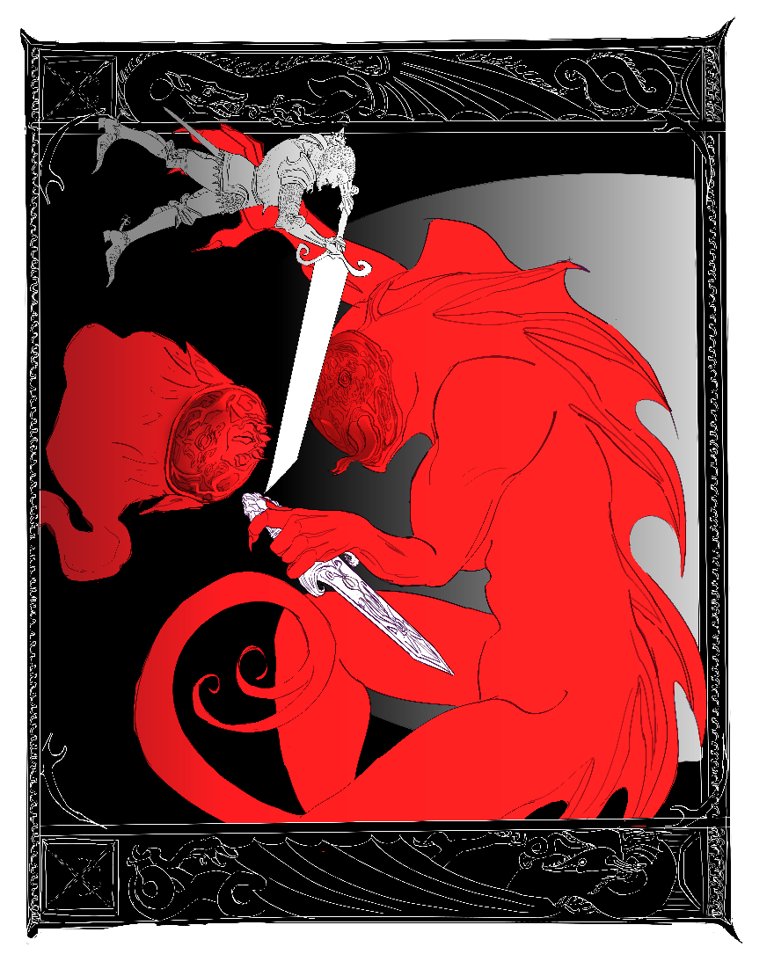

**Irene Dritsa (1563202100059)**

**Beowulf vs. Grendel’s Mother**

**Maria ‘Marietta’ Brintziki (1563202100149)**

***Beowulf*, Part II**

In the second third of *Beowulf* (ll. 1063-2196), we encounter, amongst other things, women of different class, position, even of different nature altogether. We see women as peace-weavers, women as political figures, women as commodities, women as protectors, even a woman as an avenger. Oftentimes, these women will act as ‘mirrors’ or as foils to one another, either by having similar storylines or by being ‘fillers’ in the story in order to bring out another woman’s traits. As these roles interweave and interact in complex ways, this journal will attempt to establish connections between the female characters of *Beowulf* mentioned in the aforementioned lines and examine them from a critical angle by attempting to dispel prejudices and preconceived images often shared and projected in the work by the male characters.

The first role I am going to examine is that of the *freothuwebbe* or peace-weaver. These were women who were married to a member of an enemy tribe in order to establish peace and end all animosity. In this second third of *Beowulf*, two women are noted to have this role: Hildeburh and Freawaru. Hildeburh is a character in a poem sung by Hrothgar’s scop; a woman who is married off to king Finn of Frisia in order to settle a feud between two tribes. Her role as peace-weaver however, is ultimately unsuccessful: Hildenburh not only lives to see and mourn her brother’s, Hnæf, and her son’s death, but also her husband’s, and is in the end carried away back to her native tribe. Similar to Hildenburh is the story of Freawaru, the ‘young, gold-laden’ (l. 2020) maiden, promised to Ingeld, son of king Froda, in order to settle a feud. Young Freawaru’s grim future is foretold both by the narrator and Beowulf, who vividly imagines that some conflict will spark again in the future between the warriors of the two tribes. In both cases, we see two women whose lives are spoiled and wasted, who are condemned to see loved ones be murdered, and who are themselves condemned to be passed from one tribe to another as a mere commodity, a useful tool.

The second role I will examine, is that of the woman as protector, as examined in the character of Wealhtheow, wife of Hrothgar. Wealhtheow is much more than a wife to the king; her speech to Beowulf perfectly encapsulates how politically astute and tactful she is – even if she is restrained to a speech or two of lesser importance (at least when compared to those of other male characters in the poem). However, what makes her character so admirable, is her ability to sense danger and use the available means to prevent it. Wealhtheow notably asks of Beowulf to act as a protector to her sons, perhaps sensing Hrothulf’s future treachery. If that is the case, Wealhtheow not only manages to affectively deflect danger (as Beowulf will take his role of protector very seriously later in the poem), but also senses it, unlike her husband Hrothgar, thus making her more perceptive and cunning than a male figure of power.

The third, and perhaps most notable role, is that of the woman-avenger, as seen in Grendel’s mother. Before I analyze Grendel’s mother as a character, I want to point out the significance of rendering her nameless in a story in which she clearly plays a not so minor role. As it is said in lines 1351-1352, “In earlier days the people of the region / named him Grendel”. Grendel as a ‘monster’ without logos or moral principles is unable to name himself, so this task is taken up by people who are capable of naming – and also marginalizing – him. The detail of naming the male monster, but completely omitting to do so to his female counterpart should not be dismissed or downplayed, especially in a story in which characters’ names can determine their reception by others. Even a far more minor character to Grendel’s mother is named (Æschere, elder brother of Yrmenlaf) and is even eulogized by Hrothgar, whilst Grendel’s mother remains nameless and is referred to as “a restless corpse-spirit” (l. 1327). As a character, Grendel’s mother is seen through the same lens of ‘otherness’ like her son before her. Disconsolate and bereft, Grendel’s mother acts in the exact same way as the ‘civilized’ men of the poem: she seeks revenge for her son’s death, in which she finds in the killing of Æschere. The killing of one, instead of many thanes/warriors, is downplayed by the men of the story as a personal failure of Grendel’s mother. Upon a more careful reading however, Grendel’s mother can quickly transform from a failed avenger, to a fair one. Æschere is not just any man; he is Hrothgar’s chief adviser. By killing -even unbeknownst to her- a man who is almost like a son to the king of the Danes, she is taking ‘an eye for an eye’ without any further unnecessary bloodshed. Despite the fact that Grendel’s mother is seen as a creature who lacks reason and acts on the baser instincts of one’s soul, it is the ‘civilized’ and ‘proper’ humans who hang the severed arm of Grendel as a trophy to Heorot’s wall, thus sending the already mourning mother in a grief-driven frenzy. Grendel’s mother’s acts are no different to the actions of honor-driven men of the poem and this is reflected not only through her revenge, but also by her similar act of hanging a severed member of her victim in display (this time being Æschere’s head).

Lastly, I want to briefly mention a set of two women which work as each other’s foils: Hygd and Modthrytho. Hygd is portrayed as the obedient, “very young, / wise, and courteous” (ll. 1922-1923) wife of Hygelac, whereas Modthrytho is the very opposite of her. She is reputed to have such a violent temper that every man who might as much as look at her in the eyes, he meets his end (ll. 1931-1936). Her ways are only changed upon her marriage to king Offa, wherein she becomes a great queen, reputed for her good deeds. As the story provides very little information on both women, it is hard to tell much about Modthrytho’s character. Nevertheless, it is worth mentioning that Modthrytho is a stereotypical portrayal of a Xanthippean, menacing woman, who needs to be ‘reformed’ by a husband, thereby becoming yet another literary ‘shrew’ that needs to be ‘tamed’.

Albeit being seen as a minority of lesser significance, women make up the most diverse set of characters in *Beowulf*. The female characters of *Beowulf* take the roles of mothers, daughters, sisters and wives, protectors, peace-weavers, political advisors and avengers. By assuming different kinds of roles in multiple contexts, the women of *Beowulf* offer the reader a glimpse into the life of fantastical medieval femininities in a male-dominated world, where women can range from misread, gluttonous monsters and shrews, to clever, caring mothers and political figures.

**Nikoleta Gardiki (1563202100041)**

**Grendel’s Mother**

While reading the episode of Grendel’s mother, I couldn’t help but notice the resemblance between Grendel’s mother and the Lady in the Lake from the modern horror series the *Haunting of Bly Manor*. I actually found it difficult to not picture the snatching of Aeschere without imagining the Lady’s snatching of Peter Quint. Particularly the lines 1289-1292 describe Grendel’s mother’s sudden appearance in Heorot in an almost jumpscare-like way: she left the hall as soon as she entered, snatching one of Hrothgar’s trusted advisors. A similar scene can be seen in *Bly Manor* in episode 5, when the Lady in the Lake suddenly emerges from the shadows and wraps her fingers around Peter’s throat, dragging him into the lake with her after suffocating him. The Lady in the Lake, Viola, follows the same cycle ever since her ghost was trapped inside her chest of jewels that was tossed inside the lake after her husband and daughter decided to leave the Manor. Once Viola awakes, the cycle begins. She enters the Manor looking for her daughter and, instinctively, kills whoever disrupts her path by blocking her way. As for Grendel’s mother, there is no implication in the text that she could have known who Aeschere was or his position to Hrothgar, and even if she did, he wasn’t the one she was looking for, so we can assume that she only snatched Aeschere because he was the closest man to her path in order to lure Beowulf.

Hrothgar also calls Grendel’s mother ‘a restless corpse-spirit’ in line 1327. Viola is another restless ghost that was cursed to haunt the Manor and perform the same cycle. The reasons for their restlessness are quite similar as well: their children. While Grendel’s mother is looking to avenge her son’s death at the hands of Beowulf, Viola is looking for her daughter – when she forgets that she is specifically looking for her own daughter, she is well aware that she is supposed to be searching for a child, which is why she tenderly wraps her arms around the child sleeping on her daughter’s former bed years later and takes the child along with her in the lake. Finally both Grendel’s mother and Viola live underwater and their victims are found near bodies of water, although Viola drags her prey deep inside the lake. Grendel’s mother’s approach to that is slightly different since Aeschere’s head was found beside the water and Beowulf willingly entered her own habitat to fight. Whether or not Mike Flanagan, the director and screenwriter of *Bly Manor*, was familiar with Grendel’s mother, I think this comparison proves that a Beowulf horror adaptation wouldn’t be so far-fetched. Why not even a cliche early 2000s slasher – Grendel starts murdering a group of teenagers who disturb his peace in an isolated cabin in the woods in Denmark. In the middle of the movie, the teenagers manage to kill Grendel only to realize that the real threat was Grendel’s mother who avenges her son until she is beheaded by the only survivor, Beowulf (Netflix, let me write your next movie).

And if *Beowulf* does become a slasher film, maybe we should add Beowulf’s name to the final girls list.

**George Karavas (1563202100081)**

**Beowulf and Grendel**

An attempt at writing a poem from a perspective where Grendel and his mother represent primal tribes and their native lands respectively. Thus, Beowulf’s killing of Grendel is the slaughtering of native people and the killing of Grendel’s mother is the invading of said people’s lands in an effort to exterminate them and expand in their territory.

On stories of man and monster

“From motherland to motherland, to new-found-lands and glory, men!  
Onwards! Marching on; through swamps, through plains, through caves, through rain, through thunder!  
Stepping, trembling, thudding lands. Τhe cloud-dark heavens grumbling!  
Against mighty wailing winds, against the abyss-howling of night.  
Across the cliffs, across the mountains lie foes to be beheaded!  
To be dismembered, dissected ornaments for our glorious halls!   
The sun shall rise and shine upon you, rinse your sweet sweat; silence all!  
In battlefront your fair fame waits, like fine crops to be reaped, then cherished!”  
But, as all hell broke loose, the uproars silenced beautifications.  
Perspiration was drawn from men as dew is drawn from full-drenched leaves.  
Chain-mails against chain-mails crashing, sword against sword came down clashing.  
Clanging, clinging onto dear life! Though they no longer longed for her…  
Bloodstained were from battle, the warriors' world-observers.  
As on blood were flowers warmly bathed, grounds rewritten arose anew;  
and on them a faint, fading distant past withdrew as blood dried up.  
A cursed whisper of what’s passed, a damned layer of palimpsest!  
To be engulfed in flames, to be turned into ashes, debris, dust.  
Time ticks by and epochs fly but still mothers weep and children cry  
for all that steel, for all that iron took from them, so far away.  
Picking buds to pluck, then offer purge of pain that first was absent;  
The grace of god is only as good as mercy in a battlefront.  
“What religion, what lord must I worship to remain well-alive?  
Peoples disposed of, fertile lands in fires; Chaos over peace!”,  
Begged a worn-out weary woman, before her head was slashed and tossed.  
It met the ground with a thump, and blood gushed out of where once it hung.  
“Good thinking, but the rest will be thought after to rest you’ve been put.  
At last! All that is left are fields; no fiends, no fierceness. Look, rejoice!  
There's only good and what it takes!” (for it to be transmogrified…).  
Growling, soaring over the white skies, roaring proudly of glory-  
Rowing oars, grunting voices of returning sea-ravaged wave-men;  
slowly lost in mist, figures merged with haze, even shadows vanished;   
And as time took its toll, all left alive were some sounds and some song;  
The thudding turned to panting, the trembling turned to quiet rustling.  
The clashing turned to hushing, the crashing smelt to air’s breeze passing.  
The hissing winds once howling bliss; all flora floored by fiery steps.  
The hissing winds now brushing weeds; standing so mighty tall and proud!  
And in ‘em live the sound and contents travelling through lands and times;  
From afar melodies echo beyond the temporality,  
beyond the still lying of presence; from a distant glorious past.  
Forgotten is the wailing, the woe of women; wasted womb-work.  
As such are told the lasting tales of monster and of monstrous man.

**Vasiliki-Antonia “Silia” Antoniou (1563202100014)**

***Beowulf* Part II**

After reading the second part of *Beowulf*, what stood out to me the most was the fact that Grendel’s mother had no name. Despite being the terrifying ogre’s parent and possessing equal amounts of power, her presence is simply not as important as her son’s. She is referenced to as a ‘monster-woman’, a sinner or simply as Grendel’s relative, but she has no identity other than that. We see that she doesn’t terrorize or kill humans until they attack Grendel and that sends her into a violent rage and need to avenge her fallen child. It’s interesting that both Beowulf and the mother fight to protect those who they consider family, Beowulf protecting his Lord, Hrothgar and avenging his comrades and fellow thanes, while the mother seeks revenge on behalf of her monstrous offspring. They are both not afraid to die or spill their blood in battle and that proves that Beowulf, the hero of the story, is not entirely different than the monstrous ogre woman in terms of their motives and strength of character. Of course, he ends up winning the fight (thanks to plot armor, may I add), but underwater the mother actually poses a bigger threat than her son, giving Beowulf a run for his money (literally and figurately). Even when Beowulf manages to kill the mother with his newly-acquired blade, he completely abandons her severed head (almost served on a plate for him) and chooses to decapitate Grendel, completely ignoring the woman in his way. It is pretty obvious to me at this point that she is the Other, even among monsters and demons. Perhaps Beowulf felt like Grendel symbolized a more notorious enemy for the Danish people or even ‘spared’ the mother’s head due to her gender or maternal role, but it’s still strange how he disregards this scary snake-demon and leaves her behind in the underwater cave, as if she died unnoticed, in an insignificant way. The female is overshadowed by the male, even in the case of death, probably because of medieval misogynistic conventions. I believe that she also subverts the ‘damsel in distress’ trope because instead of being described as having a flawless appearance and passive behavior, she is presented as an ‘evil’ monster and sinner, a dangerous creature to be dealt with, therefore taking a more traditionally masculine role. Had the point of view been different or had she been an ordinary human being, maybe the readers would have empathized with her more due to her grief and personal loss, as well as commended her on her bravery in avenging Grendel despite her heartbreak. Ultimately, she is a mother who lost her child, despite their circumstances. To me, she symbolizes bravery and she doesn’t search for glory or fame, only means to mend her pain and show her anger through blood, the only way she knows. Despite her efforts and ferocity, however, she is left in the dark once again.

**Panagiotis Niarchos (1563202100152)**

**Blood-soaked fairytales; how heroes are made in the epic poem “Beowulf” and Hidetaka Miyazaki’s “Dark Souls”**

When Beowulf’s fight with the monstrous Grendel ends, we are left with a ferocious scene. King Hrothgar’s hall is in ruin, its floors lined with the splinters of the broken down door and other furniture, and drenched in the viscera of Beowulf’s mangled companion as well as the blood of the dismembered beast, whose screams would grow quieter as it fled back into the safety of the night and away from the hero who had given it its first ever taste of fear. It is difficult, however, to not feel a certain degree of dread towards the victorious Beowulf; a human warrior who managed to match the strength of a monster and defeat it with ease. The question, therefore, is, where does Beowulf end and Grendel begins?

The arbitrary barrier between monster-slayer and monster is a theme that is heavily explored in Hidetaka Miyazaki’s 2011 video game “Dark Souls”. In the game’s expansive mythology, one of the most revered and legendary figures is the knight Sir Artorias. In an age long past, Sir Artorias was sent on a knightly quest on behalf of his lord, to seal away a great darkness that threatened to consume the land. He fought the great ancient beast Manus, and upon its defeat, Sir Artorias succeeded in keeping the darkness at bay, but unfortunately perished in the attempt. Ages later, in the game’s present, Sir Artorias is hailed as the greatest of all knights and a true legend of unparalleled virtue. However, thanks to a little time-travel, the player can witness the truth of the myth of Sir Artorias first-hand.

The reality is that Sir Artorias failed in his mission. It was the player who managed to defeat the ancient horror Manus and it was the player who sealed away its darkness. In their journey to the past, the player will encounter Sir Artorias, and it is in this encounter that his legend fully unravels. The knight failed to stop the beast and its darkness, and was left with a broken arm and fully corrupted by the abyss he was sent to contain. The knight is no more than a maddened husk of his former self, hopelessly fighting the abyss that consumed him, only for the player to finally put him to rest. It is in this brief encounter with the knight that we realize that the legend of Sir Artorias was merely a fabrication. Not only did he fail in his legendary quest, but he succumbed to the very evil he was sent to contain, becoming no more than another monster in the army that Manus was hoping to raise.

The tragedy of Sir Artorias and the birth of the myth of Beowulf, in my opinion, share a lot in the way they are explored. Sir Artorias’ legend was a lie, with the reality being that the proud knight met his end half-crazed and no different than the monster he was tasked with slaying. Beowulf, however, has the luxury of a warning. He is told that monstrous strength may allow him to battle beasts like Grendel, but it is precisely this strength that made Grendel the plague that he was. In essence, a hero is praised for virtues which allows them to face the supernatural, the darkness that the rest of the community shudders to confront, but in doing so the hero has to elevate themselves, shed their humanity in hope of meeting the measure of the inhuman task. It is in this gamble that the hero might lose themselves, and it is precisely this corruption that comes despite their best efforts, the most tragic and human characteristic of all.

**Elena Kodrou (202000246)**

**A Hill to Die On**

As far as battles go, vis-a-vis one choosing theirs carefully, there is no reality in which I do not defend Grendel’s Mother to the death. She had chosen a solitary life, or maybe it had chosen her, being a so-called “monster”, her son the only creature not alienating her and yet she could not find peace. Even after she had made her home in a cave in the depths of a monster-infested lake, because surely that would discourage any potential visitors (pests), she was not allowed to live, well, at all.

After finding her son bleeding out amongst the trees under which she had once felt safe, it follows of course that Grendel’s Mother thirsts for revenge. Revenge on the savages that had invaded her home and disrupted her quietude, revenge on the heathens that ripped her son apart and kept his arm as a trophy. Truthfully, their crimes against her called for much more than the death of one measly human, no matter his position, and yet the filthy humans refused to let this be the end of a twelve-year long vendetta. They chose to attack a still-grieving mother in her own home, steal from her and defile her son’s corpse.

So, yes, I will defend the right of a mother to take justice in her own hands, against her land’s invaders, her son’s murderers. This is the battle I choose. Grendel’s Mother did nothing wrong, and I will make this my hill to die on.

Also for your consideration:

*Beowulf*, ll. 1063-2195 a summary in memes:

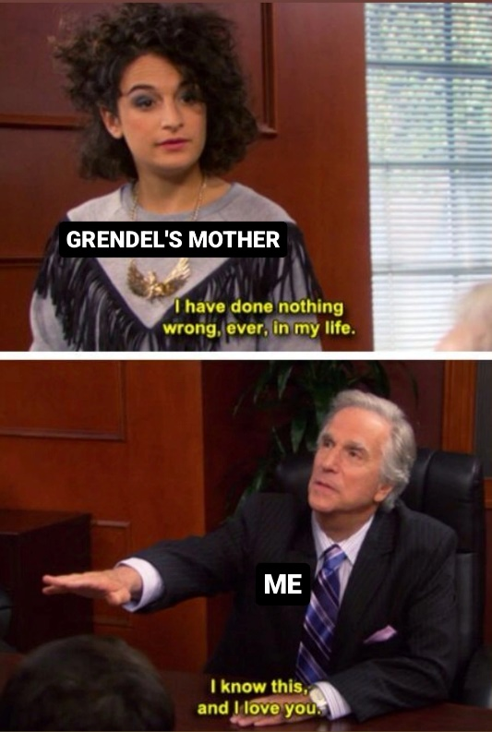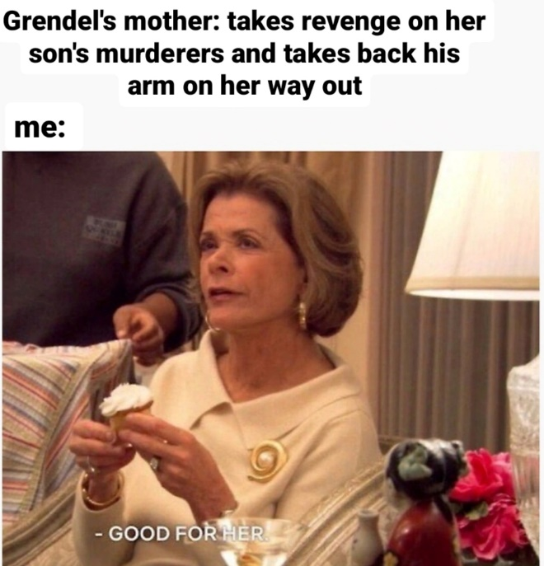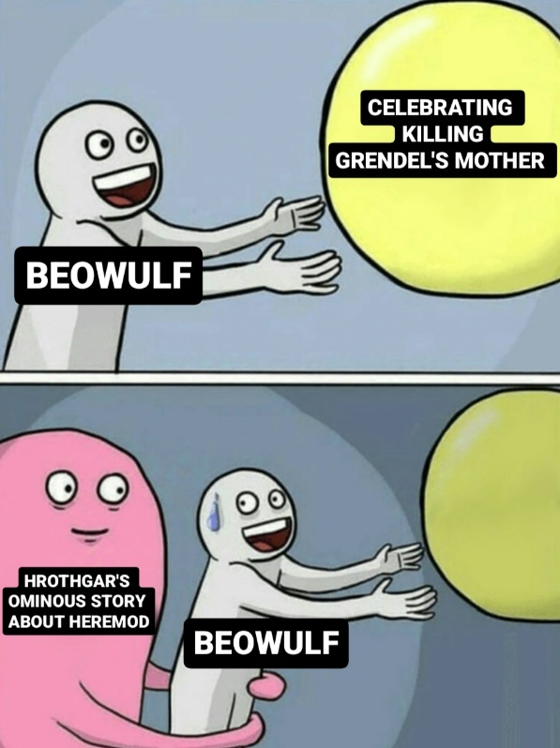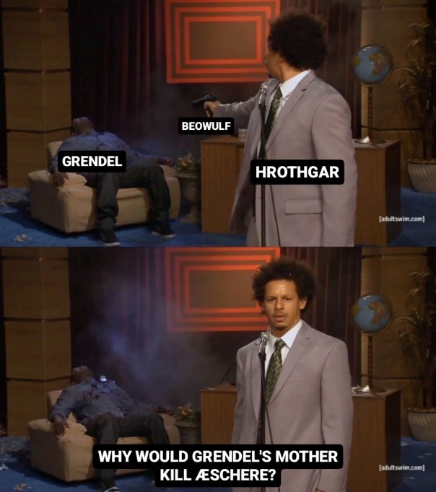

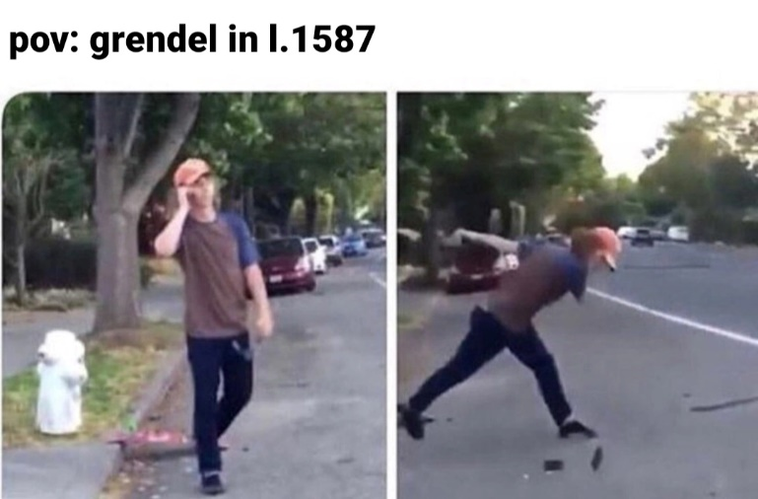

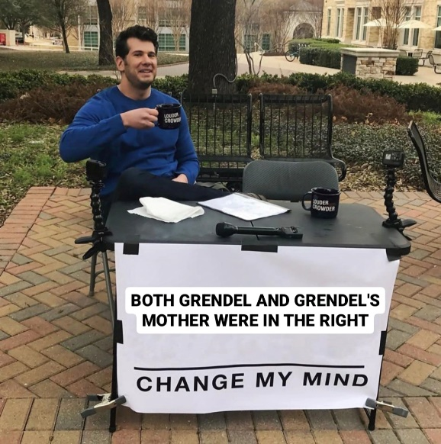

**Kyriaki Englezou (1563202100060)**

***Beowulf,* Part II**

In the epic poem ‘*Beowulf’*, Grendel and his mother are two creatures that can take on many different meanings. On of these is to see them as symbolic representations of native tribes and their culture and, therefore, the whole poem can be viewed from the perspective of invasion and conflict.

The two monsters’ lair is one with nature, away from any form of human life. This close relation to the wilderness and the clear antithesis to the Lord’s Hall symbolises the way indigenous people were viewed by the conquerors and the explorers: as untamed beasts who are too far removed from civilisation to be even considered human. Using this as a rationalisation, the invaders were free to show their cruel side to the old inhabitants of the land and forcefully remove or eliminate them. Depicting them as threats and spreading this message through the arts gave them the opportunity to attack and steal, while wiping out the old way of thinking and living in the process. Those ‘unruly’ and ‘untamed’ people became their target, as they contrasted greatly with the civilisation the invaders were attempting to establish at the time, symbolised by the great hall Heorot.

The mother’s actions can be seen as a last form of resistance from a tribe which is slowly but steadily losing its culture, traditions and lands. After Grendel’s death, his mother does not go after his killer right away. Instead, her first move is to remove her son’s hand, which has been treated disgracefully and has been hanged as a trophy for all to see in the Great Hall. This action can be interpreted as the native people trying peacefully to honour their dead, which have been mistreated in the hands of the enemy. Having done nothing wrong, those long existing tribes could, possibly, not be able to understand why someone could act so cruelly against them and harm their people and their beloved land. If the mother in the story stands symbolically for those natives, then her prioritisation of her son’s dignity shows the real face of the land’s first inhabitants; they are not cruel and uncivilised but have their own moral compasses and values.

Even the death and abduction of one of the Lord’s men can be justified as an equal counterattack performed by the mother. After making sure her son’s body can be whole again, the monstress attacks and kills Æschere and drags his corpse back to her lair. Continuing on the assumption that the mother represents the old, native way of thinking, this could be an indication of the natives’ character who chose to retaliate but not to spill blood unnecessarily. Their plan would not be revenge, as Beowulf the killer himself was not targeted, but rather an attempt to even the scale and to avoid any further conflict. We see that in the end it is the humans who returned to the lair to attack once more and not the other way around. Having nothing to gain, the native tribes would not risk the lives of their people to rid the land of the invaders, but they would have to defend themselves if they were under attack, just as the mother was forced to do when Beowulf returned for her head.

Grendel’s mother is a figure in this epic that could either be seen as a bloodthirsty monster or as a means to represent a whole other way of life. If viewed as a symbol for the native tribes, she becomes a misjudged character who did everything in her power to defend her home and its people from the unknown.

**Irene Dritsa (1563202100059)**

**Beowulf’s Final Battle**

