Charles Olson, “Album”

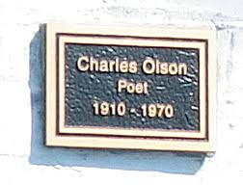
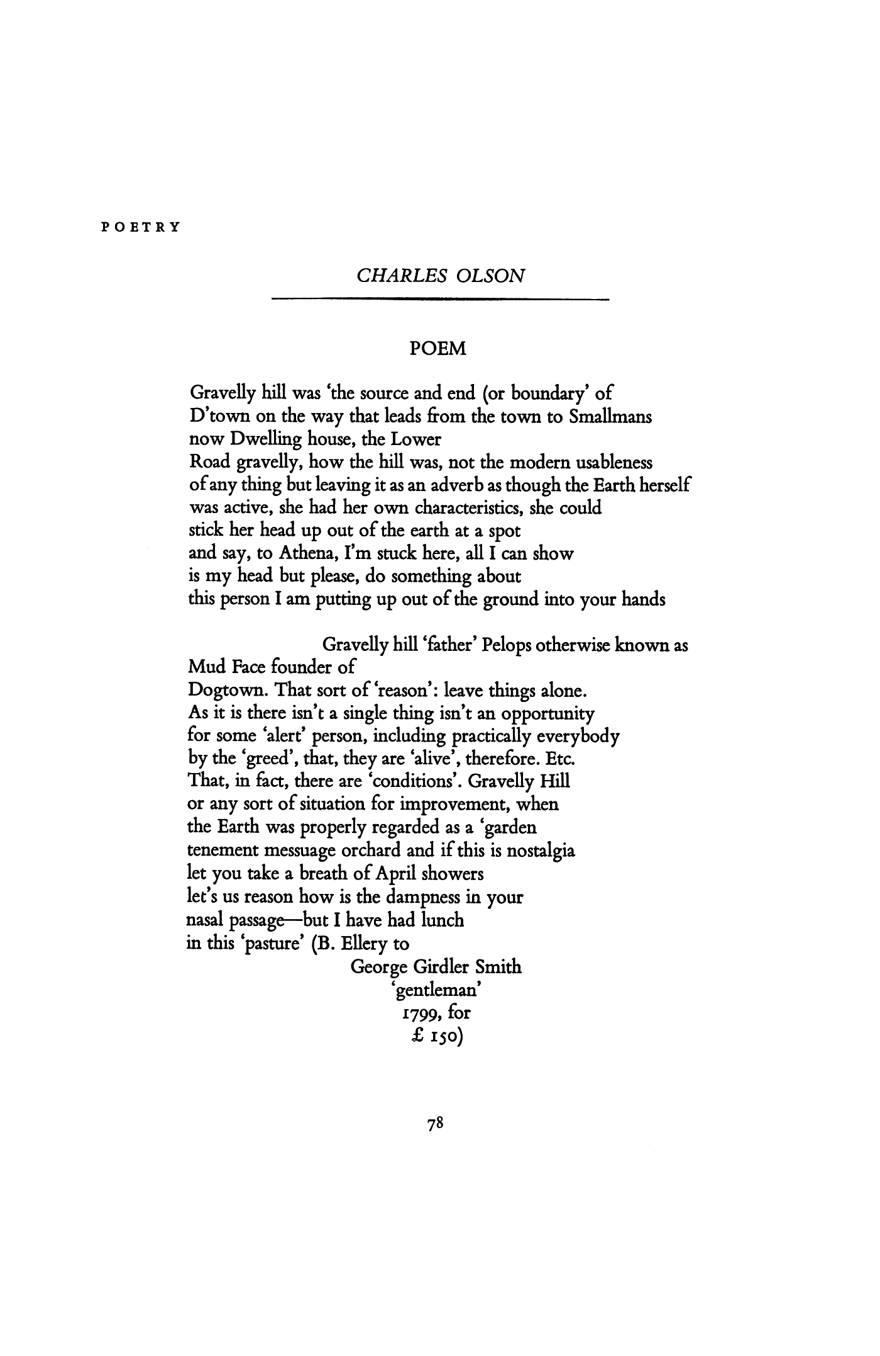
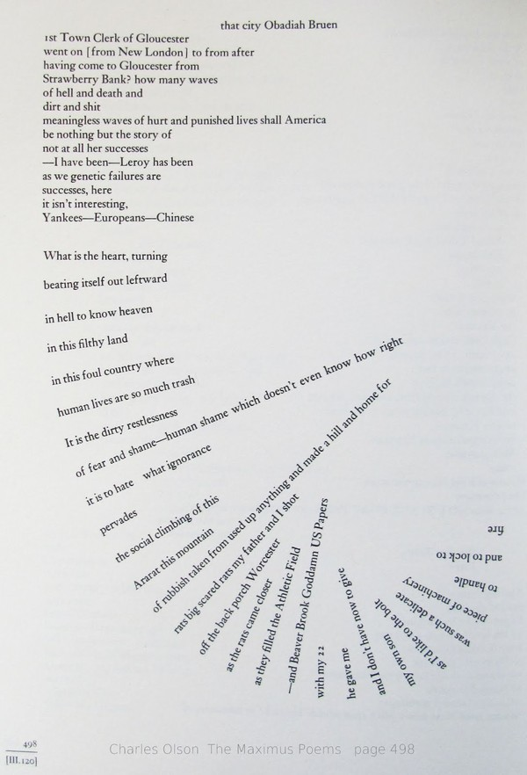

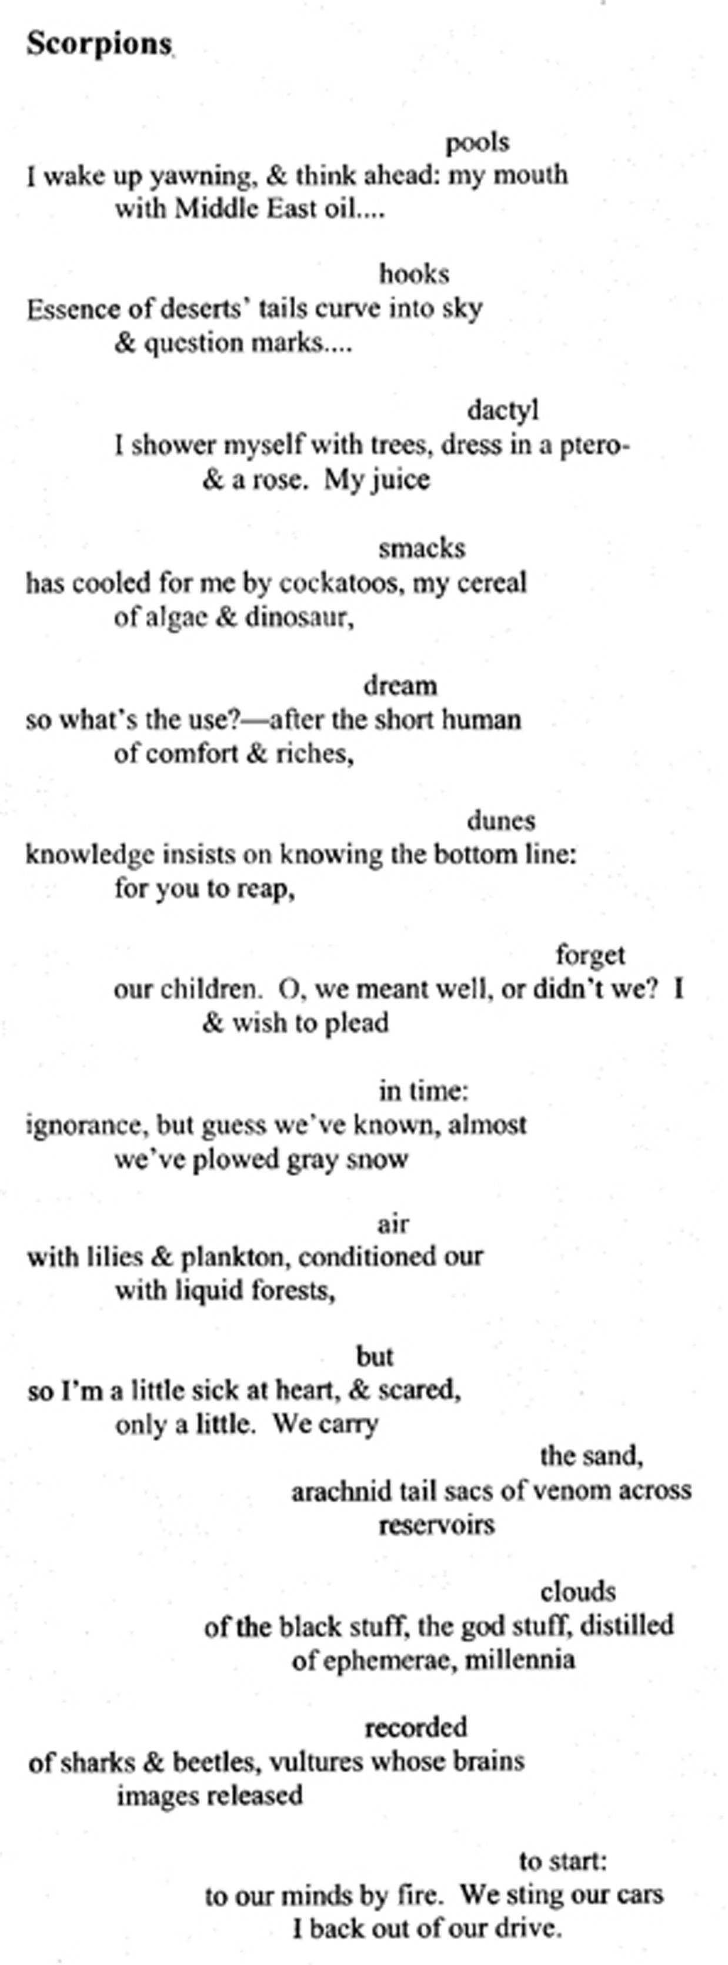

Denise Levertov

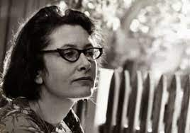

September 1961
This is the year the old ones,
the old great ones
leave us alone on the road.
The road leads to the sea.
We have the words in our pockets,
obscure directions. The old ones
have taken away the light of their presence,
we see it moving away over a hill
off to one side.
They are not dying,
they are withdrawn
into a painful privacy
learning to live without words.
E. P. "It looks like dying"-Williams: "I can't
describe to you what has been
happening to me"-
H. D. "unable to speak."
The darkness
twists itself in the wind, the stars
are small, the horizon
ringed with confused urban light-haze.
They have told us
the road leads to the sea,
and given
the language into our hands.
We hear
our footsteps each time a truck
has dazzled past us and gone
leaving us new silence.
I can't reach
the sea on this endless
road to the sea unless
one turns aside at the end, it seems,
follows
the owl that silently glides above it
aslant, back and forth,
and away into deep woods.
But for us the road
unfurls itself, we count the
words in our pockets, we wonder
how it will be without them, we don't
stop walking, we know
there is far to go, sometimes
we think the night wind carries
a smell of the sea...
…………………………………

Sands of the Well

The golden particles
descend, descend
traverse the water’s
depth and come to rest
on the level bed
Of the well until,
the full descent
accomplished, water’s
absolute transparence
is complete, unclouded
by constellations
of bright sand.
is this
the place where you
are brought in meditation?
Transparency
seen for itself –
as if its quality
were not, after all,
to enable
perception not of itself?
with a wand
of willow I again
trouble the envisioned pool,
the cloudy nebulae
form and disperse,
the separate
grains again
slowly, slowly
perform their descent,
and again
stillness ensues,
and the mystery
of that sheer
clarity, is it water indeed,
or air, or light?

…………………………

Robert Duncan, “Food for Fire, Food for Thought”

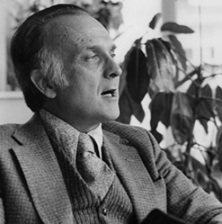

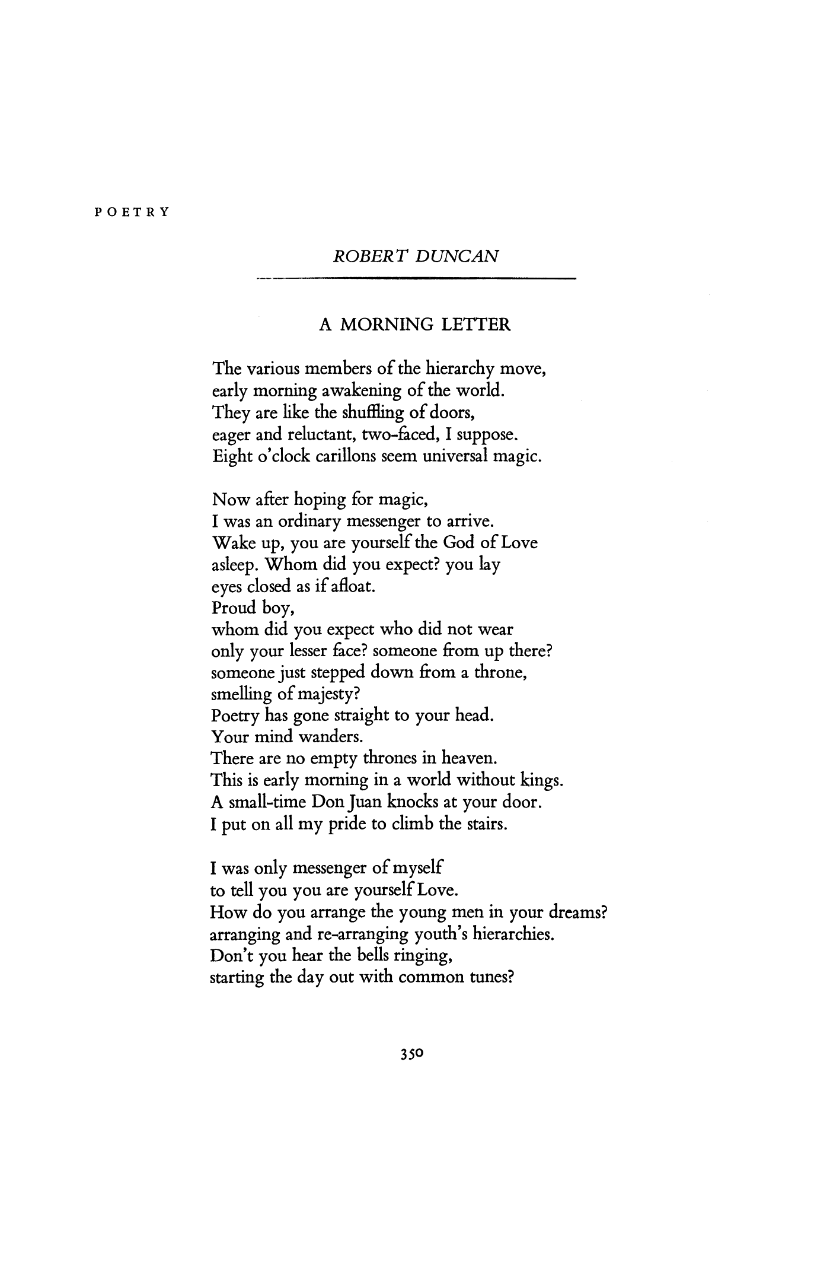

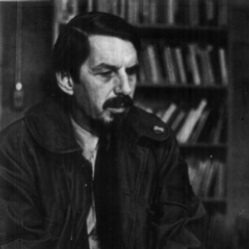

Robert Creeley

For Love—I would
Split open your head and put
A candle in
Behind the eyes.

Love is dead in us
If we forget
The virtues of an amulet
And quick surprise

Allen Ginsberg, “To Aunt Rose”

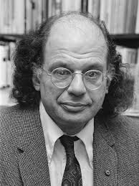

Aunt Rose-now-might I see you
with your thin face and buck tooth smile and pain
of rheumatism-and a long black heavy shoe
for your bony left leg
limping down the long hall in Newark on the running carpet
past the black grand piano
in the day room
where the parties were
and I sang Spanish loyalist songs
in a high squeaky voice
(hysterical) the committee listening
while you limped around the room
collected the money-
Aunt Honey, Uncle Sam, a stranger with a cloth arm
in his pocket
and huge young bald head
of Abraham Lincoln Brigade
-your long sad face
your tears of s**ual frustration
(what smothered sobs and bony hips
under the pillows of Osborne Terrace)
-the time I stood on the toilet seat naked
and you powdered my thighs with calamine
against the poison ivy-my tender
and shamed first black curled hairs
what were you thinking in secret heart then
knowing me a man already-
and I an ignorant girl of family silence on the thin pedestal
of my legs in the bathroom-Museum of Newark.
Aunt Rose
h***** is dead, h***** is in Eternity; h***** is with
Tamburlane and Emily Bronte
Though I see you walking still, a ghost on Osborne Terrace
down the long dark hall to the front door
limping a little with a pinched smile
in what must have been a silken
flower dress
welcoming my father, the Poet, on his visit to Newark
-see you arriving in the living room
dancing on your crippled leg
and clapping hands his book
had been accepted by Liveright
h***** is dead and Liveright's gone out of business
The Attic of the Past and Everlasting Minute are out of print
Uncle Harry sold his last silk stocking
Claire quit interpretive dancing school
Buba sits a wrinkled monument in Old
Ladies Home blinking at new babies
last time I saw you was the hospital
pale skull protruding under ashen skin
blue veined unconscious girl
in an oxygen tent
the war in Spain has ended long ago
Aunt Rose
…………………………………………..
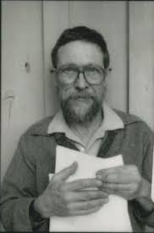

Gary Snyder, “Riprap,”

Lay down these words
Before your mind like rocks.
placed solid, by hands
In choice of place, set
Before the body of the mind
in space and time:
Solidity of bark, leaf or wall
riprap of things:
Cobble of milky way,
straying planets,
These poems, people,
lost ponies with
Dragging saddles --
and rocky sure-foot trails.
The worlds like an endless
four-dimensional
Game of Go.
ants and pebbles
In the thin loam, each rock a word
a creek-washed stone
Granite: ingrained
with torment of fire and weight
Crystal and sediment linked hot
all change, in thoughts,
As well as things.

……………………………………………………….

Axe Handles
One afternoon the last week in April
Showing Kai how to throw a hatchet
One-half turn and it sticks in a stump.
He recalls the hatchet-head
Without a handle, in the shop
And go gets it, and wants it for his own.
A broken-off axe handle behind the door
Is long enough for a hatchet,
We cut it to length and take it
With the hatchet head
And working hatchet, to the wood block.
There I begin to shape the old handle
With the hatchet, and the phrase
First learned from Ezra Pound
Rings in my ears!
"When making an axe handle
the pattern is not far off."
And I say this to Kai
"Look: We'll shape the handle
By checking the handle
Of the axe we cut with—"
And he sees. And I hear it again:
It's in Lu Ji's Wên Fu, fourth century
A.D. "Essay on Literature"-—in the
Preface: "In making the handle
Of an axe
By cutting wood with an axe
The model is indeed near at hand."
My teacher Shih-hsiang Chen
Translated that and taught it years ago
And I see: Pound was an axe,
Chen was an axe, I am an axe
And my son a handle, soon
To be shaping again, model
And tool, craft of culture,
How we go on.

Gary Snyder, "Axe Handles" from Axe Handles. Copyright © 1983 by Gary Snyder. Reprinted by permission of Counterpoint Press.

Ripples on the Surface
Gary Snyder (1993)
"Ripples on the surface of water
were silver salmon passing under—different
from the sorts of ripples caused by breezes"
A scudding plume on the wave—
a humpback whale is
breaking out in air up
gulping herring
—Nature not a book, but a performance, a
high old culture.
Ever-fresh events
scraped out, rubbed out, and used, used, again—
the braided channels of the rivers
hidden under fields of grass—
The vast wild
the house, alone.
the little house in the wild,
the wild in the house.
both forgotten.
No nature.
Both together, one big empty house.

Why I Am Not a Painter
Frank O'Hara - 1926-1966

I am not a painter, I am a poet.
Why? I think I would rather be
a painter, but I am not. Well,
for instance, Mike Goldberg
is starting a painting. I drop in.
“Sit down and have a drink” he
says. I drink; we drink. I look
up. “You have SARDINES in it.”
“Yes, it needed something there.”
“Oh.” I go and the days go by
and I drop in again. The painting
is going on, and I go, and the days
go by. I drop in. The painting is
finished. “Where’s SARDINES?”
All that’s left is just
letters, “It was too much,” Mike says.
But me? One day I am thinking of
a color: orange. I write a line
about orange. Pretty soon it is a
whole page of words, not lines.
Then another page. There should be
so much more, not of orange, of
words, of how terrible orange is
and life. Days go by. It is even in
prose, I am a real poet. My poem
is finished and I haven’t mentioned
orange yet. It’s twelve poems, I call
it ORANGES. And one day in a gallery
I see Mike’s painting, called SARDINES.

Poem

James Schuyler - 1923-1991
I do not always understand what you say.
Once, when you said, across, you meant along.
What is, is by its nature, on display.

Words' meanings count, aside from what they weigh:
poetry, like music, is not just song.
I do not always understand what you say.

You would hate, when with me, to meet by day
What at night you met and did not think wrong.
What is, is by its nature, on display.

I sense a heaviness in your light play,
a wish to stand out, admired, from the throng.
I do not always understand what you say.

I am as shy as you. Try as we may,
only by practice will our talks prolong.
What is, is by its nature, on display.

We talk together in a common way.
Art, like death, is brief: life and friendship long.
I do not always understand what you say.
What is, is by its nature, on display.

Best Poem of John Ashbery

John Ashbery

As Parmigianino did it, the right hand
Bigger than the head, thrust at the viewer
And swerving easily away, as though to protect
What it advertises. A few leaded panes, old beams,
Fur, pleated muslin, a coral ring run together
In a movement supporting the face, which swims
Toward and away like the hand
Except that it is in repose. It is what is
Sequestered. Vasari says, "Francesco one day set himself
To take his own portrait, looking at himself from that purpose
In a convex mirror, such as is used by barbers . . .
He accordingly caused a ball of wood to be made
By a turner, and having divided it in half and
Brought it to the size of the mirror, he set himself
With great art to copy all that he saw in the glass,"
Chiefly his reflection, of which the portrait
Is the reflection, of which the portrait
Is the reflection once removed.
The glass chose to reflect only what he saw
Which was enough for his purpose: his image
Glazed, embalmed, projected at a 180-degree angle.
The time of day or the density of the light
Adhering to the face keeps it
Lively and intact in a recurring wave
Of arrival. The soul establishes itself.
But how far can it swim out through the eyes
And still return safely to its nest? The surface
Of the mirror being convex, the distance increases
Significantly; that is, enough to make the point
That the soul is a captive, treated humanely, kept
In suspension, unable to advance much farther
Than your look as it intercepts the picture.
Pope Clement and his court were "stupefied"
By it, according to Vasari, and promised a commission
That never materialized. The soul has to stay where it is,
Even though restless, hearing raindrops at the pane,
The sighing of autumn leaves thrashed by the wind,
Longing to be free, outside, but it must stay
Posing in this place. It must move
As little as possible. This is what the portrait says.
But there is in that gaze a combination
Of tenderness, amusement and regret, so powerful
In its restraint that one cannot look for long.
The secret is too plain. The pity of it smarts,
Makes hot tears spurt: that the soul is not a soul,
Has no secret, is small, and it fits
Its hollow perfectly: its room, our moment of attention.
That is the tune but there are no words.
The words are only speculation
(From the Latin speculum, mirror):
They seek and cannot find the meaning of the music.
We see only postures of the dream,
Riders of the motion that swings the face
Into view under evening skies, with no
False disarray as proof of authenticity.
But it is life englobed.
One would like to stick one's hand
Out of the globe, but its dimension,
What carries it, will not allow it.
No doubt it is this, not the reflex
To hide something, which makes the hand loom large
As it retreats slightly. There is no way
To build it flat like a section of wall:
It must join the segment of a circle,
Roving back to the body of which it seems
So unlikely a part, to fence in and shore up the face
On which the effort of this condition reads
Like a pinpoint of a smile, a spark
Or star one is not sure of having seen
As darkness resumes. A perverse light whose
Imperative of subtlety dooms in advance its
Conceit to light up: unimportant but meant.
Francesco, your hand is big enough
To wreck the sphere, and too big,
One would think, to weave delicate meshes
That only argue its further detention.
(Big, but not coarse, merely on another scale,
Like a dozing whale on the sea bottom
In relation to the tiny, self-important ship
On the surface.) But your eyes proclaim
That everything is surface. The surface is what's there
And nothing can exist except what's there.
There are no recesses in the room, only alcoves,
And the window doesn't matter much, or that
Sliver of window or mirror on the right, even
As a gauge of the weather, which in French is
Le temps, the word for time, and which
Follows a course wherein changes are merely
Features of the whole. The whole is stable within
Instability, a globe like ours, resting
On a pedestal of vacuum, a ping-pong ball
Secure on its jet of water.
And just as there are no words for the surface, that is,
No words to say what it really is, that it is not
Superficial but a visible core, then there is
No way out of the problem of pathos vs. experience.
You will stay on, restive, serene in
Your gesture which is neither embrace nor warning
But which holds something of both in pure
Affirmation that doesn't affirm anything.
The balloon pops, the attention
Turns dully away. Clouds
In the puddle stir up into sawtoothed fragments.
I think of the friends
Who came to see me, of what yesterday
Was like. A peculiar slant
Of memory that intrudes on the dreaming model
In the silence of the studio as he considers
Lifting the pencil to the self-portrait.
How many people came and stayed a certain time,
Uttered light or dark speech that became part of you
Like light behind windblown fog and sand,
Filtered and influenced by it, until no part
Remains that is surely you. Those voices in the dusk
Have told you all and still the tale goes on
In the form of memories deposited in irregular
Clumps of crystals. Whose curved hand controls,
Francesco, the turning seasons and the thoughts
That peel off and fly away at breathless speeds
Like the last stubborn leaves ripped
From wet branches? I see in this only the chaos
Of your round mirror which organizes everything
Around the polestar of your eyes which are empty,
Know nothing, dream but reveal nothing.
I feel the carousel starting slowly
And going faster and faster: desk, papers, books,
Photographs of friends, the window and the trees
Merging in one neutral band that surrounds
Me on all sides, everywhere I look.
And I cannot explain the action of leveling,
Why it should all boil down to one
Uniform substance, a magma of interiors.
My guide in these matters is your self,
Firm, oblique, accepting everything with the same
Wraith of a smile, and as time speeds up so that it is soon
Much later, I can know only the straight way out,
The distance between us. Long ago
The strewn evidence meant something,
The small accidents and pleasures
Of the day as it moved gracelessly on,
A housewife doing chores. Impossible now
To restore those properties in the silver blur that is
The record of what you accomplished by sitting down
"With great art to copy all that you saw in the glass"
So as to perfect and rule out the extraneous
Forever. In the circle of your intentions certain spars
Remain that perpetuate the enchantment of self with self:
Eyebeams, muslin, coral. It doesn't matter
Because these are things as they are today
Before one's shadow ever grew
Out of the field into thoughts of tomorrow.
Tomorrow is easy, but today is uncharted,
Desolate, reluctant as any landscape
To yield what are laws of perspective
After all only to the painter's deep
Mistrust, a weak instrument though
Necessary. Of course some things
Are possible, it knows, but it doesn't know
Which ones. Some day we will try
To do as many things as are possible
And perhaps we shall succeed at a handful
Of them, but this will not have anything
To do with what is promised today, our
Landscape sweeping out from us to disappear
On the horizon. Today enough of a cover burnishes
To keep the supposition of promises together
In one piece of surface, letting one ramble
Back home from them so that these
Even stronger possibilities can remain
Whole without being tested. Actually
The skin of the bubble-chamber's as tough as
Reptile eggs; everything gets "programmed" there
In due course: more keeps getting included
Without adding to the sum, and just as one
Gets accustomed to a noise that
Kept one awake but now no longer does,
So the room contains this flow like an hourglass
Without varying in climate or quality
(Except perhaps to brighten bleakly and almost
Invisibly, in a focus sharpening toward death--more
Of this later). What should be the vacuum of a dream
Becomes continually replete as the source of dreams
Is being tapped so that this one dream
May wax, flourish like a cabbage rose,
Defying sumptuary laws, leaving us
To awake and try to begin living in what
Has now become a slum. Sydney Freedberg in his
Parmigianino says of it: "Realism in this portrait
No longer produces and objective truth, but a bizarria . . . .
However its distortion does not create
A feeling of disharmony . . . . The forms retain
A strong measure of ideal beauty," because
Fed by our dreams, so inconsequential until one day
We notice the hole they left. Now their importance
If not their meaning is plain. They were to nourish
A dream which includes them all, as they are
Finally reversed in the accumulating mirror.
They seemed strange because we couldn't actually see them.
And we realize this only at a point where they lapse
Like a wave breaking on a rock, giving up
Its shape in a gesture which expresses that shape.
The forms retain a strong measure of ideal beauty
As they forage in secret on our idea of distortion.
Why be unhappy with this arrangement, since
Dreams prolong us as they are absorbed?
Something like living occurs, a movement
Out of the dream into its codification.
As I start to forget it
It presents its stereotype again
But it is an unfamiliar stereotype, the face
Riding at anchor, issued from hazards, soon
To accost others, "rather angel than man" (Vasari).
Perhaps an angel looks like everything
We have forgotten, I mean forgotten
Things that don't seem familiar when
We meet them again, lost beyond telling,
Which were ours once. This would be the point
Of invading the privacy of this man who
"Dabbled in alchemy, but whose wish
Here was not to examine the subtleties of art
In a detached, scientific spirit: he wished through them
To impart the sense of novelty and amazement to the spectator"
(Freedberg). Later portraits such as the Uffizi
"Gentleman," the Borghese "Young Prelate" and
The Naples "Antea" issue from Mannerist
Tensions, but here, as Freedberg points out,
The surprise, the tension are in the concept
Rather than its realization.
The consonance of the High Renaissance
Is present, though distorted by the mirror.
What is novel is the extreme care in rendering
The velleities of the rounded reflecting surface
(It is the first mirror portrait),
So that you could be fooled for a moment
Before you realize the reflection
Isn't yours. You feel then like one of those
Hoffmann characters who have been deprived
Of a reflection, except that the whole of me
Is seen to be supplanted by the strict
Otherness of the painter in his
Other room. We have surprised him
At work, but no, he has surprised us
As he works. The picture is almost finished,
The surprise almost over, as when one looks out,
Startled by a snowfall which even now is
Ending in specks and sparkles of snow.
It happened while you were inside, asleep,
And there is no reason why you should have
Been awake for it, except that the day
Is ending and it will be hard for you
To get to sleep tonight, at least until late.
The shadow of the city injects its own
Urgency: Rome where Francesco
Was at work during the Sack: his inventions
Amazed the soldiers who burst in on him;
They decided to spare his life, but he left soon after;
Vienna where the painting is today, where
I saw it with Pierre in the summer of 1959; New York
Where I am now, which is a logarithm
Of other cities. Our landscape
Is alive with filiations, shuttlings;
Business is carried on by look, gesture,
Hearsay. It is another life to the city,
The backing of the looking glass of the
Unidentified but precisely sketched studio. It wants
To siphon off the life of the studio, deflate
Its mapped space to enactments, island it.
That operation has been temporarily stalled
But something new is on the way, a new preciosity
In the wind. Can you stand it,
Francesco? Are you strong enough for it?
This wind brings what it knows not, is
Self--propelled, blind, has no notion
Of itself. It is inertia that once
Acknowledged saps all activity, secret or public:
Whispers of the word that can't be understood
But can be felt, a chill, a blight
Moving outward along the capes and peninsulas
Of your nervures and so to the archipelagoes
And to the bathed, aired secrecy of the open sea.
This is its negative side. Its positive side is
Making you notice life and the stresses
That only seemed to go away, but now,
As this new mode questions, are seen to be
Hastening out of style. If they are to become classics
They must decide which side they are on.
Their reticence has undermined
The urban scenery, made its ambiguities
Look willful and tired, the games of an old man.
What we need now is this unlikely
Challenger pounding on the gates of an amazed
Castle. Your argument, Francesco,
Had begun to grow stale as no answer
Or answers were forthcoming. If it dissolves now
Into dust, that only means its time had come
Some time ago, but look now, and listen:
It may be that another life is stocked there
In recesses no one knew of; that it,
Not we, are the change; that we are in fact it
If we could get back to it, relive some of the way
It looked, turn our faces to the globe as it sets
And still be coming out all right:
Nerves normal, breath normal. Since it is a metaphor
Made to include us, we are a part of it and
Can live in it as in fact we have done,
Only leaving our minds bare for questioning
We now see will not take place at random
But in an orderly way that means to menace
Nobody--the normal way things are done,
Like the concentric growing up of days
Around a life: correctly, if you think about it.
A breeze like the turning of a page
Brings back your face: the moment
Takes such a big bite out of the haze
Of pleasant intuition it comes after.
The locking into place is "death itself,"
As Berg said of a phrase in Mahler's Ninth;
Or, to quote Imogen in Cymbeline, "There cannot
Be a pinch in death more sharp than this," for,
Though only exercise or tactic, it carries
The momentum of a conviction that had been building.
Mere forgetfulness cannot remove it
Nor wishing bring it back, as long as it remains
The white precipitate of its dream
In the climate of sighs flung across our world,
A cloth over a birdcage. But it is certain that
What is beautiful seems so only in relation to a specific
Life, experienced or not, channeled into some form
Steeped in the nostalgia of a collective past.
The light sinks today with an enthusiasm
I have known elsewhere, and known why
It seemed meaningful, that others felt this way
Years ago. I go on consulting
This mirror that is no longer mine
For as much brisk vacancy as is to be
My portion this time. And the vase is always full
Because there is only just so much room
And it accommodates everything. The sample
One sees is not to be taken as
Merely that, but as everything as it
May be imagined outside time--not as a gesture
But as all, in the refined, assimilable state.
But what is this universe the porch of
As it veers in and out, back and forth,
Refusing to surround us and still the only
Thing we can see? Love once
Tipped the scales but now is shadowed, invisible,
Though mysteriously present, around somewhere.
But we know it cannot be sandwiched
Between two adjacent moments, that its windings
Lead nowhere except to further tributaries
And that these empty themselves into a vague
Sense of something that can never be known
Even though it seems likely that each of us
Knows what it is and is capable of
Communicating it to the other. But the look
Some wear as a sign makes one want to
Push forward ignoring the apparent
NaÏveté of the attempt, not caring
That no one is listening, since the light
Has been lit once and for all in their eyes
And is present, unimpaired, a permanent anomaly,
Awake and silent. On the surface of it
There seems no special reason why that light
Should be focused by love, or why
The city falling with its beautiful suburbs
Into space always less clear, less defined,
Should read as the support of its progress,
The easel upon which the drama unfolded
To its own satisfaction and to the end
Of our dreaming, as we had never imagined
It would end, in worn daylight with the painted
Promise showing through as a gage, a bond.
This nondescript, never-to-be defined daytime is
The secret of where it takes place
And we can no longer return to the various
Conflicting statements gathered, lapses of memory
Of the principal witnesses. All we know
Is that we are a little early, that
Today has that special, lapidary
Todayness that the sunlight reproduces
Faithfully in casting twig-shadows on blithe
Sidewalks. No previous day would have been like this.
I used to think they were all alike,
That the present always looked the same to everybody
But this confusion drains away as one
Is always cresting into one's present.
Yet the "poetic," straw-colored space
Of the long corridor that leads back to the painting,
Its darkening opposite--is this
Some figment of "art," not to be imagined
As real, let alone special? Hasn't it too its lair
In the present we are always escaping from
And falling back into, as the waterwheel of days
Pursues its uneventful, even serene course?
I think it is trying to say it is today
And we must get out of it even as the public
Is pushing through the museum now so as to
Be out by closing time. You can't live there.
The gray glaze of the past attacks all know-how:
Secrets of wash and finish that took a lifetime
To learn and are reduced to the status of
Black-and-white illustrations in a book where colorplates
Are rare. That is, all time
Reduces to no special time. No one
Alludes to the change; to do so might
Involve calling attention to oneself
Which would augment the dread of not getting out
Before having seen the whole collection
(Except for the sculptures in the basement:
They are where they belong).
Our time gets to be veiled, compromised
By the portrait's will to endure. It hints at
Our own, which we were hoping to keep hidden.
We don't need paintings or
Doggerel written by mature poets when
The explosion is so precise, so fine.
Is there any point even in acknowledging
The existence of all that? Does it
Exist? Certainly the leisure to
Indulge stately pastimes doesn't,
Any more. Today has no margins, the event arrives
Flush with its edges, is of the same substance,
Indistinguishable. "Play" is something else;
It exists, in a society specifically
Organized as a demonstration of itself.
There is no other way, and those assholes
Who would confuse everything with their mirror games
Which seem to multiply stakes and possibilities, or
At least confuse issues by means of an investing
Aura that would corrode the architecture
Of the whole in a haze of suppressed mockery,
Are beside the point. They are out of the game,
Which doesn't exist until they are out of it.
It seems like a very hostile universe
But as the principle of each individual thing is
Hostile to, exists at the expense of all the others
As philosophers have often pointed out, at least
This thing, the mute, undivided present,
Has the justification of logic, which
In this instance isn't a bad thing
Or wouldn't be, if the way of telling
Didn't somehow intrude, twisting the end result
Into a caricature of itself. This always
Happens, as in the game where
A whispered phrase passed around the room
Ends up as something completely different.
It is the principle that makes works of art so unlike
What the artist intended. Often he finds
He has omitted the thing he started out to say
In the first place. Seduced by flowers,
Explicit pleasures, he blames himself (though
Secretly satisfied with the result), imagining
He had a say in the matter and exercised
An option of which he was hardly conscious,
Unaware that necessity circumvents such resolutions.
So as to create something new
For itself, that there is no other way,
That the history of creation proceeds according to
Stringent laws, and that things
Do get done in this way, but never the things
We set out to accomplish and wanted so desperately
To see come into being. Parmigianino
Must have realized this as he worked at his
Life-obstructing task. One is forced to read
The perfectly plausible accomplishment of a purpose
Into the smooth, perhaps even bland (but so
Enigmatic) finish. Is there anything
To be serious about beyond this otherness
That gets included in the most ordinary
Forms of daily activity, changing everything
Slightly and profoundly, and tearing the matter
Of creation, any creation, not just artistic creation
Out of our hands, to install it on some monstrous, near
Peak, too close to ignore, too far
For one to intervene? This otherness, this
"Not-being-us" is all there is to look at
In the mirror, though no one can say
How it came to be this way. A ship
Flying unknown colors has entered the harbor.
You are allowing extraneous matters
To break up your day, cloud the focus
Of the crystal ball. Its scene drifts away
Like vapor scattered on the wind. The fertile
Thought-associations that until now came
So easily, appear no more, or rarely. Their
Colorings are less intense, washed out
By autumn rains and winds, spoiled, muddied,
Given back to you because they are worthless.
Yet we are such creatures of habit that their
Implications are still around en permanence, confusing
Issues. To be serious only about sex
Is perhaps one way, but the sands are hissing
As they approach the beginning of the big slide
Into what happened. This past
Is now here: the painter's
Reflected face, in which we linger, receiving
Dreams and inspirations on an unassigned
Frequency, but the hues have turned metallic,
The curves and edges are not so rich. Each person
Has one big theory to explain the universe
But it doesn't tell the whole story
And in the end it is what is outside him
That matters, to him and especially to us
Who have been given no help whatever
In decoding our own man-size quotient and must rely
On second-hand knowledge. Yet I know
That no one else's taste is going to be
Any help, and might as well be ignored.
Once it seemed so perfect--gloss on the fine
Freckled skin, lips moistened as though about to part
Releasing speech, and the familiar look
Of clothes and furniture that one forgets.
This could have been our paradise: exotic
Refuge within an exhausted world, but that wasn't
In the cards, because it couldn't have been
The point. Aping naturalness may be the first step
Toward achieving an inner calm
But it is the first step only, and often
Remains a frozen gesture of welcome etched
On the air materializing behind it,
A convention. And we have really
No time for these, except to use them
For kindling. The sooner they are burnt up
The better for the roles we have to play.
Therefore I beseech you, withdraw that hand,
Offer it no longer as shield or greeting,
The shield of a greeting, Francesco:
There is room for one bullet in the chamber:
Our looking through the wrong end
Of the telescope as you fall back at a speed
Faster than that of light to flatten ultimately
Among the features of the room, an invitation
Never mailed, the "it was all a dream"
Syndrome, though the "all" tells tersely
Enough how it wasn't. Its existence
Was real, though troubled, and the ache
Of this waking dream can never drown out
The diagram still sketched on the wind,
Chosen, meant for me and materialized
In the disguising radiance of my room.
We have seen the city; it is the gibbous
Mirrored eye of an insect. All things happen
On its balcony and are resumed within,
But the action is the cold, syrupy flow
Of a pageant. One feels too confined,
Sifting the April sunlight for clues,
In the mere stillness of the ease of its
Parameter. The hand holds no chalk
And each part of the whole falls off
And cannot know it knew, except
Here and there, in cold pockets
Of remembrance, whispers out of time.

