MODULE 29 ON ENGLISH FOR PEDAGOGICAL AND HUMAN SCIENCES
SECTION 1: GUESSING SKILLS EXERCISE 29
1. .............. teachers are elementary or secondary school teachers hired as interim replacement for absent teachers.
a) prospective b) teacher candidates
c) preservice d) substitute
2. Independent, publicly-funded schools in the UK.
a) multi-academy trusts b) comprehensive schools
c) academies d) bilingual schools
3. A standard against which performance or achievements can be assessed.
a) block teaching b) benchmark
c) core curriculum d) cross-cutting theme
4. If a student plays ............. he stays away from school without permission.
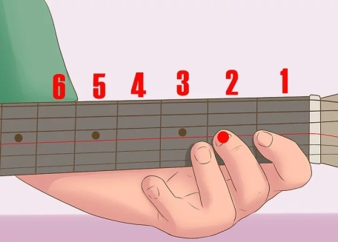
a) scale
b) truant
c) wisdom
d) havoc

5. A ............ is a private teacher for one pupil or an individual providing personalized teaching in a British university.
a) tutelage b) tutu
c) tutor d) tutee
6. A ................. is someone who is just beginning to learn something.
a) tyro b) tyrant
c) matron d) patron
7. The study of self-determined learning.
a) anagogy /άναγκότζι/ b) demagogy /ντέμαγκότζι/
c) andragogy /άντραγκότζι/ d) heutagogy /χιούταγκότζι/

8. A student-centered method of education focused on asking questions.
a) novel method b) analytical method
c) survey method d) inquiry method
9. A/An .................... is a student with the highest grade ranking in a university class, selected to present a farewell speech at the graduation ceremony.
a) stipend /στάιπεντ/ b) valetudinarian
c) valedictorian d) invigilator
10. When students perform better than other students simply because they are expected to do so.
a) overlearning b) obscurantism
c) polymath d) Pygmalion effect /πιγκμέιλιον ιφέκτ/
11. The idea that an object is bigger or smaller than it actually is, caused by a false perception of its distance from the viewer.
a) moon illusion
b) Moro reflex
c) kinesia /κινίζια ή καϊνίζια/
d) mussitation

12. Any method for producing a negative or positive change in mood, often by selectively reminding individuals of pleasant or unpleasant aspects of their lives.
a) mood induction b) mood swing
c) mood-congruent memory d) mood-dependent memory

SECTION 2: AUDIOVISUAL RESOURCES AND TASKS RELATED TO PEDAGOGICAL AND EDUCATIONAL ISSUES
TASK 1: Read the synopsis below and then watch the attached 49-minute video (with English subtitles) about the life of three people with bipolar disorder (previously known as manic depression). After watching the video, discuss it with your teacher and classmates. What are the challenges faced by those people? What does the video tell us about how they should be treated?
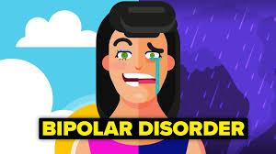
To the outsider, Mike, Erin, and Martha appear to have little in common, but they are all living under the shadow of one of the most commonly misunderstood and misdiagnosed mental illnesses - bipolar disorder. The video challenges the stereotypes of the disorder by following three people living with this complex illness. Mike is a charismatic young man whose partying lifestyle and abuse of recreational drugs foreshadow* a severe manic episode that has him committed to a psychiatric ward**. His experience with the hospital is just the wake-up call***. Mike needs as he begins taking his illness seriously and rebuilding his life. Erin is a young mom whose ‘moodiness’**** is starting to escalate as she swings rapidly between destructive hypomania and soul-crushing depressions. As she tries to deal with her new baby, her husband Eric struggles to find her the help she needs to get better. Martha is a divorced single mom who lost her career and marriage to a manic episode. Now with continued group therapy and medication, she is finally lifting herself out of a crippling two-year depression. Treating them all is Dr. Paul Termansen. Through a groundbreaking mood disorders program he created at his clinic, Dr. Termansen offers a holistic approach to treatment that goes beyond just prescribing a pill. With intimate access and great sensitivity, the video details Mike, Erin, and Martha's personal struggles with the emotional highs and lows of a disorder they must learn to manage in order to lead productive, balanced lives, and sheds light on a disorder that often relegates***** its victims to the shadows.
* foreshadow =προμηνύουν = they are a sign of something to come, esp. something important or bad
** ward =θάλαμος = Block forming a division of a hospital (or a suite of rooms) shared by patients who need a similar kind of care
*** wake-up call = γεγονός που ανέδειξε το μέγεθος του προβλήματος = A warning to take action concerning something that was overlooked or neglected.
**** moodiness = απότομη αλλαγή διάθεσης = having temperamental and changeable moods
***** relegates =υποβιβάζει = assign to a lower position; reduce in rank
TASK 2: Read the synopsis below and then watch the attached 14-minute video about rapport and disruptive behavior in classroom situations. After watching the video, discuss it with your teacher and classmates. What are the challenges faced when student behavior is disruptive? What kind of strategies are used in the video and how effective are they? Are there particular strategies to face disruptive behavior in the school context of your country?
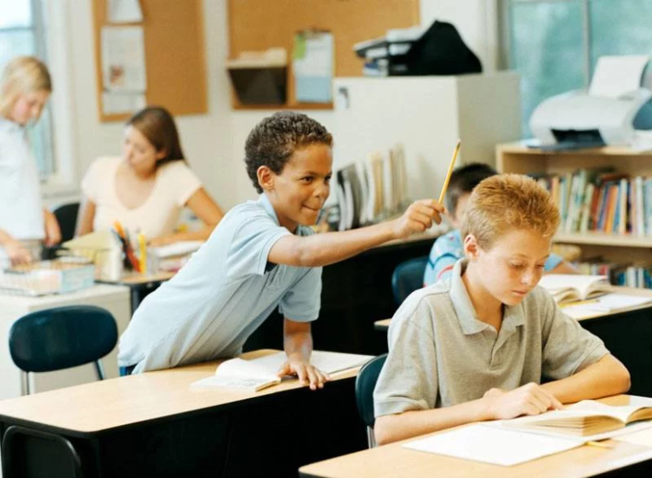

In this video, John Bayley visits Eltham Green School in south London. With the focus on girls at Key Stage 4*, Bayley hears from staff how a large group of bright girls are entering the school with scores at level 5, only to remain at level 5 at the end of Key Stage 3. As the girls begin their GCSE** courses, the series sees Bayley offering teachers a range of strategies to help them overcome the morale-sapping***, low-level disruption which characterizes many lessons.
In this programme, Bayley works with English NQT Sally Jenkins who, though highly effective at basic behaviour and class control, finds it difficult to establish a rapport**** with the girls. Bayley encourages her to adopt a warmer approach, viewing much of the disruption as a search for greater support and encouragement.
* Key Stage 4 (KS4) is the legal term for the two years of school education which incorporate GCSEs, and other examinations, in maintained schools in England normally known as Year 10 and Year 11, when pupils are aged between 14 and 16.
** GCSE = General Certificate of Secondary Education = (in the UK except Scotland) a qualification in a specific subject typically taken by school students aged 14–16, at a level below A level.
*** morale-sapping = που κόβει το ηθικό και το ομαδικό πνεύμα = breaking the team spirit
**** rapport = (αμοιβαία) συμπάθεια ή έλξη, συνάφεια, ταύτιση = A relationship of mutual understanding or trust and agreement between people

SECTION 3: VOCABULARY ANALYSIS IN PEDAGOGICAL TEXT
TASK 1. The text below contains some notes about Child Discipline (by Dr. Robert Brooks, Ph.D., extracts from his monthly newsletters). While reading it, please, focus on particular words, phrases and/or collocations and match them to the following synonyms, images, and/or Greek meanings.

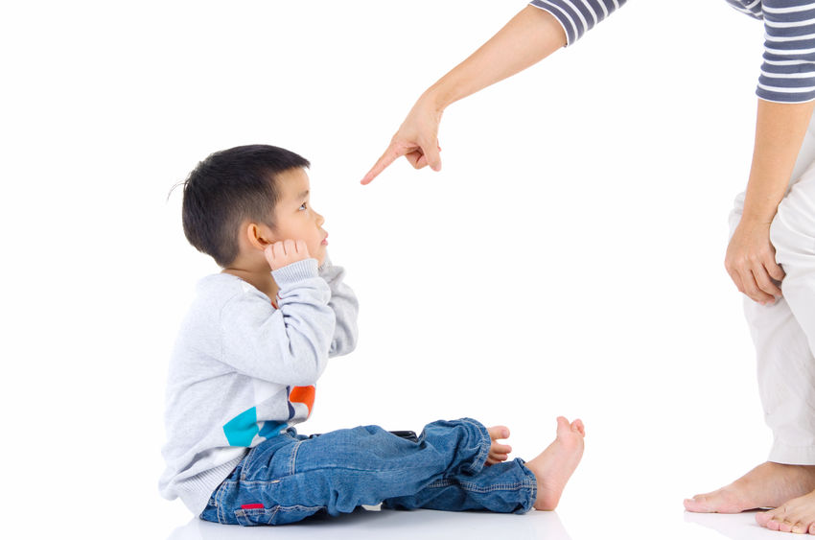

Many of the questions I receive in my parenting workshops, in my clinical practice, and in e-mails concern the topic of discipline. The importance of this topic is reflected in the large number of books and magazine articles advising parents of the most effective ways to discipline their children. In reaction to displays of aggression in society, law enforcement officials as well as politicians will frequently provide their own opinions on disciplinary approaches.
Not surprisingly, the suggestions offered by child development specialists about discipline represent a wide spectrum of views, many of which seem to contradict each other. As a parent noted in one of my workshops, "The more I read, the more confused I become about discipline." I can understand why. I recently read two articles by child specialists, one of whom advocated parents using timeout, while another questioned the efficacy of that practice.
There are many different aspects about discipline that I have been discussing for years. Interestingly, in the last few months I have noticed an increase in the number of questions pertaining to corporal punishment or spanking. One father said that he read
that "if kids don’t listen, a spanking can serve a useful function." This father added, "The article said that spanking was okay as long as the parent did not lose control and hurt the child." But then he wondered, "Do young kids know when parents have lost
control when they are spanking?" A mother in the group noted that she had read that spanking should never be used. It is little wonder that parents get confused.

Hostility: …………….. Range, scope: …………….Contravene, oppose: …………….

Baffled: ………………. Relevant to: …………….. Beat: ……………….

So with trepidation as one more child development expert, I am ready to offer some observations and advice about discipline. Obviously, while a number of readers may disagree with my views, it is my hope that what I have to say will generate reflection
and discussion about this important topic. I would like to share in this and my next couple of newsletters my thoughts about discipline, including what are its main goals in raising and teaching children and how best to reach these goals. Given the obvious
interest in the question of spanking, I will devote this column to examining this particular disciplinary practice. Future columns will address what I consider to be more effective forms of discipline. A few preliminary thoughts about discipline are in order. First, a reminder about the meaning of discipline: we must not forget that the word discipline stems from the word disciple and is best conceived of as a teaching process. As a form of education, discipline should not be linked to so-called teaching practices that serve to humiliate, scare, or embarrass children. Second, at my workshops for parents, teachers, and other caregivers, I pose the question, "What are the main functions of discipline?" or worded somewhat differently, "If discipline is an educational process, what is it that we are attempting to teach?" The initial answer I typically receive is that discipline serves to ensure a safe and secure environment in which children not only learn the importance of rules, limits, and consequences but they also appreciate the reasons that rules and limits exist. This is certainly a very important goal of discipline.
What I consider to be another major function of discipline is to reinforce the development of self-discipline or self-control. Daniel Goleman, author of "Emotional Intelligence," views self-discipline as one of the crucial components of emotional intelligence, a component that serves as a source of satisfying interpersonal relationships and success in various facets of one’s life. Self-discipline implies that a child has incorporated rules so that even when a parent or other adult is not present, the child will act in a thoughtful, considerate fashion. Self-discipline may be viewed as learning to take responsibility for one’s own behavior. Most of us do not want to be with other adults who lack self-discipline and are constantly yelling, shouting, saying hurtful things, jumping to conclusions, or blaming others. These major functions of discipline challenge us to implement disciplinary practices that nurture self-control rather than eliciting feelings of anger and resentment in children. Let’s examine spanking from this perspective. I am especially influenced by the ideas and writings of a friend, Nancy Samalin, a renowned parent educator who is one of the foremost experts on the subject of discipline and the author of the book, "Loving Your Child Is Not Enough." In the February, 2001 issue of Sesame Street Parents Magazine, Nancy, together with Editor Susan Lapinski, wrote a very thoughtful and thought-provoking article titled, "The Spanking Report."

Dread, apprehension: ……………… Article: …………Exploratory: …………
Derive: ……………… Conceptualize: ………………. Abase: …………….. Brightness: ……… Shout out: …………Aspect: ……… Connote: …………… Reproach: ……………. Point of view: …………..Draw out: …………..
Leading: ……………… Put to use: ……………..
…………………
They note, "The child who gets an occasional swat across the bottom when the parents regretfully lose control is not the child most professionals worry about. It’s when spanking becomes a habit that a child–and his family–may be at risk. And spanking is a habit for a majority of American families, according to the results of a study of 3,000 adults last summer by pollster Daniel Yankelovich. The study revealed that 61 percent of the adults who responded condone spanking as a regular form of punishment."
Nancy and Susan quote Murray Straus, Ph.D., founder and co-director of the Family Research Lab at the University of New Hampshire in Durham and the author of a book about spanking, "Beating the Devil Out of Them." Dr. Straus observes, "In the last three years, we’ve had a revolution in our state of knowledge about spanking and violence. Spanking increases the probability of kids hitting other kids. It often leads to antisocial behavior like cheating and getting into trouble at school. When they are teenagers, these children are more likely to hit their parents. When they grow up, kids who have been spanked are more likely to hit their partners than kids who haven’t."
Similarly, in the 1980’s psychologists Malcolm Watson and Ying Peng at Brandeis University found that children who displayed the most aggressive behavior toward other children were those who were spanked most often by their parents. The more spanking youngsters received at home, the more likely they were to hit their peers.
Thus, it appears that not only is spanking an ineffective disciplinary practice but it actually may increase the very behaviors that parents wish their children to stop.
Some may argue that spanking did not increase aggressive behavior in the children observed in these studies but that they were more likely to be spanked because they were already very aggressive. Certainly, as I discussed in my newsletters last year about children with so-called "difficult" temperaments (please see the April, May, and June, 2000 newsletters), some children from birth may be more predisposed to becoming more frustrated and angry than their peers. These children quickly express their frustrations through aggressive behavior and are more likely to "invite" spanking as a way of curbing their misbehavior. I would argue that while the style of some youngsters does elicit more anger in parents, to respond by spanking serves to reinforce the message that the way we handle frustration is through physical force. Many, if not all, of us have witnessed a parent slapping a child and saying, "I told you that you shouldn’t hit your brother/sister! This is what you get when you do so." What a mixed message of what is appropriate behavior!
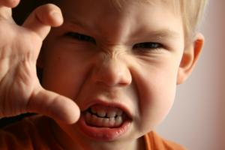
Hit, blow: …………….. In jeopardy: ……………..
Excuse: …………….. Force: ……………..
Deceive: ……………..
Effete, inefficient: …………….. Control: ………………
Inclined: ……………..
Disposition, usual mood: ………… Ire, wrath: ……………
Defeat: ……………….
……………………………..

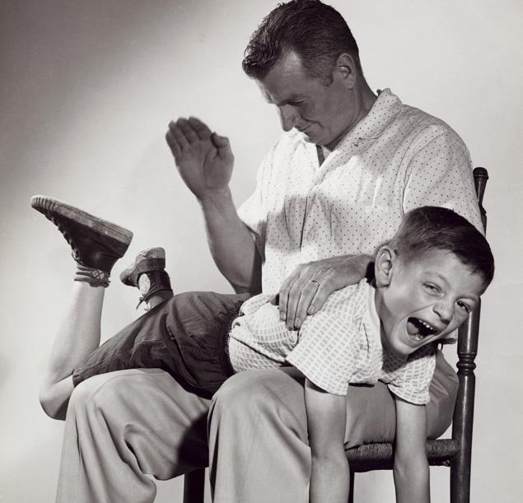
Before I continue, I would not want parents who have ever spanked their child to feel that I am criticizing them or begin to experience a twinge of guilt (or perhaps more than a twinge). I should note that many loving parents have at some point spanked their child even if it involved only one quick slap. Doing so doesn’t mean we are terrible parents but rather should prompt us to find better ways to teach our children than through spankings. I can count on one hand the number of times I hit my sons on their rear end and quite honestly, I think that the only thing it accomplished in the short term was for me to release some frustration; however, afterwards I felt even worse. I should emphasize that I quickly realized that spanking accomplished nothing positive in the short or long term and was soon abandoned as a disciplinary tactic. Obviously if the basic climate in a home is positive, if children feel loved and accepted, one spanking is not going to do irreparable harm. However, I believe that when parents find themselves spanking a child, they must ask what the other ways they can teach children right from wrong are and hold children accountable for their actions. I am not advocating that there should not be consequences for children’s behavior, but rather that spanking should not be one of these consequences. Parents must remember that if their main form of discipline is corporal punishment then any existing positive climate at home may soon be replaced by a tense, angry atmosphere that leads to an erosion of the parent-child relationship. In my clinical practice and workshops I have asked parents what prompted them to spank their child. A number of well-meaning parents have said that they just didn’t know what else to do. One parent said, "If people would have told me before I had children that I would resort to hitting my child, I would have looked at them in disbelief. But sometimes I get so angry and nothing else seems to work. When I hit him, he stops his behavior. Also, I’m not out of control when I do it." Thus, some parents may spank out of frustration, feeling they have exhausted all other disciplinary techniques. However, others use spanking as their first "line of attack" believing it is the most effective and quickest way to teach children right from wrong. Even those who resort to spanking only after they feel that all other consequences have failed have said, "I hated to spank my child but when I did it worked." But does it work, especially if spanking is used repeatedly? I believe that the use of spanking has a seductive quality in that it seems to work by producing the desired results; for example, the child either stops a behavior that the parent wants to see stopped (throwing a ball in the living room) or prompts the child to do something the parent has requested over and over (putting away toys). However, in my experience these immediate results are often short-lived or counterproductive. Children may stop the behavior in question but at the cost of developing a great deal of anger and resentment. Some children may feel intimidated and "comply" with their parents’ demands at home but as the research shows they may take out their anger towards others outside the home. Also, when these children become as big as their parents they may direct their anger directly and intensely at their parents.

Sting, pinch: ………….. Incite: ………… Desert, leave: ……………
Impossible to fix: ……………. Responsible: …………….. Break-up: ……………..
Unthreatening: …………… Spend: …………… Despise, detest: ……………….
Enticing, beguiling: ……………. Rancor, hate: ………….. Abide by: ……………..
The argument that it is okay to spank since "my child knows I have not lost control" must also be challenged. While parents may feel in control, I have spoken with many youngsters in my clinical practice who do not perceive it that way. Some have told me
that they worry that their parents may hurt them; many parents were surprised to hear this. When I mentioned this worry at one of my workshops, a father asked, "Is there anything wrong if a child is scared he will get hit if it leads him to behave and to do what he is told?" I believe there are problems. If a child’s compliance comes at the expense of a more comfortable parent-child relationship, one must question the disciplinary approach. Relatedly, I have been impressed over the years by the number of youngsters who are so upset and angry about being hit that they often lose sight of what prompted the parents to hit them. Instead of developing self-discipline, which is one of the main goals of disciplining children, they developed what I call a "reservoir of anger or self-hatred." One of the most important roles we have as parents, teachers, and other caregivers is that of a disciplinarian. If we keep in mind that discipline is a teaching process that should be free of intimidation or humiliation and if we recognize the importance of raising children who understand why there are rules, limits, and consequences, who develop self-discipline or self-control, and who accept responsibility for their behavior, then the use of spanking will take a back seat or disappear as a disciplinary technique.
Before ending, I want to discuss briefly what one child described as "spanking with words." This child was referring to harsh comments made by his parents that were just as hurtful as being spanked. The comments included, "What a stupid thing to do!"
"Do you ever use your brains?" "Are you that dumb?" As I have discussed in the past, empathy should guide our interactions with our children including our disciplinary practices. We should ask, "Would we want anyone to say and do things to us what we are saying and doing to our children? If someone treated us the way we are treating our children would we truly learn from them or would we resent them?" We should consider these questions as we discipline our children. If we are to be disciplinarians in the true and positive sense of the word, what is it that we might do to nurture self-control, responsibility, accountability and compassion in our children without in any way lessening their self-worth and dignity? This is an important question that I will address in next month’s newsletter.
Stormed: …………….. Sacrifice: ………………. Distressed, disquieted: …………… Source: ……………… Injurious: ……………….. Slow, imbecile: ……………….. Fellow feeling: …………… Pity: ……………… Self-regard: ………………
…………………….

SECTION 4: WRITING SKILLS DEVELOPMENT
TASK: According to the instructions provided in Module 1 Section 4, write an essay about the following topic. The vocabulary below may help you to develop your essay.
ESSAY TOPIC 29
English is quickly becoming the world language. Some people think this is good. Others think it is not good. Discuss the advantages and disadvantages of English as the world language. Use specific reasons and examples to support your answer.
Potentially useful vocabulary:
- Lingua franca: a language that is adopted as a common language between speakers whose native languages are different.
- Mother tongue: one's native language; the language learned by children and passed from one generation to the next
- Dialect: the usage or vocabulary that is characteristic of a specific group of people
- Interlanguage: a common language used by speakers of different languages
- Parlance: a manner of speaking that is natural to native speakers of a language
- Monolingual: a person who knows only one language
- Bilingualism: the ability to speak two languages colloquially
- Neologism: a newly invented word or phrase
- Received pronunciation: the approved pronunciation of British English; originally based on the King's English as spoken at public schools and at Oxford and Cambridge Universities (widely accepted elsewhere in Britain)
- Multilingual: using or knowing more than one language
- Linguist: a specialist in linguistics
- Trilingual: using or knowing three languages
- Intralinguistic: using or knowing three languages
- Linguistic communication: a systematic means of communicating by the use of sounds or conventional symbols
- Grammatist: a usually pedantic grammarian
- Loan translation: an expression introduced into one language by translating it from another language
- Polyglotism: the use of many languages, the ability to speak many languages
- Native speaker: a speaker of a particular language who has spoken that language since earliest childhood
- Fluent: expressing yourself readily, clearly, effectively
- Predominant language: most frequent or common language
- Foreign language misuse: improper or excessive use of a foreign language
- Syntax: the grammatical arrangement of words in sentences
- Colloquial: characteristic of informal spoken language or conversation
- Vernacular: the everyday speech of the people (as distinguished from literary language)
- Terminology: a system of words used to name things in a particular discipline
- Lexis: all of the words in a language; all word forms having meaning or grammatical function

KEY-WORD-IN-CONTEXT ACTIVITY. In pairs or individually, study the following concordance lines and find out the meaning of the common word (‘rations’) that they have in the middle. Then report it to your teacher orally or in written form.
