1 Introduction
The report was created by the company Analysys for the European Commission services.
It is entitled: Public policy treatment of digital terrestrial television (DTT) on communication markets. It aims at broadcasting industry and broadcasting policy makers
The report:
- places DTT in the context of other digital television platforms
- draws upon experience to date to identify DTT success factors.
- incorporates analysis of network economics, DTT business models and the regulatory environment in Member States.
- explores Public policy towards DTT is explored, highlighting the objectives of Member States in developing DTT and the regulatory challenges that lie ahead
- Refers to new technologies relevant to the development of digital television in Europe are also covered.
1.1 Report objectives:
However, the migration fro analogue to digital TV raises a number of questions:
- is it simply a case of replacing analogue terrestrial with digital terrestrial broadcasting, or should we replace analogue terrestrial with a mix of digital television platforms?
- if DTT is to contribute towards the migration, how do we ensure that it is successful?
- if DTT success requires some support from public institutions, how far can such support go without negatively impacting private investments in alternative platforms, and infringing Community law?
- what contribution may new digital technologies make in developing digital television?
The objective of this report is to address these questions and to identify what measures may be taken at Community level to help Member States develop digital television in general, and DTT in particular. In doing so, we draw upon European experience to date and examine the current objectives of Member States in developing DTT.

1.2 Report Structure:
This report begins by placing DTT in the context of the various digital television platforms, and explores its strengths and weaknesses, both qualitatively as well as economically. It then focuses on DTT and examines:
- the development of DTT in Europe to date, highlighting the business models that are developing and key lessons for and reasons for DTT success (Chapter 3)
- the regulatory context for digital television across the European Union (Chapter 4)
- developments in new technologies, and their impact on digital television (Chapter 5)
- the impact of existing Community law upon digital television development, and specifically the importance of general interest objectives (Chapter 6).
2 Comparison of digital television platforms
2.1 Qualitative comparison of platforms
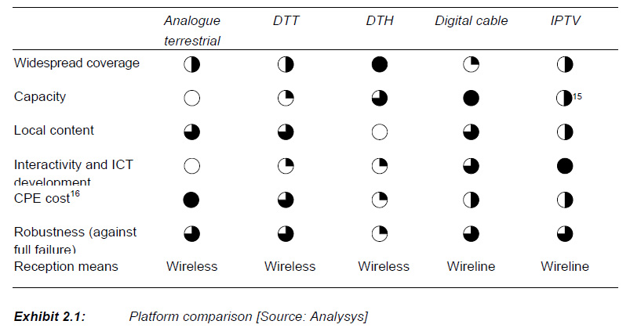
Platform comparison: DTT->DVB-T, DTH->DVB-S
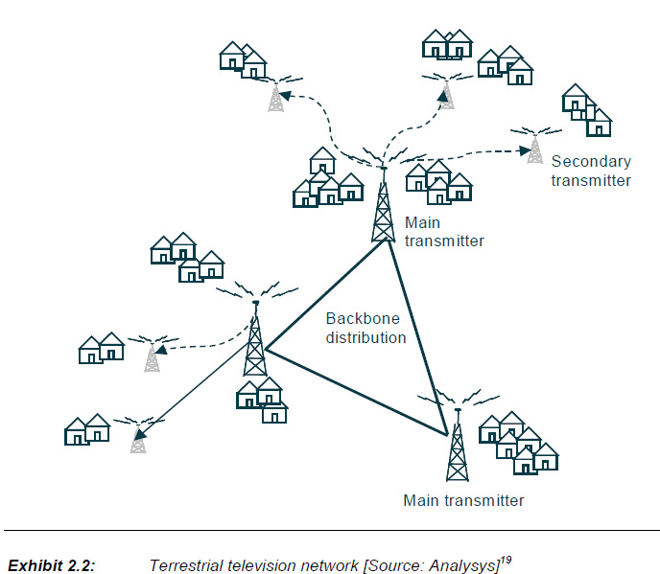
Limited effect of failure and they can vbe easily addressed
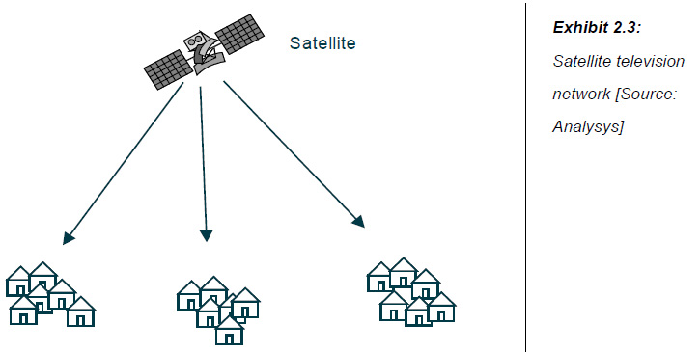

Satellite: Existence of single point of failure

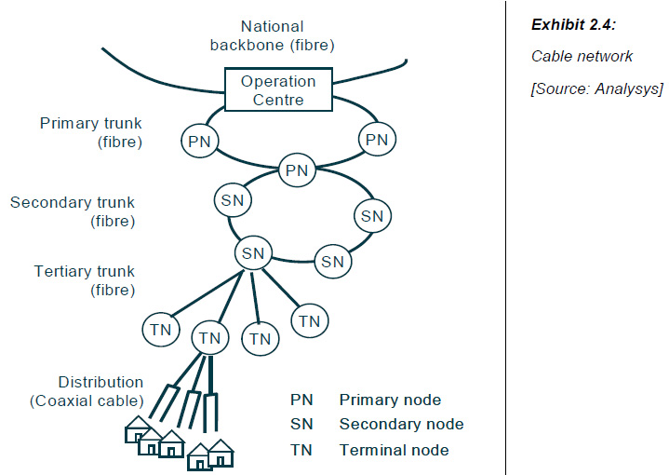
Cable network: hierarchy of rings together with interactivity

IP strengths: capacity and interactivity
Importance of VDSL2; fibre optic networks

Review, based on the previous slides

2.2 Quantitative comparison of platforms
General:
- An approach to economic analysis
- Cable and IPTV are not appropriate for providing USO
- DVB-S has the lowest transmission costs amongst all platforms
Roles affecting DTV:
- Current status of market
- Public policy objectives
Note: for broadcasters, transmission costs are a small % of costs; therefore if a selection of transmission platform has negative effects on audience levels, any transmission cost benefits maybe nullified.

2.2.1 Methodology

Three scenarios for DTT deployment
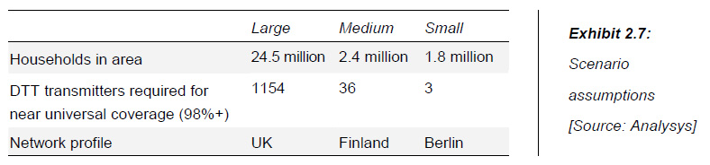

Difference of population distribution
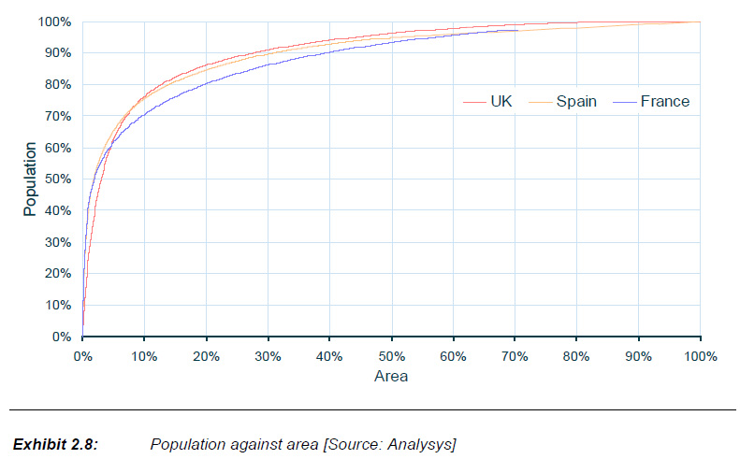
Apart from population, DCB-T depends on
- the country relief and
- the split between urban and rural populations

Note 1 Indicative 80% population coverage UK 80 transmitters, Spain 147 transmitters
Note 2 Cost of larger no of transmitters is reduced due to use of incremental transmitters.

Other assumptions for DVB-T
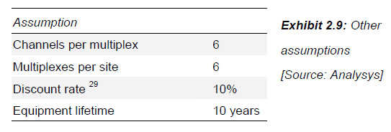

Key assumptions for DVB-S, cable and IPTV:
- the DTH transmission cost analysis is based on benchmarks of the current cost of satellite transponders
- cable transmission costs are based on benchmarks of the capital expenses incurred by European cable operators (per household passed)
- IPTV transmission costs are based on the costs of the equipment required to deliver the service.

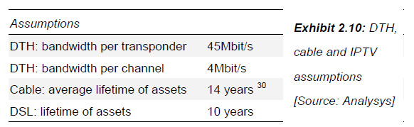

2.2.2 Results of economic analysis
Scenario 1: small country/region
Scenario 2: medium country/region
Scenario 3: large country/region

Scenario 1 small country region (full coverage)
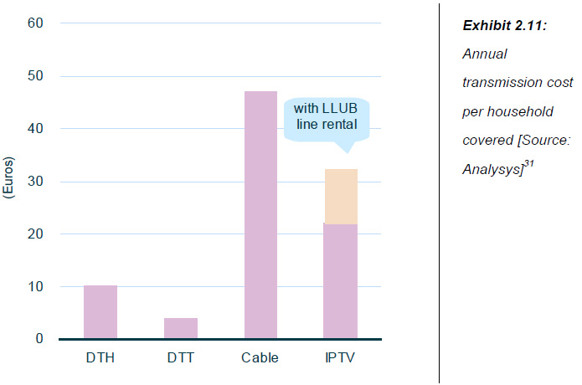
Annual transmission cost per household covered.

Note: extra additional cost for IPTV, if local loop line rental is included (not if the subscriber has already broadband connection!)

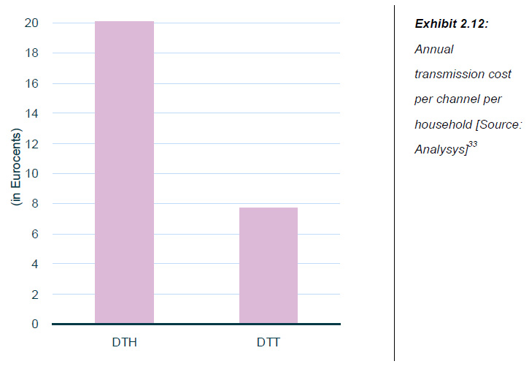
Comparison of DVB-S and DVB-T cost per channel
Note: If the country is not flat the cost of DVB-T (DTT) becomes higher

Scenario 2: Medium size country
In this case the different levels of population coverage are addressed
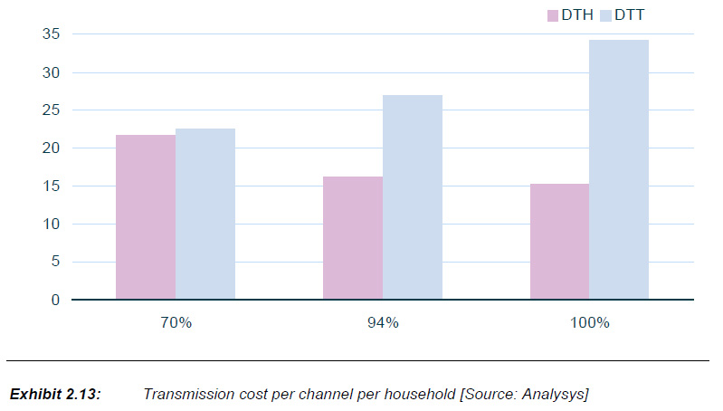

It is clear an increase in DVB-T compared with DVB-S as population coverage increases (per channel, per household)
IPTV and Cable are not comparable for large countries, since they area significantly higher on a per household basis.
Scenario 3: large country
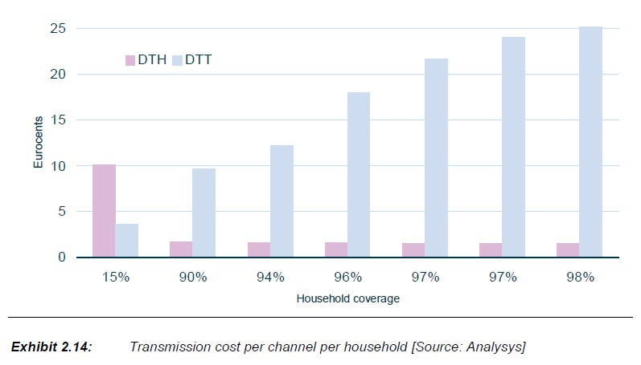
15% coverage by a single transmitter in the UK!
DVB-S is cheaper for large areas of coverage; however DVB-T can be driven by legacy issues, not by pure economics!

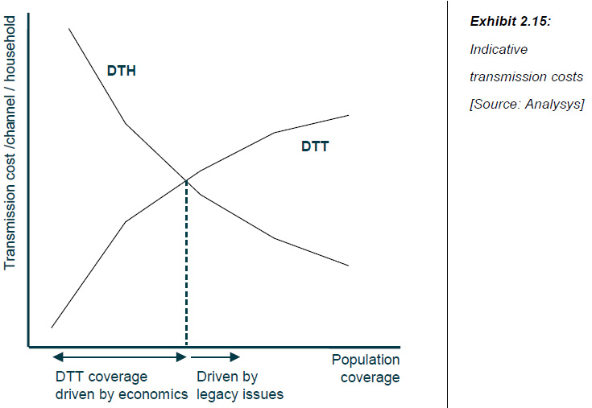

Please note that for large countries a hybrid coverage scenario (terrestrial and Satellite) might be cheaper:
Considering this case does however narrow the difference between DTH and DTT, especially for medium countries (where fewer rural transmitters are required), as shown below: the chart compares the annual transmission costs under three scenarios:
- considering full DTT coverage costs
- considering the DTT costs for an increase in coverage from 70% to 100%
- considering the costs of an alternative platform (DTH).
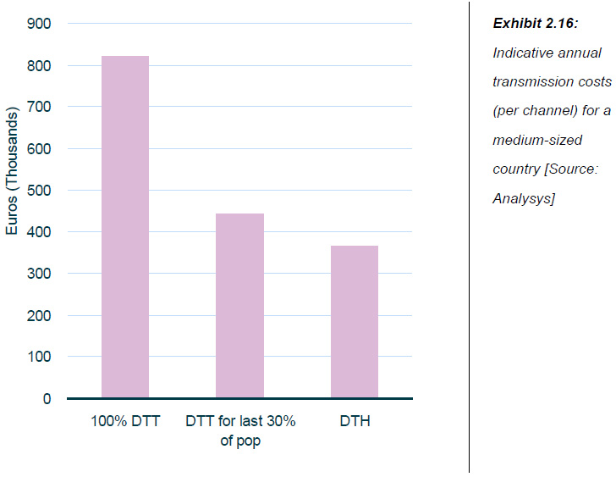

Exhibit 2.17 below compares the annual transmission costs under the following scenarios:
- providing 98% DTT coverage
- the DTT costs for an increase in coverage from 90% to 98%
- use of an alternative platform (DTH).
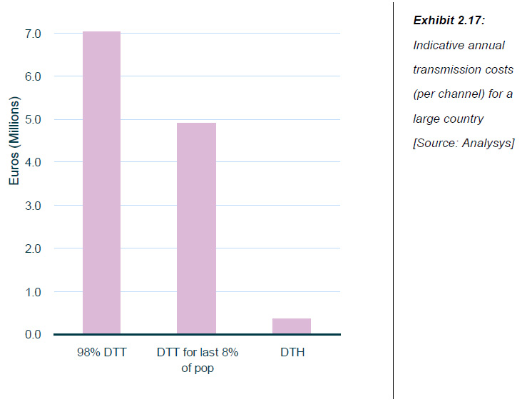
Assumption is made that up to 90% will be voluntarily provided by the broadcasters.

2.3 Implications for public policy

Conclusions

- DTT enables the broadcast of local content (including local advertising), a factor of significant importance in many European countries
- DTT provides greater robustness than DTH: the risk of a catastrophic satellite failure needs to be addressed where DTH is the primary means of providing television services39
- Delivery of FTA content via DTH may result in content rights issues though encryption may address this40
- DTH reception is likely to be less than 100%, as steep cliffs and high buildings create shadow areas. Reception in these areas is much more difficult with DTH than DTT41
- In some European countries, much value is being placed upon portable and indoor television reception enabled by DTT, which is not easily possible via DTH.

Suggestions
- From the perspective of policymakers in countries with a high terrestrial dependence, a rapid shift towards alternative platforms (for example, DTH) may be considered risky.
- Where fixed telephony penetration is significant, focus on the fixed telephony infrastructure instead of DTT will enable higher quality interactive services. Wireline platforms are more appropriate for ICT development.
3 Comparison of Digital Television Platforms

General
Covers the following issues:
- Looking for the correlation, if any, between DTT business model and DTT take-up.
- Key factors for DTT platform success

3.1 DTT business models
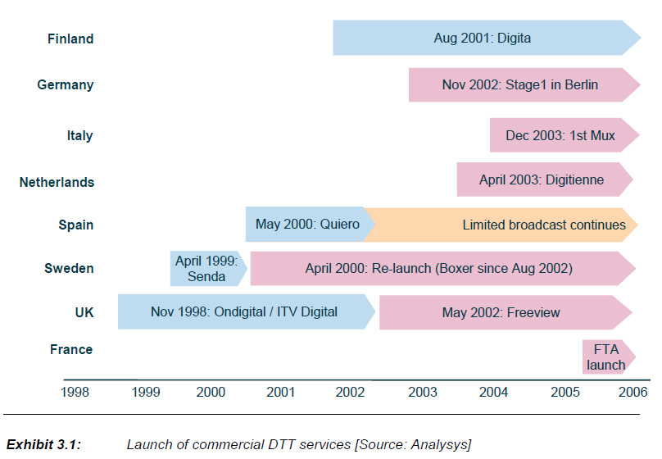
First DTT launches in European countries

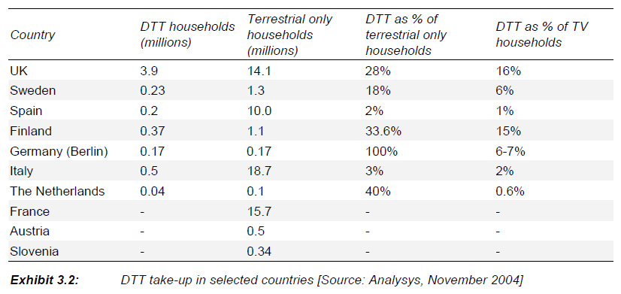
Introduction and acceptance of DTT (DVB-T) services by 2004.

Three business models have emerged for DVB-T

- Pay-TV platform – DTT multiplexes used to develop a premium content offering in direct competition with cable and satellite platforms and primarily financed by subscription revenues. This was the original business model in the UK, Spain and Sweden. A DTT Pay-TV platform also exists in the Netherlands, though it does not compete directly against premium pay offerings.
- FTA platform – DTT multiplexes used to offer a variety of free-to-air (FTA) channels, financed either by public funds (in the case of public service broadcasters) or advertising revenues. This was the original business model in Italy, Finland and Germany, and has been the business model in the UK since May 2002.
- Hybrid DTT – An offering combining a number of FTA channels supported by public funds or advertising revenues, together with a limited pay offering. Migration to a hybrid DTT model has taken place in the UK, Sweden and Finland.

Most Pay-TV models have not succeeded
UK fro Pay-TV changed to FTA
ITV Digital (UK) and Quierro (ES) collapsed as Pay-TV platforms
Sweden changed its model to include FTA after limited subscriber growth

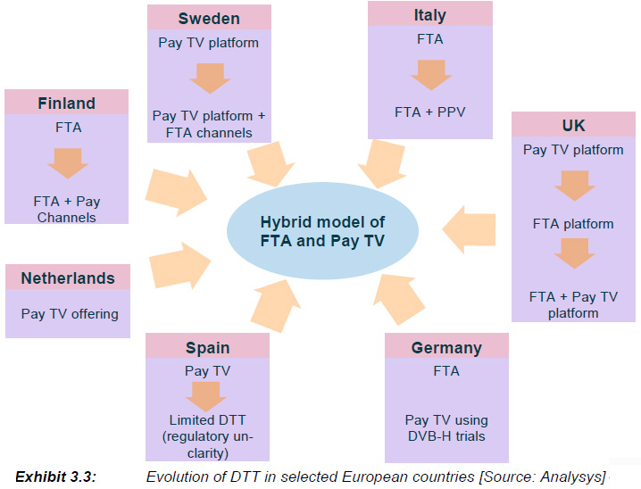

Note Format of Pay-TV varies between countries

FTA has been key to take-up with a migration to a hybrid model now taking place.

3.2 Key lessons and reasons for DTT success
Key lessons

Common factors for DTT development have been identified :
- attractive offering – the DTT platform should provide viewers with tangible benefits at an affordable cost. What is considered as an attractive offering will depend on market conditions and varies between countries (see below) 52
- cheap set-top-boxes (STBs) – low cost and widely available STBs are required. This condition is dependent on market factors including the DTT business model adopted, availability of subsidies and technology developments. Recent price falls mean that in many countries the requirement of cheap STBs has been met
- strong communication – experience from various countries has demonstrated the importance of strong market communication. However, clear market communication is only possible where a clear and stable regulatory regime exists
- co-operation – a variety of different organisations have a stake in the future of DTT: the success of DTT requires co-operation between key stakeholders.

- Attractiveness of offering depends on market situation
  - content – offered content (including interactive content) that is not already available at the same price, both in quantity and quality
  - technology improvements – better sound and picture quality, portable indoor reception, etc
  - cost – total cost of the platform, including subscription charges and one-off costs (for example, the STB).

- Multi-channel has been a key attraction even though viewing is dominated by the simulcast channels
- Technology can be a differentiator for DTT in some cases but success of interactivity to date has been mixed
- Some correlation exists between digital television and wide screen TV take-up
- Cheap STBs have contributed to DVB-T growth
- Variety in STB types is driven by business models, policy decisions and technology convergence
- Take-up of advanced STBs is limited unless specific driver
- Market communication is important and stakeholder co-operation is essential
- This requires a DTT enabler
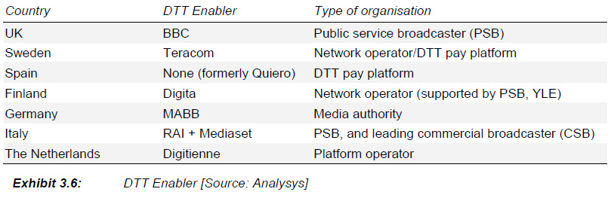
- Policy makers need to incentivise incumbent broadcasters DTT and commercial broadcasters as well
- Appropriate incentives depend on the market situation
- The policy environment needs to respond to market conditions
- The same objective can be achieved by different means
- A holistic approach is more likely to balance the various goals

3.3 Key technical issues
- Technology issues have been generally successfully addressed
- Planning assumptions were not sufficiently proved, and this led to unsatisfactory coverage accentuated by the network planning approach adopted and other implementation issues have arisen
- Poor receiver installations affected the marketing of DTT as a ‘plug and play’ offering
- STB problems have also affected DTT viewing
- The ‘cliff effect’ is more difficult to address
- Mobile DTT commercial deployments are still far, despite several trials taking place

Digital switchover issues
- The UK has opted for full DTT coverage using a regional rollout
- Berlin has shown that regional switchover is feasible though other regions may provide greater challenges
- The analogue switch-off may require controversial intervention

4 Regulatory Context for Digital Television
General
Aim: Right balance between incentive and obligations in order to make DVB-T a success
Initial approaches:
- Based on pay-TV model (unsuccessful)
- Imposition of high-coverage obligations on commercial broadcasters
- Imposition of technical specifications leading to expensive STBs
At next level regulatory developments improved:
- In most countries, either the choice of business model has been left to industry or an FTA business model has been chosen by policymakers.
- Although policymakers widely continue to expect widespread DTT coverage of the PSB channels, coverage obligations for commercial broadcasters have typically been softened or lifted altogether.
- Furthermore, despite strong continuing interest in developing interactive services and the MHP standard, with a few exceptions policymakers do not plan to impose specific services or standards on the market.
Exceptions to general trends exist:
- France imposes a business model combining FTA with Pay-TV
- South and East European countries (Italy) expect DVB-T to contribute to ICT (hence subsidies)
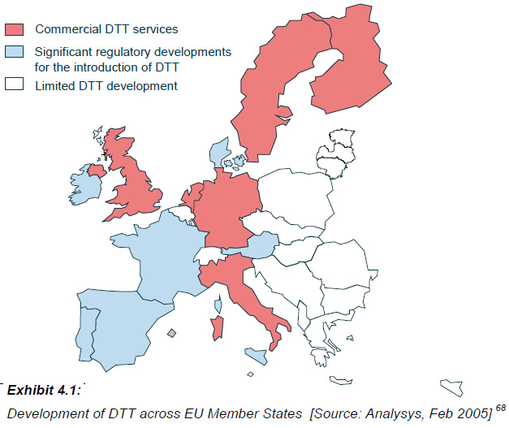
Europe outline by 2004

4.1 Public objectives and perceived benefits of DTT
Spectrum efficiency and Pluralism are common policy objectives
Interactivity and better service quality are key perceived benefits
Significant policy differences exist, grouped into the three following categories
- Competition between platforms
- ICT development
- Public control
Switching costs for consumers is the primary disadvantage of DVB-T

4.2 Influence of analogue terrestrial on DTT policymaking
Analogue PSB terrestrial has typically been considered a universal service and many States have the same approach towards DTT though some exceptions exist
Italy and France have not fully addressed how to get universal DTV coverage
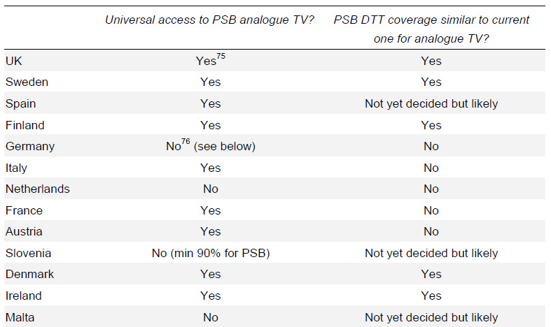

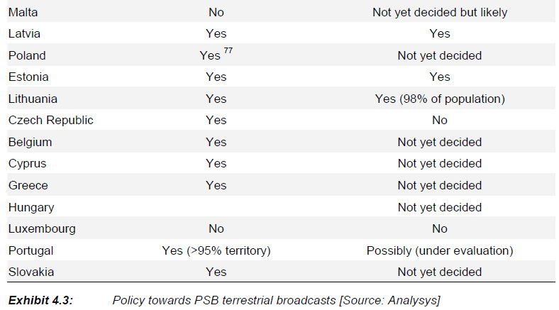
4.3 The licensing regime
In DBV-T various licensing regimes exist that complicate the usually clear distinction between a broadcast license (content related) and the granting of the right to radio frequency use:

- In the UK, different types of organisations (broadcasters, network operators, etc.) are assigned multiplexes (frequencies). Broadcasters may then obtain separate content licences from Ofcom. In this case, a clear separation between content licence and frequency rights may be maintained.
- In France, the CSA (regulator) selects individual channels via a beauty contest for inclusion in a specific DTT multiplex. An association of the broadcasters on each multiplex then selects the network operator. Thus, content licensing and assignment of frequency rights are intertwined in France.
- In other countries such as Italy or Spain, multiplexes (frequencies) have been assigned to individual broadcasters. Thus, content licensing and assignment of frequency rights are again intertwined.

Regulators and Ministries share licensing authority
Beauty contests are the dominant licensing process placing particular emphasis on the broadcaster viability and content pluralism
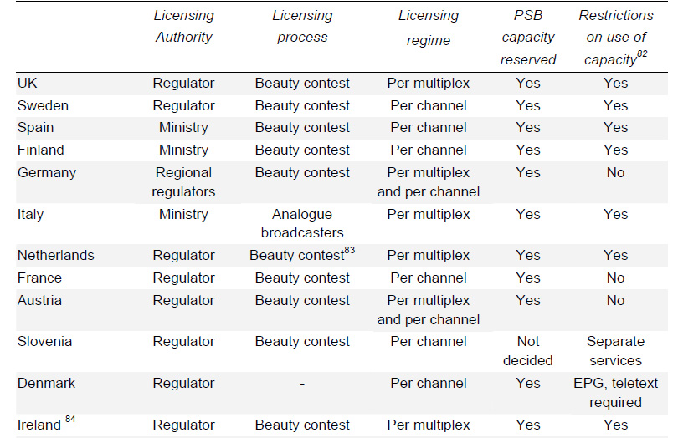

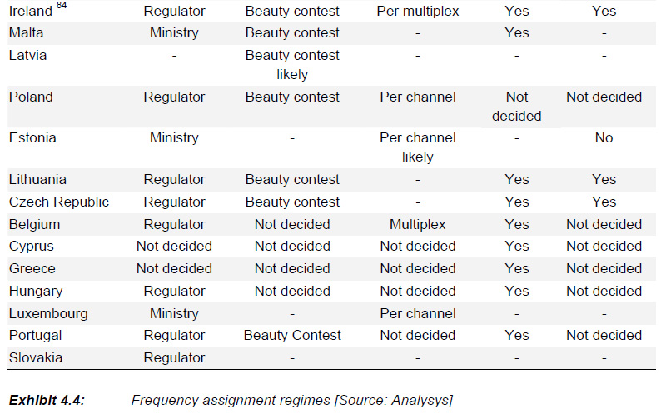
Per channel and per multiplex regimes are both common
Pluralism (content) is addressed via diverse measures and is aided by rules that imply multiple broadcasters:
- Licence commitments help ensure pluralism. In the UK, multiplex applications made commitments in terms of the content to be offered, and Ofcom refers back to these as part of licence conditions.
- Reserving DTT capacity for the PSB that has specific content obligations is seen as a means to ensure pluralism in some countries (such as the Netherlands, Sweden, etc.).
- Ownership rules help ensure broadcaster pluralism. In many countries (for example, the UK, Italy, etc.) there are limits on how many television licences a broadcaster can have. On the other hand, in some other countries such as Spain, the fact that more TV channels will be available in the DTT context is seen as a guarantee of greater pluralism.
- Specific rules, as those in Italy, that stipulate that at least 40% of a “commercial” multiplex should be used by third-party broadcasters.86
- General competition laws have also been highlighted as a means towards ensuring broadcaster pluralism.

Some restrictions on non-TV capacity are common
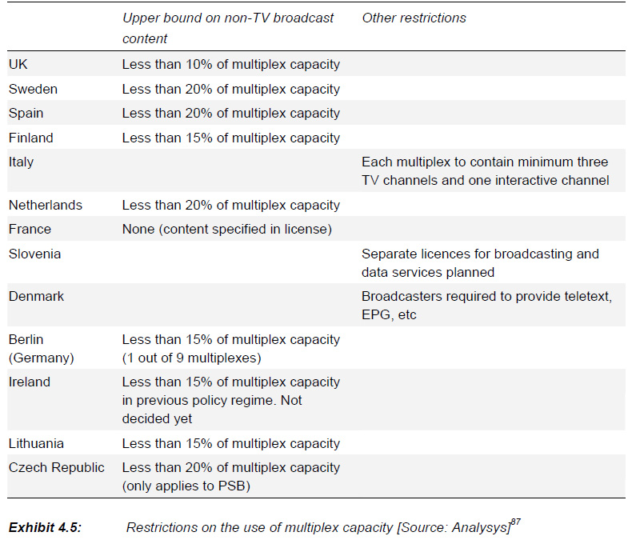

4.4 Public funding of DTT development
Public finances may also play a role in developing DTT with PSB funding drawn from a variety of sources:
- Funding of PSBs – Some Governments have taken measures that provide the PSBs with additional funds to be used to develop DTT. In many cases, this is a continuation of the role that the public administration has played in the analogue television arena.
- Funding of CSBs – In order to incentivise CSBs to contribute to DTT, some policymakers have decided to or are considering subsidising transition costs of CSBs
- Network operator – Some governments may contribute directly towards the roll-out costs of the network operator.
- Consumers – Adoption of DTT requires that viewers acquire a digital STB. In order to facilitate a migration to DTT, some Governments have or are considering subsidising to varying extents the costs of such STBs.

State funding of DTT can be controversial and limited transparency exists in the use of PSB funds
Public funds are planned to be raised from a variety of sources to develop DTT, with limited commonality between the different Member States:
- Higher license fees
- Network sale
- Government budget
Use of public funds for CSB subsidies is more controversial
- EC’s decision on the use of public funds is key and will directly impact the DTT policies in Germany and Austria
- An EC ruling against CSB subsidies could place an upper bound on DTT coverage

Widespread concern about STB costs are leading to various measures
This ranges from
- subsidising MHP compatible STBs sold as in Italy to
- only subsidising STB take-up by specific segments of the population.

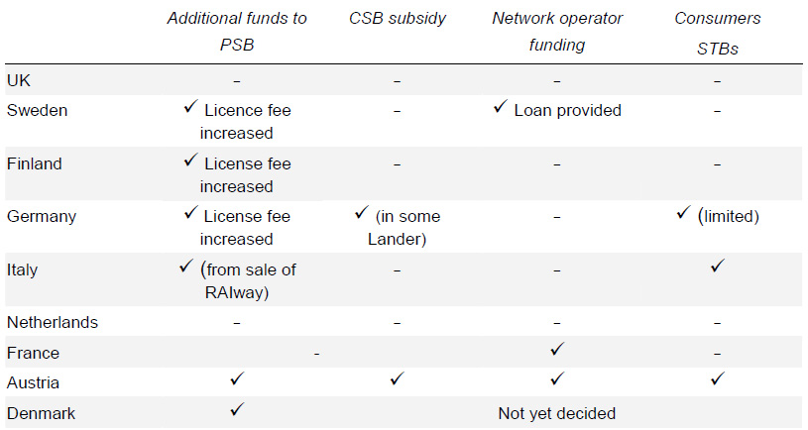

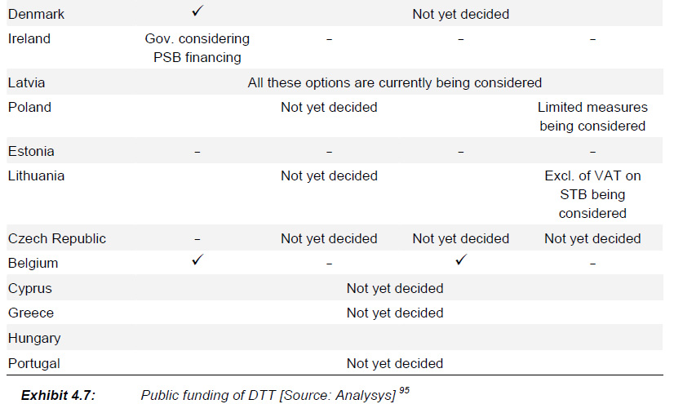
4.5 Other public measures to promote DTT

- Spectrum/Concession Fees – In some countries such as the UK, no charge is made for the DTT spectrum.
- ‘Must carry’ on cable – In France, FTA DTT channels have a ‘must-carry’ right on cable for five years
- Funding of trials and applications – In some countries including Belgium, Luxembourg, Spain102 and Slovakia, public funds contribute towards the funding of DTT trials

Notion of must carry TV program
In the mid to late 1970s, the Canadian Radio-television and Telecommunications Commission (CRTC) implemented a rule that a cable system must carry a terrestrial TV channel at no cost to the terrestrial broadcaster. Things are changing in the digital world and this issue is now challenged by Terrestrial TV channels asking compensation.

4.6 Role of public service and commercial broadcasters
PSBs widely have reserved DTT channels or multiplexes
This is partly due to their ability to lead DTT development and in some cases is driven by the desire to promote the local culture
PSB key roles have been in providing content and promoting DTT
PSBs’ contribution is driven by several factors Principally:
- Public service – DTT may enable PSBs to better meet their public service obligations by using the additional broadcasting capacity to cover a variety of interests.
- Maintain audience share –DTT enables PSBs to maintain share of audience in face of cable and satellite competition (where PSBs are given significant DTT capacity).
- Digital vision/deploy leading technology – Some PSBs aim to play a major role in developing digital television and deploying leading technology in their country.
- Other reasons cited include delivery of better quality services and cost savings (DTT transmission is typically cheaper than analogue transmission on a per channel basis).
Some CSBs also actively participate in DTT driven by a variety of incentives
However, others are less likely to participate The following reasons have been identified:
- High cable and satellite penetration – In countries where alternative platforms have high penetrations, limited commercial incentive exists for CSBs to invest in a terrestrial network. This is particularly the case for low density areas such as some Landers in Germany.
- Participation in DTT competing platform – In France, some of the analogue terrestrial CSBs belong to the same organisation as the DTH pay-TV services. These broadcasters do not form part of the organisation created to promote DTT in France, TNT
- Limited resources – In countries such as Estonia and Slovenia, the analogue terrestrial CSBs are relatively small with limited financial resources to contribute to DTT development.

5 New Digital Television Technologies
5.1 HDTV
5.2 DVB-H
5.3 AVC
5.4 DVB-T2
6 Community Law and DTT Development
General
Existing legislation includes three main areas:
- specific media legislation,
- various directives in the field of electronics communications, and
- competition law,
6.1 Impact of existing legislation affecting DTT
At the Community level, basic legislation affecting DTT may be split into three groups:
- media regulation – principally, the Television without Frontiers Directive
- electronic communications – the Electronic Communications Framework Directive, associated directives and the Radio Spectrum Decision regulate transmission facilities and radio spectrum
- competition law – all areas of competition law impact DTT, including the Merger Control Regulation, Antitrust (Articles 81 and 82 EU Treaty), standards for services of general interest (Article 86 and state aid review (Article 87).
6.1.1 Media Regulation
The Television without Frontier Directive is the centrepiece of media regulation
- access rights to events of general public interest (‘events of major importance for society’)
- measures to promote the production and dissemination of European and independently produced television programmes
- consumer protection as regards advertising, sponsorship and teleshopping, including unfair commercial practices
- protection of minors and public order, and
- the right of reply.
Basic policy since 1999: ‘services providing audiovisual content should be regulated according to their nature and not according to their means of delivery’
Future media and electronic communications regulation must be consistent, avoiding gaps or inconsistencies between the regulation of broadcasting versus information society services (i.e. Video on Demand and the Electronic Commerce Directive).

6.1.2 Electronic communication Regulation
Related directives:
- Framework Directive (2002/21/EC) on a common regulatory framework for electronic communications networks and services
- Access
- Universal service
- Local loop unbundling (LLU)
- Libalisation/competition
- Data protection
- Regulatory framework for radio spectrum

6.1.3 Competition Rules

Numerous well-defined competition instruments exist that might apply to digital television
For DTT, state aid may be the most relevant competition issue
Criteria for determining state aid are clearly established; the Commission must assess whether they:
- are granted by the State or through state resources
- are capable of distorting competition by favouring certain undertakings or the production of certain goods, and
- affect trade between Member States.

State aid rules may be applied beyond direct funding of broadcasters and subsidies may take many other forms
It should be noted that decoder subsidies, when applicable to all of the digital television platforms, would normally not distort competition between technologies

6.2 General Interest Objectives
Any rulings and State Aid must be justified by reference to General Interest Objectives; therefore:
1 need for assessment of General Interest Objectives and
2. their relation to DVB-T networks and services
General Interest Objectives permits policy intervention in markets
Areas of DVB-T falling into General Interest Objectives
- Public service broadcasting as well as some commercial broadcasts
- Content in public interest requires widespread distribution, that may justify intervention to an extend (Member States define what is in the public interest)
- Digital switchover is also in the general interest
- Spectrum reservation is in general interest
- Important role of the Commission

