University of Athens
Postgraduate course: DIGITAL TELEVISION
Instructor: Dr. Nicholas Desypris

4th lecture :
Digital Television: set of standards
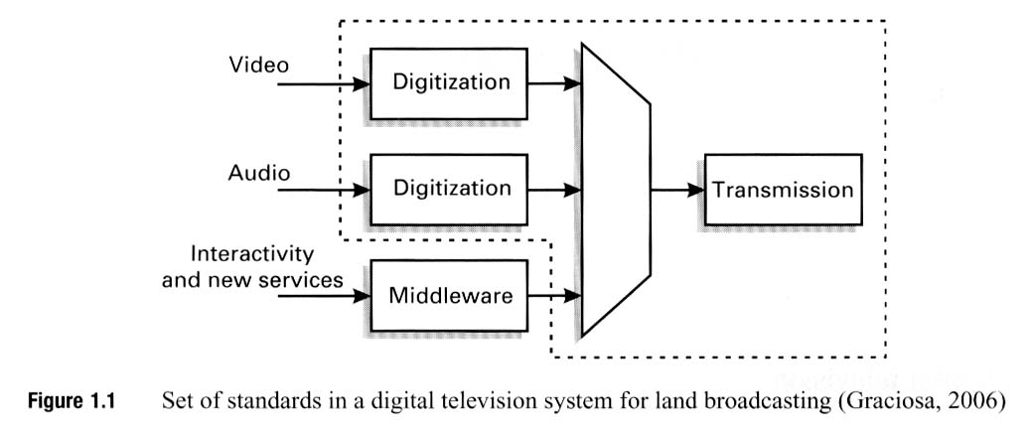
Comparison of aspect ratios
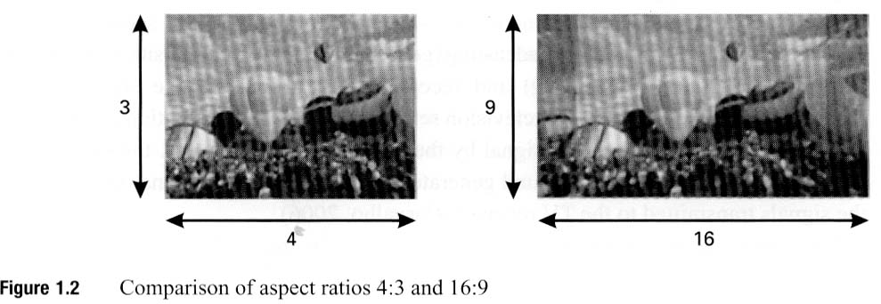

Popular DTV systems
HDTV:
750 lines/picture,
60 pictures /second
Progressive scanning 60 fields / second
720 active lines / picture (720p)

HDTV:
1125 lines/picture,
30 pictures /second
alternate scanning 60 fields / second (interlaced)
1080 active lines / picture (1080i)

SDTV:
640 pixels/ line,
60 pictures / second (interlaced)
480 active lines / picture

Roughly 4 SDTV channels -> 1 HDTV channel (720p)

Other digital TV standards

EDTV:
16:9 aspect ratio
640 pixels/ line,
60 pictures / second (progressive)
480 active lines / picture

LDTV:
320 pixels/ line,
60 pictures / second (progressive)
240 active lines / picture

Popular DTV systems
Name | lines / picture | pictures/ second | Scanning | lines/picture (active) | Aspect Ratio
HDTV | 750 | 60 | 60 fields/sec – progressive | 720p
HDTV | 1125 | 30 | 60 fields/sec – interlaced | 1080i
SDTV | 640 | 60 | 60 fields/sec – interlaced | 480
Other digital TV standards
EDTV | 640 | 60 | 60 fields/sec – interlaced | 480 | 16:9
LDTV | 320 | 60 | 60 fields/sec – interlaced | 240

The digital programming platform
Structure of middleware
- Resources
- Middleware
- API
  - Audio and video streams
  - Commands or events
  - Records and files
  - H/w resources
- Applications (interactive services)

Interactive services
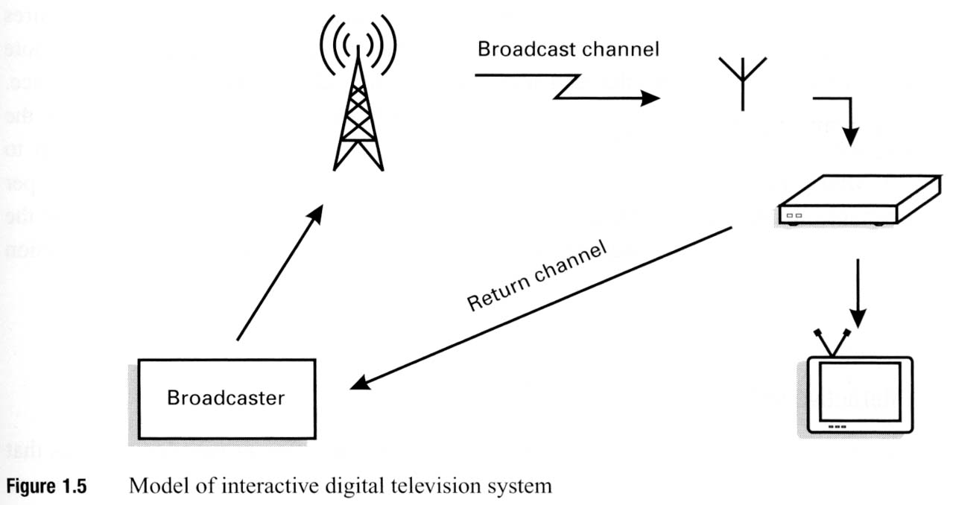
Two types of interactivity
- Local interactivity
- Provision of an interactive channel through out the broadcasting network

Interactive services
- Electronic programming guide (EPG)
- Enhanced TV (interaction of the user with the station though the digital television set itself!)
- Individualised TV (level of interactivity similar to that of a DVD player: set cameras, sound and subtitles at will)
- Internet TV (accessing internet on TV)
- Video on Demand (VoD) (different to EPG: the user searches a database of films, sees when they are on, when and on which channel)
- Commercials (similar application to shopping channels – not in Greece)
- Purchase of MP3 files, films or educational products to be downloaded from the supplier after purchase

Other services
- Monoprogramming: showing of one program on an exclusively designated frequency (often used for the transmission of HDTV)
- Multiprogramming: many programs on an exclusively designated frequency (between 4 and 6 SDTV channels on one frequency)
- Mobility, portability: reception of television signals in different movement conditions on TV sets on vehicles or TV receivers integrated in cell phones or palmtops.
- Multiservices: several broadcasting and telecom services simultaneously on the same digital TV platform.

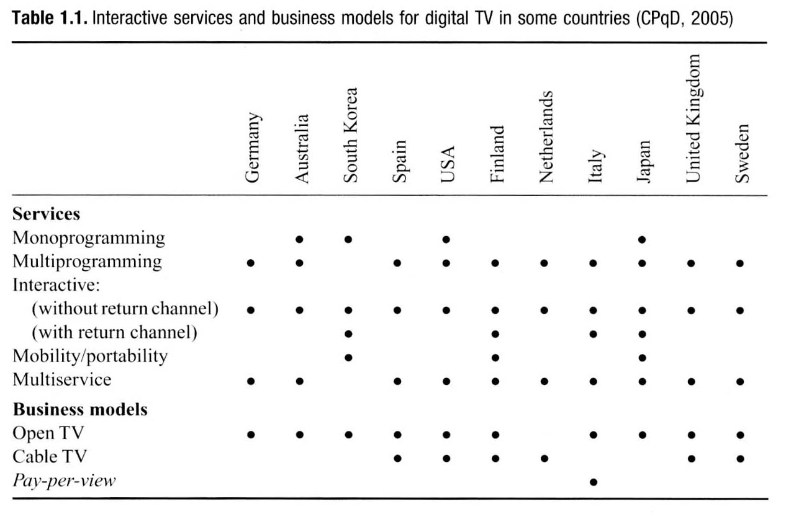
Return channel
South Korea: ADSL technology
Finland: Shared land telephone system
Italy: Shared land telephone system
Japan: ADSL technology
Recommended return channel in Brasil: using IEEE WiMax technology

Note in the UK the return channel never reached the critical number of households for successful commercial exploitation

Standards options for digital Television

Five main digital television systems in the world:
- American Advanced television Systems Committee (ATSC)
- European Digital Video Broadcasting Terrestrial (DVB-T)
- Japanese Integrated Services Digital Broadcasting Terrestrial (ISDB-T)
- Brazilian International Standard for Digital Television (ISDTV or ISDTV-Tb)
- Chinese Standard for Digital Television (DTMB)

Note: Two standards exist for hand held devices:
- Digital Video Broadcasting Handsets (DTV-H) and
- Digital Multimedia broadcasting (DMB), with twice the transmission rate of DTV-H

System similarities:
- They are using the same frequency band
- Improve vertical and horizontal resolutions
- Present an aspect ratio of 16:9
- Support multichannel sound
- Support data transmission

Main difference is the modulation technique used to broadcast the signal:
- Single carrier modulation
- Multiple carrier modulation
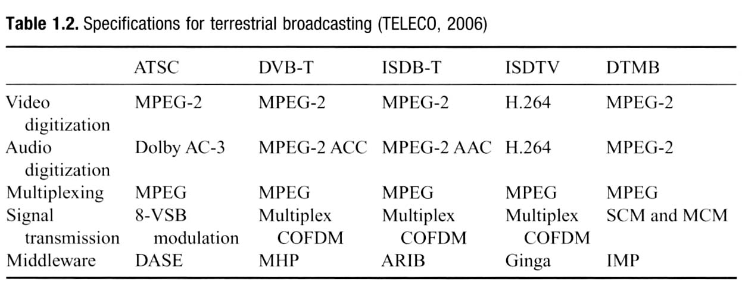

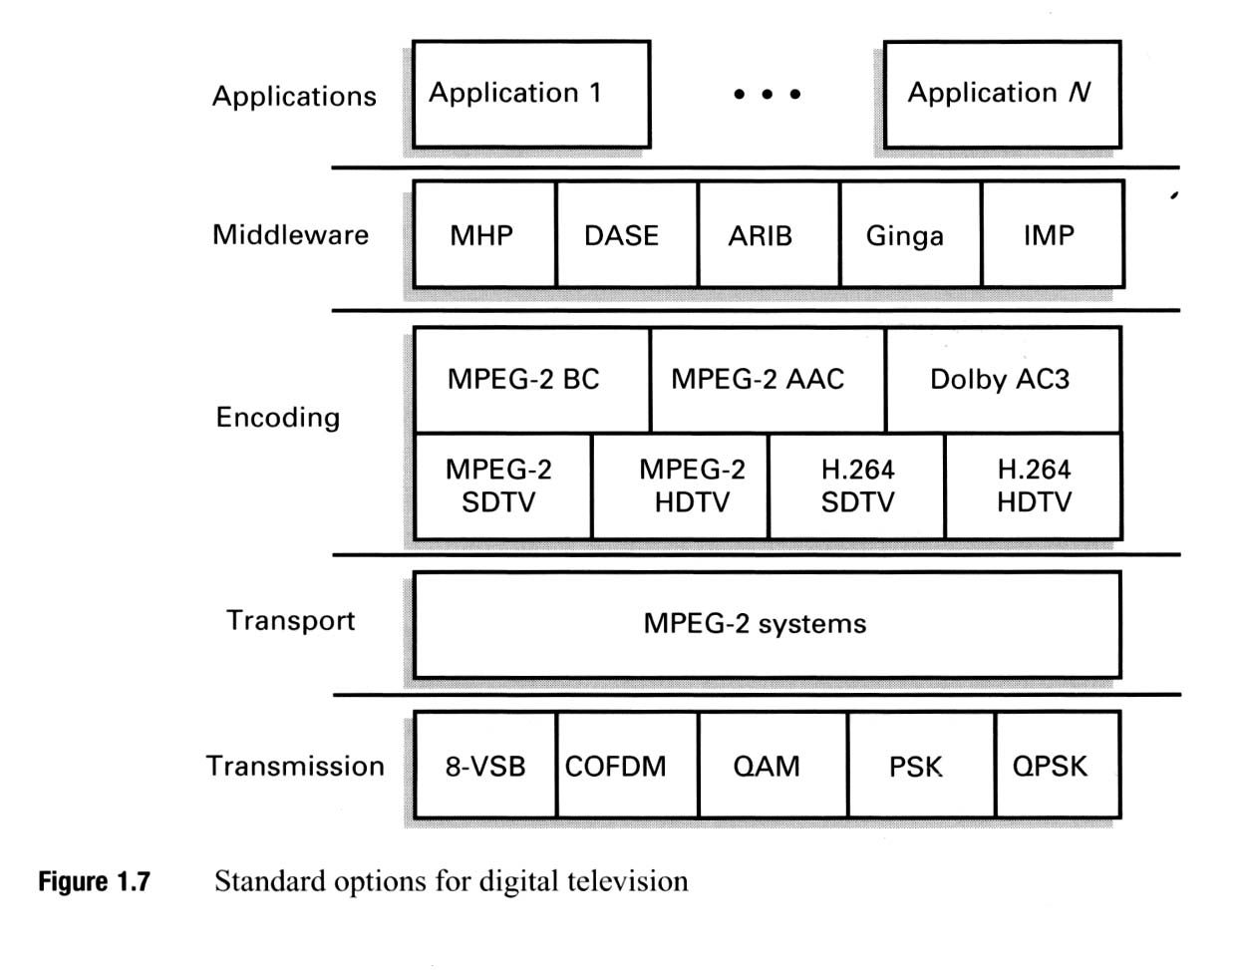

Middleware standards:
ATSC, US: DASE – DTV applications software environment
ISDB-T, Japan: ARIB – Association of Radio Industries and Business
ISDTV, Brasil: Ginga
BVB-T, Europe: MHP – Multimedia Home Platform
DTMB, China: IMP – Interactive Media Platform

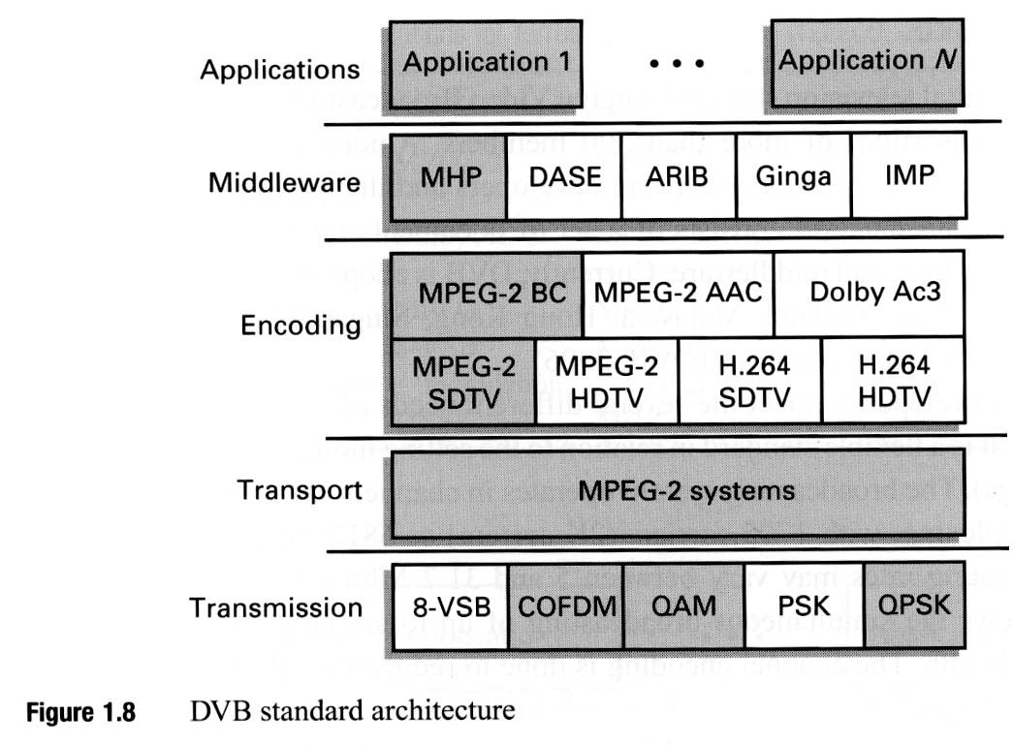
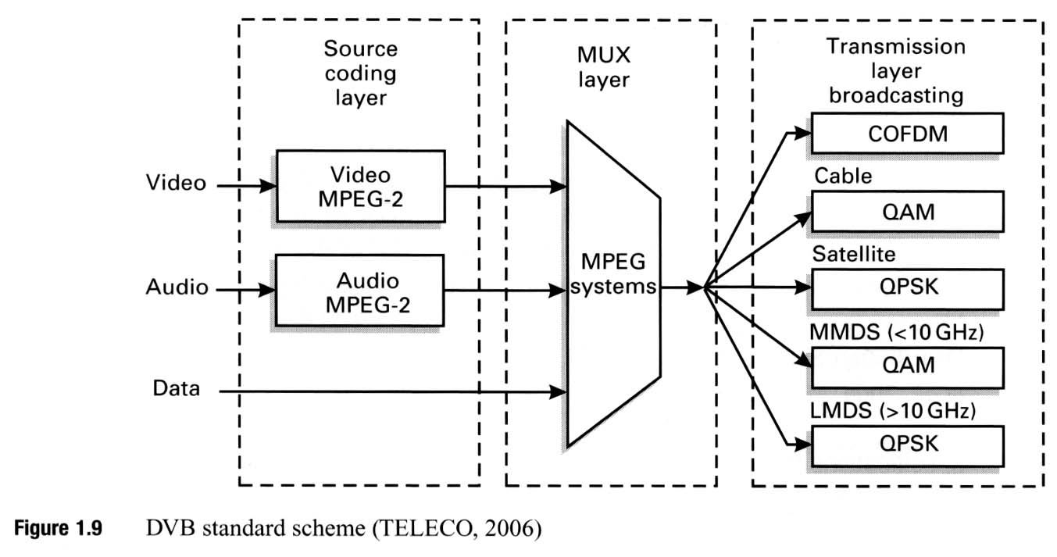

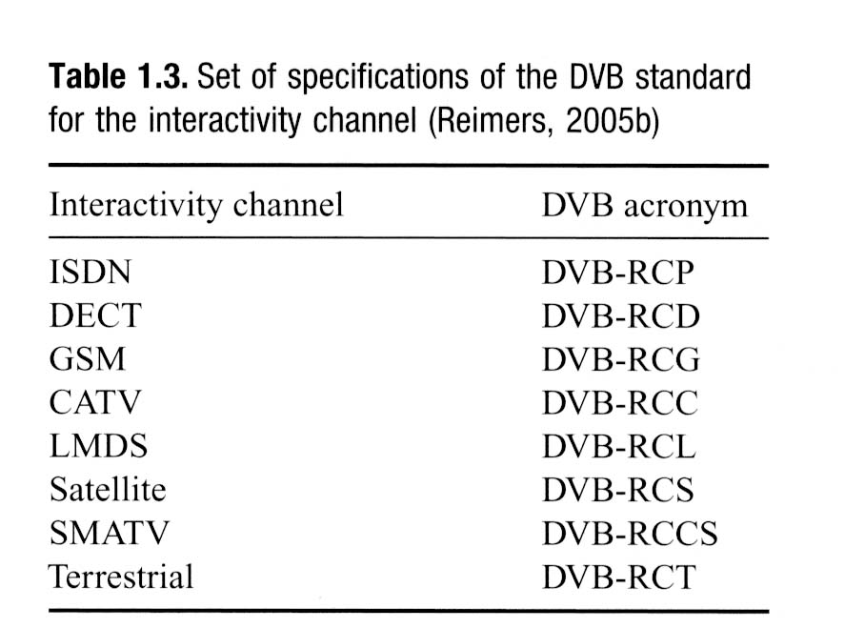

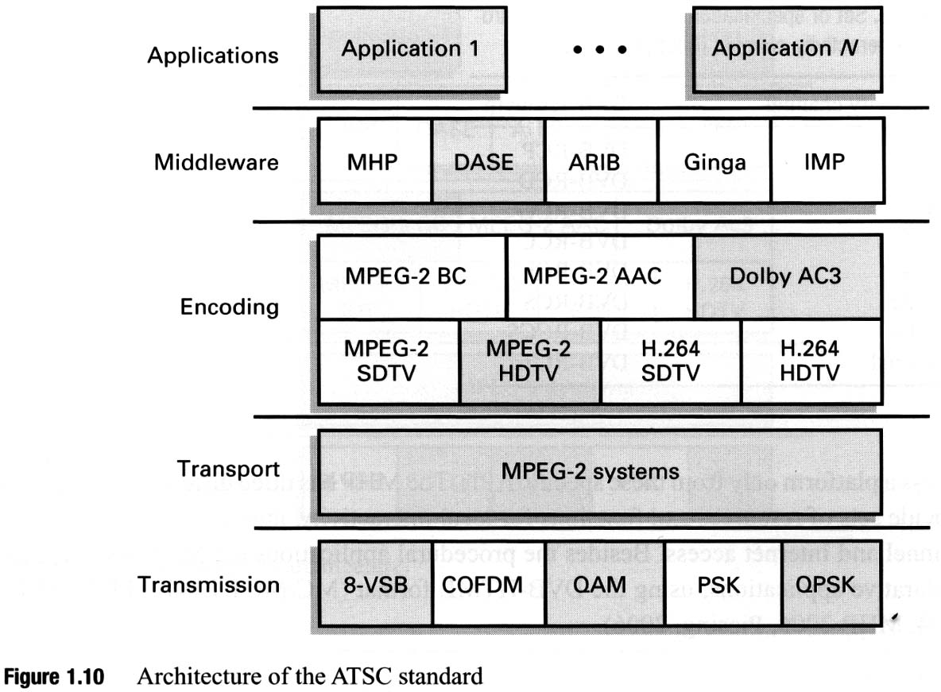

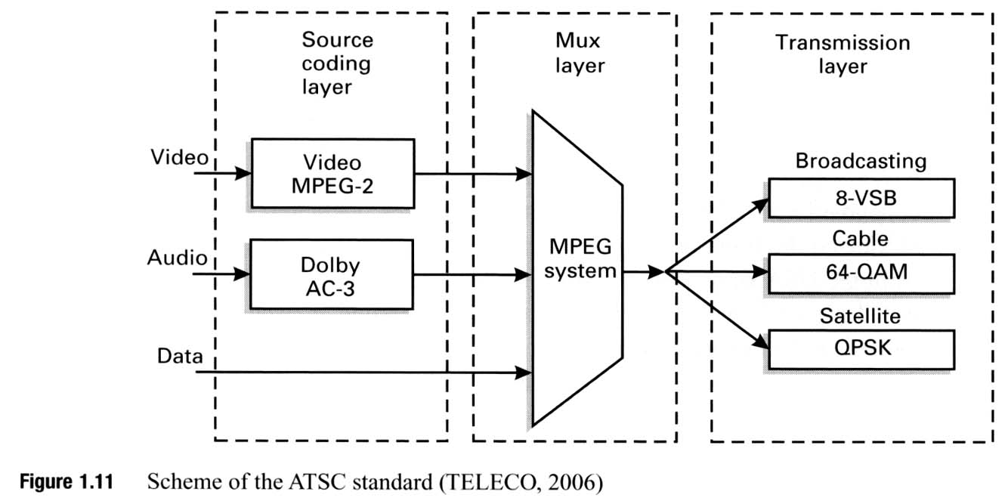
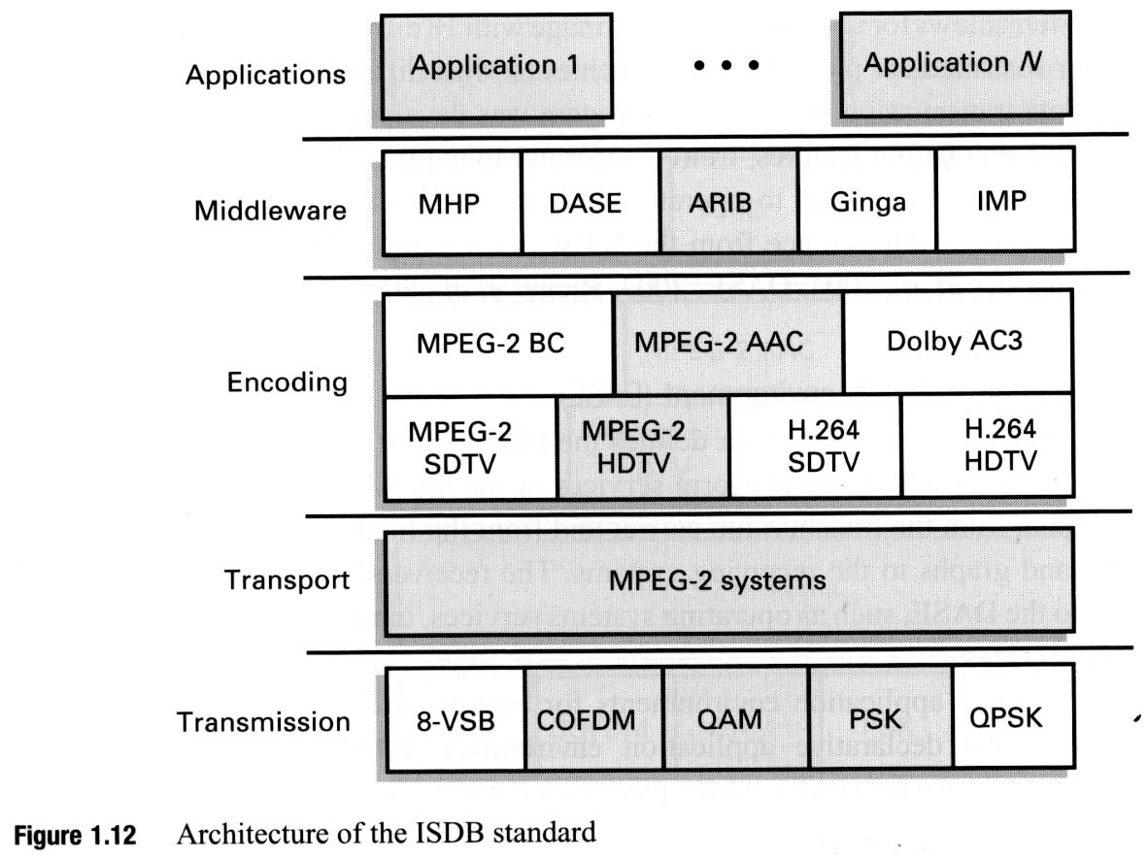

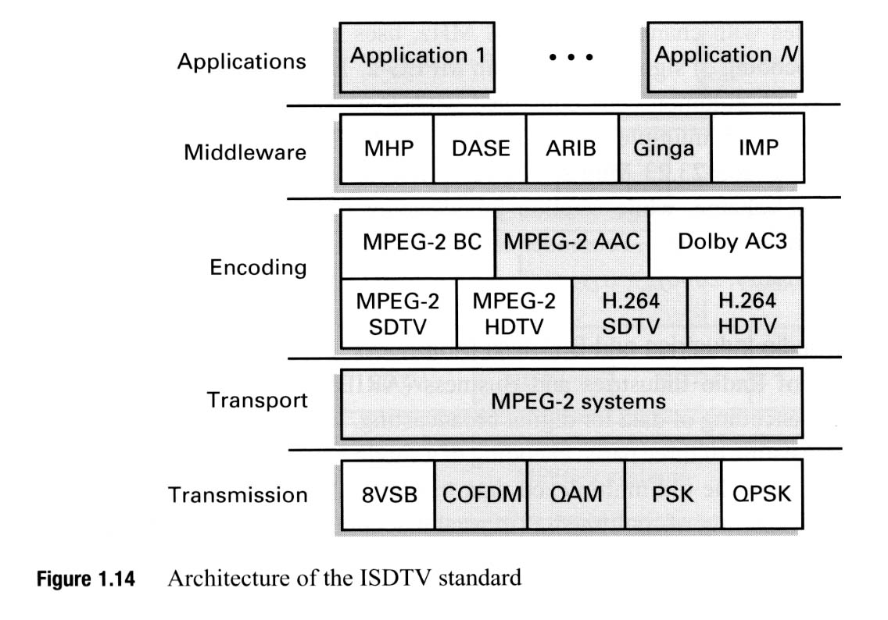

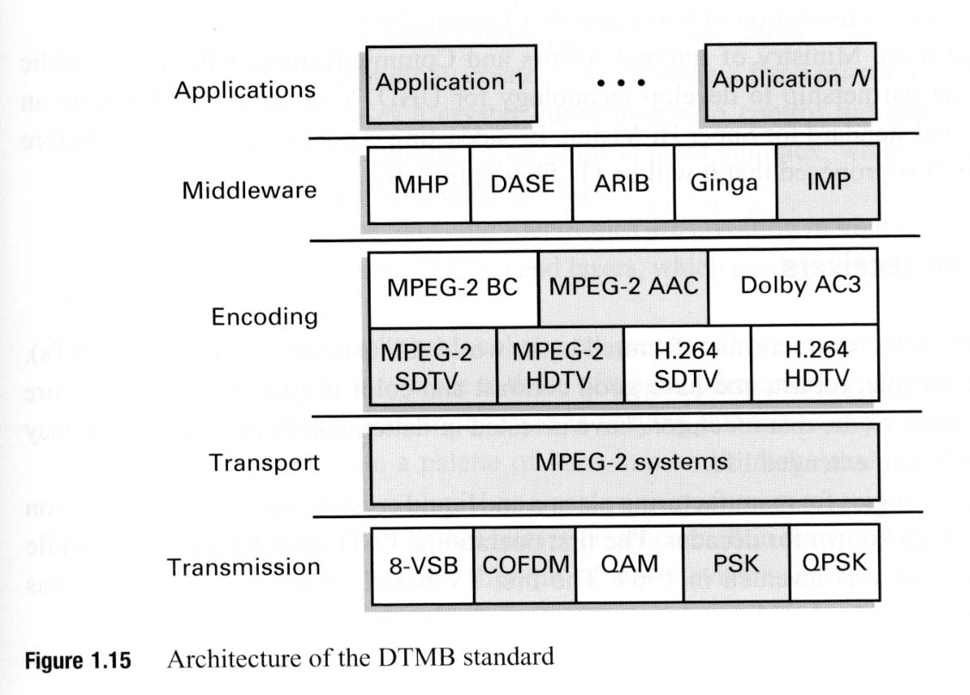

Television receivers
LCD displays (depends on the source of light positioned behind the screen)
LED displays (or plasma displays: emit light directly from LEDs)
LED-backlit LCD TVs (the light positioned behind the screen is LED)
LED-backlit LCD TVs differ from conventional CCFL-backlit LCD TVs in the following:
- Produce images with greater dynamic contrast.
- With Edge-LED lighting they can be extremely slim. Models on the market can be approximately one inch thick.
- Offer a wider color gamut, especially when RGB-LED backlighting is used.
- Less environmental pollution on disposal.
- Higher price.
- Generally 20-30% lower power consumption

