University of Athens
Postgraduate course: DIGITAL TELEVISION
Instructor: Dr. Nicholas Desypris

3rd lecture :
Standards Bodies related to Broadcast Television field

International bodies
Former CCIR: International Radio Consultative Committee
Branch of ITU (International Telecommunications Union), part of the United Nations (UN) Organisation

ITU-R: Radiocommunications sector of ITU (new name of CCIR in 1993).
ITU-R Study Group 11 deals with Television and issues Recommendations and Reports, containing explicit information in reasonably general form (implementation variants are allowed). ITU-R documents related to broadcast television have the prefix BT

ITU-T: ITU Telecommunication Standardisation Sector, a permanent organ of ITU, responsible for studying technical, operating and tariff questions and issuing Recommendations aiming at developing world-wide standards on a world wide basis

ISO: International Organisation on Standardisation. ISO issues standards through its branches International Electrotechnical Commission (IEC), International Illumination Commission (CIE). ISO issues Publications containing detailed descriptions.
National bodies, members of ISO and IEC participate in the development of Standards though technical committees. ISO and IEC technical Committees collaborate and draft international standards that are circulating to national bodies for voting. Publication of an international standard requires at least 75% from national bodies

Regional level
EBU: European Broadcasting Union issues EBU Technical Documentations which are in fact obligatory for its members. EBU is the world’s largest professional association of national broadcasters. Founded in 1950, it merged with East – European International Radio and television Organisation (OIRT) and todayit has 74 active members, from 56 countries in and around Europe and 36 associate members around the world reaching an audience of 650 million weekly.
ETSI: European Telecommunications Standard Institute, an intergovernmental organisation issuing European Telecommunications Standards

Society of Motion Picture and Television Engineers (SMPTE) started activity in North America, but is now an international Organisation, linking broadcasters, manufacturers and academicians. Issues SMPTE Recommended Practice, SMPTE Standards and SMPTE Engineering Guidelines.

FCC: Federal Communications Commission, the national government agency of the US
The Video standards:
video = I see (in latin)
In this course when we are talking of video signals, we are referring to TV broadcast environment
Convergence: demands harmonisation of terminologies and technologies

Standard: Set of rule or characteristics defining a particular system or product. Some are mandatory but most, including TV signals are voluntary.

Broadcast Colour TV standards
Today we have three quite different colour TV standards:
NTSC (National television Standard Committee), PAL (Phase Alternating Lines) and SECAM (Sequence de Couleur a Memoire).
Broadcast standards not only define the video signal parameters, but many others such as those related to modulation. In reality they are not three, but many more although many have small differences.
Figures 1.2.1a, b, c
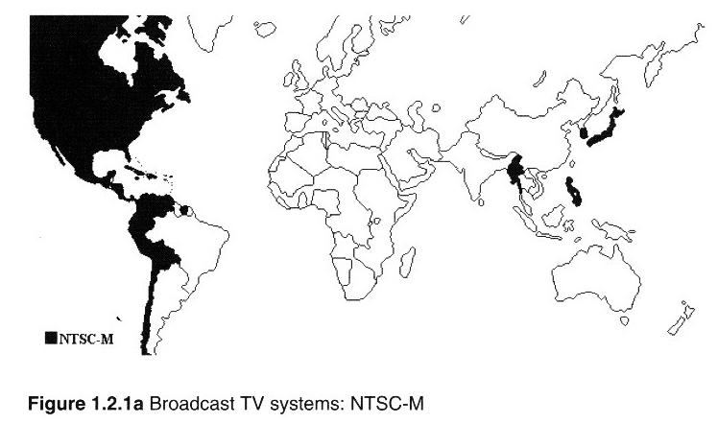
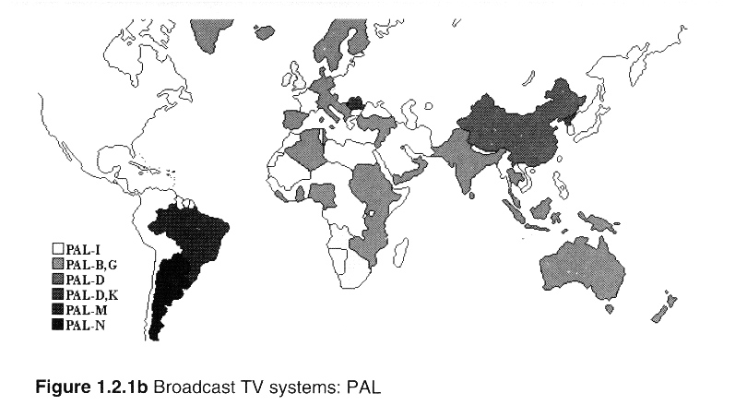
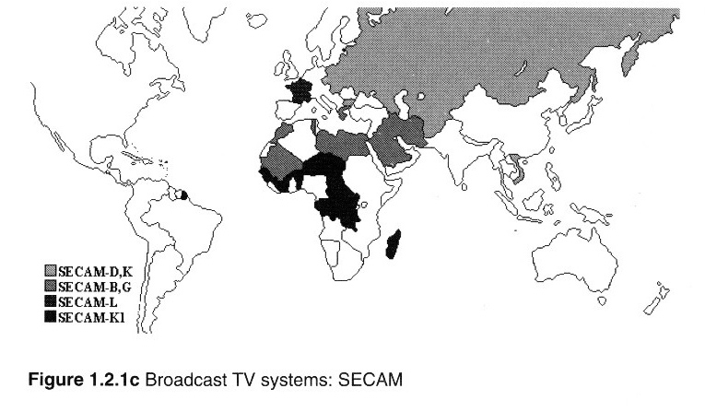

Table: Characteristics of radiated monochrome and colour signal (analogue terrestrial)
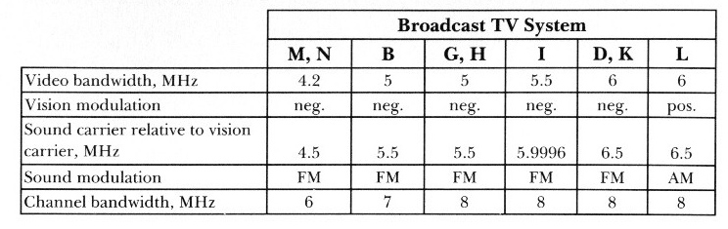
The structure of the video Standard
- The several (major) parts of a video standard
  - Scanning standard: determines:
    - How the picture is scanned in space and time (no lines/picture, no pictures /second) including interlace
  - Colour Information Representation:
    - Component (for production) and composite (for broadcasting, i.e. NTSC, PAL, SECAM)
  - Aspect Ratio (how a signal fits in a screen of a particular proportion)
  - The signal levels:
    - in analogue domain it determines how the receiver should interpret a video waveform in the voltage domain;
    - in digital domain it standardises the relationship between analogue voltages and the corresponding digital codes
  - Format: agreed way of packaging the picture information for transmission or recording
    - D1 corresponds to two distinct standards 529/59.94/2:1 and 625/50/2:1
  - New formats using compression are used for distribution purposes
    - i.e. ISO/IEC MPEG1 and MPEG2
    - Old analogue scanning standards crate still incompatibilities; for example MPEG2/50 and MPEG2/59.94 are NOT compatible
- The scanning standard
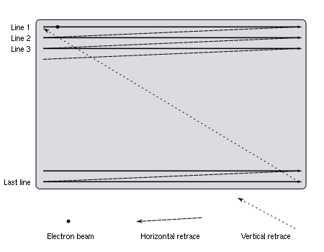
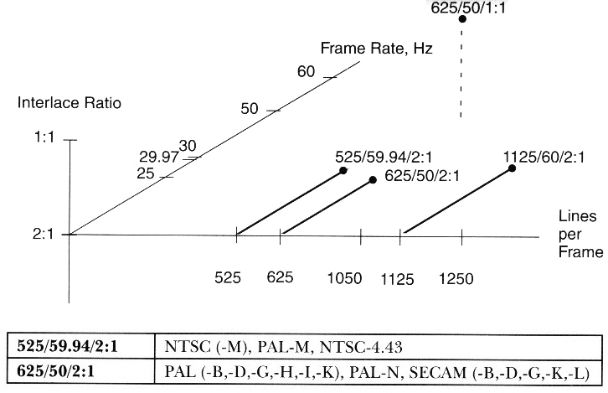
  - Number of Lines per frame
  - Frame Rate
  - Interlace Ratio
  - Line Rate, Field Rate result from the above
  - What is Progressive Scanning
  - Short specification of the scanning standard :
no of lines/frame rate/Interlace video i.e. ‘625/50/2:1’
  - What is a HDTV and relevant standards
  - Typical production is multistandard i.e
    - signal from HD camera
    - Down-converted
    - Transferred to a format compatible with storage media

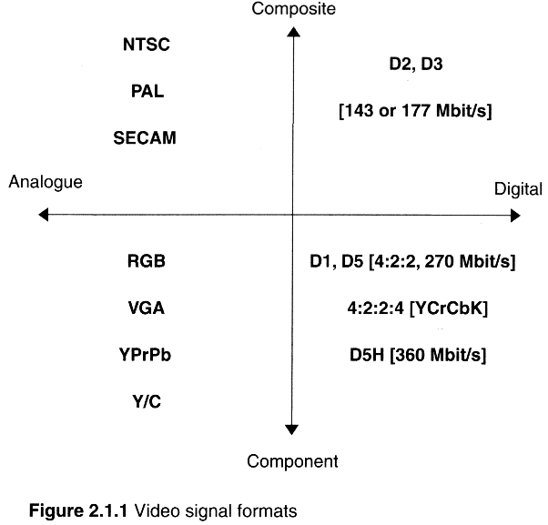
- Aspect Ratio
  - Ratio of width of an object to its height
  - Defined as a two integer number (i.e. 4:3) or as a single number (i.e. 1.33)
  - Difference between Screen Aspect Ratio and Picture Aspect Ratio
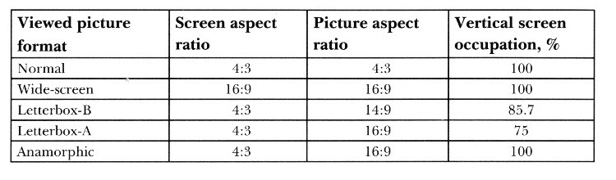
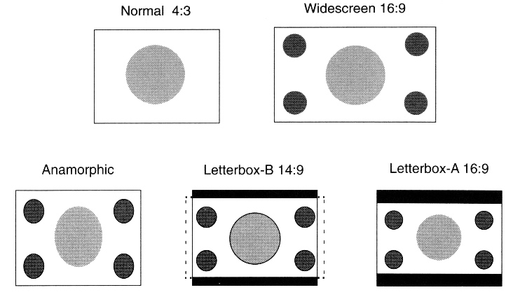
  - HDTV and EDTV different aspect ratio to 4:3
  - Cinematography from 1.333 (early films) to 2.35 (CinemaScope) and 2.77 in Dynavision widescreen 3D format
  - NOTE: Aspect Ratio is independent of the scanning parameters. As a result we can have video signals with exactly the same scanning parameters but different aspect ratios
  - Widescreen 16:9 productions and 4:3 productions are incompatible
    - 4:3 -> 720 samples/active line @13.5 MHz (Rec. CCIR 601, Part A)
    - 16:9 -> 960 samples/active line @18 MHz (Rec. CCIR 601, Part B)
  - Aspect Ratio conversion and HDTV down converters
    - Zoom and Panscan mode (operator involvement)
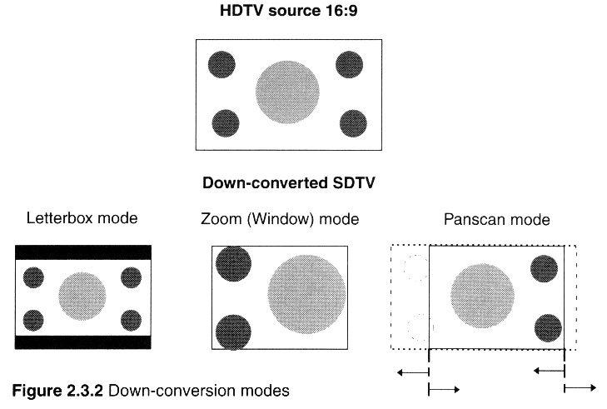

- Colour Information representation
  - RGB
  - Component : Luminance and colour difference signals
  - Composite video (fig 2.4.1)
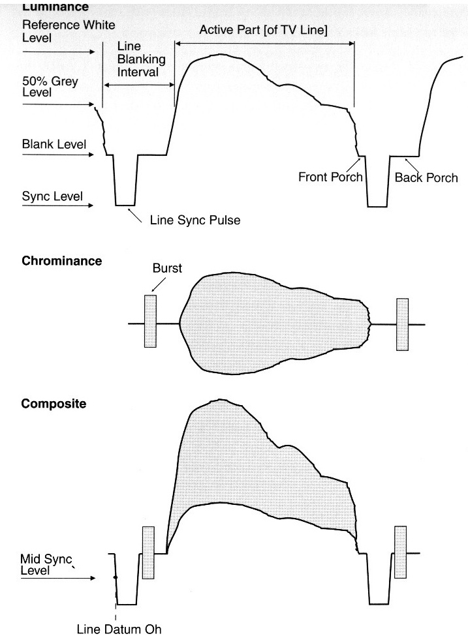
- Accompanying audio
Audio standards and formats need to be taken into account, since the digital studio interface SDI (Serial Digital Interface) can carry Embedded Audio
Two main types of production of audio formats: analogue and digital and the analogue sound interfaces are well defined

In digital TV the AES/EBU digital audio interface was specified as a result between Audio Engineering Society and the European Broadcasting Union, resulting in the AES3 (ANSI4.40) document, entitled:
‘AES recommended practice for digital audio engineering – Serial transmission format for two-channel linearly represented digital audio data.’
AES3 offers a lot of flexibility:
- Support word-lenghts from 16 to 24 bits
- Fixed sampling rates of 32, 44.1 and 48 kHz
- Support dynamic sampling rate
- May lock the audio sampling rate to the video line rate for synchronisation purposes
- Standard line impedance at 75 Ohm
- Standardised signal level to 1 Volt

- Capturing video signals
  - 1 CCD (videocameras)
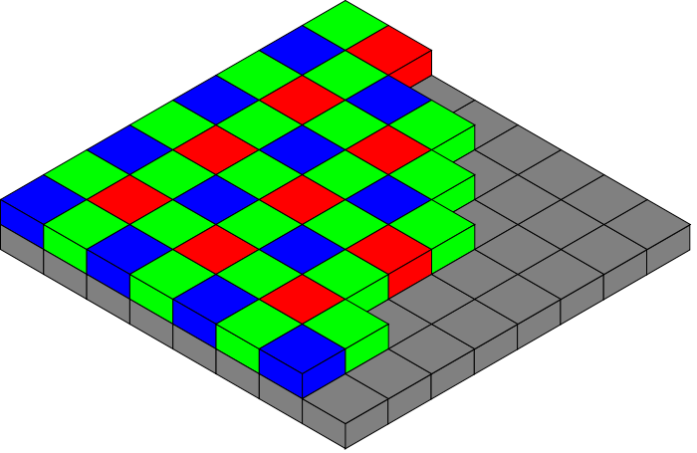

  - 3 CCD (videocameras)
  - 
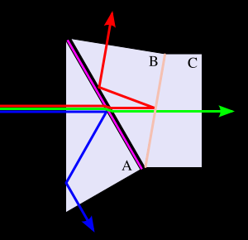

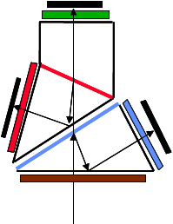

Reference Data
- Introduction
- Analogue video signal parameters
  - Scanning and synchronisation
  - Luminance signal derivation
    - Y = 0.299 R + 0.587 G +0.114 B
  - Analogue component signals
    - Luminance and colour difference signals (YPrPb)
    - Pr =0.71327 (R-Y)
    - Pb = 0.56433 (B-Y)
- Digital component video signals
- Sampling and quantisation

  - 4:2:2 format (625 /50 13.5 MHz standard TV signal)
Fig3311
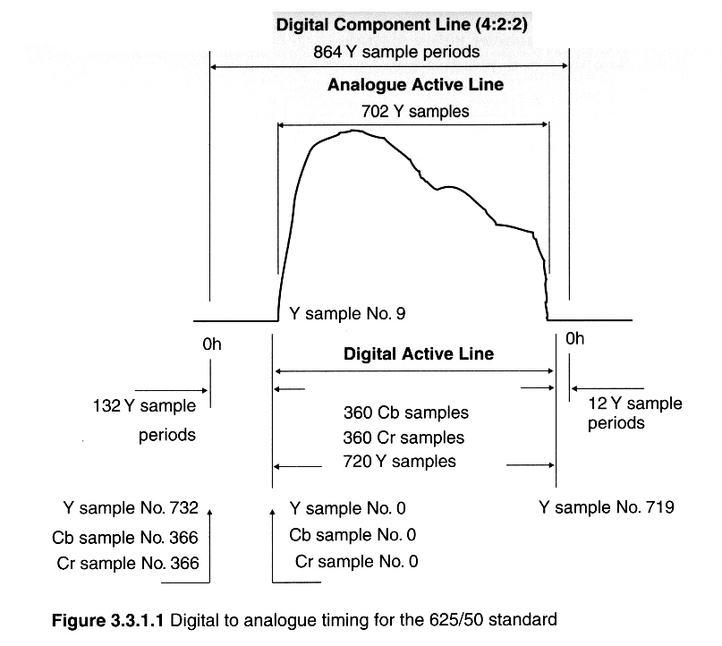
  - 4:2:2 format (625 /50 19MHz 16:9 video signal)
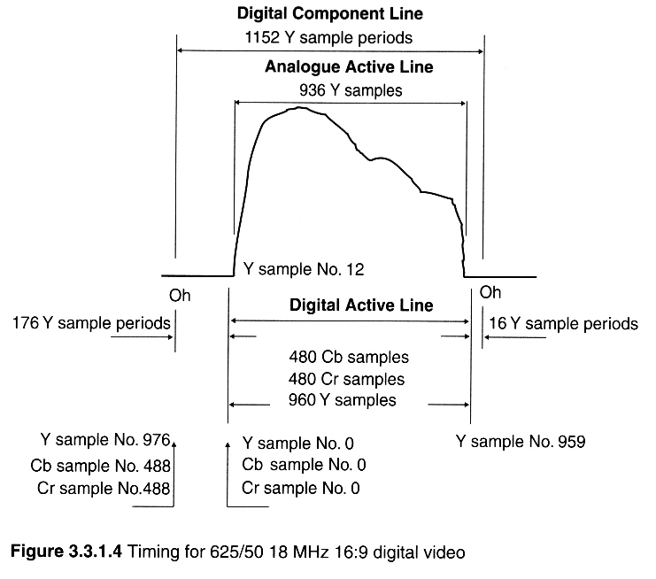

  - 4:2:2 sampling structure

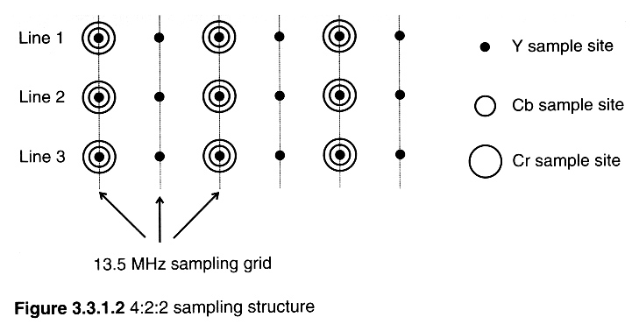

  - 4:1:1 sampling grid (horizontal chrominance half the standard)
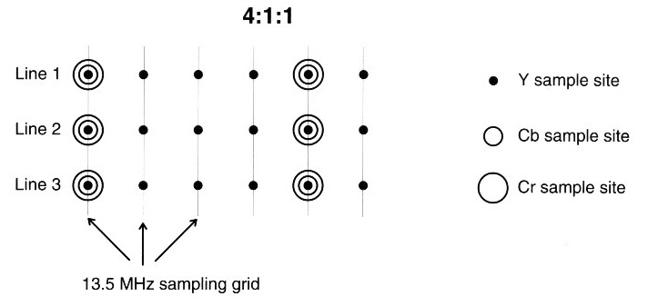
  - 4:2:0 sampling grid (horizontal chrominance half the standard) and chrominance samples shifted vertically by one quarter of the field (down in the top field and up in the bottom field
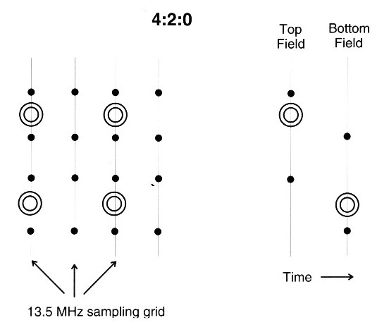
Fig 3315b
  - Generally non-uniform quantisation is used
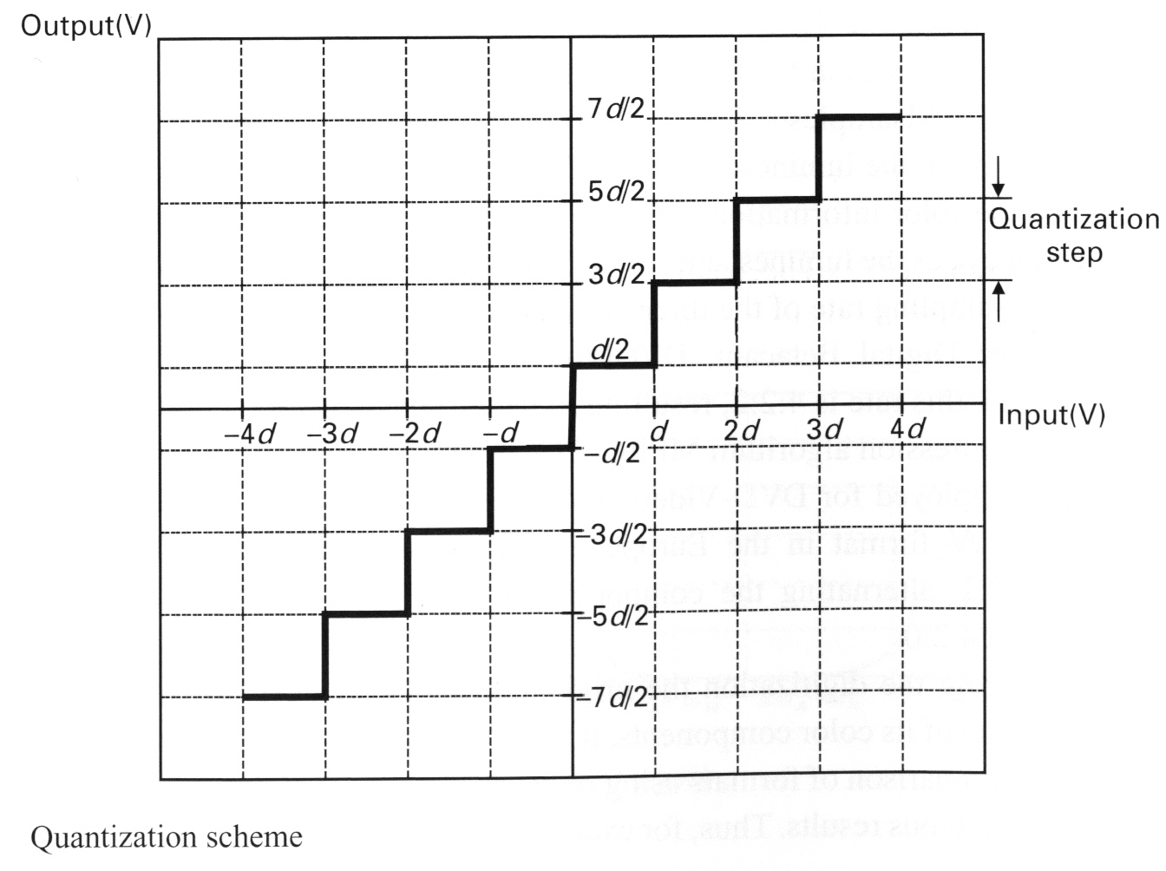
Uniform quantisation scheme

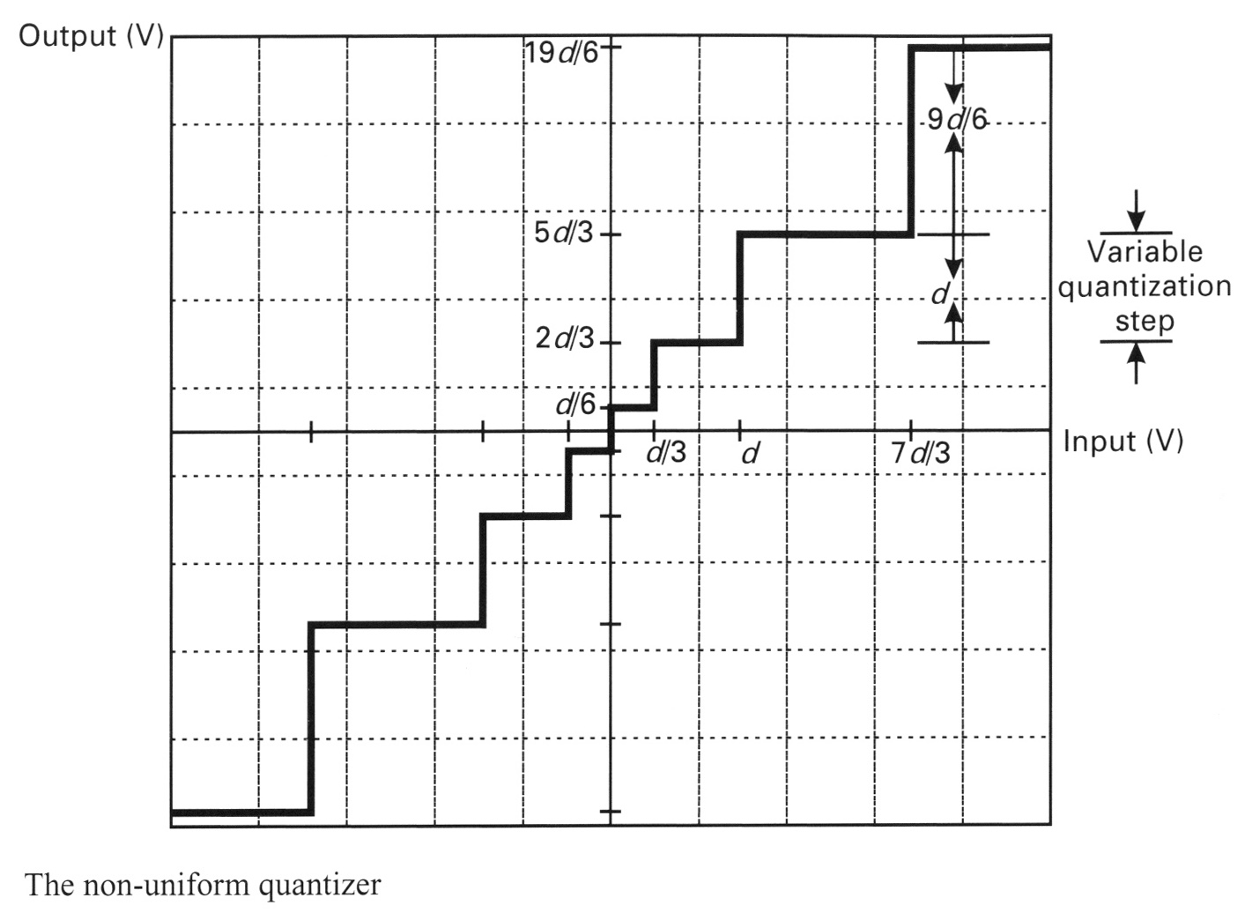

Non uniform quantisation scheme

