Digital Image Fundamentals

- Elements of visual perception
  - The human eye
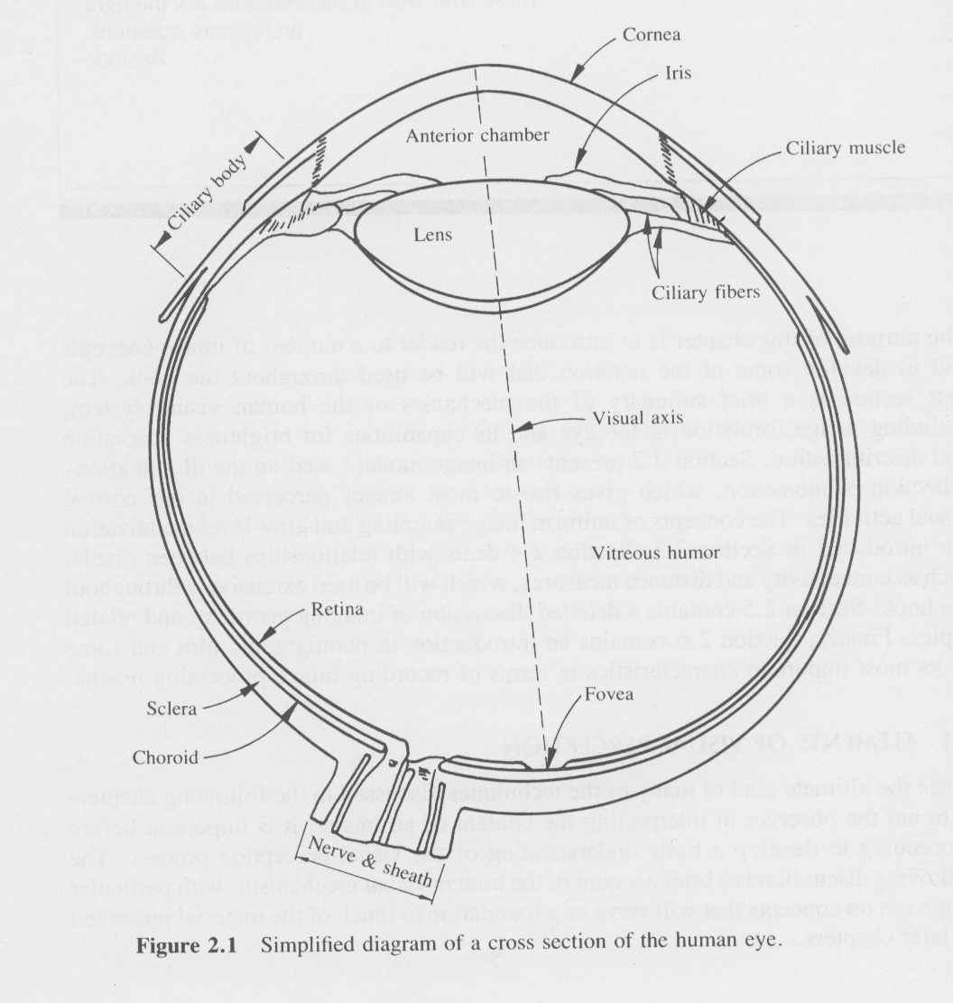
  - Image formation in the eye
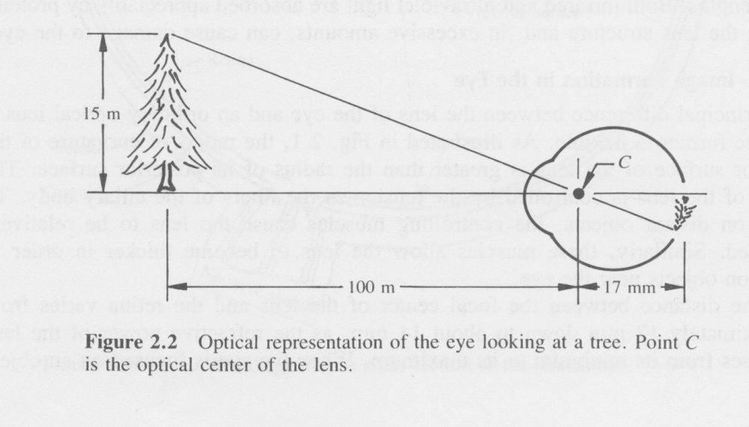
  - Brightness adaptation and discrimination (mach band effect – gray scale/ eye spatial response

How many different gray levels can humans see?

The above image contains a series of 32 steps in gray level from black at the left to white at the right.
The image below contains a series of 64 steps in gray level from black at the left to white at the right.

Look at the 2 images on the screen...are they different? You should be able to clearly see the distinct steps in the top image. In the lower image it is difficult to see the distinct steps.
What do you conclude?
For a "typical" display, humans can distinguish something more than 32 levels and something less than 64 levels. That is, we can distinguish more than 5 bits but less than 6 bits.






- Sampling and quantisation (bits, bytes and channels)
  - Uniform sampling and quantisation
Digitization of the spatial coordinates -> image sampling
Amplitude quantisation -> gray level quantisation

A continuous image f(x,y) is approximated by equally spaced samples arranged in a form of NxN array, where each element of the array is a discrete quantity.
f(0,0) | f(0,1) | F(0,2) | …… | f(0, N-1)
f(1,0) | f(1,1) | F(1,2) | …… | f(1, N-1)
…..
f(N-1,0) | f(N-1,1) | F(N-1,2) | …… | f(N-1, N-1)

The whole table above is a (square) digital image; each element of the array is referred as image element, picture element, pixel, or pel. This image has one channel.

A colour image consists of three grey level images each one corresponding to red, green and blue channels of the screen monitor

Three channel colour image Blue channel

Green Channel Red Channel

Reducing the sampling grid size of an image (a 3 channel colour image)

Sampled @ 512 x 512 pixels Sampled @ 256 x 256 pixels

Sampled @ 128 x 128 pixels Sampled @ 64 x 64 pixels

Sampled @ 32 x 32 pixels Sampled @ 16 x 16 pixels

Changing the number of levels of an image (bits per pixel)

Sampled at 16.777.216 levels (24 bits per pixel) Sampled at 256 levels (8 bits per pixel)
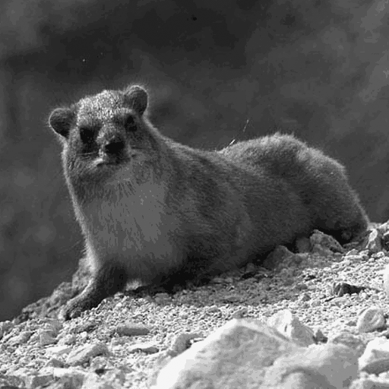
Sampled at 128 levels (7 bits per pixel) Sampled at 64 levels (6 bits per pixel)
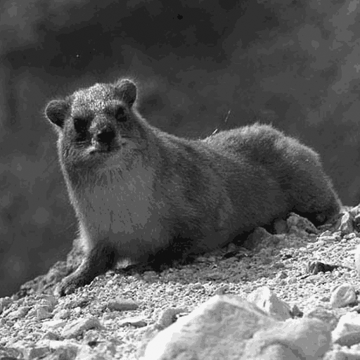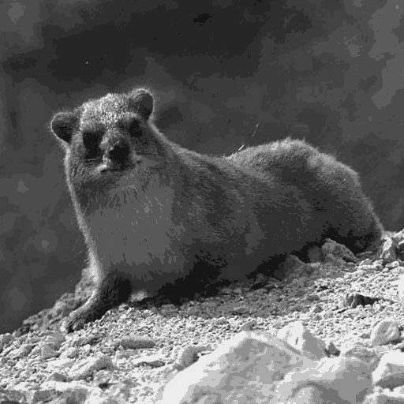
Sampled at 32 levels (5 bits per pixel) Sampled at 16 levels (4 bits per pixel)

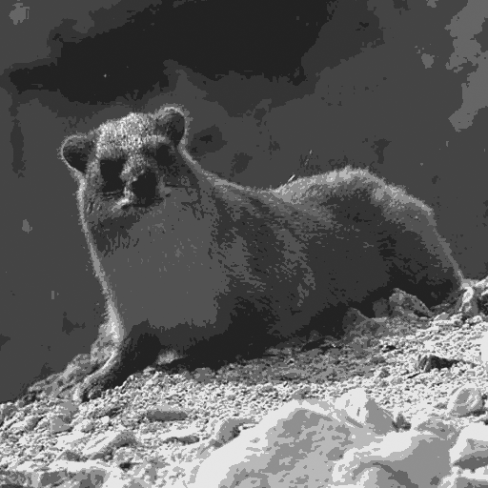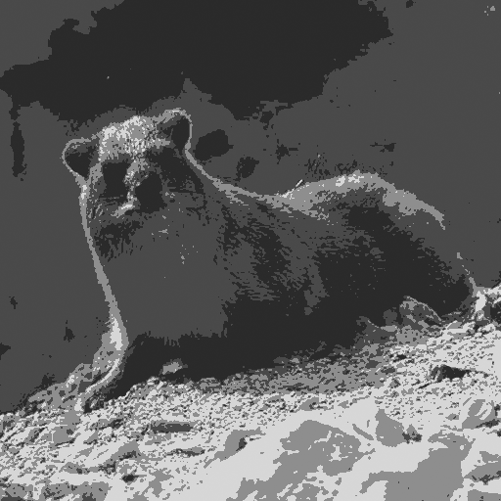
Sampled at 8 levels (3 bits per pixel) Sampled at 4 levels (2 bits per pixel)

Sampled at 2 levels (1 bits per pixel) Sampled at 2 levels, dithering (1 bits per pixel)

  - Non uniform sampling and quantisation
It is possible to sample and quantise different parts of an image in a different way: i.e. the face with fine detail and the background in a coarse detail

- Some basic relationships between pixels
  - Neighbours of a pixel

  - Distance measures

- Imaging geometry
  - Basic transformations
    - Translation
    - Scaling
    - Rotation
  - Perspective transformations
  - Camera model
  - Camera calibration
  - Stereo imaging
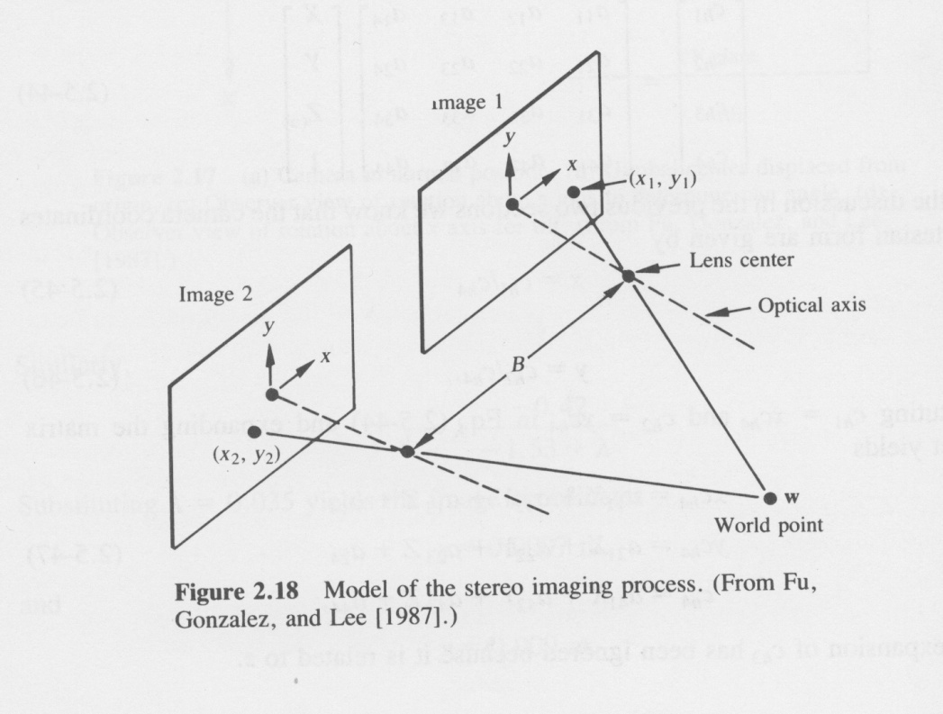
- A moving image model (no of images per second, including sound)

Image Transforms
Fourier Theory

- Introduction to the Fourier Transform
What is a signal?
In the fields of communications, signal processing, and in electrical engineering more generally, a signal is any time-varying or spatial-varying quantity.
In the physical world, any quantity measurable through time or over space can be taken as a signal. Within a complex society, any set of human information or machine data can also be taken as a signal. Such information or machine data (for example, the dots on a screen, the ink making up text on a paper page, or the words now flowing into the reader's mind) must all be part of systems existing in the physical world – either living or non-living.
Despite the complexity of such systems, their outputs and inputs can often be represented as simple quantities measurable through time or across space (www.wikipedia.org).
Signals are generally analogue, meaning that they have values at any time or at any spatial location. Often signals are expressed with the notion of function ie: a signal is a function of time or a function of length.

What is a continuous signal?
Continuous signals are signals that theoretically have an infinite duration (over time or across space).

What is a finite signal?
Finite signals are signals that have finite duration, they are either restricted in a specific period of time (i.e from t₀ to t₀+Δt) or have a specific spatial extend (i.e. a line that extend from location x₀ to location x₀+Δx). A finite signal is an analogue signal.

What is a digital signal?
A digital signal is an analogue signal that has been sampled at (usually) repetitive intervals. Digital signals are approximations of analogue signals and exist only for the points/locations/intervals where they were sampled.

- Fourier Transform in one dimension
The theory of Fourier Transform tells us that any signal can be expressed as a sum of a series of sinusoids of different frequencies. Practically this means that we have two representations of a signal. One representation in the time domain where the signal is a function of time and the other representation which a signal is a representation of frequencies (i.e no time is involved).
The important point to notice is that both representations depict the same signal and we can move from time domain to frequency domain through mathematical transforms. Since the transforms are rather complicated we will try to present them in a schematic way in order to grasp the basic notions first in one dimension and secondly in two dimensions.

- FT of aperiodic signals (infinite no of frequencies, infinite range)
  - Fourier Transform can work on Aperiodic Signals.
  - Fourier Transform is an infinite sum of infinitesimal sinusoids.
  - Fourier Transform has an inverse transform, that allows for conversion from the frequency domain back to the time domain
- FT of finite periodic signals (infinite no of frequencies, specific period)
- FT of a periodic bandpass signal (specific range of frequencies and specific range of length)

Signals | Time domain | Freq. Domain
Aperiodical | Continuous, Infinite | Continuous, Infinite
 | 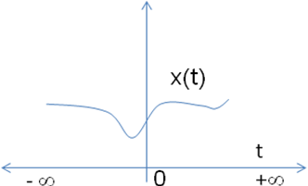 | 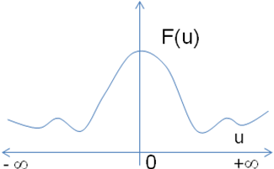
Periodical | Continuous, Finite | Continuous, Infinite
 | 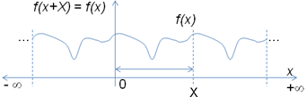 | 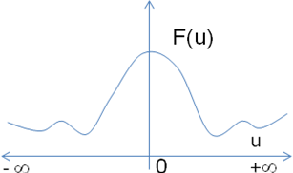
Digital signals:  Periodical and Bandlimited | Discrete, Finite (periodical) | Discrete Finite (periodical)
 | 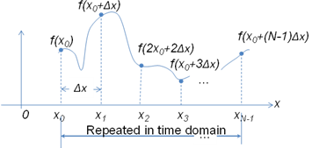 | 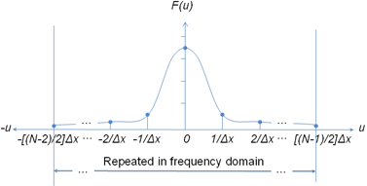

The FT of one continuous variable

{,
where =.

Given can be obtained through the Inverse Fourier Transform

{

⎟⎟
where
⎟⎟ =
and
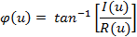
⎟⎟ =

The Power Spectrum
==

The Euler form:

Discrete FT

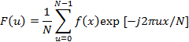

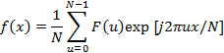
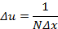

Implementation of a Fourier Transform of a 4 samples signal
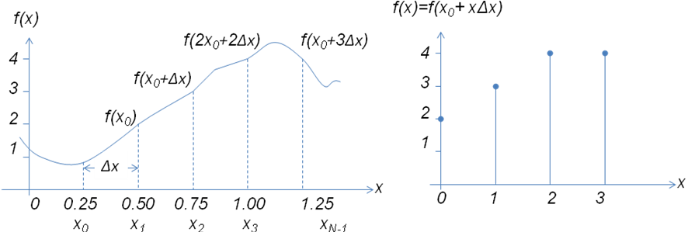
We sample the signal on the left and we end up with the four values on the right:

Signal in  Time Domain  (integer numbers) |  |  | Signal in  Frequency Domain  (complex numbers) |  |  | Power Spectrum in Frequency domain  (float numbers)
f(0) | 2 | FT | F(0) | 3.25 |  | ⎟⎟ | 3.25
f(1) | 3 | -> | F(1) | [-2+j] |  | ⎟⎟ | /4
f(2) | 4 | iFT | F(2) | -[1+j0] |  | ⎟⎟ | 1/4
f(3) | 4 | <- | F(3) | -[2+j] |  | ⎟⎟ | /4

For example: F(0) = = [f(0)+f(1)+f(2)+f(3)] = [2+3+4+4] = 3.25
F(1) = == [-2+j] and so on.

Please note that the PS is part only of the Frequency domain presentation, since it provides amplitude information but misses phase information. Phase information is used only to calculate the displacement (left or right) of the sinusoid waveform in the time.

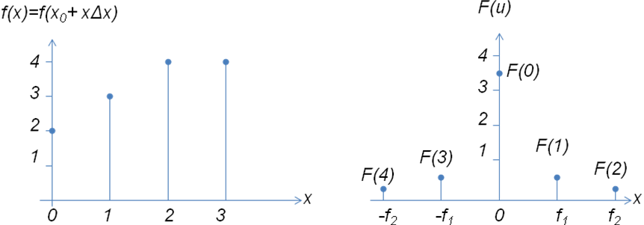
Signal in Time Domain Power Spectrum in Frequency domain

Explanation of the Frequency domain coefficients

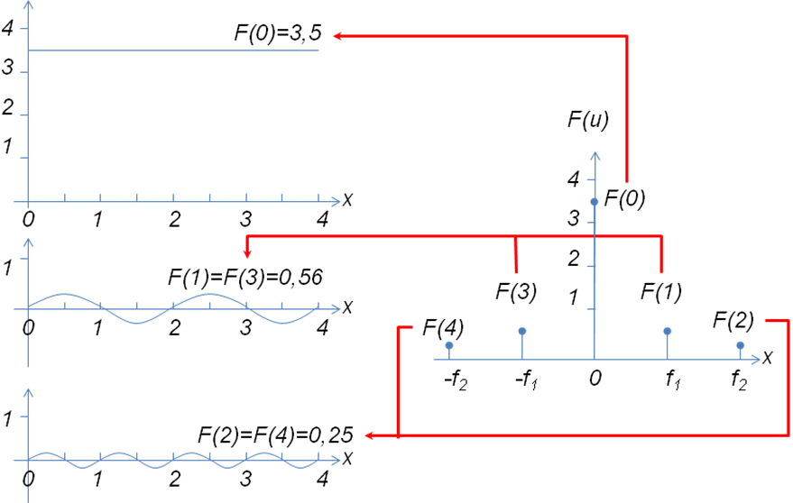
Time Domain Power Spectrum in Frequency domain
Note: Phase information it related to the displacement of sinusoids in time domain.

Sampling of a signal
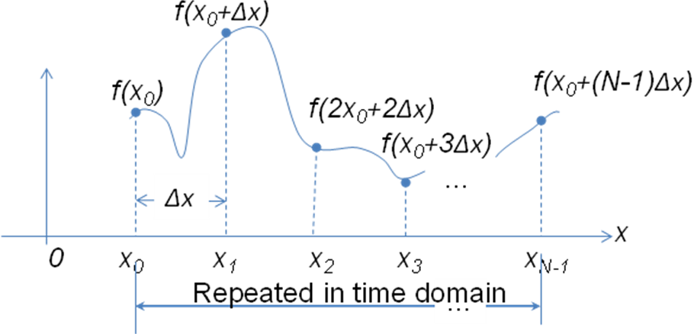

Aliasing and how it is avoided

The Nyquist theorem: In order not to lose information, we must sample the analogue signal with a rate at least double the maximum frequency component that exists in the signal

The only solution to the aliasing problem is to ensure that the sampling rate is higher than twice of the highest frequency present in the signal. If that is not possible, then use an anti-aliasing filter to screen out those frequencies higher than ½ of the sampling frequency before sampling, assuming the removed frequencies are not of importance.
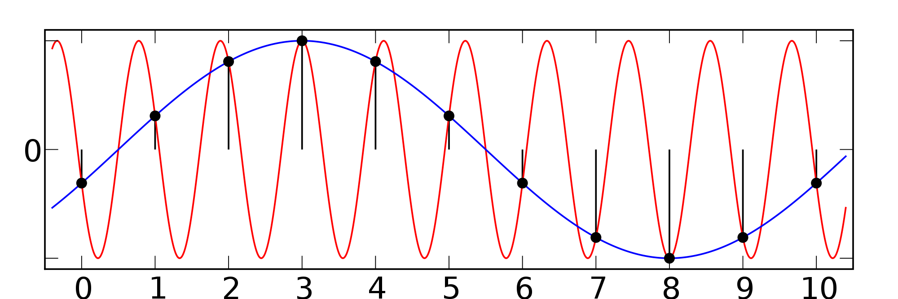

Two different sinusoids that fit the same set of samples

Fourier Transform in two dimensions

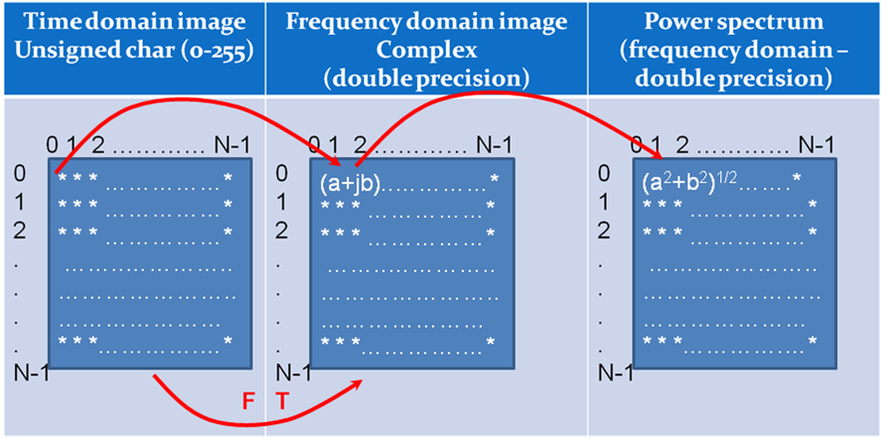


Sinusoid with 8 vertical cycles and its power spectrum


Sinusoid with 8 horizontal cycles and its power spectrum

Sinusoid with 32 vertical cycles and its power spectrum


Sinusoid with 32 horizontal cycles and its power spectrum


Sinusoid with 16 diagonal cycles

Sinusoid with 16.2 diagonal cycles


The figure above presents replication of the sinusoid with 16.2 diagonal cycles. Note the discrepancies at the edges that result in high frequencies presence in the Power Spectrum

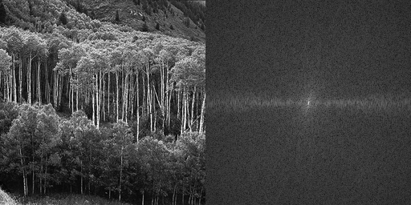
Power spectrum of a forest

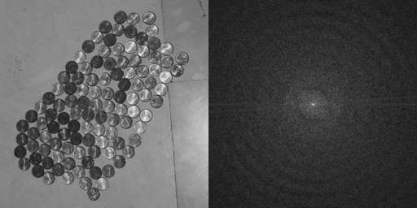

Coins and the corresponding power spectrum of coins. Please note the frequencies multiples of the coin size.

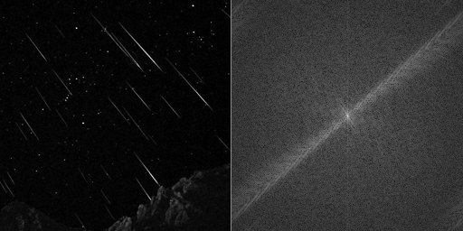
Falling stars and its power Spectrum. Please note the existence of high frequencies perpendicular to the direction of the falling stars.

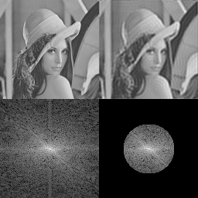
Low pass filtering (step edge causing ringing effect)
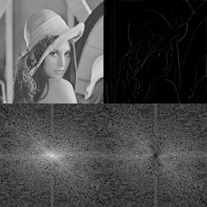
Butterworth high pass filter (smooth slope attenuates the lower frequencies)
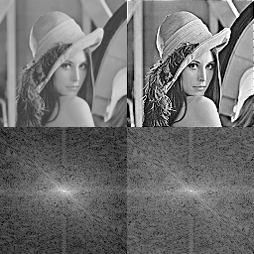
Filter reducing low frequencies (by 0,5) and accentuating high frequencies (by 4.0)

