**BPEL:**

**What are partnerLinkTypes, roles, and partnerLinks.**

By gopalan on Jul 03, 2006

BPEL is a *Web Service Sequencing Language*. A BPEL Process defines a *conversation* flow chart and a BPEL Process instance is a particular conversation following the chart which consists of only *WSDL-described message exchanges*. BPEL provides and consumes WSDL-defined services. BPEL execution systems can thus support multiple concurrent conversations.

Links to all the different WSDL-defined web services that a BPEL process instance interacts with are called ***partner links***. They are concrete references to services that a BPEL business process interacts with. Links to WSDL-defined web services that *are invoked* by a BPEL process are called ***Invoked partner links***. Similarly, links to WSDL-defined web services that can *invoke* a BPEL process are called ***Client partner links***. Each BPEL process will definitely have at least one *Client partner link* since a BPEL process can only be instantiated with a call from a *Client partner*.

A BPEL process can interact with a WSDL-defined web service in *three* distinct ways:

1. WSDL-defined web services can *invoke* a BPEL process
2. WSDL-defined web services *can be invoked* by a BPEL process
3. WSDL-defined web services that have either characteristics or ***roles***, in that, they may be invoked by the BPEL process, and they may in turn invoke the BPEL process.

**Scenario 1: WSDL-defined web services can *invoke* a BPEL process**

In this scenario, the BPEL process provides a *IRequestLoan* portType (interface) through which a WSDL-defined Client Partner web service invokes the *requestLoan* operation.

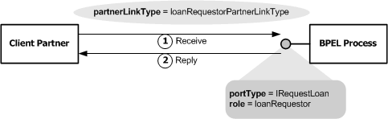

From the WSDL-service Client Partner's point of view, it requires a BPEL Process to provide a *IRequestLoan* portType(interface) with a *requestLoan* operation that it can invoke. From the BPEL Process's point of view, it offers a *IRequestLoan* portType(interface) with a *requestLoan* operation that any other web service could invoke.

**Partner Link Type and Role**:

Instead of describing business processes based on a certain point of view, BPEL introduces the concept of a ***role***, and the concept of a ***partner link type***. Relationships are modeled based on the *role* that they play in the business process rather than individual points of view. A partner link type defines how two individual WSDL-defined partners can interact together and what each of the partners have to offer. ***partner link type***s are defined in WSDL files through the WSDL extensibility element mechanism.

**Scenario 2: WSDL-defined web services *can be invoked* by a BPEL process**

In this scenario, the Invoked partner provides a *ILoanProcessor* portType (interface) through which a WSDL-defined BPEL Process invokes the *processLoanRequest* operation.

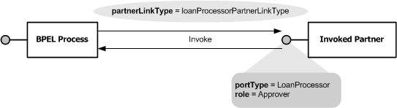

From the BPEL Process's point of view, it requires a WSDL-defined Invoked Partner to provide a *LoanProcessor* portType with a *processLoanRequest* operation that it can invoke. From the Invoked Partner's point of view, it offers a *LoanProcessor* portType with a *processLoanRequest* operation that any other web service could invoke.

**Scenario 3: WSDL-defined web services that have either characteristics**

In this scenario, a WSDL-defined Invoked Partner offers a *IAdjuster* portType (interface) that has an *addNewAdjustmentJob* operation. the BPEL process provides a *AdjusterCallback* portType (interface) that the Invoked Partner can use to callback the BPEL Process's *submitAdjustmentJob* operation.

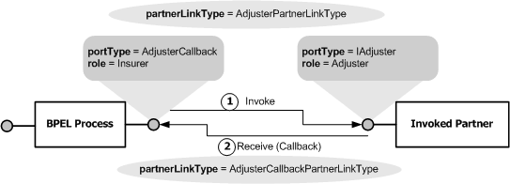

From the BPEL Process's point of view, the process requires a WSDL-defined Invoked Partner that implements the *IAdjuster* portType (interface) with a *addNewAdjustmentJob* operation and provides an *AdjusterCallback* portType (interface) with a *submitAdjustmentJob* operation. From the WSDL-defined Invoked Partner's point of view, it offers an *IAdjuster* portType (interface) with a *addNewAdjustmentJob* operation and requires a BPEL Process that provides an *AdjusterCallback* portType (interface) with a *submitAdjustmentJob* operation.

**The partnerLinkType and role Definitions in WSDL Files**

***Partner  link  type***s are defined in WSDL files through the WSDL extensibility element mechanism. The ***<partnerLinkType>*** element is embedded directly within the WSDL file of every partner process and service process involved in a BPEL orchestration. ***<partnerLinkType>*** elements defined in the partner’s WSDL file identify the WSDL portType (interface) element referenced by the partnerLink in the service process’s BPEL process definition.

The ***<partnerLinkType>*** element contains one ***<role>*** element for each role (service provider or service consumer) the service process can play, as defined by its ***partnerLink*** element—***myRole*** (indicating a service provider) and ***partnerRole*** (indicating a service consumer) attributes—in the service process’s BPEL process definition. Therefore, a ***partnerLinkType*** can have either one or two ***<role>*** child elements. The following example shows one ***<role>*** child element.

|  |
| --- |
| <definitions name="LoanProcessorEJBWrapper"              targetNamespace="http://localhost/loanRequestorBpel/LoanProcessorEJBWrapper"              xmlns:tns="http://localhost/loanRequestorBpel/LoanProcessorEJBWrapper"              xmlns="http://schemas.xmlsoap.org/wsdl/"              xmlns:plink="http://schemas.xmlsoap.org/ws/2004/03/partner-link/"  ...  >  ...  **<plink:partnerLinkType name="loanProcessorEjbPartner">**  **<plink:role name="loanProcessorEJB"**  **portType="ns:LoanProcessorEJBSEI">**  **</plink:role>**  **</plink:partnerLinkType>**  ...  </definitions> |

In situations when a service process has the same relationship with multiple partner processes, the service process’s BPEL ***partnerLink*** elements can reference the same ***partnerLinkType***.

**The partnerLinks and partnerLink Definitions in BPEL files**

***Partner Link***s are defined in BPEL files. The ***<partnerLink>*** definition defines the portType (interface) of the partner process that will participate in BPEL orchestrations of the business process being defined. These partner processes can act as clients to the service process being defined or can be invoked by the service process. The ***<partnerLink>*** element encodes communication exchange information between the service process and its partner processes. The role of the service process will vary according to the nature of communication with its partner process. For the example, when the LoanRequestor service process invokes a LoanProcessorEJB partner process, it may act in a LoanRequestor role and the LoanProcessorEJB partner process may act in a LoanProcessorEJB role.

The ***<partnerLink>*** element contains the ***myRole*** and ***partnerRole*** attributes that establish the roles for the service process and its partner process, respectively, as illustrated in the following code example.

|  |
| --- |
| **<partnerLinks>**  **<partnerLink name="bpelImplemented"**  **partnerLinkType="ns0:loanRequestorPartnerLinkType"**  **myRole="loanRequestor"/>**  **<partnerLink name="ejbInvoked"**  **partnerLinkType="ns1:loanProcessorEjbPartner"**  **partnerRole="loanProcessorEJB"/>**  **</partnerLinks>** |

The ***myRole*** attribute is used when the service process acts as the service provider and is being invoked by a service consumer partner process client. Similarly, the ***partnerRole*** attribute identifies the service provider partner process that the service process is invoking when acting in a service consumer client role.