THE POSTGRADUATE ESSAY

Some Guidelines for Academic Writing

A. General Instructions

1. Students must:
- Work independently on the subject.
- Apply the specific methods and approaches of their scientific field.
- Locate and use productively the necessary bibliography.
- Structure the content appropriately.
- Limit the text to the necessary extent.
- Write linguistically correct text.
- Present conclusions in a meaningful and clear manner.

2. Style
Style is not solely the author’s free choice but is subject to academic rules:
- Accuracy and objectivity.
- Simplicity and austerity.
- Arguments rather than rhetoric; proofs rather than bombast.
- Avoid ornamentation, stereotypes, and commonplaces.

B. Preparation
- Create a basic structure/diagram of your paper.
- Compose an initial layout early; expect modifications during writing.
- The final layout should appear in the Table of Contents.
- Begin writing early, even if bibliography collection is incomplete.

C. Writing

1. General Writing Principles
- Ensure flow and unity in your writing; connect ideas smoothly.
- Maintain internal unity: beginning, middle, and end linked to the main purpose.
- Do not write anything you have not fully understood.
- Use the polytonic system (e.g., Palatino Linotype) for ancient Greek words and titles.
- Ensure each sentence supports the overall argument.
- Check that each chapter relates logically to the main purpose.
- Re-read your text from the reader’s perspective for clarity.
Suggestion: Print your final text to make a last check: theoverall image may
not be ‘visible’ on the computer screen.

2. Citations and References
- Scientific work is based on arguments and engagement with previous research.
- Cite others for documentation and academic integrity.
- Integrate bibliography effectively into your reasoning.
- Avoid excessive quotations.
- Quoting methods: direct quotation, paraphrase, summary.
Use footnotes (recommended: AJA system) = https://ajaonline.org/submissions/abbreviations/

- Always cite source: author, year, page (e.g., Taplin 2007, 231, p.23).
- Ancient texts example: Homer, Iliad 4, 543.
- List references in chronological order when grouped.
- Do not overload footnotes with irrelevant information.

3. Plagiarism
- Using someone else’s work without proper citation constitutes plagiarism.
- Bibliography listing alone is not sufficient.
- Readers must clearly distinguish your ideas from borrowed material.
- Always record sources when taking notes.
- Paraphrase carefully and use your own words.
- Place exact quotations within quotation marks.

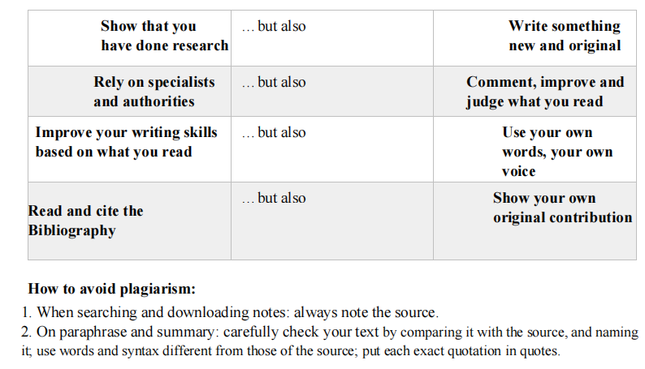

4. Presentation and Bibliography

A. Cover Page
- Course title and semester/year.
- Author’s name.
- Title and subtitle (if applicable).

B. Structure
- Introduction.
- Chapters (with descriptive titles).
- Conclusions.
- Bibliography.
- Catalogue of Objects (if required).
- Catalogue of Ancient Texts (if required).

C. Common Errors and Omissions
- Always insert page numbers.
- Properly cite image sources in captions or in a separate list.
- For Attic vases, include BAPD number.
- For mythological subjects, refer to LIMC.

5. Sample Bibliography Format
Abramov, A. P. 2002. “Tipologija I chronologija amfor o Chios”, Drevnosti Bospora 5, 7-26.
Aellen, C. 1994. À la recherche de l’ordre cosmique. Zurich.
Aellen, C., Cambitoglou, A. & Chamay, J. 1986. Le peintre de Darius et son milieu. Geneva.
Ahlberg-Cornell, G. 1984. Herakles and the Sea-Monster in Attic Black-Figure Vase-Painting. Stockholm.
Albert, W.-D. 1979. Darstellungen des Eros in Unteritalien. Amsterdam.
Amyx, D. A. 1988. Corinthian Vases of the Archaic Period. Berkeley-Los Angeles.
Amyx, D. A. & Lawrence P. 1996. Studies in Archaic Corinthian Vase Painting. Princeton.
Anderson, J. K. 1970. Military Theory and Practice in the Age of Xenophon. Berkeley-Los Angeles.
Avronidaki, C, 2025. “Of Painters and Scholars. New Vases, Old Questions and a Different Name for the Painter of Corinth 1937-525”, in G. Shepherd (ed.), From Corinth to Campania. Studies on Greek Vase-Painting in Honour of Ian McPhee. Nicosia, 7-20

